Feel Good Friday Activities
Second Level, Friday 5th February
s

Healthy Body | Healthy Mind | Outdoors/Science | Music
Just Dance!  Dancing is a great way to keep fit and express yourself. Put on your favourite music and dance like no one is watching.  You can also try learning some new moves by following some dance routines. Check out the Just Dance YouTube Channel:  https://www.youtube.com/justdance/videos | This week is Children’s Mental Health Week and the theme this year is Express Yourself! Expressing yourself is all about celebrating your individuality and the fact that there is only one of you! We are all unique.  Have a look at the suggested activities below and have a go at expressing yourself through creativity! | This week there have been some snow showers. Sledging is a fun winter activity.  Can you design and build a sledge for a small toy? Can you make it go down a ramp? Can you investigate how to make it go fast and slow? What materials work best?  Take a look at the activity below. | Mr Mac our Kodaly teacher has sent some resources to help you learn all about yodelling!  Take a look at the resources and links below and see if you can have a go!

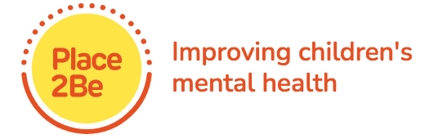

Express Yourself!

Arts and Crafts  Self expression is about communicating your individuality. Sometimes it can be hard to be ourselves and we can worry about what other people think.  Make an Inside- Out box. Decorate a box with words/pictures that represent the parts of you that you show to the world. Decorate the inside with images, words or objects that represent the passions and interests you share with the people closest to you.  Discuss with someone at home why we don’t always share all of ourselves with others. What stops us? | Photography  As we grow up we express ourselves in different ways and our tastes and interests can change. For example, the music we like, the clothes we wear, our hobbies, our hairstyle, our friends and our relationships.  Create a slide show of photos of yourself or a video clip that expresses who you are as a person right now. You could include your current likes and dislikes, strengths, interests, dreams and passions.  You could watch this back as you get older and see if anything has changed.  Enjoy an opportunity to look back at old photographs of you and your family. Do you notice any differences in how your family express yourself? | Music  Music can make us feel lots of different emotions such as happy, sad or excited. Watch this video clip and discuss with someone at home how each piece of music makes you feel.  https://www.youtube.com/watch?v=sELz0aCx9Lw  Research shows that people feel more positive after singing to music, than they do just listening to music.  Have a go at learning the lyrics to this song. Dance, mime, clap or sing along.  https://www.youtube.com/watch?v=yKpVM9QQzIs  What music do you enjoy? Listen to some music and sing and dance along. How does it make you feel?
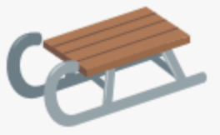
Design and Build a Sledge!
Use household objects/recycling to design your own sledge for a small toy. Can your sledge go down a ramp? Investigate how to make it go faster and slower by using different materials. and different weights.

Draw your initial design. What does it need to be a successful sledge?

List the materials you plan to use:

How successful was your design? How could you improve it?

Our Yodelling adventure takes place in the Austrian Alps. The Alps are the highest and longest mountain range in Europe, crossing the borders of 8 different countries, stretching for 750 miles. The highest mountain in the Alps is Mont Blanc, reaching 4,809 metres, (15, 778ft.)

Follow the link below to see some professional yodelling:
https://www.youtube.com/watch?v=1rPAnxsSk40&list=RDMvFFb_oUvzY&index=7
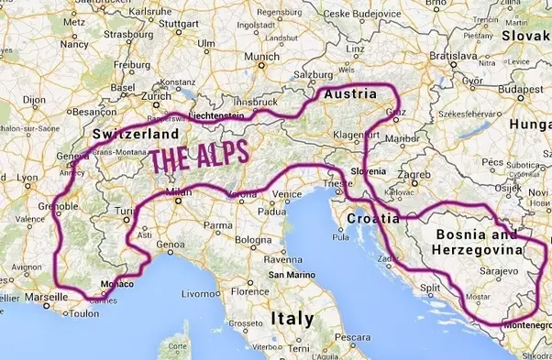
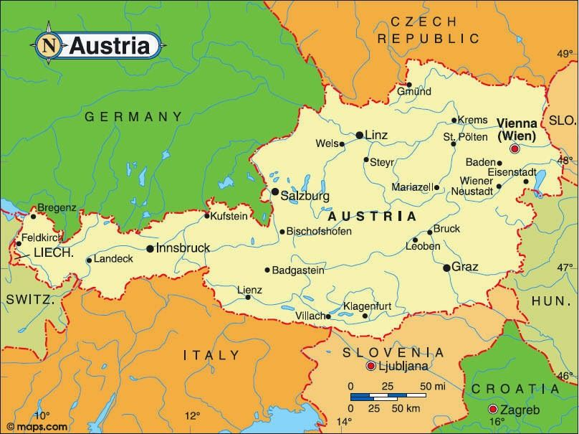

One instrument from the Alpine region that we didn’t see in the yodelling clip is the Alpine Horn. Typically, the Alpine Horn measures 2.4m, (8ft,) in length.
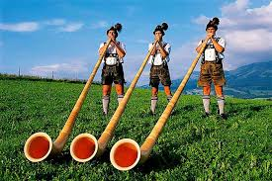
Follow this link to see the Alpine Horn being played:
https://youtu.be/E8Y2GzjqMVU

For certain, the most well-known piece of musical theatre to be set in Austria is “The Sound of Music.” Here is a MEDLEY of songs from the MUSICAL sung in an A CAPELLA style. https://youtu.be/HiHc0a0OrLc
The Von Trapp family in “The Sound of Music,” like Mozart, came from Salzburg in Austria.

“THE SOUND OF MUSIC.”
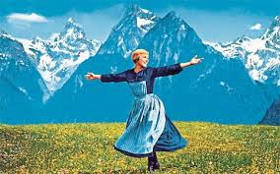

A LÄNDLER is a Bavarian folk dance in TRIPLE TIME.
It is danced with a partner and features hopping and stamping.
The music can be instrumental, a song, and can even feature yodelling.
“The Sound of Music” features a LÄNDLER.
https://youtu.be/dUFBOC6lQoo

The Capital city of Austria is Vienna, and Vienna was home to two of the world’s best known composers of classical music, namely Mozart and Beethoven. Mozart came from a different Austrian city known as Salzburg, and Beethoven was originally from the German city of Bonn, but they both did most of their work when living in Vienna.

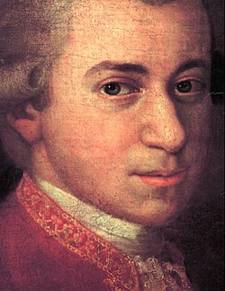
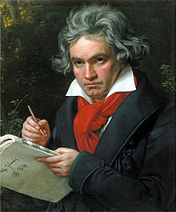
WOLFGANG AMADEUS MOZART LUDWIG VAN BEETHOVEN

1756 – 1791. (DIED AGED 35.) 1770 – 1827. (DIED AGED 57.)

Mozart wrote 12 variations based on “Twinkle, Twinkle, Little Star.”
Have a listen here - https://youtu.be/tGSDVrnjDqI

Learn more about Mozart here - https://youtu.be/_-gyNPeYhYc

Beethoven wrote one of the world’s most famous pieces of music. DA-DA-DA-DUM!!
This is the rhythmic opening to his 5th symphony.
Learn more about Beethoven here - https://youtu.be/kQ4cqdCzOwo

Have a go at these songs!

HI-LO CHICK-A-LO.
HI-LO CHICK-A-LO, CHICK-A-LO, CHICK-A-LO,
HI-LO CHICK-A-LO, CHICK-A-LO, HI.

LO-HI, CHICK-A-HI, CHICK-A-HI, CHICK-A-HI,
LO-HI, CHICK-A-HI, CHICK-A-HI, LO.

HI-LO, CHICK-A-LO, CHICK-A-LO, CHICK-A-LO,
HI-LO, CHICK-A-LO, CHICK-A-LO, HI.

KNEES-CLAP-CLICK. (Z = 1 BEAT REST)
KNEES-CLAP-CLICK, Z.
KNEES-CLAP-CLICK, Z.
KNEES-CLAP- CLICK-KNEES,
KNEES-CLAP-CLICK, Z.
KNEES-CLAP-CLAP-CLAP-CLAP, Z.
KNEES-CLAP-CLAP-CLAP-CLAP, Z.
KNEES-CLAP-CLAP, KNEES-CLAP-CLAP.
KNEES-CLAP-CLICK, Z.

