Feel Good Friday Activities
First Level Friday 5th Of February

Healthy Body | Healthy Mind | Outdoors/Science | Music
Born to Move!  Keep up your fitness levels by accessing these free Les Mills workouts. Choose a workout to suit you and your fitness level.  I recommend Move Like an Avenger!  https://watch.lesmillsondemand.com/born-to-move-free/season:1 | This week is Children’s Mental Health Week and the theme this year is Express Yourself! Expressing yourself is all about celebrating your individuality and the fact that there is only one of you! We are all unique.  Have a look at the suggested activities below and have a go at expressing yourself through creativity! | This week there have been some snow showers. Sledging is a fun winter activity.  Can you design your own sledge for a small toy? Can you make it go down a ramp? Can you investigate how to make it go fast and slow?  Take a look at the activity below. | Mr Mac our Kodaly teacher has sent some resources to help you learn all about yodelling!  Take a look at the resources and links below and see if you can have a go!

ART  Self expression is about communicating your individuality. We can express our thoughts and feelings through lots of ways using art. Crafting, painting, sculpture, drawing and photography are just some ideas. Follow the link below and try this simple ‘draw your feelings’ activity.  https://www.youtube.com/watch?v=STdJ__8ORyE&feature=youtu.be | MOVEMENT  We can often understand how someone is feeling by looking at their body language and facial expressions.  Watch this clip by Fitzrovia Youth in Action and think about the movement, music, words and masks they are wearing: https://www.youtube.com/watch?v=m0R-ftFBm38  Choose an emotion and try acting it out or making a dance. See if your family can guess which emotion you are acting out. Think about songs you like and how they make you feel. Can you create a dance to a song that you enjoy or makes you think of special memories? | MUSIC  Music can make us feel lots of different emotions such as happy, sad or excited. Watch this video clip and discuss with someone at home how each piece of music makes you feel. *Please note a toy is destroyed at 2m 30s but is rebuilt shortly after.  https://www.youtube.com/watch?v=sELz0aCx9Lw  Research shows that people feel more positive after singing to music, than they do just listening to music.  Have a go at learning the lyrics to this song. Dance, mime or clap along: https://www.youtube.com/watch?v=YH5uDZIZEME
Express Yourself!
Build a Sledge!
Use household objects/recycling to design your own sledge for a small toy. Can your sledge go down a ramp? Investigate how to make it go faster and slower by using different materials and different weights.

Draw what your sledge will look like.

List the materials you think you will need:

How successful was your design? How could you improve it?

- 0ur yodelling trip takes place in the country of AUSTRIA.
- There are a lot of high mountains in Austria. These are known as the Alps.
National Costume Wolfgang Amadeus Mozart
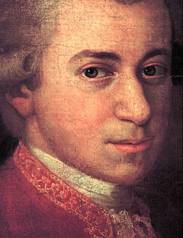
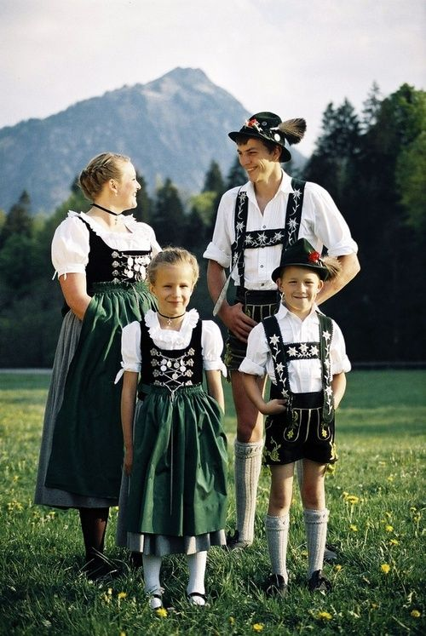

A very famous music composer came from Austria. His name is Wolfgang Amadeus MOZART. He wrote lots of different ways to play “Twinkle, Twinkle Little Star.” Have a listen, and try to sing “Twinkle, Twinkle” to each different way it is played.
https://youtu.be/tGSDVrnjDqI

We’ve performed our yodel, so you may now want to listen to a professional yodeller.
https://www.youtube.com/watch?v=1rPAnxsSk40&list=RDMvFFb_oUvzY&index=7

One musical instrument only seen in the Alps is the Alpine Horn. It is very, very long, usually 8 feet long!!
Have a listen to the Alpine Horn being played. https://youtu.be/E8Y2GzjqMVU

A very famous musical was filmed in Austria. Maybe you’ve already heard of, or seen, “The Sound of Music?” Here’s a link for some songs from “The Sound of Music.”

https://youtu.be/HiHc0a0OrLc

Now have a go at singing these songs!

BUBBLE GUM.
BUBBLE GUM, BUBBLE GUM, CHEW AND BLOW.
BUBBLE GUM, BUBBLE GUM, SCRAPE YOUR TOE.
BUBBLE GUM, BUBBLE GUM, TASTES SO SWEET.
WIPE THAT BUBBLE GUM OFF YOUR FEET.

DOUBLE-DOUBLE.
DOUBLE-DOUBLE THIS, THIS.
DOUBLE-DOUBLE THAT, THAT.
DOUBLE THIS, DOUBLE THAT.
DOUBLE-DOUBLE THIS, THAT.

OLD MAN MOSES.
OLD MAN MOSES, SICK IN BED,
CALLED FOR THE DOCTOR AND THE DOCTOR SAID,
“STAMP TWICE ON THE GROUND, TURN YOURSELF AROUND,
DO THE WIGGLE-WAGGLE AND GET OUT OF TOWN!”

