Feel Good Friday Activities
Early Level Friday 5th Of February

Healthy Body | Healthy Mind | Outdoors | Music
10 Minute Shake up  Access the link below and have a go at some of the 10minute shake up ideas from the NHS Change 4 Life Website. Each game is inspired by Disney characters.  You could play hide and seek with Forky or try balloon volleyball with Kristoff and Anna.  https://www.nhs.uk/10-minute-shake-up/shake-ups | This week is Children’s Mental Health Week and the theme this year is Express Yourself! Expressing yourself is all about celebrating your individuality and the fact that there is only one of you!  Use the grid below to find ideas about how you can express yourself and share your thoughts, feelings and ideas by being creative. | Ice Sun Catchers  As winter continues and the weather is cold. Experiment with water and natural treasures to make your own ice sun catcher decorations.  Follow the instructions below to see what you can make. | Mr Mac our Kodaly teacher has sent some resources to help you learn all about yodelling!  Take a look at the resources and links below and see if you can have a go!

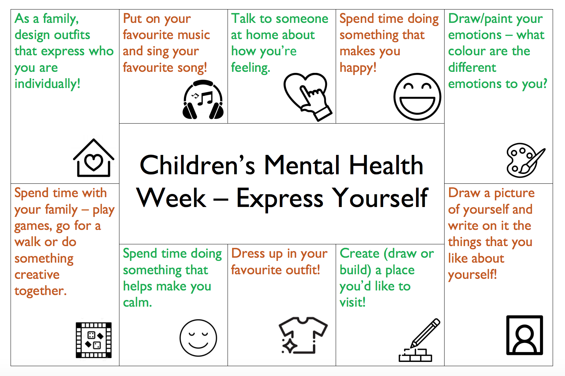

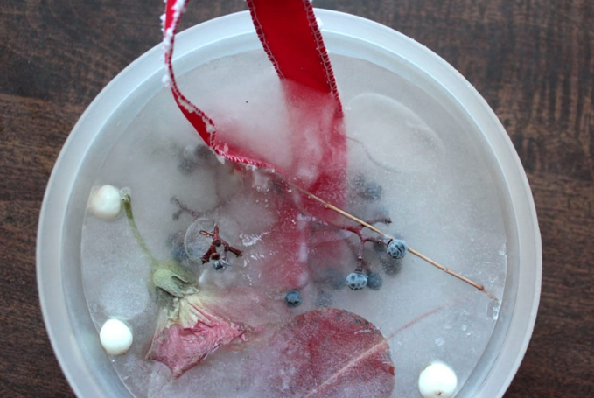
Ice Sun Catchers

- Collect some natural treasures from your garden or when out for a walk with your adult. Leaves, twigs, feathers, grass, flowers and berries work well. You could also use shells if you have any.

- Pop your treasures into clean yogurt pots or a cupcake tray.

- Fill with water.

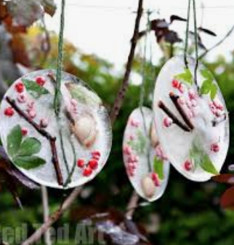
- Add a loop of ribbon, wool or string to each one.

- If cold enough leave outside overnight to freeze or pop into the freezer.

- In the morning pop your decorations out of the containers.

- Hang outside and enjoy. Notice when temperatures rise they slowly melt and turn back to liquid.

- 0ur yodelling trip takes place in the country of AUSTRIA.
- There are a lot of high mountains in Austria. These are known as the Alps.
National Costume Wolfgang Amadeus Mozart
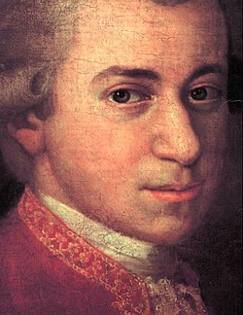
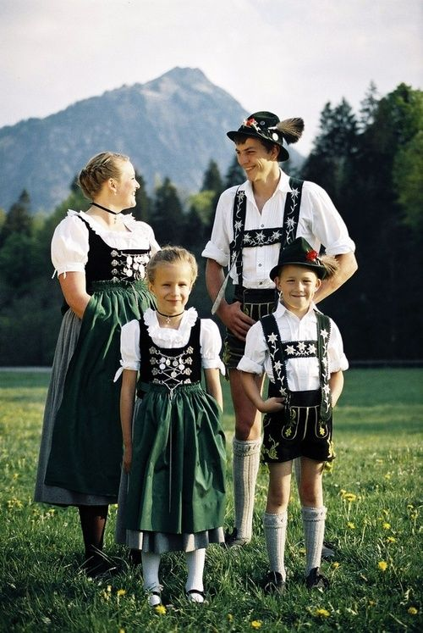

A very famous music composer came from Austria. His name is Wolfgang Amadeus MOZART. He wrote lots of different ways to play “Twinkle, Twinkle Little Star.” Have a listen, and try to sing “Twinkle, Twinkle” to each different way it is played.
https://youtu.be/tGSDVrnjDqI

We’ve performed our yodel, so you may now want to listen to a professional yodeller.
https://www.youtube.com/watch?v=1rPAnxsSk40&list=RDMvFFb_oUvzY&index=7

One musical instrument only seen in the Alps is the Alpine Horn. It is very, very long, usually 8 feet long!!
Have a listen to the Alpine Horn being played. https://youtu.be/E8Y2GzjqMVU
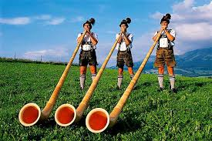

A very famous musical was filmed in Austria. Maybe you’ve already heard of, or seen, “The Sound of Music?” Here’s a link for some songs from “The Sound of Music.”

https://youtu.be/HiHc0a0OrLc

Now have a go at singing these songs!

BUBBLE GUM.
BUBBLE GUM, BUBBLE GUM, CHEW AND BLOW.
BUBBLE GUM, BUBBLE GUM, SCRAPE YOUR TOE.
BUBBLE GUM, BUBBLE GUM, TASTES SO SWEET.
WIPE THAT BUBBLE GUM OFF YOUR FEET.

5 LITTLE MONKEYS.

5 LITTLE MONKEYS, SWINGING IN A TREE.
ALONG CAME A CROCODILE, AS QUIET AS CAN BE.
5 LITTLE MONKEYS, SWINGING IN A TREE.
THIS CHEEKY MONKEY SAID, “YOU WON’T CATCH ME!”
SNAP!!

ZERO LITTLE MONKEYS, SWINGING IN A TREE.
ALONG CAME MUMMY CROCODILE, SHE SAID,
“WHERE’S MY TEA?”

