Scottish Week
First Level 29th January

Robert Burns  Robert Burns was a Scottish poet and song writer. Listen to this short video clip to learn a bit more about Robert Burns and why we still celebrate him and his life in Scotland today.  https://www.youtube.com/watch?v=qMxIBqpryG0 | Wildlife  Research Scottish wildlife and write some facts about the animal you find most interesting. You could draw, paint or make the animal you choose. | Art  These are lots of famous castles in Scotland, including a very famous one in the country’s capital city. Can you build your own castle from LEGO or junk?
Songs  Have a go at learning a Scottish song.  Ask an adult to help you read the song lyrics below and have a sing song.  You can also find them on the links below:  https://www.youtube.com/watch?v=ZWth8SFPxt8  https://www.youtube.com/watch?v=0UNJx3WIiCs | Poetry  Create your own acrostic poem using the template below.  For an extra challenge try using some Doric words like coos or neeps. | Baking  Shortbread is a traditional Scottish biscuit. Can you follow the recipe below and make your own?  Have a go at Mrs Brown’s tried and tested recipe! Enjoy!

S

C

O

T

L

A

N

D

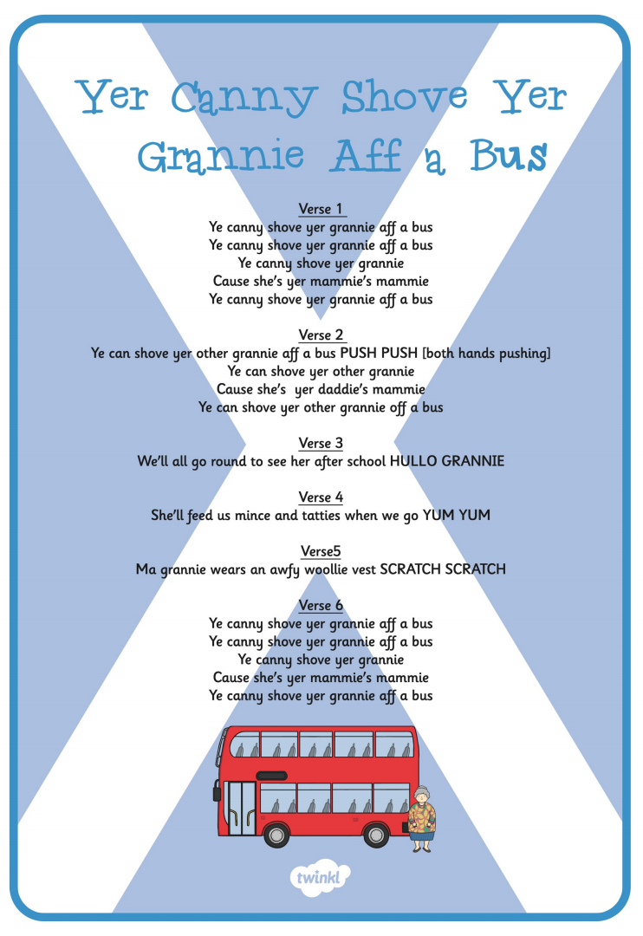
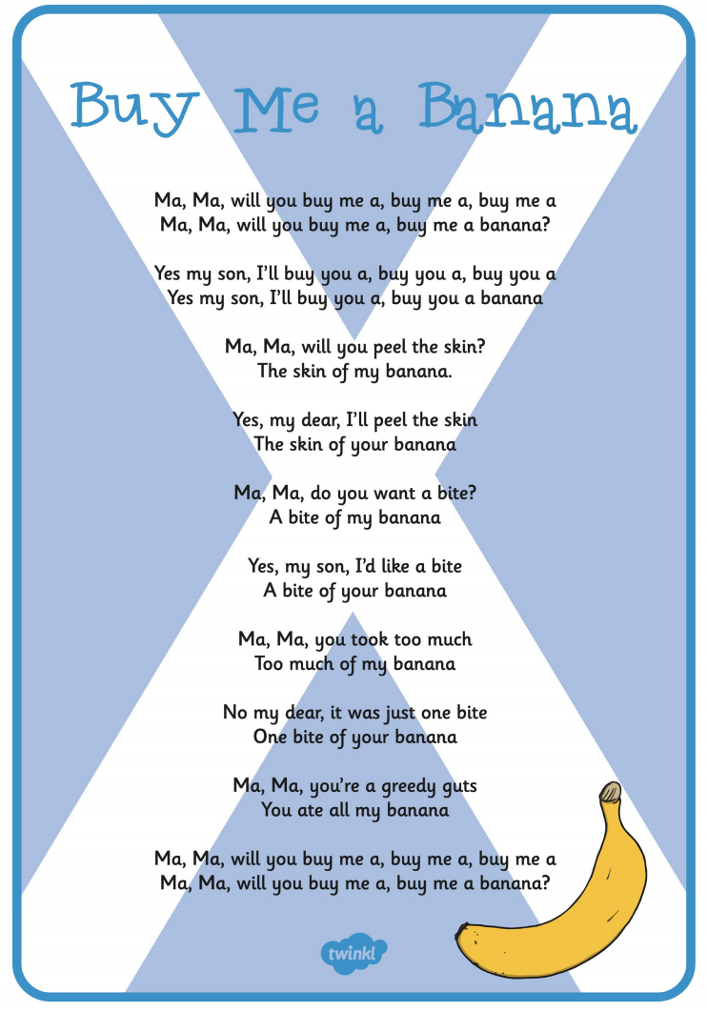

Shortbread Recipe

Ingredients:

12oz/3 cups plain flour
8oz/2 cups unsalted butter
4oz/1 cup caster sugar

Method

- Preheat the oven to 200/180 fan/Gas 6.
- Cream the butter and sugar together with a spoon or mixer.
- Add the flour and mix to form a dough.
- Roll out flat (about the thickness of a £1)
- Cut out shapes with a cutter or knife or roll into sausage shape and cut into rounds.
- Place biscuits on a lined baking tray, prick with a fork and sprinkle with caster sugar.
- Bake in oven for 10-12 minutes or until as brown as you like it.
- Leave to cool and enjoy!

