Feel Good Friday Activities
First Level 15th January

Healthy Body | Healthy Mind | Outdoors | 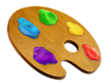  Art
Exercise keeps us fit and healthy and gives our mood an energy boost!  Sometimes it can be tricky to motivate yourself to get active!  Have a go at the snakes and ladders game below and have fun adding exercise into this classic board game.  Can you add exercise into any games you have?  Can you create your own game adding exercise? | Sometimes the way we feel inside can be like the weather outside. If we are happy and smiling, it’s just like a sunny day. If we’re grumpy it’s just like our mind is full of dark clouds. Perhaps if we’re angry – we can imagine it’s just like a thunder storm, if we’re sad – it’s raining.  Our moods are changeable just like the weather.  Draw your own personal weather report each day. Use the template provided or create your own. Share it with a family member. | Can you design and construct a den?  Find a space outdoors/indoors where you can design and build a den. Set criteria, for example: how are you going to make it safe, cosy and have everything you need. If you’re lucky enough to be outside is it waterproof? | Have you tried weaving before?  Below is an activity card showing you how to paper weave. You can choose your own colours of paper and then decorate the frame. It would make a lovely gift or look great on your wall.

If you don’t have a dice, just cut up 6 pieces of paper, write 1-6 on them and pick 1 out of a cup to show how many squares you need to move. Normal snakes and ladder rules apply. If you land at the bottom of the ladder, climb it, if you land snakes, head back down to the tail. Remember to do the exercise if you land on any of them!
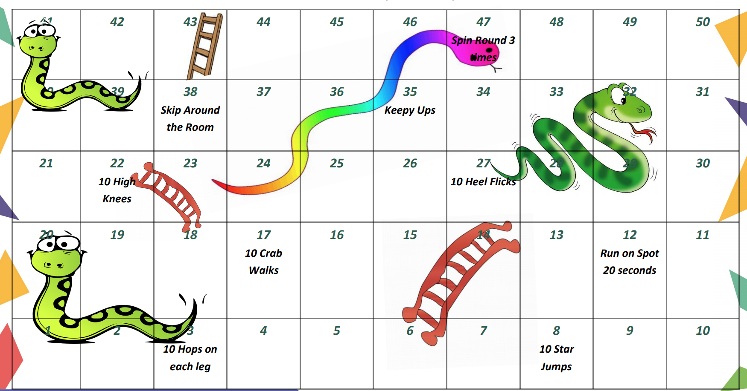
My Daily Weather Report
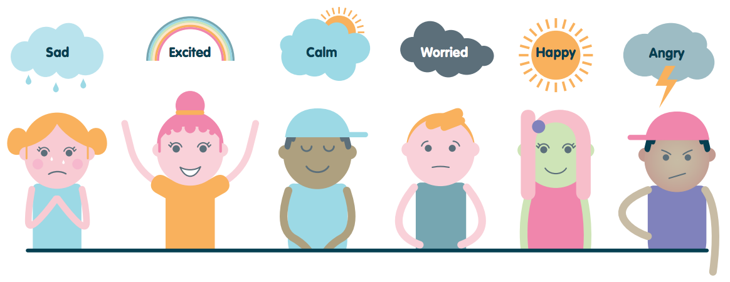

Monday | Tuesday | Wednesday | Thursday
Friday | Saturday | Sunday | Draw how you feel each day of the week. You could write a sentence to explain your feelings or talk to someone about them.

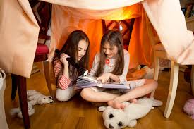
Design and Construct a Den
Cosy, safe, hidden, tall enough to sit up, favourite toys, books…..

LI: I can design and construct a den
What three things must your den have to make it successful to you:
1.) 2.)
3.)
Cardboard boxes, duvet, cloth horse, table

What materials are you going to use to make your den?

Draw a picture of your den showing how you are going to use all your materials and the shape of your den.

Now build your den – remember to take photos.
Paper weaving

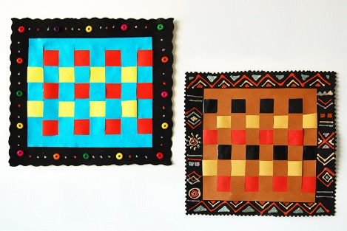
SUPPLIES NEEDED
- Paper in various colours
- Glue
- Scissors
- Paper edging scissors (optional)
- Glitter glue, puffy paint, stickers, beads, or other decorative materials

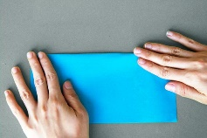
STEPs:
1.Cut paper. Cut paper into the desired shape and size of your paper weave picture. I cut mine into a 20cm square

2. Fold the paper in half.

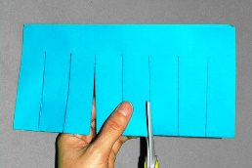
3. Cut slits. Cut evenly-spaced slits (mine are about 2.5cm wide) starting from the folded edge and stopping about 2.5cm from the opposite edge. Drawing vertical lines to use as guides for cutting can be quite helpful.

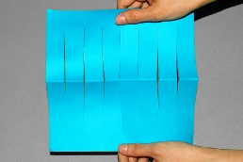
4. Unfold the paper.
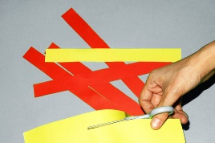
5. Cut coloured paper strips. Mine are 2.5cm wide and 25 cm long. The strips must be longer than the length of your square's side.

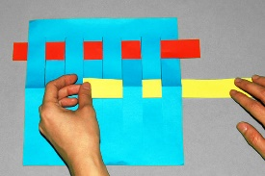
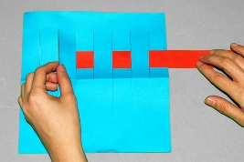

7. Weave the second strip. Move the woven strip to the top and start with the next one. Weave the second strip in an opposite pattern as the first. If your first strip went over and then under the slits, the second strip should go under and then over the slits.

6. Weave the first strip. Take one paper strip and weave it across the slits, going over and under the slits.

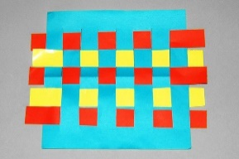
8.Weave the rest of the strips. Weave more strips in an alternating pattern until you get to the bottom of the slits and your square is full.

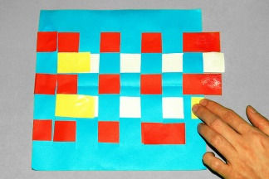
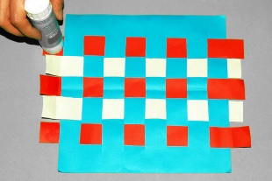
10. Fold the ends of each strip over the edges of the paper square or over the slits. Press to glue in place.

11. Flip the woven square so that the folded ends are concealed at the bottom.

9. Carefully flip the paper square so that the back is now facing up. Apply glue at the ends of each paper strip.

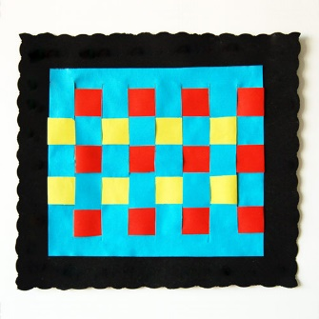
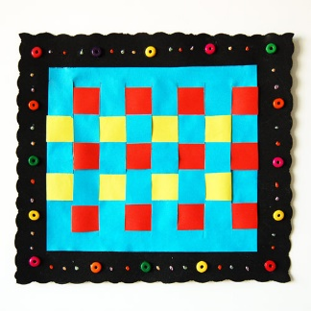
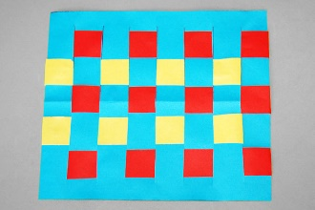
12. Make a paper frame. Cut a larger piece of construction paper or craft foam to frame your paper weave. You can use a pair of paper edging scissors to create a wavy-edged frame. Glue your paper weave at the centre of the frame.
13. Decorate the frame, if you like. Use some glitter glue, puffy paint, sequins, beads, small craft foam shapes, stickers, buttons, ribbons, etc.

Resource from: https://www.firstpalette.com/craft/paper-weaving.html

