Feel Good Friday Activities
Early Level 22nd January

Healthy Body | Healthy Mind | Outdoors | 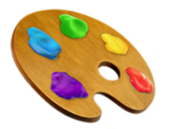  Art
Floor is Lava!  Create your own obstacle course indoors or out.  You could use cushions, blankets or sheets of paper/cardboard. Get creative! Dot them around the room and see if you can cross from one side of the room to the other but try to keep your balance because the floor is lava! | It is important to talk about your emotions – a problem shared is a problem halved. Sometimes talking about how you feel can be tricky.  Can you use play dough to make faces showing different emotions? Talk to an adult about when you feel these different emotions.  How do you feel today?  You can print and use the face template below. | Can you investigate how solids turn to liquid by making your very own ice lantern?  Collect some natural materials from your garden or when out for a walk. Ask an adult to help you follow the step by step instructions below to make an ice lantern Queen Elsa would be proud of. | Go on a colour walk!  Take a colourful treasure hunt walk through your neighbourhood or around your house.  What colours can you find?
Floor is Lava!

You can take exercise indoors with this fun game for all the family.
Can you think quickly and creatively to avoid the hot lava? Imagine that the floor is covered in hot lava and you must stay off the ground. Use your balance and jumping skills to cross the treacherous lava to safety!

You will need:

- Large space
- Equipment, furniture, obstacles, cushions, blankets etc.

Set up your obstacle course. An adult sets the rules of what is safe and what children can and cannot climb on then you are ready to play. Have fun!

Try playing along with this song which incorporates dancing for extra fun and fitness:
https://www.youtube.com/watch?v=wbNAiN8FTfc
Playdough Emotions
Can you make a play dough face to show how you are feeling?

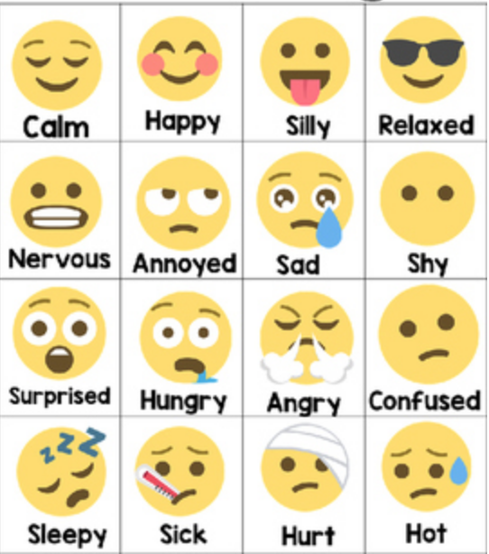

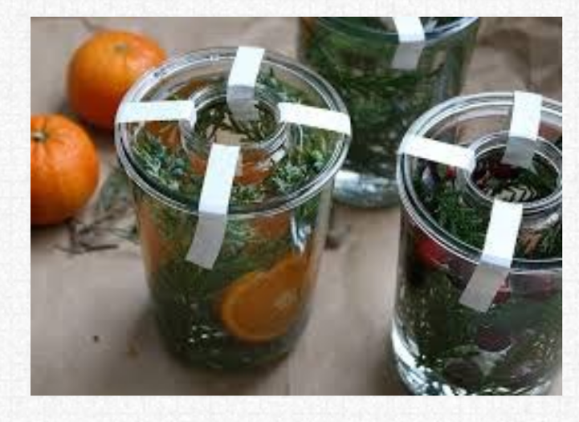
Ice Lanterns
You will need:
- large plastic cup or plastic container from your recycling
- small plastic cup or plastic container from your recycling
- leaves, berries, flowers
- tape
- tea light or battery candle
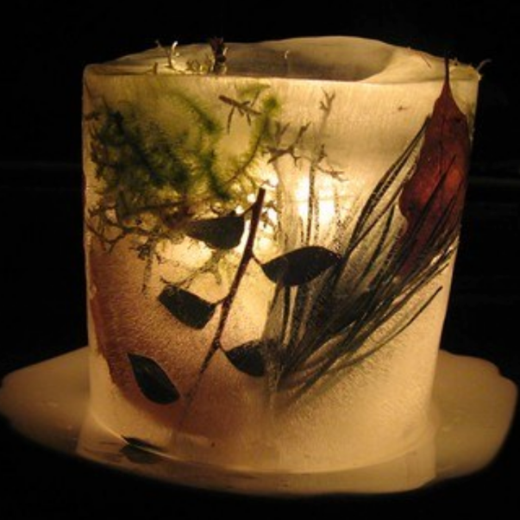
How to:
Put the small cup inside the large cup and tape it so the tops of the cups are flush with each other.
Carefully add water into the large cup leaving a bit of space at the top. Add your leaves etc. by pushing them into the water.
Put some stones in the small cup to stop the top popping up.
Pop into the freezer or leave outside on a cold night until frozen solid.
With adult help carefully remove the cups.
Place a candle in the lantern and enjoy! Remember to pop on a plate or large bowl if using indoors to catch water as the ice slowly melts.
Colour Walk
What you need:
- a grown up with you
- your imagination
- somewhere to go for a walk – outdoors or around your house
- optional: a phone, a camera, some paper and some pens or pencils
After your walk:

- Draw a map of your walk and add colourful drawings of some of the things your saw
- Make a collage of the pictures you took
- Make colourful drawings of the things you saw
Look for things in every colour of the rainbow, one by one. You can photograph or draw each thing you find, write them down or just look.
It’s up to you how many things you want to find in the same colour. At different times of year this activity might look quite different.
If you’re playing at home, you could collect a few things of each colour and arrange them.
Source: https://www.tate.org.uk/kids/make/cut-paste/go-on-colour-walk

