Feel Good Friday Activities
Early Level 15th January

Healthy Body | Healthy Mind | 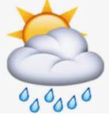  Outdoors | 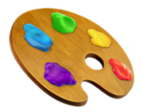  Art
Exercise keeps us fit and healthy and gives our mood an energy boost!  Can you give the alphabet exercise challenge a go?  Use the activity card and find out what exercise combinations you can create.  You could make a challenge for a family member to try! | It’s important to take care of ourselves and talk about our emotions especially when we are missing loved ones.  Think about all the people you love and make a list: it can be family or friends; people you share your home with or people that you miss seeing at the moment.  Choose someone from your list and make them a special note or drawing to surprise them. Use the template below or create your own. | Can you create a shelter for a favourite teddy? You can do this outside if the weather allows or inside.  One way to create a shelter is to make a tipi. First you need to find some sticks, then ask an adult to help you to tie them together. Finally, you need to decide what you are going to use as a cover for your tipi.  Your teddy will love its new home! | Enjoy some time creating imaginative pictures using straight and curved pieces of paper or foam.  Start with basic lines and make different shapes and then move onto creating entire pictures.  You can stick them down to make a picture to keep or you can use the same pieces of paper or foam to make lots of different pictures.  Use the activity card to get started.
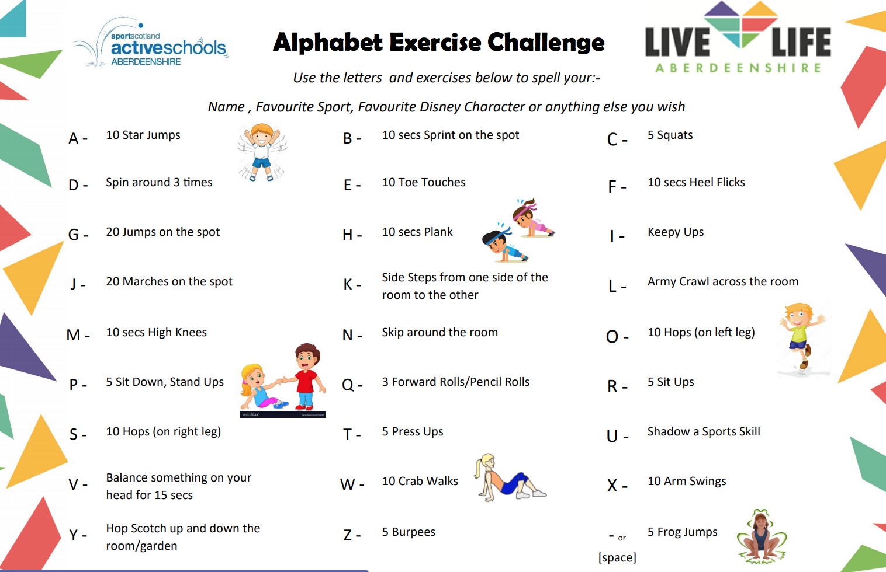

Use the heart template to make a special note for someone you love. Cut out and decorate. You could hide it somewhere for them to find as a special surprise!
From
To

Tipi for Teddy
Learn how to make a simple shelter for teddy and friends!
Instructions

Bind 3 or more sticks together using string, an elastic band or by weaving natural materials. The longer the sticks the bigger the tipi!
Now you have the tripod structure needed to create a simple den. (See picture to the left.)

Add a covering for your tipi such as an old sheet or blanket and use something like clothes pegs to hold it in place.

Decorate the cover with markers or paint.
Alternatively, you could use natural materials or layer them over the top for camouflage.

Experiment with other den designs once the art of tipi making is mastered!
The desire to create a special place is identified as one of Sobel’s principles of play in nature and a den is a place for hiding, relaxing and imagining.

Support your children’s health and wellbeing through this free play opportunity.

Encourage the children to use dens for role play, reading and storytelling thus meeting literacy outcomes.

Use a STEM slant with the activity through basic measuring of the sticks, selecting appropriate coverings for camouflage or waterproofing and learning the skill for life of connecting the sticks together effectively.
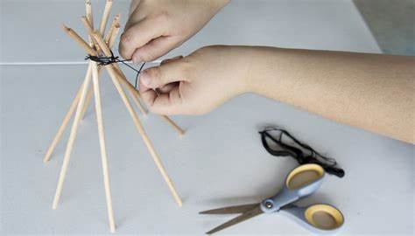
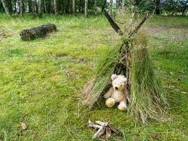
Resource from: Outdoor learning ideas | Outdoor Lesson ideas | LtL

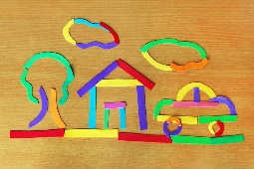
Line Pictures
Make use of paper, foam or felt scraps from previous craft projects in this creative line and shapes learning activity. Combine various line cut-outs into shapes and interesting images. Put together an entire picture if you like!

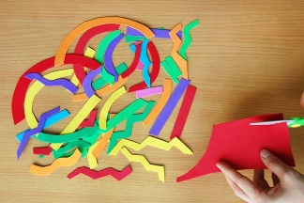
SUPPLIES NEEDED

1.Make line cut-outs. Gather paper, craft foam or felt scraps. Cut out different kinds of lines like straight lines, arcs, curved lines, wavy lines, and zigzags. Make them in a variety of sizes and colours.

- Paper, foam or felt scraps in various colours
- Scissors
- Glue (optional)
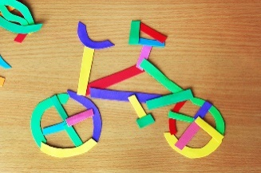
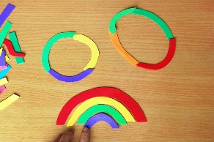
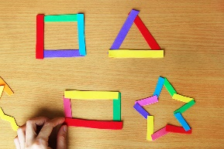
- Construction paper (optional)

Form basic shapes. Learn all about shapes by putting the lines together to form all kinds of shapes.
Put straight lines together to form basic shapes like triangles, squares, rectangles, stars, and other polygons.
Connect three or more arcs or curved lines to form a circle or oval.
Though a rainbow is not a shape, you can make one by stacking together arcs of increasing size.

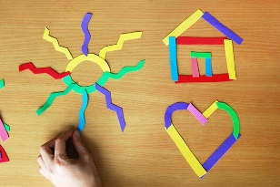
Resource from: https://www.firstpalette.com/craft/line-pictures.html

3. Create objects. Combine the lines to come up with more shapes and objects. You can make easy ones like a sun, house and heart.

Try making more complex objects and images. You can make anything out of lines!

