Accessing support services can be challenging for people and partners. Just knowing where to start can be confusing therefore this support document has been created to give partners the information on what support is out there and how they and their clients can access it.
This information is to be used to support clients across Aberdeenshire especially at a time of service transition.
Organisation | Services Delivered |  | Geographical Area |  | Client Group | How Services are Accessed |  | Contact details
Aberdeen Foyer | - Income Maximisation  - Benefits Checks  - Support clients to identify and apply for benefits they are entitled to  - Support with employability  - Access to a range of free accredited training and collage courses.  - Access to support with health & wellbeing.  - Digital access can support skills development and access to digital kit. |  | Mainly in the north of the Shire but will go to where Foyer is running programmes to offer support to those attending. |  | Will see anyone, but we focus on Foyer clients as our priority. | Community outreach but not in people’s homes. |  | 01224 212924  https://www.aberdeenfoyer.com/
Aberdeenshire Council  Aberdeenshire Advice and Support Team  (ASAT) | - Income Maximisation  - Money Advice  - Benefits Checks  - Support clients to identify and apply for benefits they are entitled to, including Housing Benefit, Local Housing Allowance, Council Tax Reduction, Scottish Welfare Fund, Community Care Grants and Discretionary Housing Payments, Free School Meals, School Clothing Grants, Blue Badges.  - A flexible fund is in place to support families who require financial support to cover household bills & essential items. |  | All areas. |  | Anyone can access support; council tenants will be given priority. | Council venues, community-based outreach and phone support. |  | Housing Benefit / Council Tax Reduction / Discretionary Housing Payment enquiries:  03456 08 12 00  asat@aberdeenshire.gov.uk  Free School Meals / School Clothing Grants enquiries:  01467 538555  fsm@aberdeenshire.gov.uk
Aberdeenshire Council Employment Support Team | Support with all aspects of employability including digital skills and keeping the claimant commitment updated.  Support with employment incentive schemes such as Kick Start.  Has links into a range of Employablity partners including further education partners |  | All areas. |  | Anyone looking for employability support. | Council venues and community-based outreach provision. |  | 01467 534261  https://employmentconnect.org.uk
Aberdeenshire North Foodbank | Emergency food parcels for those in food crisis – at least 3 days of emergency food provided.  In partnership with Aberdeen Foyer clients can also get access to an income maximisation worker to help with money and reducing household bills. |  | North Aberdeenshire – Foodbank Centre in Fraserburgh Emergency food boxes can also be held by agencies across the area. |  | Anyone experiencing food poverty. | On a referral basis – vouchers issued from referral partners across the area. |  | 07561 750574 (Peterhead)  info@aberdeenshirenorth.foodbank.org.uk
Salvation Army | Support can be given to access food , finance to cover household bills, Xmas gifts, social isolation and employability support, |  | Peterhead |  | Anyone experiencing food poverty, social isolation or require support | Referrals including self presentations. |  | The Salvation Army Peterhead  47 Windmill Street, Peterhead AB42 1UL  01779 470208
Aberdeenshire Voluntary Action | Enabling support for third sector organisations and community groups and for individuals looking to engage in volunteering. |  | All areas. |  | Primarily third sector organisations and voluntary community groups and local individuals looking for guidance or support to engage in volunteering – we also engage in a variety of partnership activities with a range of statutory agencies. | Our main office is in Ellon but our Development Team are located across Aberdeenshire – see website for contact information |  | General enquiries –  0371 811 0008  enquiries@avashire.org.uk  or contact your Local Development Officer details on website – www.avashire.org.uk
Banff and Buchan CAB | Financial Health Checks, support for European Citizens and support with Universal Credit. |  | Banff, Fraserburgh, and surrounding areas. |  | Self or partners referrals.  All welcome no restrictions. | In the office, outreach or a home visit. |  | 01779 471515  bureau@aberdeenshirecab.casonline.org.uk  UC Help to Claim  0800 023 2581  Money Talk Team  0800 085 7145
LEND A Hand Project, Friends of People First Fraserburgh | Income Maximisation  Benefits Checks  Support clients to identify and apply for benefits they are entitled to. |  | Banff & Buchan |  | Only people with learning difficulties can access this service. | In the office in Fraserburgh outreach or a home visit. |  | 01346 378739  People First Fraserburgh  51 Mid Street  Fraserburgh
Community Food Initiative North East  Support Advice, Finance, Education (SAFE) | To support those who are facing financial difficulty or need help navigating the welfare system.  Access to FareShare food which they deliver to food outlets  Access to low cost good quality fresh fruit & veg  The fruit mart in Peterhead also operates a community pantry. |  | All areas |  | Anyone | Phone support  Aberdeen based.  Delivery of food to community pantries/ foodbanks / outlets.  Pantry within Peterhead. |  | 01224 531386  Monday-Friday, 10am-4pm.  https://www.cfine.org/forms/safe-referral  Fruit Mart Peterhead  19 Skelton Street, Peterhead AB42 1HR  01779 477948  01224 596156  www.cfine.org  2-4 Poynernook Rd. Aberdeen, AB11 5RW
Hillcrest Homes | Income Maximisation  Benefits Checks  Support clients to identify and apply for benefits they are entitled to.  Foodbank Referrals  Can refer to in-house HEAT team for energy advice / fuel support / warm home discount applications.  Apply for Charity and Grant Application. | All areas that Hillcrest have accommodation |  | Only Hillcrest tenants – they can self-refer. |  |  | Home visits predominantly. |  | https://www.hillcresthomes.org.uk/
Home Energy Advice Team @ Scarf | Fuel debt concerns, heating demonstrations, access homes for damp and condensation problems. | All of the North East. |  | Self-referrals and referrals from other agencies. |  |  | Phone advice & Home visits. |  | Freephone  0808 129 0888
Home Energy Scotland @ Scarf | Free impartial advice on energy saving, keeping warm at home, helping to reduce fuel bills. | All of the North East. |  | Self-referrals and referrals from other agencies. |  |  | Phone advice & Home visits. |  | Freephone  0808 808 2282
Buchan  Community Planning | A partnership of public. private and third sector partners who work together on a strategic level to improve the lives of those who live in the Buchan Area. This partnership identify priorities and develop an action plan to take them forward. | Buchan Area |  | Contact directly with the Community Planning Officer |  |  | Phone & online support |  | Steph Swales  01467534703  steph.swales@aberdeenshire.gov.uk  Maureen Stephen  01467533137  maureen.stephen@aberdeenshire.gov.uk
Aberdeenshire Council  Banff & Buchan Area Manager | Manages and coordinates services and strategic developments across the Buchan Area.  Allocates and manages the Community Food Fund. | Banff & Buchan Area |  | Contact directly with the Area Managers team |  |  | Phone & online support |  | Amanda Roe  01467 536139  Amanda.roe@aberdeenshire.gov.uk
Money Advice Scotland | Independent, impartial and confidential debt advice and financial inclusion. | All areas. |  | Anyone. |  |  | Online and phone will refer to local services if required. |  | 0141 572 0237  info@moneyadvicescotland.org.uk
RSABI | Provide emotional, practical and financial support. | All areas  National organisation. |  | Land based – principally farming either current or historic involvement in agriculture/horticulture. |  |  | Home visits. |  | 0300 111 4166  https://www.rsabi.org.uk/
Shelter Scotland | Housing Advice to address and prevent Homelessness. | All areas. |  |  |  |  | Online, phone and community based, 1-1 appointments can be arranged. |  | 0808 800 4444  The helpline is open weekdays from 9am until 5pm. Calls are free from UK landlines and main mobile networks  https://scotland.shelter.org.uk/
SMART Project | - Impartial and confidential Money advice  - Income Maximisation  - Debt counselling,  - Benefits Checks  - Budgeting advice  - Support clients to identify and apply for benefits. | All areas. |  | For tenants of Grampian, Castlehill and Langstane Housing Associations who are facing financial difficulties. |  |  | Home visits or community outreach. |  | 01224 202934  smart@grampianhousing.co.uk
Social Security Scotland | Support clients to identify and apply for benefits they are entitled to, focusing on devolved benefit– Best Start Grants etc. | All areas. |  | Open to all who require pre-claim support for the devolved benefits. |  |  | A range of venues as appropriate and this will include home visits, hospital visits, prison visits as well as drop-in sessions across Aberdeenshire. |  | 0783 314 4458.  https://www.socialsecurity.gov.scot
Homestart North East Aberdeenshire. | Support families with children under 5 who have been identified | Peterhead & Central Buchan |  | Families that have children under 5 |  |  | Referral or contact directly |  | Home-Start NEA, Crimond Medical and Community Hub, Logie Avenue West, Crimond, Fraserburgh, Aberdeenshire, AB43 8QJ  01346 532007  office@home-startnea.org.uk  www.facebook.com/Northeastaberdeenshire  www.home-startnea.org.uk
Be – Link’D | Community transport project to link people in rural Buchan with shopping, training, employment and accessing services, | Central Buchan |  | anyone |  |  | Referral or contact direct |  | 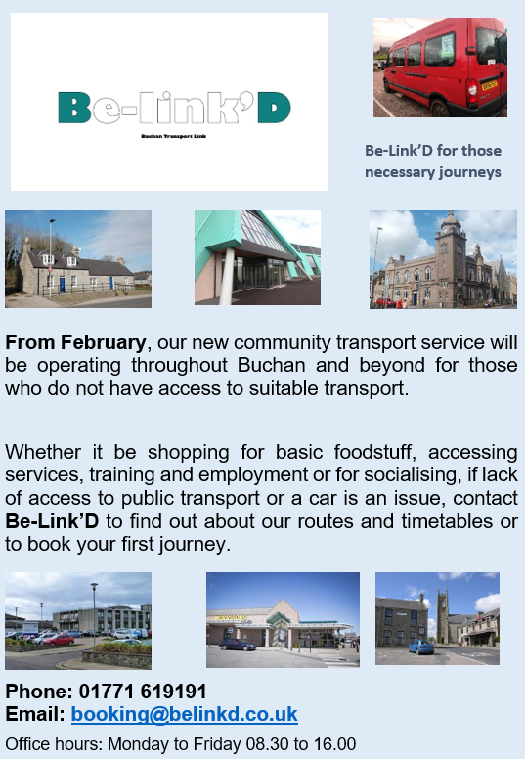

Mental Health Support
Support the new Scottish movement, www.unitedtopreventsuicide.org.uk .
There are some really fantastic resources to help with this, if you want to read more to help someone you care about, or if you are struggling yourself, there is also the ‘Prevent Suicide North East’ app that has many resources in one place and can talk you through how to start the conversation.
www.preventsuicideapp.com: provides info for those affected by suicide, contact details for services in Aberdeen city and Aberdeenshire and allows users to create their own safety plan. Available to download as a free phone app from your app store
SAMARITANS is a confidential 24hr emotional support service for anyone in the UK and Ireland, Phone - 116 123, Samaritans.org, Email: jo@samaritans.org
BREATHING SPACE 0800 83 85 87 is a free and confidential phone line service. Mon – Thurs 6pm to 2am, Fri 6pm – Mon 6am (lines open 24hrs at weekends)
Trading Standards Scotland - Scam Share Update 15.10.2020
As Scottish communities deal with uncertainty and isolation, there is a rapidly increasing variety of scams related to the Coronavirus (COVID-19) outbreak.
Read the latest edition here.

Our Aberdeenshire
Our Aberdeenshire is a Community Planning Website where you can access information around Tackling Poverty & Inequalities and information that is relevant to the Buchan area. https://www.ouraberdeenshire.org.uk.
National helplines
Alcoholics Anonymous 0800 9177 650
www.alcoholics-anonymous.org.uk

Narcotics Anonymous (NA) 0300 999 1212
(10am - midnight)
www.ukna.org

Scottish Domestic Abuse & 0800 027 1234

Forced Marriage Helpline (24hrs)
www.sdafmh.org.uk

Victim Support 0800 160 1985
www.victimsupportsco.org.uk

Fair Start Scotland (free phone) 0800 049 7061
employment support service
email: fairstartscotland@momentumscotland.org.uk

Skills Development Scotland 0800 917 8000
www.skillsdevelopmentscotland.co.uk

Childline 0800 1111
direct children support
www.childline.org.uk

Family Information Service 0800 298 3330
www.families.scot
www.facebook.com/FISabdnshire

Avenue 01224 587571
mediation, counselling and child contact
www.avenue-info.com

Relationships Scotland 0345 119 2020
www.relationships-scotland.org.uk

SPARK 0808 802 2088
relationship and individual support
www.thespark.org.uk

Alzheimer Scotland Freephone 0808 808 3000
www.alzscot.org

Local Contacts
Substance Misuse Service or 01467 537743

Alcohol & Drugs Action 01224 594700
www.alcoholanddrugsaction.org.uk

Domestic Abuse
Grampian Womens’ Aid (GWA) 01224 593381
www.grampian-womens-aid.com

Houseability 01779 490908
providing housing information, advice and advocacy to
people with disabilities or long- term health problems,
living in or wishing to relocate to Aberdeenshire
www.houseability.org.uk

Aberdeenshire 1st Response 0800 1357950
(Mon-Fri, 9-5)
provides short term support for those who feel at crisis
point, for anyone aged over 16 years
www.penumbra.org.uk/aberdeenshire1stresponse

Advocacy North East 01467 651604
works with people aged 16 years and over with learning
disabilities, dementia and acquired brain injury, to support
them in their dealings with health and social care matters
www.advocacyne.org.uklatio
n
Quarriers Carers Service - services 01467 5387

