Monday - All About Me  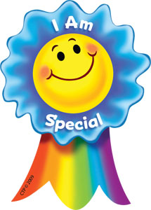  All About Me Booklet  I am an Amazing Person -activity sheet  I am Special Song – join in this upbeat and catchy song about how God made everyone unique and special. https://www.youtube.com/watch?v=LfcBsEV-Ntw&vl=en  Can you make up a verse to add to the song to say why you are special? | Tuesday - Friendships  How to be a good friend -PowerPoint  Trying to be a good friend – fill in the sheet and think about the qualities and actins needed to be a good friend.  Friendship Struggles Video  https://www.bbc.co.uk/teach/class-clips-video/pshe-ks2-friendship-struggles/zbpvcqt  Think about why Jess let Megan win? Did she do the right thing? What would you have done?  -Draw a picture of one of your good friends and write some adjectives around them to describe what makes them a good friend.  -Draw a self-portrait and write down some adjectives to describe what makes you a good friend.
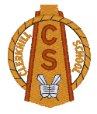

Transition Week – Primary 5-7
Thursday – Mindfulness  -Mindful Me – an introduction to mindfulness PowerPoint  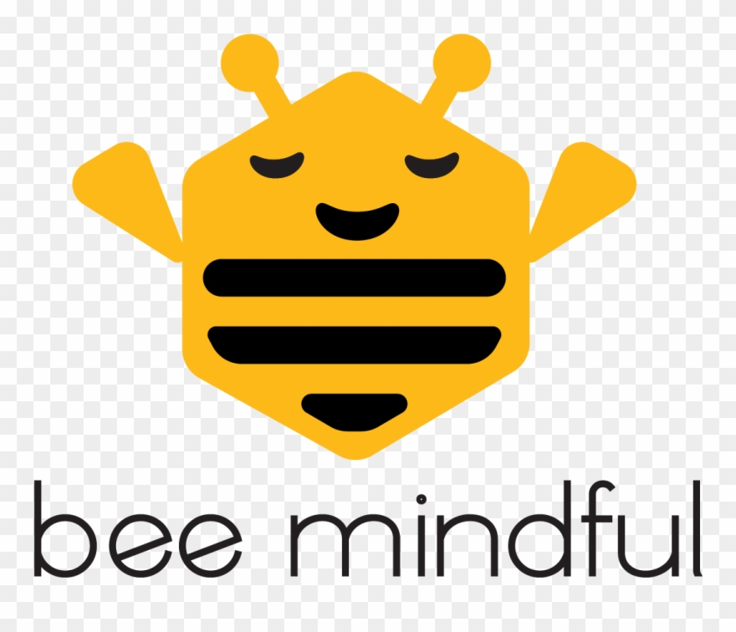  -My Wellbeing Wheel - How do you feel? Stop and check in with how you feel during your day.  Discuss with an adult  -Mindfulness Colouring Pack  Cosmic Yoga  https://www.youtube.com/user/CosmicKidsYoga |  | Friday  End of Term Assembly

