Internet Safety / Science / Technology Week
Primary 5, 6 & 7
Internet Safety  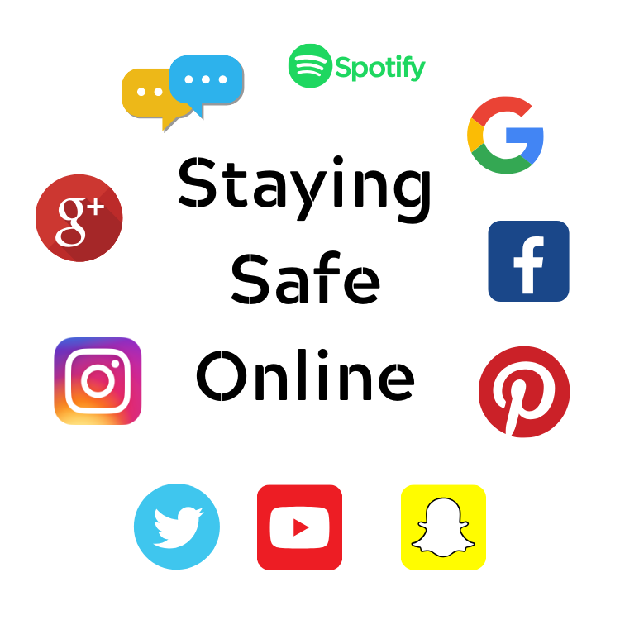 | Science | Technology
Smartie the Penguin – PowerPoint – learn about staying safe online  Internet Safety Rules Activity Sheet – answer the extra questions by doing some additional research  Internet Safety Wordsearch  Research Surprise – Madison thinks she’s won an IPad- What do you think?  Online Friend? – What do you think Sergio should do?  Online Safety – Interactive Website for families  https://www.thinkuknow.co.uk/  https://www.childnet.com/young-people/primary  Information site for Parents https://www.internetmatters.org/resources/ esafety-leaflets-resources/ | Make a Rainbow in a Jar!  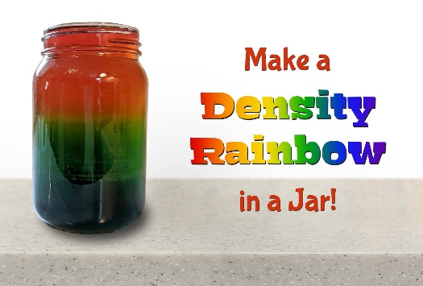  -----------------------  For more fun science facts, videos and experiments, visit:  https://www.sciencekids.co.nz/  and  http://www.sciencefun.org/kidszone/ experiments/ | Changes in Technology – PowerPoint  Design a piece of technology that could help people in the future- think about it’s design, what does it do, how is it powered, who would use it?  Alexander Graham Bell -Information PowerPoint  Alexander Graham Bell – Fact File Sheet  Design a Bridge Activity– a lot of planning must have gone into the designing and building of the bridge over the River Ugie. Follow the instruction in the link below to design and then test weights on your bridge!  https://www.sfi.ie/site-files/primary-science/media/pdfs/col/design_a_bridge.pdf

