Health and Well Being Activities - Primary 5, 6 & 7
Clerkhill School  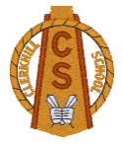  Health Week  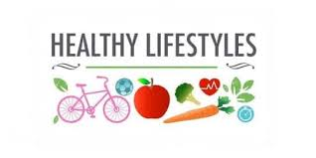 | Monday  Healthy Eating / Foods Groups  - Food Labelling PowerPoint  - Food Labels Hunt  Have a look at some of the tins and packets of food in your kitchen. Can you list five that are healthy and five that aren’t so healthy?!  Hand Washing  - Personal Hygiene PowerPoint  Using the information from the PowerPoint, create an information poster. Think about using: Bullet Points, Diagrams, Drawings etc to organise your work. | Tuesday  Road Safety  - Have a look at how you can keep safe when crossing the road by visiting the road safety Scotland website.  Second Level - https://roadsafety.scot/learning-zone/second/  Fire Safety  - Watch the Stop Drop and Roll Video Stop, Drop and Roll Video Link https://www.youtube.com/watch?v=O2iAO2651o8  - Try acting out this safety procedure at home. Can you teach it to someone in your family?  - Fire Escape Plan template– complete a fire escape plan for your home. Can you also find how many smoke detectors you have?
Wednesday  SPORTS DAY | Thursday  Sun Safety  SunSmart PowerPoint – look through the PowerPoint, answer questions along the way and complete the poster activity at the end.  Keeping Safe Near Water  Staying Safe in Open Water -activity sheet  Living near water means it is important for us to know how to be safe in our community. Please visit the RNLI website and complete the Spot the Difference activities.  https://rnli.org/youth-education/education-resources/upper-primary/spot-the-dangers-head-cam | Friday  Staying Active / Exercise  - The Heart PowerPoint – read the information about how the heart works before completing the  - Heart Worksheet  Healthy Teeth  - All about teeth and their functions – Inforrmation PowerPoint  - Teeth labelling sheet  - All about teeth crossword

