Health and Well Being Activities - Primary 2, 3 & 4
Clerkhill School  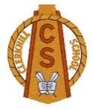  Health Week  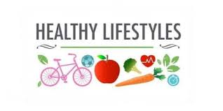 | Monday  Healthy Eating / Foods Groups  - P2-P4 Healthy Eating PowerPoint  - Healthy Packed Lunch – draw some food and snacks you would have in your Healthy Packed Lunch  Hand Washing  When we return to school after the holidays, washing our hands is going to be really important.  - All about washing your hands - PowerPoint  - How to wash your hands – cut n stick sheet  - Design a hand washing poster | Tuesday  Road Safety  - Have a look at how you can keep safe when crossing the road by visiting the road safety Scotland website.  First Level - https://roadsafety.scot/learning-zone/first/  Keeping Safe at Home  - Complete the: Dangers in the Living room, bathroom and Kitchen activity sheets.  - Walk around the rooms in your home to see if you can spot any dangers.  Fire Safety  - Look at the P2-P4 Fire Safety PowerPoint  - Watch the Stop Drop and Roll Video Stop, Drop and Roll Video Link https://www.youtube.com/watch?v=O2iAO2651o8  - Try acting out this safety procedure at home. Can you teach it to someone in your family?
Wednesday  SPORTS DAY  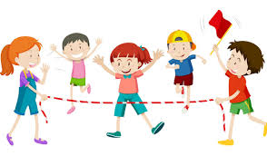 | Thursday  Sun Safety  - Pack for Sun Safety – cut n stick  - Sun Awareness Wordsearch  - Sun Awareness – Design your own sun hat  Keeping Safe Near Water  Living near beaches, harbours and a river means it is important we know how to be safe near them  - Complete the: Spot the Dangers Posters x 3 activity and other activities on the RNLI website  https://rnli.org/youth-education/education-resources/activity-sheets-and-posters?page=2 | Friday  Staying Active / Exercise  - Being Active is a Healthy Way to be -PowerPoint  - Draw three types of fruit and vegetables that you like to eat and three types of sports or activities that you like to take part in.  Healthy Teeth  - Teeth and Eating Challenge - PowerPoint  - Tooth drawing box and writing frame sheet. Write about why it is important to brush your teeth and draw foods and drink inside the tooth that can cause decay.

