Monday - All About Me  All About Me – Booklet – this is a good way for your new teacher to learn all about you.  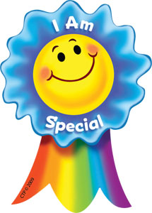  I am an Amazing Person – think about all the things that makes you special.  I am Special Song – join in this upbeat and catchy song about how God made everyone unique and special.  https://www.youtube.com/watch?v=LfcBsEV-Ntw&vl=en  Can you make up a verse to add to the song to say why you are special?! | Tuesday - Friendships  Friendship and what it means -PowerPoint  Trying to be a good friend – fill in the chart and discuss what makes a good friend  Positive Comments Colouring Sheets – Maybe you could give your friend on of these lovely comment sheets once you have coloured it in.  BBC Bitesize-friendships https://www.bbc.co.uk/bitesize/clips/zs8c87h  https://www.bbc.co.uk/bitesize/clips/zp9g9j6  - Draw a picture of one of your good friends and write some words to describe them. What makes them a good friend? How are you a good friend to them?
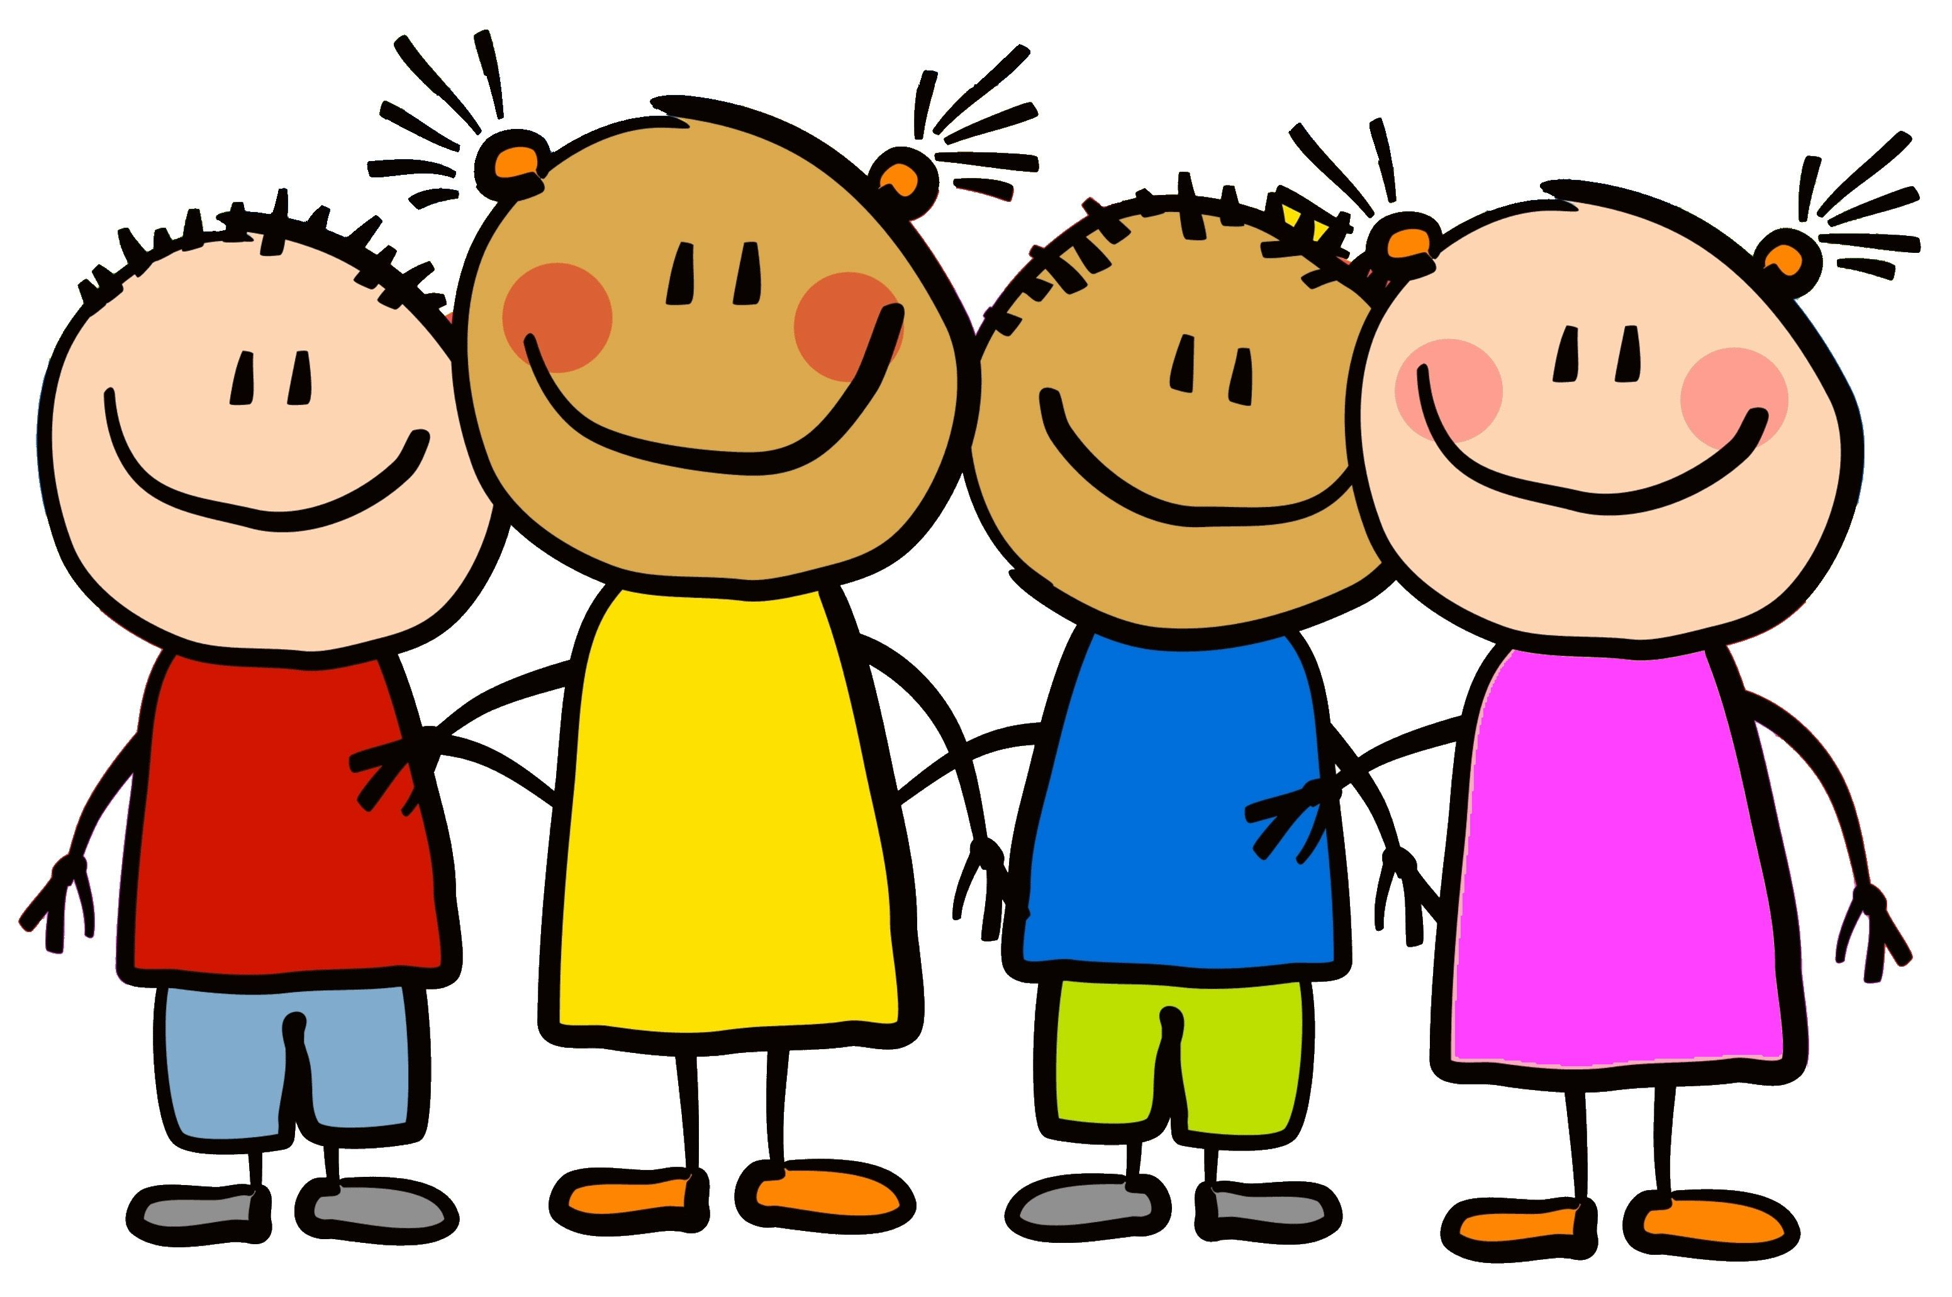
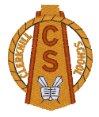

Transition Week – Primary 2-4

Thursday – Mindfulness  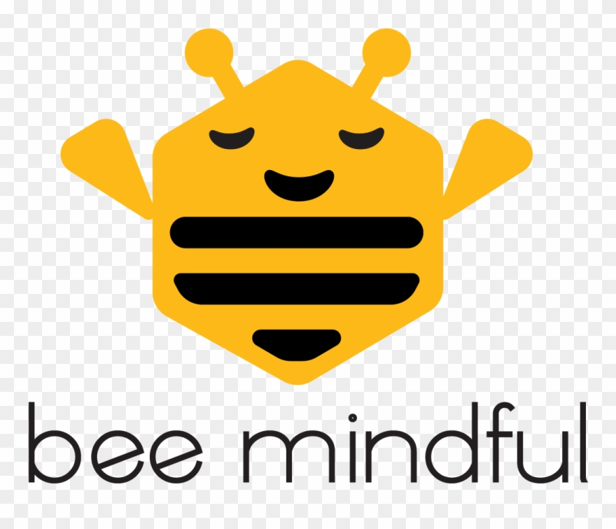  Mindfulness PowerPoint – learn about what Mindfulness is and how it can  help you  Mindful Mats – puzzle sheets and Mindfulness Colouring Pack  Mindfulness Activity Task Cards – take time to relax, be calm and be mindful  Cosmic Yoga  https://www.youtube.com/user/CosmicKidsYoga |  | Friday  End of Term

