Internet Safety / Science / Technology Week
Primary 2-4
Internet Safety  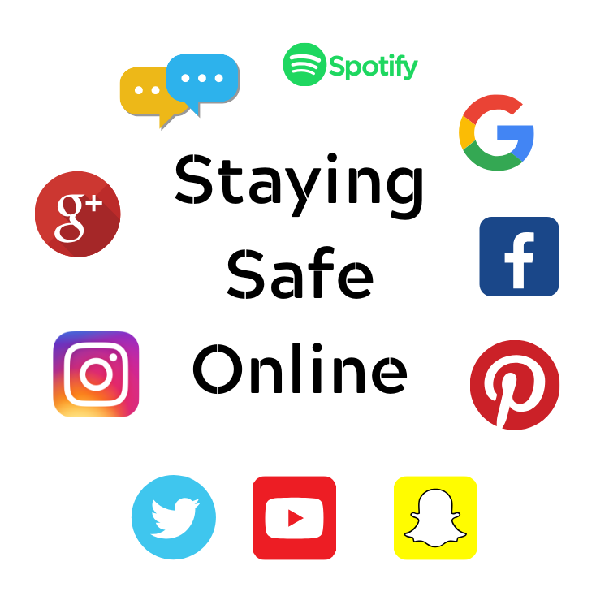 | Science | Technology
Information, videos and interactive games  https://www.thinkuknow.co.uk/  https://www.thinkuknow.co.uk/parents/jessie-and-friends-videos/  https://www.childnet.com/resources/the-adventures-of-kara-winston-and-the-smart-crew  https://www.childnet.com/resources/smartie-the-penguin  - Internet Safety Wordsearch  - Advice Bubbles for On-line Safety – write in the bubbles things you need to do to stay safe online  Information site for Parents  https://www.internetmatters.org/resources/esafety-leaflets-resources/  https://beinternetlegends.withgoogle.com/en_uk/ | Make a Rainbow in a Jar!  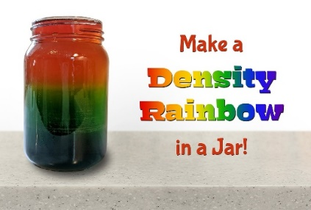  ----------------------  For more fun science facts, videos and experiments, visit:  https://www.sciencekids.co.nz/  and  http://www.sciencefun.org/kidszone/ experiments/ | - Lego Building Brick Flashcards – can you build the designs using the cards to help you?  Design a Bridge Activity– a lot of planning must have gone into the designing and building of the bridge over the River Ugie. Follow the instruction in the link below to design and then test weights on your bridge!  https://www.sfi.ie/site-files/primary-science/media/pdfs/col/design_a_bridge.pdf

