Internet Safety / Science / Technology Week
Primary 1
Internet Safety  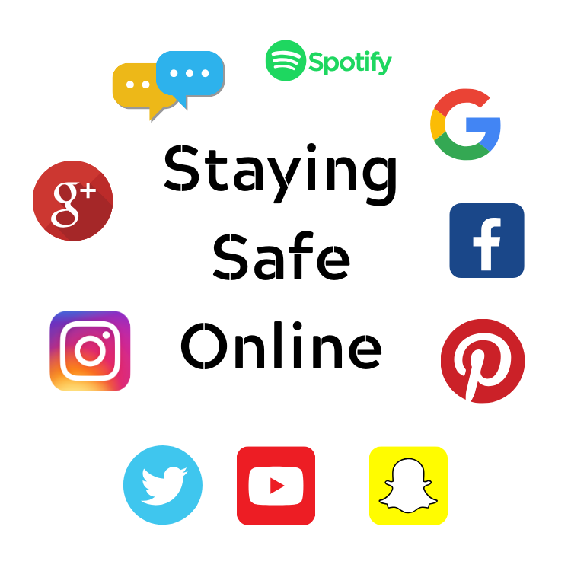 | Science | Technology
Staying Safe on the Internet – PowerPoint  Draw your very own superhero who keeps children safe on-line  Online Safety – Interactive Website for families  https://www.thinkuknow.co.uk/  www.gridclub.com  https://www.thinkuknow.co.uk/parents/jessie-and-friends-videos/  Internet Safety – Smartie the Penguin https://www.childnet.com/resources/smartie-the-penguin  Information site for Parents  https://www.internetmatters.org/resources/ esafety-leaflets-resources/  https://beinternetlegends.withgoogle.com/en_uk/ | Make a Rainbow in a Jar!  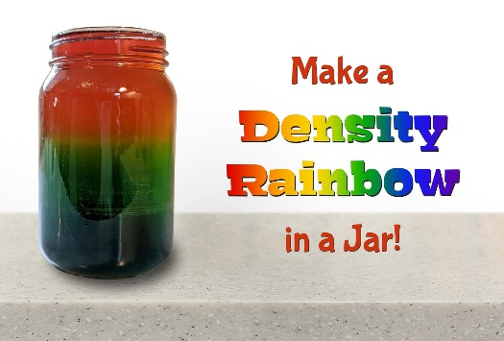  ---------------------------------------------  For more fun science facts, videos and experiments, visit:  https://www.sciencekids.co.nz/  and  http://www.sciencefun.org/kidszone/ experiments/ | STEM Lego Rainbow Activity – can you use Lego bricks to copy the pattern and build a rainbow?  Lego Building Brick Flashcards – can you build the designs using the cards to help you?  Household items from the past -PowerPoint  Technology All Around Us -PowerPoint  - Go on a technology hunt around your house – What can you see?  - Draw some of the things you found in each room.

