Health and Well Being Activities - Primary 1
Clerkhill School  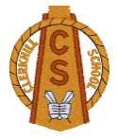  Health Week  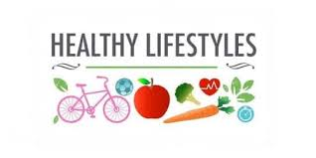 | Monday  Healthy Eating / Foods Groups  - Healthy Foods or Unhealthy Foods -PowerPoint  - Healthy Eating Packed lunch sheet – cut out the foods or draw your own healthy foods to make a healthy packed lunch.  Hand Washing  - All about washing your hands – PowerPoint  - Wash your hands cut n stick sheet  - How to wash your hands cut n stick | Tuesday  Road Safety  Road Safety Scotland Website  Try out some of the online activities on the Road Safety Scotland website for Early Level.  Early Years  https://roadsafety.scot/learning-zone/early-years/  Fire Safety  - Please read Frances the Firefly story book to your child– PowerPoint  - Complete the Frances the Firefly colouring sheet  - Stop, Drop and Roll Video Link https://www.youtube.com/watch?v=O2iAO2651o8  - Stop Drop and Roll- Parent Information Sheet  Can you act out Stop, Drop and Roll?!
Wednesday  SPORTS DAY  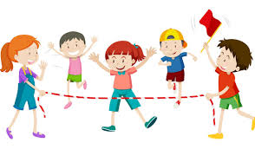 | Thursday  Sun Safety  - Sun Awareness Information PowerPoint  - Design your own Sunhat sheet  - Design your own Sun glasses sheet  try and make them bright and colourful  Keeping Safe Near Water  - Beach / River / Harbour Dangers  How many dangers can you spot in each picture? | Friday  Staying Active / Exercise  - Being active is a healthy way to be PowerPoint  - Draw a picture of your favourite sport or outdoor activity  - 20 Activity Walks ideas  Healthy Teeth  - Teeth- Spot the Difference Sheet  - Tooth Brushing Chart

