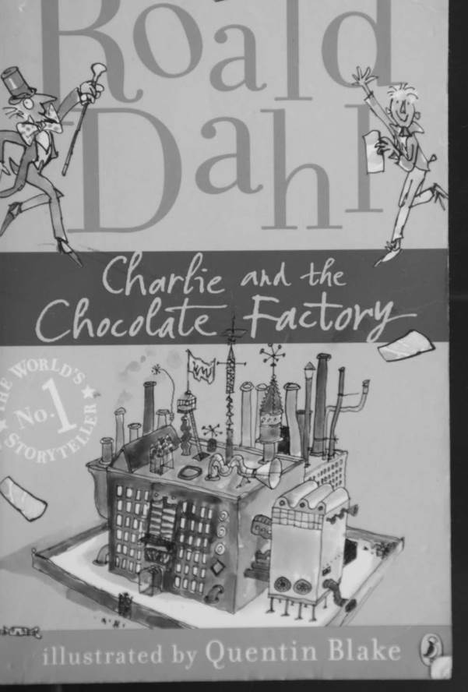

Charlie and the Chocolate Factory
by
Roald Dahl
This electronic copy of the original work is made under a Copyright Licensing Agency license by The Seeing Ear. It is for the personal use of a Print Disabled Person and may not be further copied, (including any electronic copying or transmission), or dealt with without permission, save as may be permitted by law.
Contents
Chapter 1 - Here Comes Charlie
Chapter 2 - Mr Willy Wonka's Factory
Chapter 3 - Mr Wonka and the Indian Prince
Chapter 4 - The Secret Workers
Chapter 5 - The Golden Tickets
Chapter 6 - The First Two Finders
Chapter 7 - Charlie's Birthday
Chapter 8 - Two More Golden Tickets Found
Chapter 9 - Grandpa Joe Takes a Gamble
Chapter 10 - The Family Begins to Starve
Chapter 11 - The Miracle
Chapter 12 - What It Said on the Golden Ticket
Chapter 13 - The Big Day Arrives
Chapter 14 - Mr Willy Wonka
Chapter 15 - The Chocolate Room
Chapter 16 - The Oompa-Loompas
Chapter 17 - Augustus Gloop Goes up the Pipe
Chapter 18 - Down the Chocolate River
Chapter 19 - The Inventing Room - Everlasting Gobstoppers and Hair Toffee
Chapter 20 - The Great Gum Machine
Chapter 21 - Good-bye Violet
Chapter 22 - Along the Corridor
Chapter 23 - Square Sweets That Look Round
Chapter 24 - Veruca in the Nut Room
Chapter 25 - The Great Glass Lift
Chapter 26 - The Television-Chocolate Room
Chapter 27 - Mike Teavee is Sent by Television
Chapter 28 - Only Charlie Left
Chapter 29 - The Other Children Go Home
Chapter 30 - Charlie's Chocolate Factory

Chapter 16 - The Oompa-Loompas
'Oompa-Loompas!' everyone said at once. 'Oompa- Loompas!''
'Imported direct from Loompaland,' said Mr Wonka proudly.
'There's no such place,' said Mrs Salt.
'Excuse me, dear lady, but ...'
'Mr Wonka,' cried Mrs Salt. 'I'm a teacher of geography.'
'Then you'll know all about it,' said Mr Wonka. 'And oh, what a terrible country it is! Nothing but thick jungles infested by the most dangerous beasts in the world - hornswogglers and snozzwangers and those terrible wicked whangdoodles. A whangdoodle would eat ten Oompa-Loompas for breakfast and come galloping back for a second helping. When I went out there, I found the little Oompa-Loompas living in tree houses. They had to live in tree houses to escape from the whangdoodles and the hornswogglers and the snozzwangers. And they were living on green caterpillars, and the caterpillars tasted revolting, and the Oompa-Loompas spent every moment of their days climbing through the treetops looking for other things to mash up with the caterpillars to make them taste better red beetles, for instance, and eucalyptus leaves, and the bark of the bong-bong tree, all of them beastly, but not quite so beastly as the caterpillars. Poor little Oompa-Loompas! The one food that they longed for more than any other was the cacao bean. But they couldn't get it. An Oompa-Loompa was lucky if he found three or four cacao beans a year. But oh, how they craved them. They used to dream about cacao beans all night and talk about them all day. You had only to mention the word "cacao" to an Oompa-Loompa and he would start dribbling at the mouth. The cacao bean,' Mr Wonka continued, 'which grows on the cacao tree, happens to be the thing from which all chocolate is made. You cannot make chocolate without the cacao bean. The cacao bean is chocolate. I myself use billions of cacao beans every week in this factory. And so, my dear children, as soon as I discovered that the Oompa-Loompas were crazy about this particular food, I climbed up to their tree-house village and poked my head in through the door of the tree house belonging to the leader of the tribe. The poor little fellow, looking thin and starved, was sitting there trying to eat a bowl full of mashed-up green caterpillars without being sick. "Look here," I said (speaking not in English, of course, but in Oompa-Loompish), "look here, if you and all your people will come back to my country and live in my factory, you can have all the cacao beans you want! I've got mountains of them in my storehouses! You can have cacao beans for every meal! You can gorge yourselves silly on them! I'll even pay your wages in cacao beans if you wish!"
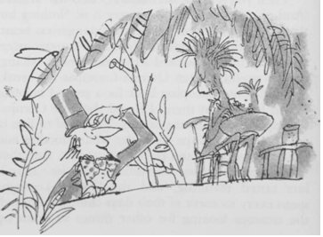
"'You really mean it?" asked the Oompa-Loompa leader, leaping up from his chair.
"'Of course I mean it," I said. "And you can have chocolate as well. Chocolate tastes even better than cacao beans because it's got milk and sugar added."
'The little man gave a great whoop of joy and threw his bowl of mashed caterpillars right out of the tree-house window. "It's a deal!" he cried. "Come on! Let's go!"
'So I shipped them all over here, every man, woman, and child in the Oompa-Loompa tribe. It was easy. I smuggled them over in large packing cases with holes in them, and they all got here safely. They are wonderful workers. They all speak English now. They love dancing and music. They are always making up songs. I expect you will hear a good deal of singing today from time to time. I must warn you, though, that they are rather mischievous. They like jokes. They still wear the same kind of clothes they wore in the jungle. They insist upon that. The men, as you can see for yourselves across the river, wear only deerskins. The women wear leaves, and the children wear nothing at all. The women use fresh leaves every day
'Daddy!' shouted Veruca Salt (the girl who got everything she wanted). 'Daddy! I want an Oompa-Loompa! I want you to get me an Oompa-Loompa! I want an Oompa-Loompa right away! I want to take it home with me! Go on, Daddy! Get me an Oompa-Loompa!'
'Now, now, my pet!' her father said to her, 'we mustn't interrupt Mr Wonka.'
'But I want an Oompa-Loompa!'' screamed Veruca.
'All right, Veruca, all right. But I can't get it for you this second. Please be patient. I'll see you have one before the day is out.'
'Augustus!' shouted Mrs Gloop. 'Augustus, sweetheart, I don't think you had better do that.' Augustus Gloop, as you might have guessed, had quietly sneaked down to the edge of the river, and he was now kneeling on the riverbank, scooping hot melted chocolate into his mouth as fast as he could.
Chapter 17 - Augustus Gloop Goes up the Pipe
When Mr Wonka turned round and saw what Augustus Gloop was doing, he cried out, 'Oh, no! Please, Augustus, please! I beg of you not to do that. My chocolate must be untouched by human hands!'
'Augustus!' called out Mrs Gloop. 'Didn't you hear what the man said? Come away from that river at once!'
'This stuff is fabulous!' said Augustus, taking not the slightest notice of his mother or Mr Wonka. 'Gosh, I need a bucket to drink it properly!'
'Augustus,' cried Mr Wonka, hopping up and down and waggling his stick in the air, 'you must come away. You are dirtying my chocolate!'
'Augustus!' cried Mrs Gloop.
'Augustus!' cried Mr Gloop.
But Augustus was deaf to everything except the call of his enormous stomach. He was now lying full length on the ground with his head far out over the river, lapping up the chocolate like a dog.
'Augustus!' shouted Mrs Gloop. 'You'll be giving that nasty cold of yours to about a million people all over the country!'
'Be careful, Augustus!' shouted Mr Gloop. 'You're leaning too far out!'
Mr Gloop was absolutely right. For suddenly there was a shriek, and then a splash, and into the river went Augustus Gloop, and in one second he had disappeared under the brown surface.
'Save him!' screamed Mrs Gloop, going white in the face, and waving her umbrella about. 'He'll drown! He can't swim a yard! Save him! Save him!'
'Good heavens, woman,' said Mr Gloop, 'I'm not diving in there! I've got my best suit on!'
Augustus Gloop's face came up again to the surface, painted brown with chocolate. 'Help! Help! Help!' he yelled. 'Fish me out!'
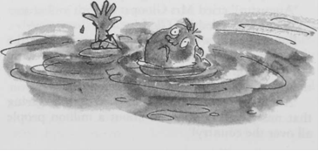
'Don't just stand there!' Mrs Gloop screamed at Mr Gloop. 'Do something!'
'I am doing something!' said Mr Gloop, who was now taking off his jacket and getting ready to dive into the chocolate. But while he was doing this, the wretched boy was being sucked closer and closer towards the mouth of one of the great pipes that was dangling down into the river. Then all at once, the powerful suction took hold of him completely, and he was pulled under the surface and then into the mouth of the pipe.
The crowd on the riverbank waited breathlessly to see where he would come out.
'There he goes!' somebody shouted, pointing upwards.
And sure enough, because the pipe was made of glass, Augustus Gloop could be clearly seen shooting up inside it, head first, like a torpedo.
'Help! Murder! Police!' screamed Mrs Gloop. 'Augustus, come back at once! Where are you going?'
'It's a wonder to me,' said Mr Gloop, 'how that pipe is big enough for him to go through it.'
'It isn't big enough!' said Charlie Bucket. 'Oh dear, look! He's slowing down!'
'So he is!' said Grandpa Joe.
'He's going to stick!' said Charlie.
'I think he is!' said Grandpa Joe.
'By golly, he has stuck!' said Charlie.
'It's his stomach that's done it!' said Mr Gloop.
'He's blocked the whole pipe!' said Grandpa Joe.
'Smash the pipe!' yelled Mrs Gloop, still waving her umbrella. 'Augustus, come out of there at once!'
The watchers below could see the chocolate swishing around the boy in the pipe, and they could see it building up behind him in a solid mass, pushing against the blockage. The pressure was terrific.
Something had to give. Something did give, and that something was Augustus. WHOOF! Up he shot again like a bullet in the barrel of a gun.
'He's disappeared!' yelled Mrs Gloop. 'Where does that pipe go to? Quick! Call the fire brigade!'
'Keep calm!' cried Mr Wonka. 'Keep calm, my dear lady, keep calm. There is no danger! No danger whatsoever! Augustus has gone on a little journey, that's all. A most interesting little journey. But he'll come out of it just fine, you wait and see.'
'How can he possibly come out just fine!' snapped Mrs Gloop. 'He'll be made into marshmallows in five seconds!'
'Impossible!' cried Mr Wonka. 'Unthinkable! Inconceivable! Absurd! He could never be made into marshmallows!'
'And why not, may I ask?' shouted Mrs Gloop.
'Because that pipe doesn't go anywhere near it! That pipe - the one Augustus went up - happens to lead directly to the room where I make a most delicious kind of strawberry-flavoured chocolate-coated fudge ...'
'Then he'll be made into strawberry-flavoured chocolate-coated fudge!' screamed Mrs Gloop. 'My poor Augustus! They'll be selling him by the pound all over the country tomorrow morning!'
'Quite right,' said Mr Gloop.
'I know I'm right,' said Mrs Gloop.
'It's beyond a joke,' said Mr Gloop.
'Mr Wonka doesn't seem to think so!' cried Mrs Gloop. 'Just look at him! He's laughing his head off! How dare you laugh like that when my boy's just gone up the pipe! You monster!' she shrieked, pointing her umbrella at Mr Wonka as though she were going to run him through. 'You think it's a joke, do you? You think that sucking my boy up into your Fudge Room like that is just one great big colossal joke?'
'He'll be perfectly safe,' said Mr Wonka, giggling slightly.
'He'll be chocolate fudge!' shrieked Mrs Gloop.
'Never!' cried Mr Wonka.
'Of course he will!' shrieked Mrs Gloop.
'I wouldn't allow it!' cried Mr Wonka.
'And why not?' shrieked Mrs Gloop.
'Because the taste would be terrible,' said Mr Wonka. 'Just imagine it! Augustus-flavoured chocolate-coated Gloop! No one would buy it.'
'They most certainly would!' cried Mr Gloop indignantly.
'I don't want to think about it!' shrieked Mrs Gloop.
'Nor do I,' said Mr Wonka. 'And I do promise you, madam, that your darling boy is perfectly safe.'
'If he's perfectly safe, then where is he?' snapped Mrs Gloop. 'Lead me to him this instant!'
Mr Wonka turned around and clicked his fingers sharply, click, click, click, three times. Immediately, an Oompa-Loompa appeared, as if from nowhere, and stood beside him.
The Oompa-Loompa bowed and smiled, showing beautiful white teeth. His skin was rosy-white, his long hair was golden-brown, and the top of his head came just above the height of Mr Wonka's knee. He wore the usual deerskin slung over his shoulder.
'Now listen to me!' said Mr Wonka, looking down at the tiny man. 'I want you to take Mr and Mrs Gloop up to the Fudge Room and help them to find their son, Augustus. He's just gone up the pipe.'
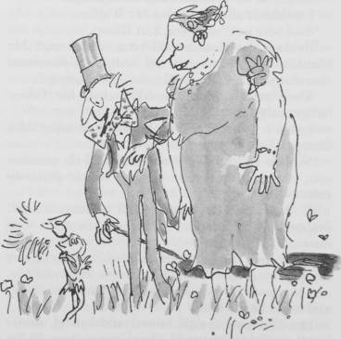
The Oompa-Loompa took one look at Mrs Gloop and exploded into peals of laughter.
'Oh, do be quiet!' said Mr Wonka. 'Control yourself! Pull yourself together! Mrs Gloop doesn't think it's at all funny!'
'You can say that again!' said Mrs Gloop.
'Go straight to the Fudge Room,' Mr Wonka said to the Oompa-Loompa, 'and when you get there, take a long stick and start poking around inside the big chocolate-mixing barrel. I'm almost certain you'll find him in there. But you'd better look sharp! You'll have to hurry! If you leave him in the chocolate-mixing barrel too long, he's liable to get poured out into the fudge boiler, and that really would be a disaster, wouldn't it? My fudge would become quite uneatable!'
Mrs Gloop let out a shriek of fury.
'I'm joking,' said Mr Wonka, giggling madly behind his beard. 'I didn't mean it. Forgive me. I'm so sorry. Good-bye, Mrs Gloop! And Mr Gloop! Good-bye! I'll see you later.'
As Mr and Mrs Gloop and their tiny escort hurried away, the five Oompa-Loompas on the far side of the river suddenly began hopping and dancing about and beating wildly upon a number of very small drums. 'Augustus Gloop!' they chanted. 'Augustus Gloop! Augustus Gloop! Augustus Gloop!'
'Grandpa!' cried Charlie. 'Listen to them, Grandpa! What are they doing?'
'Ssshh!' whispered Grandpa Joe. 'I think they're going to sing us a song!'
'Augustus Gloop!' chanted the Oompa-Loompas.
'Augustus Gloop! Augustus Gloop!
The great big greedy nincompoop!
How long could we allow this beast
To gorge and guzzle, feed and feast
On everything he wanted to?
Great Scott! It simply wouldn't do!
However long this pig might live,
We're positive he'd never give
Even the smallest bit of fun
Or happiness to anyone.
So what we do in cases such
As this, we use the gentle touch,
And carefully we take the brat
And turn him into something that
Will give great pleasure to us all -
A doll, for instance, or a ball,
Or marbles or a rocking horse.
But this revolting boy, of course,
Was so unutterably vile,
So greedy, foul, and infantile,
He left a most disgusting taste
Inside our mouths, and so in haste
We chose a thing that, come what may,
Would take the nasty taste away.
"Come on!" we cried. " The time is ripe
To send him shooting up the pipe!
He has to go! It has to be!"
And very soon, he's going to see
Inside the room to which he's gone
Some funny things are going on.
But don't, dear children, be alarmed;
Augustus Gloop will not be harmed,
Although, of course, we must admit,
He will be altered quite a bit.
He'll be quite changed from what he's been,
When he goes through the fudge machine:
Slowly, the wheels go round and round,
The cogs begin to grind and pound;
A hundred knives go slice, slice, slice;
We add some sugar, cream, and spice;
We boil him for a minute more,
Until we're absolutely sure
That all the greed and all the gall
Is boiled away for once and all.
Then out he comes! And now! By grace!
A miracle has taken place!
This boy, who only just before
Was loathed by men from shore to shore,
This greedy brute, this louse's ear,
Is loved by people everywhere!
For who could hate or bear a grudge
Against a luscious bit of fudge?'

I told you they loved singing!' cried Mr Wonka. 'Aren't they delightful? Aren't they charming? But you mustn't believe a word they said. It's all nonsense, every bit of it!'
'Are the Oompa-Loompas really joking, Grandpa?' asked Charlie.
'Of course they're joking,' answered Grandpa Joe. 'They must be joking. At least, I hope they're joking. Don't you?'

Chapter 18 - Down the Chocolate River
'Off we go!' cried Mr Wonka. 'Hurry up, everybody! Follow me to the next room! And please don't worry about Augustus Gloop. He's bound to come out in the wash. They always do. We shall have to make the next part of the journey by boat! Here she comes! Look!'
A steamy mist was rising up now from the great warm chocolate river, and out of the mist there appeared suddenly a most fantastic pink boat. It was a large open row boat with a tall front and a tall back (like a Viking boat of old), and it was of such a shining sparkling glistening pink colour that the whole thing looked as though it were made of bright, pink glass. There were many oars on either side of it, and as the boat came closer, the watchers on the riverbank could see that the oars were being pulled by masses of Oompa-Loompas - at least ten of them to each oar.
'This is my private yacht!' cried Mr Wonka, beaming with pleasure. 'I made her by hollowing out an enormous boiled sweet! Isn't she beautiful! See how she comes cutting through the river!'
The gleaming pink boiled-sweet boat glided up to the riverbank. One hundred Oompa-Loompas rested on their oars and stared up at the visitors. Then suddenly, for some reason best known to themselves, they all burst into shrieks of laughter.
'What's so funny?' asked Violet Beauregarde.
'Oh, don't worry about them,' cried Mr Wonka. 'They're always laughing! They think everything's a colossal joke! Jump into the boat, all of you! Come on! Hurry up!'
As soon as everyone was safely in, the Oompa-Loompas pushed the boat away from the bank and began to row swiftly downriver.
.Hey, there! Mike Teavee!' shouted Mr Wonka. 'Please do not lick the boat with your tongue! It'll only make it sticky!'
'Daddy,' said Veruca Salt, 'I want a boat like this! I want you to buy me a big pink boiled-sweet boat exactly like Mr Wonka's! And I want lots of Oompa-Loompas to row me about, and I want a chocolate river and I want ... I want...'
'She wants a good kick in the pants,' whispered Grandpa Joe to Charlie. The old man was sitting in the back of the boat and little Charlie Bucket was right beside him.
Charlie was holding tightly on to his grandfather's bony old hand. He was in a whirl of excitement. Everything that he had seen so far - the great chocolate river, the waterfall, the huge sucking pipes, the minty sugar meadows, the Oompa-Loompas, the beautiful pink boat, and most of all, Mr Willy Wonka himself had been so astonishing that he began to wonder whether there could possibly be any more astonishments left. Where were they going now? What were they going to see? And what in the world was going to happen in the next room?
'Isn't it marvellous?' said Grandpa Joe, grinning at Charlie.
Charlie nodded and smiled up at the old man.
Suddenly, Mr Wonka, who was sitting on Charlie's other side, reached down into the bottom of the boat, picked up a large mug, dipped it into the river, filled it with chocolate, and handed it to Charlie. 'Drink this,' he said. 'It'll do you good! You look starved to death!'
Then Mr Wonka filled a second mug and gave it to Grandpa Joe. 'You, too,' he said.
'You look like a skeleton! What's the matter? Hasn't there been anything to eat in your house lately?'
'Not much,' said Grandpa Joe.
Charlie put the mug to his lips, and as the rich warm creamy chocolate ran down his throat into his empty tummy, his whole body from head to toe began to tingle with pleasure, and a feeling of intense happiness spread over him.
'You like it?' asked Mr Wonka.
'Oh, it's wonderful!' Charlie said.
'The creamiest loveliest chocolate I've ever tasted!' said Grandpa Joe, smacking his lips.
'That's because it's been mixed by waterfall,' Mr Wonka told him.
The boat sped on down the river. The river was getting narrower. There was some kind of a dark tunnel ahead - a great round tunnel that looked like an enormous pipe - and the river was running right into the tunnel. And so was the boat! 'Row on!' shouted Mr Wonka, jumping up and waving his stick in the air. 'Full speed ahead!' And with the Oompa-Loompas rowing faster than ever, the boat shot into the pitch-dark tunnel, and all the passengers screamed with excitement.
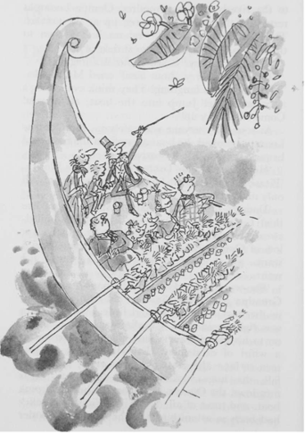
'How can they see where they're going?' shrieked Violet Beauregarde in the darkness.
'There's no knowing where they're going!' cried Mr Wonka, hooting with laughter.
'There's no earthly way of knowing which direction they are going! There's no knowing where they're rowing, Or which way the river's flowing! Not a speck of light is showing, So the danger must be growing, For the rowers keep on rowing, And they're certainly not showing Any signs that they are slowing ...'
'He's gone off his rocker!' shouted one of the fathers, aghast, and the other parents joined in the chorus of frightened shouting. 'He's crazy!' they shouted.
'He's balmy!'
'He's nutty!'
'He's screwy!'
'He's batty!'
'He's dippy!'
'He's dotty!'
'He's daffy!'
'He's goofy!'
'He's beany!'
'He's buggy!'
'He's wacky!'
'He's loony!'
'No, he is not!' said Grandpa Joe.
'Switch on the lights!' shouted Mr Wonka. And suddenly, on came the lights and the whole tunnel was brilliantly lit up, and Charlie could see that they were indeed inside a gigantic pipe, and the great upward-curving walls of the pipe were pure white and spotlessly clean. The river of chocolate was flowing very fast inside the pipe, and the Oompa-Loompas were all rowing like mad, and the boat was rocketing along at a furious pace. Mr Wonka was jumping up and down in the back of the boat and calling to the rowers to row faster and faster still. He seemed to love the sensation of whizzing through a white tunnel in a pink boat on a chocolate river, and he clapped his hands and laughed and kept glancing at his passengers to see if they were enjoying it as much as he.
'Look, Grandpa!' cried Charlie. 'There's a door in the wall!' It was a green door and it was set into the wall of the tunnel just above the level of the river. As they flashed past it there was just enough time to read the writing on the door: STOREROOM NUMBER 54, it said. ALL THE CREAMS - DAIRY CREAM, WHIPPED CREAM, VIOLET CREAM, COFFEE CREAM, PINEAPPLE CREAM. VANILLA CREAM, AND HAIR CREAM.
'Hair cream?' cried Mike Teavee. 'You don't use hair cream?'
'Row on!' shouted Mr Wonka. 'There's no time to answer silly questions!'
They streaked past a black door. STOREROOM NUMBER 71, it said on it. WHIPS ALL SHAPES AND SIZES.
'Whips!' cried Veruca Salt. 'What on earth do you use whips for?'
'For whipping cream, of course,' said Mr Wonka. 'How can you whip cream without whips? Whipped cream isn't whipped cream at all unless it's been whipped with whips. Just as a poached egg isn't a poached egg unless it's been stolen from the woods in the dead of night! Row on, please!'
They passed a yellow door on which it said: STOREROOM NUMBER 77 - ALL THE BEANS, CACAO BEANS, COFFEE BEANS, JELLY BEANS, AND HAS BEANS.
'Has beans?' cried Violet Beauregarde.
'You're one yourself!' said Mr Wonka. 'There's no time for arguing! Press on, press on!'
But five seconds later, when a bright red door came into sight ahead, he suddenly waved his gold-topped cane in the air and shouted, 'Stop the boat!'

Chapter 19 - The Inventing Room - Everlasting Gobstoppers and Hair Toffee
When Mr Wonka shouted 'Stop the boat!' the Oompa-Loompas jammed their oars into the river and backed water furiously. The boat stopped.
The Oompa-Loompas guided the boat alongside the red door. On the door it said, INVENTING ROOM - PRIVATE - KEEP OUT. Mr Wonka took a key from his pocket, leaned over the side of the boat, and put the key in the keyhole.
'This is the most important room in the entire factory!' he said. All my most secret new inventions are cooking and simmering in here! Old Fickelgruber would give his front teeth to be allowed inside just for three minutes! So would Prodnose and Slugworth and all the other rotten chocolate makers! But now, listen to me! I want no messing about when you go in! No touching, no meddling, and no tasting! Is that agreed?'
'Yes, yes!' the children cried. 'We won't touch a thing!'
'Up to now,' Mr Wonka said, 'nobody else, not even an Oompa-Loompa, has ever been allowed in here!' He opened the door and stepped out of the boat into the room. The four children and their parents all scrambled after him.
'Don't touch!' shouted Mr Wonka. 'And don't knock anything over!'
Charlie Bucket stared around the gigantic room in which he now found himself. The place was like a witch's kitchen! All about him black metal pots were boiling and bubbling on huge stoves, and kettles were hissing and pans were sizzling, and strange iron machines were clanking and spluttering, and there were pipes running all over the ceiling and walls, and the whole place was filled with smoke and steam and delicious rich smells.
Mr Wonka himself had suddenly become even more excited than usual, and anyone could see that this was the room he loved best of all. He was hopping about among the saucepans and the machines like a child among his Christmas presents, not knowing which thing to look at first. He lifted the lid from a huge pot and took a sniff; then he rushed over and dipped a finger into a barrel of sticky yellow stuff and had a taste; then he skipped across to one of the machines and turned half a dozen knobs this way and that; then he peered anxiously through the glass door of a gigantic oven, rubbing his hands and cackling with delight at what he saw inside. Then he ran over to another machine, a small shiny affair that kept going phut- phut-phut-phut-phut, and every time it went phut, a large green marble dropped out of it into a basket on the floor. At least it looked like a marble.
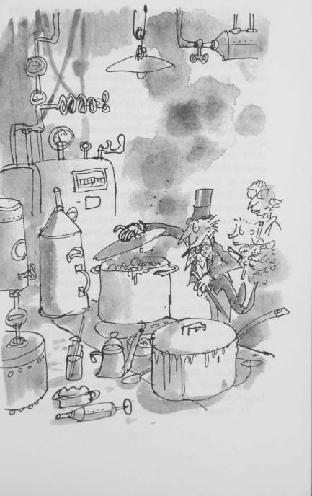
'Everlasting Gobstoppers!' cried Mr Wonka proudly. 'They're completely new! I am inventing them for children who are given very little pocket money. You can put an Everlasting Gobstopper in your mouth and you can suck it and suck it and suck it and suck it and it will never get any smaller!'
'It's like gum!' cried Violet Beauregarde.
'It is not like gum,' Mr Wonka said. 'Gum is for chewing, and if you tried chewing one of these Gobstoppers here you'd break your teeth off! And they never get any smaller! They never disappear! NEVER! At least I don't think they do. There's one of them being tested this very moment in the Testing Room next door. An Oompa-Loompa is sucking it. He's been sucking it for very nearly a year now without stopping, and it's still just as good as ever!
'Now, over here,' Mr Wonka went on, skipping excitedly across the room to the opposite wall, 'over here I am inventing a completely new line in toffees!' He stopped beside a large saucepan. The saucepan was full of a thick gooey purplish treacle, boiling and bubbling. By standing on his toes, little Charlie could just see inside it.
'That's Hair Toffee!' cried Mr Wonka. 'You eat just one tiny bit of that, and in exactly half an hour a brand-new luscious thick silky beautiful crop of hair will start growing out all over the top of your head! And a moustache! And a beard!'
'A beard!' cried Veruca Salt. 'Who wants a beard, for heaven's sake?'
'It would suit you very well,' said Mr Wonka, 'but unfortunately the mixture is not quite right yet. I've got it too strong. It works too well. I tried it on an Oompa-Loompa yesterday in the Testing Room and immediately a huge black beard started shooting out of his chin, and the beard grew so fast that soon it was trailing all over the floor in a thick hairy carpet. It was growing faster than we could cut it! In the end we had to use a lawn mower to keep it in check! But I'll get the mixture right soon! And when I do, then there'll be no excuse any more for little boys and girls going about with bald heads!'
'But Mr Wonka,' said Mike Teavee, 'little boys and girls never do go about with ...'
'Don't argue, my dear child, please don't argue!' cried Mr Wonka. 'It's such a waste of precious time! Now, over here, if you will all step this way, I will show you something that I am terrifically proud of. Oh, do be careful! Don't knock anything over! Stand back!'

Chapter 20 - The Great Gum Machine
Mr Wonka led the party over to a gigantic machine that stood in the very centre of the Inventing Room. It was a mountain of gleaming metal that towered high above the children and their parents. Out of the very top of it there sprouted hundreds and hundreds of thin glass tubes, and the glass tubes all curled downwards and came together in a bunch and hung suspended over an enormous round tub as big as a bath.
'Here we go!' cried Mr Wonka, and he pressed three different buttons on the side of the machine. A second later, a mighty rumbling sound came from inside it, and the whole machine began to shake most frighteningly, and steam began hissing out of it all over, and then suddenly the watchers noticed that runny stuff was pouring down the insides of all the hundreds of little glass tubes and squirting out into the great tub below. And in every single tube the runny stuff was of a different colour, so that all the colours of the rainbow (and many others as well) came sloshing and splashing into the tub. It was a lovely sight. And when the tub was nearly full, Mr Wonka pressed another button, and immediately the runny stuff disappeared, and a whizzing whirring noise took its place; and then a giant whizzer started whizzing round inside the enormous tub, mixing up all the different coloured liquids like an ice-cream soda. Gradually, the mixture began to froth. It became frothier and frothier, and it turned from blue to white to green to brown to yellow, then back to blue again.
'Watch!' said Mr Wonka.
Click went the machine, and the whizzer stopped whizzing. And now there came a sort of sucking noise, and very quickly all the blue frothy mixture in the huge basin was sucked back into the stomach of the machine. There was a moment of silence. Then a few queer rumblings were heard. Then silence again. Then suddenly, the machine let out a monstrous mighty groan, and at the same moment a tiny drawer (no bigger than the drawer in a slot machine) popped out of the side of the machine, and in the drawer there lay something so small and thin and grey that everyone thought it must be a mistake. The thing looked like a little strip of grey cardboard.
The children and their parents stared at the little grey strip lying in the drawer.
'You mean that's all?' said Mike Teavee, disgusted.
'That's all,' answered Mr Wonka, gazing proudly at the result. 'Don't you know what it is?'
There was a pause. Then suddenly, Violet Beauregarde, the silly gum-chewing girl, let out a yell of excitement. 'By gum, it's gum,' she shrieked. 'It's a stick of chewing-gum!'
'Right you are!' cried Mr Wonka, slapping Violet hard on the back. 'It's a stick of gum! It's a stick of the most amazing and fabulous and sensational gum in the world!'
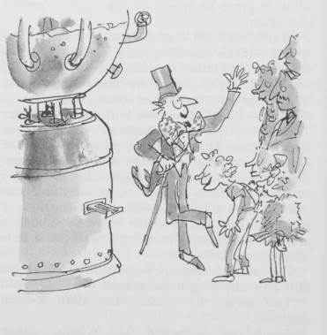

Chapter 21 - Good-bye Violet
'This gum,' Mr Wonka went on, 'is my latest, my greatest, my most fascinating invention! It's a chewing-gum meal! It's ... it's ... it's ... That tiny little strip of gum lying there is a whole three-course dinner all by itself!'
'What sort of nonsense is this?' said one of the fathers.
'My dear sir!' cried Mr Wonka, 'when I start selling this gum in the shops it will change everything. It will be the end of all kitchens and all cooking! There will be no more shopping to do! No more buying of meat and groceries! There'll be no knives and forks at mealtimes! No plates! No washing up! No rubbish! No mess! Just a little strip of Wonka's magic chewing-gum - and that's all you'll ever need at breakfast, lunch, and supper! This piece of gum I've just made happens to be tomato soup, roast beef, and blueberry pie, but you can have almost anything you want!'
'What do you mean, it's tomato soup, roast beef, and blueberry pie?' said Violet Beauregarde.
'If you were to start chewing it,' said Mr Wonka, 'then that is exactly what you would get on the menu. It's absolutely amazing! You can actually feel the food going down your throat and into your tummy! And you can taste it perfectly! And it fills you up! It satisfies you! It's terrific!'
'It's utterly impossible,' said Veruca Salt.
'Just so long as it's gum,' shouted Violet Beauregarde, 'just so long as it's a piece of gum and I can chew it, then that's for me!' And quickly she took her own world-record piece of chewing-gum out of her mouth and stuck it behind her left ear. 'Come on, Mr Wonka,' she said, 'hand over this magic gum of yours and we'll see if the thing works.'
'Now, Violet,' said Mrs Beauregarde, her mother; 'don't let's do anything silly, Violet.'
'I want the gum!' Violet said obstinately. 'What's so silly?'
'I would rather you didn't take it,' Mr Wonka told her gently. 'You see, I haven't got it quite right yet. There are still one or two things ...'
'Oh, to blazes with that!' said Violet, and suddenly, before Mr Wonka could stop her, she shot out a fat hand and grabbed the stick of gum out of the little drawer and popped it into her mouth. At once, her huge, well-trained jaws started chewing away on it like a pair of tongs.
'Don't!' said Mr Wonka.
'Fabulous!' shouted Violet. 'It's tomato soup! It's hot and creamy and delicious! I can feel it running down my throat!'
'Stop!' said Mr Wonka. 'The gum isn't ready yet! It's not right!'
'Of course it's right!' said Violet, 'it's working beautifully! Oh my, what lovely soup this is!'
'Spit it out!' said Mr Wonka.
'It's changing!' shouted Violet, chewing and grinning both at the same time. 'The second course is coming up! It's roast beef! It's tender and juicy! Oh boy, what a flavour! The baked potato is marvellous, too! It's got a crispy skin and it's all filled with butter inside!'
'But how interesting, Violet,' said Mrs Beauregarde. 'You are a clever girl.'
'Keep chewing, baby!' said Mr Beauregarde. 'Keep right on chewing! This is a great day for the Beauregardes! Our little girl is the first person in the world to have a chewing-gum meal!'
Everybody was watching Violet Beauregarde as she stood there chewing this extraordinary gum. Little Charlie Bucket was staring at her absolutely spellbound, watching her huge rubbery lips as they pressed and unpressed with the chewing, and Grandpa Joe stood beside him, gaping at the girl. Mr Wonka was wringing his hands and saying, 'No, no, no, no, no! It isn't ready for eating! It isn't right! You mustn't do it!'
'Blueberry pie and cream!' shouted Violet. 'Here it comes! Oh my, it's perfect! It's beautiful! It's ... it's exactly as though I'm swallowing it! It's as though I'm chewing and swallowing great big spoonfuls of the most marvellous blueberry pie in the world!'
'Good heavens, girl!' shrieked Mrs Beauregarde suddenly, staring at Violet, 'what's happening to your nose!'
'Oh, be quiet, mother, and let me finish!' said Violet.
'It's turning blue!' screamed Mrs Beauregarde. 'Your nose is turning blue as a blueberry!'
'Your mother is right!' shouted Mr Beauregarde. 'Your whole nose has gone purple!'
'What do you mean?' said Violet, still chewing away.
'Your cheeks!' screamed Mrs Beauregarde. 'They're turning blue as well! So is your chin! Your whole face is turning blue!'
'Spit that gum out at once!' ordered Mr Beauregarde.
'Mercy! Save us!' yelled Mrs Beauregarde. 'The girl's going blue and purple all over! Even her hair is changing colour! Violet, you're turning violet, Violet! What is happening to you?'
'I told you I hadn't got it quite right,' sighed Mr Wonka, shaking his head sadly.
'I'll say you haven't!' cried Mrs Beauregarde. 'Just look at the girl now!'
Everybody was staring at Violet. And what a terrible, peculiar sight she was! Her face and hands and legs and neck, in fact the skin all over her body, as well as her great big mop of curly hair, had turned a brilliant, purplish-blue, the colour of blueberry juice!
'It always goes wrong when we come to the dessert,' sighed Mr Wonka, it's the blueberry pie that does it. But I'll get it right one day, you wait and see.'
'Violet,' screamed Mrs Beauregarde, 'you're swelling up!'
'I feel sick,' Violet said.
'You're swelling up!' screamed Mrs Beauregarde again.
'I feel most peculiar!' gasped Violet.
I'm not surprised!' said Mr Beauregarde.
'Great heavens, girl!' screeched Mrs Beauregarde. 'You're blowing up like a balloon!'
'Like a blueberry,' said Mr Wonka.
'Call a doctor!' shouted Mr Beauregarde.
'Prick her with a pin!' said one of the other fathers.
'Save her!' cried Mrs Beauregarde, wringing her hands.
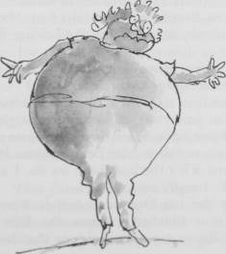
But there was no saving her now. Her body was swelling up and changing shape at such a rate that within a minute it had turned into nothing less than an enormous round blue ball - a gigantic blueberry, in fact - and all that remained of Violet Beauregarde herself was a tiny pair of legs and a tiny pair of arms sticking out of the great round fruit and little head on top.
'It always happens like that,' sighed Mr Wonka, 'I've tried it twenty times in the Testing Room on twenty Oompa-Loompas, and every one of them finished up as a blueberry. It's most annoying. I just can't understand it.'
'But I don't want a blueberry for a daughter!' yelled Mrs Beauregarde. 'Put her back to what she was this instant!'
Mr Wonka clicked his fingers, and ten Oompa-Loompas appeared immediately at his side.
'Roll Miss Beauregarde into the boat,' he said to them, 'and take her along to the Juicing Room at once.'
'The Juicing Room?' cried Mrs Beauregarde. 'What are they going to do to her there?'
'Squeeze her,' said Mr Wonka. 'We've got to squeeze the juice out of her immediately. After that, we'll just have to see how she comes out. But don't worry, my dear Mrs Beauregarde. We'll get her repaired if it's the last thing we do. I am sorry about it all, I really am ...'
Already the ten Oompa-Loompas were rolling the enormous blueberry across the floor of the Inventing Room towards the door that led to the chocolate river where the boat was waiting. Mr and Mrs Beauregarde hurried after them. The rest of the party, including little Charlie Bucket and Grandpa Joe, stood absolutely still and watched them go.
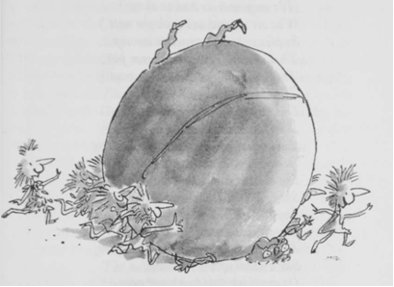
'Listen!' whispered Charlie. 'Listen, Grandpa! The Oompa-Loompas in the boat outside are starting to sing!'
The voices, one hundred of them singing together, came loud and clear into the room:
'Dear friends, we surely all agree
There's almost nothing worse to see
Than some repulsive little bum
Who's always chewing chewing-gum.
(It's very near as bad as those
Who sit around and pick the nose.)
So please believe us when we say
That chewing gum will never pay;
This sticky habit's bound to send
The chewer to a sticky end.
Did any of you ever know
A person called Miss Bigelow?
This dreadful woman saw no wrong
In chewing, chewing all day long.
She chewed while bathing in the tub,
She chewed while dancing at her club,
She chewed in church and on the bus;
It really was quite ludicrous!
And when she couldn't find her gum,
She'd chew up the linoleum,
Or anything that happened near -
A pair of boots, the postman's ear,
Or other people's underclothes,
And once she chewed her boy-friend's nose.
She went on chewing till, at last,
Her chewing muscles grew so vast
That from her face her giant chin
Stuck out just like a violin.
For years and years she chewed away,
Consuming fifty bits a day,
Until one summer's eve, alas,
A horrid business came to pass.
Miss Bigelow went late to bed,
For half an hour she lay and read,
Chewing and chewing all the while
Like some great clockwork crocodile.
At last, she put her gum away
Upon a special little tray,
And settled back and went to sleep-
(She managed this by counting sheep).
But now, how strange! Although she slept,
Those massive jaws of hers still kept
On chewing, chewing through the night,
Even with nothing there to bite.
They were, you see, in such a groove
They positively had to move.
And very grim it was to hear
In pitchy darkness, loud and clear.
This sleeping woman's great big trap
Opening and shutting, snap-snap-snap!
Faster and faster, chop-chop-chop,
The noise went on, it wouldn't stop.
Until at last her jaws decide
To pause and open extra wide,
And with the most tremendous chew
They bit the lady's tongue in two.
Thereafter, just from chewing gum,
Miss Bigelow was always dumb,
And spent her life shut up in some
Disgusting sanatorium.
And that is why we'll try so hard
To save Miss Violet Beauregarde
From suffering an equal fate.
She's still quite young. It's not too late.
Provided she survives the cure.
We hope she does. We can't be sure.'

Chapter 22 - Along the Corridor
'Well, well, well,' sighed Mr Willy Wonka, 'two naughty little children gone. Three good little children left. I think we'd better get out of this room quickly before we lose anyone else!'
'But Mr Wonka,' said Charlie Bucket anxiously, 'will Violet Beauregarde ever be all right again or will she always be a blueberry?'
'They'll de-juice her in no time flat!' declared Mr Wonka. 'They'll roll her into the de-juicing machine, and she'll come out just as thin as a whistle!'
'But will she still be blue all over?' asked Charlie.
'She'll be purple,' cried Mr Wonka. 'A fine rich purple from head to toe! But there you are! That's what comes from chewing disgusting gum all day long!'
'If you think gum is so disgusting,' said Mike Teavee, 'then why do you make it in your factory?'
'I do wish you wouldn't mumble,' said Mr Wonka. 'I can't hear a word you're saying. Come on! Off we go! Hurry up! Follow me! We're going; into the corridors again!' And so saying, Mr Wonka scuttled across to the far end of the Inventing Room and went out through a small secret door hidden behind a lot of pipes and stoves. The three remaining children - Veruca Salt, Mike Teavee, and Charlie Bucket - together with the five remaining grown-ups, followed after him.
Charlie Bucket saw that they were now back in one of those long pink corridors with many other pink corridors leading out of it. Mr Wonka was rushing along in front, turning left and right and right and left, and Grandpa Joe was saying, 'Keep a good hold of my hand, Charlie. It would be terrible to get lost in here.'
Mr Wonka was saying, 'No time for any more messing about! We'll never get anywhere at the rate we've been going!' And on he rushed, down the endless pink corridors, with his black top hat perched on the top of his head and his plum- coloured velvet coat-tails flying out behind him like a flag in the wind.
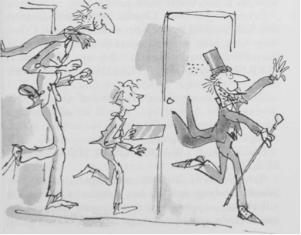
They passed a door in the wall. 'No time to go in!' shouted Mr Wonka. 'Press on! Press on!'
They passed another door, then another and another. There were doors every twenty paces or so along the corridor now, and they all had something written on them, and strange clanking noises were coming from behind several of them, and delicious smells came wafting through the keyholes, and sometimes little jets of coloured steam shot out from the cracks underneath.
Grandpa Joe and Charlie were half running and half walking to keep up with Mr Wonka, but they were able to read what it said on quite a few of the doors as they hurried by. EATABLE MARSHMALLOW PILLOWS, it said on one.
'Marshmallow pillows are terrific!' shouted Mr Wonka as he dashed by. 'They'll be all the rage when I get them into the shops! No time to go in, though! No time to go in!'
LICKABLE WALLPAPER FOR NURSERIES, it said on the next door.
'Lovely stuff, lickable wallpaper!' cried Mr Wonka, rushing past. 'It has pictures of fruits on it - bananas, apples, oranges, grapes, pineapples, strawberries, and snozzberries ... '
'Snozzberries? said Mike Teavee.
'Don't interrupt!' said Mr Wonka. 'The wallpaper has pictures of all these fruits printed on it, and when you lick the picture of a banana, it tastes of banana. When you lick a strawberry, it tastes of strawberry. And when you lick a snozzberry, it tastes just exactly like a snozzberry ...'
'But what does a snozzberry taste like?'
'You're mumbling again,' said Mr Wonka. 'Speak louder next time. On we go! Hurry up!'
HOT ICE CREAMS FOR COLD DAYS, it said on the next door.
'Extremely useful in the winter,' said Mr Wonka, rushing on. 'Hot ice cream warms you up no end in freezing weather. I also make hot ice cubes for putting in hot drinks. Hot ice cubes make hot drinks hotter.'
COWS THAT GIVE CHOCOLATE MILK, it said on the next door.
'Ah, my pretty little cows!' cried Mr Wonka. 'How I love those cows!'
'But why can't we see them?' asked Veruca Salt. 'Why do we have to go rushing on past all these lovely rooms?'
'We shall stop in time!' called out Mr Wonka. 'Don't be so madly impatient!'
FIZZY LIFTING DRINKS, it said on the next door.
'Oh, those are fabulous!' cried Mr Wonka. 'They fill you with bubbles, and the bubbles are full of a special kind of gas, and this gas is so terrifically lifting that it lifts you right off the ground just like a balloon, and up you go until your head hits the ceiling and there you stay.'
'But how do you come down again?' asked little Charlie.
'You do a burp, of course,' said Mr Wonka. 'You do a great big long rude burp, and up comes the gas and down comes you! But don't drink it outdoors! There's no knowing how high up you'll be carried if you do that. I gave some to an old Oompa-Loompa once out in the back yard and he went up and up and disappeared out of sight! It was very sad. I never saw him again.'
'He should have burped,' Charlie said.
'Of course he should have burped,' said Mr Wonka. 'I stood there shouting, "Burp, you silly ass, burp, or you'll never come down again!" But he didn't or couldn't or wouldn't, I don't know which. Maybe he was too polite. He must be on the moon by now.'
On the next door, it said, SQUARE SWEETS THAT LOOK ROUND.
'Wait!' cried Mr Wonka, skidding suddenly to a halt. 'I am very proud of my square sweets that look round. Let's take a peek.'

Chapter 23 - Square Sweets That Look Round
Everybody stopped and crowded to the door. The top half of the door was made of glass. Grandpa Joe lifted Charlie up so that he could get a better view, and looking in, Charlie saw a long table, and on the table there were rows and rows of small white square-shaped sweets. The sweets looked very much like square sugar lumps - except that each of them had a funny little pink face painted on one side. At the end of the table, a number of Oompa-Loompas were busily painting more faces on more sweets.
'There you are!' cried Mr Wonka. 'Square sweets that look round!'
'They don't look round to me,' said Mike Teavee.
'They look square,' said Veruca Salt. 'They look completely square.'
'But they are square,' said Mr Wonka. 'I never said they weren't.'
'You said they were round?' said Veruca Salt.
'I never said anything of the sort,' said Mr Wonka. 'I said they looked round.'
'But they don't look round!' said Veruca Salt.
'They look square!'
'They look round,' insisted Mr Wonka.
'They most certainly do not look round!' cried Veruca Salt.
'Veruca, darling,' said Mrs Salt, 'pay no attention to Mr Wonka! He's lying to you!'
'My dear old fish,' said Mr Wonka, 'go and boil your head!'
'How dare you speak to me like that!' shouted Mrs Salt.
'Oh, do shut up,' said Mr Wonka. 'Now watch this!'
He took a key from his pocket, and unlocked the door, and flung it open ... and suddenly ... at the sound of the door opening, all the rows of little square sweets looked quickly round to see who was coming in. The tiny faces actually turned towards the door and stared at Mr Wonka.
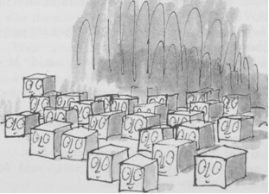
'There you are!' he cried triumphantly. 'They're looking round! There's no argument about it! They are square sweets that look round!'
'By golly, he's right!' said Grandpa Joe.
'Come on!' said Mr Wonka, starting off down the corridor again. 'On we go! We mustn't dawdle!'
BUTTERSCOTCH AND BUTTERGIN, it said on the next door they passed.
'Now that sounds a bit more interesting,' said Mr Salt, Veruca's father.
'Glorious stuff!' said Mr Wonka. 'The Oompa-Loompas all adore it. It makes them tiddly. Listen! You can hear them in there now, whooping it up.'
Shrieks of laughter and snatches of singing could be heard coming through the closed door.
'They're drunk as lords,' said Mr Wonka. 'They're drinking butterscotch and soda. They like that best of all. Buttergin and tonic is also very popular. Follow me, please! We really mustn't keep stopping like this.' He turned left. He turned right. They came to a long flight of stairs. Mr Wonka slid down the banisters. The three children did the same. Mrs Salt and Mrs Teavee, the only women now left in the party, were getting very out of breath. Mrs Salt was a great fat creature with short legs, and she was blowing like a rhinoceros. 'This way!' cried Mr Wonka, turning left at the bottom of the stairs.
.Go slower,' panted Mrs Salt.
'Impossible,' said Mr Wonka 'we should never get there in time if I did.'
'Get where?' asked Veruca Salt.
'Never you mind,' said Mr Wonka. 'You just wait and see.'
Chapter 24 - Veruca in the Nut Room
Mr Wonka rushed on down the corridor. THE NUT ROOM, it said on the next door they came to.
'All right,' said Mr Wonka, 'stop here for a moment and catch your breath, and take a peek through the glass panel of this door. But don't go in! Whatever you do, don't go into THE NUT ROOM! If you go in, you'll disturb the squirrels!'
Everyone crowded around the door.
'Oh look, Grandpa, look!' cried Charlie.
'Squirrels!' shouted Veruca Salt.
'Crikey!' said Mike Teavee.
It was an amazing sight. One hundred squirrels were seated upon high stools around a large table. On the table, there were mounds and mounds of walnuts, and the squirrels were all working away like mad, shelling the walnuts at a tremendous speed.
'These squirrels are specially trained for getting the nuts out of walnuts,' Mr Wonka explained.
'Why use squirrels?' Mike Teavee asked. 'Why not use Oompa-Loompas?'
'Because,' said Mr Wonka, 'Oompa-Loompas can't get walnuts out of walnut shells in one piece. They always break them in two. Nobody except squirrels can get walnuts whole out of walnut shells every time. It is extremely difficult. But in my factory, I insist upon only whole walnuts. Therefore I have to have squirrels to do the job. Aren't they wonderful, the way they get those nuts out! And see how they first tap each walnut with their knuckles to be sure it's not a bad one! If it's bad, it makes a hollow sound, and they don't bother to open it. They just throw it down the rubbish chute. There! Look! Watch that squirrel nearest to us! I think he's got a bad one now!'
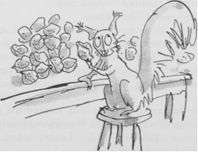
They watched the little squirrel as he tapped the walnut shell with his knuckles. He cocked his head to one side, listening intently, then suddenly he threw the nut over his shoulder into a large hole in the floor.
'Hey, Mummy!' shouted Veruca Salt suddenly, 'I've decided I want a squirrel! Get me one of those squirrels!'
'Don't be silly, sweetheart,' said Mrs Salt. 'These all belong to Mr Wonka.'
'I don't care about that!' shouted Veruca. 'I want one. All I've got at home is two dogs and four cats and six bunny rabbits and two parakeets and three canaries and a green parrot and a turtle and a bowl of goldfish and a cage of white mice and a silly old hamster! I want a squirrel!'
'All right, my pet,' Mrs Salt said soothingly. 'Mummy'll get you a squirrel just as soon as she possibly can.'
'But I don't want any old squirrel!' Veruca shouted. 'I want a trained squirrel!'
At this point, Mr Salt, Veruca's father, stepped forward. 'Very well, Wonka,' he said importantly, taking out a wallet full of money, 'how much d'you want for one of these squirrels? Name your price.'
'They're not for sale,' Mr Wonka answered. 'She can't have one.'
'Who says I can't!' shouted Veruca. 'I'm going in to get myself one this very minute!'
'Don't!' said Mr Wonka quickly, but he was too late. The girl had already thrown open the door and rushed in.
The moment she entered the room, one hundred squirrels stopped what they were doing and turned their heads and stared at her with small black beady eyes.
Veruca Salt stopped also, and stared back at them. Then her gaze fell upon a pretty little squirrel sitting nearest to her at the end of the table. The squirrel was holding a walnut in its paws.
'All right,' Veruca said, 'I'll have you!'
She reached out her hands to grab the squirrel ... but as she did so ... in that first split second when her hands started to go forward, there was a sudden flash of movement in the room, like a flash of brown lightning, and every single squirrel around the table took a flying leap towards her and landed on her body.
Twenty-five of them caught hold of her right arm, and pinned it down.
Twenty-five more caught hold of her left arm, and pinned that down.
Twenty-five caught hold of her right leg and anchored it to the ground.
Twenty-four caught hold of her left leg.
And the one remaining squirrel (obviously the leader of them all) climbed up on to her shoulder and started tap-tap-tapping the wretched girl's head with its knuckles.
'Save her!' screamed Mrs Salt. 'Veruca! Come back! What are they doing to her?'
'They're testing her to see if she's a bad nut,' said Mr Wonka. 'You watch.'
Veruca struggled furiously, but the squirrels held her tight and she couldn't move. The squirrel on her shoulder went tap-tap-tapping the side of her head with his knuckles.
Then all at once, the squirrels pulled Veruca to the ground and started carrying her across the floor.
'My goodness, she is a bad nut after all,' said Mr Wonka, 'her head must have sounded quite hollow.'
Veruca kicked and screamed, but it was no use. The tiny strong paws held her tightly and she couldn't escape.
'Where are they taking her?' shrieked Mrs Salt.
'She's going where all the other bad nuts go,' said Mr Willy Wonka. 'Down the rubbish chute.'
.By golly, she is going down the chute!' said Mr Salt, staring through the glass door at his daughter.
'Then save her!' cried Mrs Salt.
'Too late,' said Mr Wonka. 'She's gone!'
And indeed she had.
'But where?' shrieked Mrs Salt, flapping her arms. 'What happens to the bad nuts? Where does the chute go to?'
'That particular chute,' Mr Wonka told her, 'runs directly into the great big main rubbish pipe which carries away all the rubbish from every part of the factory - all the floor sweepings and potato peelings and rotten cabbages and fish heads and stuff like that.'
'Who eats fish and cabbage and potatoes in this factory, I'd like to know?' said Mike Teavee.
'I do, of course,' answered Mr Wonka. 'You don't think I live on cacao beans, do you?'
'But ... but ... but ...' shrieked Mrs Salt, 'where does the great big pipe go to in the end?'
'Why, to the furnace, of course,' Mr Wonka said calmly. 'To the incinerator.'
Mrs Salt opened her huge red mouth and started to scream.
'Don't worry,' said Mr Wonka, 'there's always a chance that they've decided not to light it today.'
'A chance!' yelled Mrs Salt. 'My darling Veruca! She'll ... she'll ... she'll be sizzled like a sausage!'
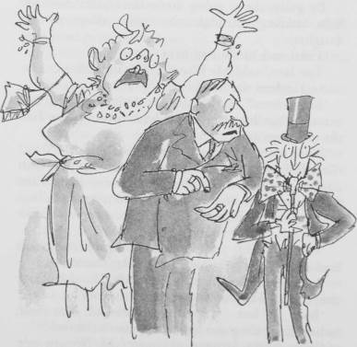
'Quite right, my dear,' said Mr Salt. 'Now see here, Wonka,' he added, 'I think you've gone just a shade too far this time, I do indeed. My daughter may be a bit of a frump - I don't mind admitting it - but that doesn't mean you can roast her to a crisp. I'll have you know I'm extremely cross about this, I really am.'
'Oh, don't be cross, my dear sir!' said Mr Wonka. I expect she'll turn up again sooner or later. She may not even have gone down at all. She may be stuck in the chute just below the entrance hole, and if that's the case, all you'll have to do is go in and pull her up again.'
Hearing this, both Mr and Mrs Salt dashed into the Nut Room and ran over to the hole in the floor and peered in.
'Veruca!' shouted Mrs Salt. 'Are you down there?!'
There was no answer.
Mrs Salt bent further forward to get a closer look. She was now kneeling right on the edge of the hole with her head down and her enormous behind sticking up in the air like a giant mushroom. It was a dangerous position to be in. She needed only one tiny little push ... one gentle nudge in the right place ... and that is exactly what the squirrels gave her! Over she toppled, into the hole head first, screeching like a parrot.
'Good gracious me!' said Mr Salt, as he watched his fat wife go tumbling down the hole, 'what a lot of rubbish there's going to be today!' He saw her disappearing into the darkness. 'What's it like down there, Angina?' he called out. He leaned further forward.
The squirrels rushed up behind him ...
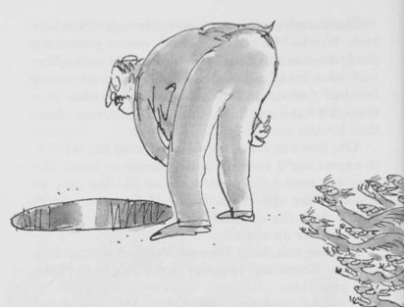
'Help!' he shouted.
But he was already toppling forward, and down the chute he went, just as his wife had done before him and his daughter.
'Oh dear!' cried Charlie, who was watching with the others through the door, 'what on earth's going to happen to them now?'
'I expect someone will catch them at the bottom of the chute,' said Mr Wonka.
'But what about the great fiery incinerator?' asked Charlie.
'They only light it every other day,' said Mr Wonka. 'Perhaps this is one of the days when they let it go out. You never know ... they might be lucky.'
'Ssshh!' said Grandpa Joe. 'Listen! Here comes another song!'
From far away down the corridor came the beating of drums. Then the singing began.
'Veruca Salt!' sang the Oompa-Loompas.
'Veruca Salt, the little brute,
Has just gone down the rubbish chute
(And as we very rightly thought
That in a case like this we ought
To see the thing completely through,
We've polished off her parents, too).
Down goes Veruca! Down the drain!
And here, perhaps, we should explain
That she will meet, as she descends,
A rather different set of friends
To those that she has left behind -
These won't be nearly so refined.
A fish head, for example, cut
This morning from a halibut.
"Hello! Good morning! How d'you do?
How nice to meet you! How are you?"
And then a little further down
A mass of others gather round:
A bacon rind, some rancid lard,
A loaf of bread gone stale and hard,
A steak that nobody could chew,
An oyster from an oyster stew,
Some liverwurst so old and grey
One smelled it from a mile away,
A rotten nut, a reeky pear,
A thing the cat left on the stair,
And lots of other things as well,
Each with a rather horrid smell.
These are Veruca's new-found friends
That she will meet as she descends,
And this is the price she has to pay
For going so very far astray.
But now, my dears, we think you might
Be wondering - is it really right
That every single bit of blame
And all the scolding and the shame
Should fall upon Veruca Salt?
Is she the only one at fault?
For though she's spoiled, and dreadfully so,
A girl can't spoil herself, you know.
Who spoiled her, then? Ah, who indeed?
Who pandered to her every need?
Who turned her into such a brat?
Who are the culprits? Who did that?
Alas! You needn't look so far
To find out who these sinners are.
They are (and this is very sad)
Her loving parents, MUM and DAD.
And that is why we're glad they fell
Into the rubbish chute as well.'
Chapter 25 - The Great Glass Lift
'I've never seen anything like it!' cried Mr Wonka. 'The children are disappearing like rabbits! But you mustn't worry about it! They'll all come out in the wash!'
Mr Wonka looked at the little group that stood beside him in the corridor. There were only two children left now - Mike Teavee and Charlie Bucket. And there were three grown-ups, Mr and Mrs Teavee and Grandpa Joe. 'Shall we move on?' Mr Wonka asked.
'Oh, yes!' cried Charlie and Grandpa Joe, both together.
'My feet are getting tired,' said Mike Teavee. 'I want to watch television.'
'If you're tired then we'd better take the lift,' said Mr Wonka. 'It's over here. Come on! In we go!' He skipped across the passage to a pair of double doors. The doors slid open.
The two children and the grown-ups went in.
'Now then,' cried Mr Wonka, 'which button shall we press first? Take your pick!'
Charlie Bucket stared around him in astonishment. This was the craziest lift he had ever seen.
There were buttons everywhere! The walls, and even the ceiling, were covered all over with rows and rows and rows of small, black push buttons! There must have been a thousand of them on each wall, and another thousand on the ceiling! And now Charlie noticed that every single button had a tiny printed label beside it telling you which room you would be taken to if you pressed it.
'This isn't just an ordinary up-and-down lift!' announced Mr Wonka proudly. 'This lift can go sideways and longways and slantways and any other way you can think of! It can visit any single room in the whole factory, no matter where it is! You simply press the button ... and zing! ... you're off!'
'Fantastic!' murmured Grandpa Joe. His eyes were shining with excitement as he stared at the rows of buttons.
'The whole lift is made of thick, clear glass!' Mr Wonka declared. 'Walls, doors, ceiling, floor, everything is made of glass so that you can see out!'
'But there's nothing to see,' said Mike Teavee.
'Choose a button!' said Mr Wonka. 'The two children may press one button each. So take your pick! Hurry up! In every room, something delicious and wonderful is being made.'
Quickly, Charlie started reading some of the labels alongside the buttons.
THE ROCK-CANDY MINE - 10,000 FEET DEEP, it said on one.
COKERNUT-ICE SKATING RINKS, it said on another.
Then ... STRAWBERRY-JUICE WATER PISTOLS.
TOFFEE-APPLE TREES FOR PLANTING OUT IN YOUR GARDEN - ALL SIZES.
EXPLODING SWEETS FOR YOUR ENEMIES.
LUMINOUS LOLLIES FOR EATING IN BED AT NIGHT.
MINT JUJUBES FOR THE BOY NEXT DOOR - THEY'LL GIVE HIM GREEN TEETH FOR A MONTH.
CAVITY-FILLING CARAMELS - NO MORE DENTISTS.
STICKJAW FOR TALKATIVE PARENTS.
WRIGGLE-SWEETS THAT WRIGGLE DELIGHTFULLY IN YOUR TUMMY AFTER SWALLOWING.
INVISIBLE CHOCOLATE BARS FOR EATING IN CLASS.
SUGAR-COATED PENCILS FOR SUCKING.
FIZZY LEMONADE SWIMMING POOLS.
MAGIC HAND-FUDGE - WHEN YOU HOLD IT IN YOUR HAND, YOU TASTE IT IN YOUR MOUTH.
RAINBOW DROPS - SUCK THEM AND YOU CAN SPIT IN SIX DIFFERENT COLOURS.
'Come on, come on!' cried Mr Wonka. 'We can't wait all day!'
'Isn't there a Television Room in all this lot?' asked Mike Teavee.
'Certainly there's a television room,' Mr Wonka said. 'That button over there.' He pointed with his finger. Everybody looked. TELEVISION CHOCOLATE, it said on the tiny label beside the button.
'Whoopee!' shouted Mike Teavee. 'That's for me!' He stuck out his thumb and pressed the button. Instantly, there was a tremendous whizzing noise. The doors clanged shut and the lift leaped away as though it had been stung by a wasp. But it leapt sideways. And all the passengers (except Mr Wonka, who was holding on to a strap from the ceiling) were flung off their feet on to the floor.
'Get up, get up!' cried Mr Wonka, roaring with laughter. But just as they were staggering to their feet, the lift changed direction and swerved violently round a corner. And over they went once more.
'Help!' shouted Mrs Teavee.
'Take my hand, madam,' said Mr Wonka gallantly. 'There you are! Now grab this strap! Everybody grab a strap. The journey's not over yet!'
Old Grandpa Joe staggered to his feet and caught hold of a strap. Little Charlie, who couldn't possibly reach as high as that, put his arms around Grandpa Joe's legs and hung on tight.
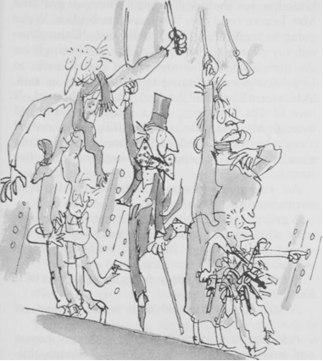
The lift rushed on at the speed of a rocket. Now it was beginning to climb. It was shooting up and up and up on a steep slanty course as if it were climbing a very steep hill. Then suddenly, as though it had come to the top of the hill and gone over a precipice, it dropped like a stone and Charlie felt his tummy coming right up into his throat, and Grandpa Joe shouted, 'Yippee! Here we go!' and Mrs Teavee cried out, 'The rope has broken! We're going to crash!' And Mr Wonka said, 'Calm yourself, my dear lady,' and patted her comfortingly on the arm. And then Grandpa Joe looked down at Charlie who was clinging to his legs, and he said, 'Are you all right, Charlie?' Charlie shouted, 'I love it! It's like being on a roller coaster!' And through the glass walls of the lift, as it rushed along, they caught sudden glimpses of strange and wonderful things going on in some of the other rooms:
An enormous spout with brown sticky stuff oozing out of it on to the floor ...
A great, craggy mountain made entirely of fudge, with Oompa-Loompas (all roped together for safety) hacking huge hunks of fudge out of its sides ...
A machine with white powder spraying out of it like a snowstorm ...
A lake of hot caramel with steam coming off it...
A village of Oompa-Loompas, with tiny houses and streets and hundreds of Oompa-Loompa children no more than four inches high playing in the streets ...
And now the lift began flattening out again, but it seemed to be going faster than ever, and Charlie could hear the scream of the wind outside as it hurtled forward ... and it twisted ... and it turned ... and it went up ... and it went down ... and ...
'I'm going to be sick!' yelled Mrs Teavee, turning green in the face.
'Please don't be sick,' said Mr Wonka.
'Try and stop me!' said Mrs Teavee.
'Then you'd better take this,' said Mr Wonka, and he swept his magnificent black top hat off his head, and held it out, upside down, in front of Mrs Teavee's mouth.
'Make this awful thing stop!' ordered Mr Teavee.
'Can't do that,' said Mr Wonka. 'It won't stop till we get there. I only hope no one's using the other lift at this moment.'
'What other lift?' screamed Mrs Teavee.
'The one that goes the opposite way on the same track as this one,' said Mr Wonka.
'Holy mackerel!' cried Mr Teavee. 'You mean we might have a collision?'
'I've always been lucky so far,' said Mr Wonka.
'Now I am going to be sick!' yelled Mrs Teavee.
'No, no!' said Mr Wonka. 'Not now! We're nearly there! Don't spoil my hat!'
The next moment, there was a screaming of brakes, and the lift began to slow down. Then it stopped altogether.
'Some ride!' said Mr Teavee, wiping his great sweaty face with a handkerchief.
'Never again!' gasped Mrs Teavee. And then the doors of the lift slid open and Mr Wonka said, 'Just a minute now! Listen to me! I want everybody to be very careful in this room. There is dangerous stuff around in here and you must not tamper with it.'

Chapter 26 - The Television-Chocolate Room
The Teavee family, together with Charlie and Grandpa Joe, stepped out of the lift into a room so dazzlingly bright and dazzlingly white that they screwed up their eyes in pain and stopped walking. Mr Wonka handed each of them a pair of dark glasses and said, 'Put these on quick! And don't take them off in here whatever you do! This light could blind you!'
As soon as Charlie had his dark glasses on, he was able to look around him in comfort. He saw a long narrow room. The room was painted white all over. Even the floor was white, and there wasn't a speck of dust anywhere. From the ceiling, huge lamps hung down and bathed the room in a brilliant blue-white light. The room was completely bare except at the far ends. At one of these ends there was an enormous camera on wheels, and a whole army of Oompa-Loompas was clustering around it, oiling its joints and adjusting its knobs and polishing its great glass lens. The Oompa- Loompas were all dressed in the most extraordinary way. They were wearing bright-red space suits, complete with helmets and goggles at least they looked like space suits - and they were working in complete silence. Watching them, Charlie experienced a queer sense of danger. There was something dangerous about this whole business, and the Oompa-Loompas knew it. There was no chattering or singing among them here, and they moved about over the huge black camera slowly and carefully in their scarlet space suits.
At the other end of the room, about fifty paces away from the camera, a single Oompa-Loompa (also wearing a space suit) was sitting at a black table gazing at the screen of a very large television set.
'Here we go!' cried Mr Wonka, hopping up and down with excitement. 'This is the Testing Room for my very latest and greatest invention - Television Chocolate!'
'But what is Television Chocolate?' asked Mike Teavee.
'Good heavens, child, stop interrupting me!' said Mr Wonka. 'It works by television. I don't like television myself. I suppose it's all right in small doses, but children never seem to be able to take it in small doses. They want to sit there all day long staring and staring at the screen ...'
'That's me!' said Mike Teavee.
'Shut up!' said Mr Teavee.
'Thank you,' said Mr Wonka. 'I shall now tell you how this amazing television set of mine works. But first of all, do you know how ordinary television works? It is very simple. At one end, where the picture is being taken, you have a large cine camera and you start photographing something. The photographs are then split up into millions of tiny little pieces which are so small that you can't see them, and these little pieces are shot out into the sky by electricity. In the sky, they go whizzing around all over the place until suddenly they hit the antenna on the roof of somebody's house.
'They then go flashing down the wire that leads right into the back of the television set, and in there they get jiggled and joggled around until at last every single one of those millions of tiny pieces is fitted back into its right place (just like a jigsaw puzzle), and presto! the photograph appears on the screen ...'
'That isn't exactly how it works,' Mike Teavee said.
'I am a little deaf in my left ear,' Mr Wonka said. 'You must forgive me if I don't hear everything you say.'
'I said, that isn't exactly how it works!' shouted Mike Teavee.
'You're a nice boy,' Mr Wonka said, 'but you talk too much. Now then! The very first time I saw ordinary television working, I was struck by a tremendous idea. "Look here!" I shouted. "If these people can break up a photograph into millions of pieces and send the pieces whizzing through the air and then put them together again at the other end, why can't I do the same thing with a bar of chocolate? Why can't I send a real bar of chocolate whizzing through the air in tiny pieces and then put the pieces together at the other end, all ready to be eaten?"'
'Impossible!' said Mike Teavee.
'You think so?' cried Mr Wonka. 'Well, watch this! I shall now send a bar of my very best chocolate from one end of this room to the other - by television! Get ready, there! Bring in the chocolate!'
Immediately, six Oompa-Loompas marched forward carrying on their shoulders the most enormous bar of chocolate Charlie had ever seen. It was about the size of the mattress he slept on at home.
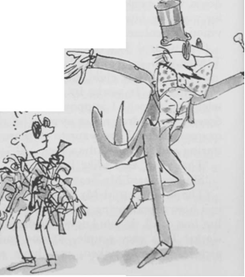
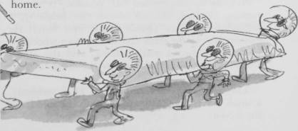
'It has to be big,' Mr Wonka explained, 'because whenever you send something by television, it always comes out much smaller than it was when it went in. Even with ordinary television, when you photograph a big man, he never comes out on your screen any taller than a pencil, does he? Here we go, then! Get ready! No, no! Stop! Hold everything! You there! Mike Teavee! Stand back! You're too close to the camera! There are dangerous rays coming out of that thing! They could break you up into a million tiny pieces in one second! That's why the Oompa-Loompas are wearing space suits! The suits protect them! All right! That's better! Now, then! Switch on!'
One of the Oompa-Loompas caught hold of a large switch and pulled it down.
There was a blinding flash.
'The chocolate's gone!' shouted Grandpa Joe, waving his arms.
He was quite right! The whole enormous bar of chocolate had disappeared completely into thin air!
'It's on its way!' cried Mr Wonka. 'It is now rushing through the air above our heads in a million tiny pieces. Quick! Come over here!' He dashed over to the other end of the room where the large television set was standing, and the others followed him. 'Watch the screen!' he cried. 'Here it comes! Look!'
The screen flickered and lit up. Then suddenly, a small bar of chocolate appeared in the middle of the screen.
'Take it!' shouted Mr Wonka, growing more and more excited.
'How can you take it?' asked Mike Teavee, laughing. 'It's just a picture on a television screen!'
'Charlie Bucket!' cried Mr Wonka. 'You take it! Reach out and grab it!'
Charlie put out his hand and touched the screen, and suddenly, miraculously, the bar of chocolate came away in his fingers. He was so surprised he nearly dropped it.
'Eat it!' shouted Mr Wonka. 'Go on and eat it! It'll be delicious! It's the same bar! It's got smaller on the journey, that's all!'
'It's absolutely fantastic!' gasped Grandpa Joe. 'It's ... it's ... it's a miracle!'
'Just imagine,' cried Mr Wonka, 'when I start using this across the country ... you'll be sitting at home watching television and suddenly a commercial will flash on to the screen and a voice will say, "EAT WONKA'S CHOCOLATES! THEY'RE THE BEST IN THE WORLD! IF YOU DON'T BELIEVE US, TRY ONE FOR YOURSELF – NOW!" And you simply reach out and take one! How about that, eh?'
'Terrific!' cried Grandpa Joe. 'It will change the world!'

Chapter 27 - Mike Teavee is Sent by Television
Mike Teavee was even more excited than Grandpa Joe at seeing a bar of chocolate being sent by television. 'But Mr Wonka,' he shouted, 'can you send other things through the air in the same way? Breakfast cereal, for instance?'
'Oh, my sainted aunt!' cried Mr Wonka. 'Don't mention that disgusting stuff in front of me! Do you know what breakfast cereal is made of? It's made of all those little curly wooden shavings you find in pencil sharpeners!'
'But could you send it by television if you wanted to, as you do chocolate?' asked Mike Teavee.
'Of course I could!'
'And what about people?' asked Mike Teavee. 'Could you send a real live person from one place to another in the same way?'
'A person!' cried Mr Wonka. 'Are you off your rocker?'
'But could it be done?'
'Good heavens, child, I really don't know ... I suppose it could ... yes. I'm pretty sure it could ... of course it could ... I wouldn't like to risk it, though ... it might have some very nasty results ...'
But Mike Teavee was already off and running. The moment he heard Mr Wonka saying, 'I'm pretty sure it could ... of course it could,' he turned away and started running as fast as he could towards the other end of the room where the great camera was standing. 'Look at me!' he shouted as he ran. 'I'm going to be the first person in the world to be sent by television!'
'No, no, no, no!' cried Mr Wonka.
'Mike!' screamed Mrs Teavee. 'Stop! Come back! You'll be turned into a million tiny pieces!'
But there was no stopping Mike Teavee now. The crazy boy rushed on, and when he reached the enormous camera, he jumped straight for the switch, scattering Oompa-Loompas right and left as he went.
'See you later, alligator!' he shouted, and he pulled down the switch, and as he did so, he leaped out into the full glare of the mighty lens.
There was a blinding flash.
Then there was silence.
Then Mrs Teavee ran forward ... but she stopped dead in the middle of the room ... and she stood there ... she stood staring at the place where her son had been ... and her great red mouth opened wide and she screamed, 'He's gone! He's gone!'
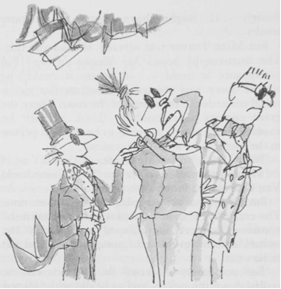
'Great heavens, he has gone!' shouted Mr Teavee.
Mr Wonka hurried forward and placed a hand gently on Mrs Teavee's shoulder. 'We shall have to hope for the best,' he said. 'We must pray that your little boy will come out unharmed at the other end.'
'Mike!' screamed Mrs Teavee, clasping her head in her hands. 'Where are you?'
'I'll tell you where he is,' said Mr Teavee, 'he's whizzing around above our heads in a million tiny pieces!'
'Don't talk about it!' wailed Mrs Teavee.
'We must watch the television set,' said Mr Wonka. 'He may come through any moment.'
Mr and Mrs Teavee and Grandpa Joe and little Charlie and Mr Wonka all gathered round the television and stared tensely at the screen. The screen was quite blank.
'He's taking a heck of a long time to come across,' said Mr Teavee, wiping his brow.
'Oh dear, oh dear,' said Mr Wonka, 'I do hope that no part of him gets left behind.'
'What on earth do you mean?' asked Mr Teavee sharply.
I don't wish to alarm you,' said Mr Wonka, 'but it does sometimes happen that only about half the little pieces find their way into the television set. It happened last week. I don't know why, but the result was that only half a bar of chocolate came through.'
Mrs Teavee let out a scream of horror. 'You mean only a half of Mike is coming back to us?' she cried.
'Let's hope it's the top half,' said Mr Teavee.
'Hold everything!' said Mr Wonka. 'Watch the screen! Something's happening!'
The screen had suddenly begun to flicker.
Then some wavy lines appeared.
Mr Wonka adjusted one of the knobs and the wavy lines went away.
And now, very slowly, the screen began to get brighter and brighter.
'Here he comes!' yelled Mr Wonka. 'Yes, that's him all right!'
'Is he all in one piece?' cried Mrs Teavee.
'I'm not sure,' said Mr Wonka. 'It's too early to tell.'
Faintly at first, but becoming clearer and clearer every second, the picture of Mike Teavee appeared on the screen. He was standing up and waving at the audience and grinning from ear to ear.
'But he's a midget!' shouted Mr Teavee.
'Mike,' cried Mrs Teavee, 'are you all right? Are there any bits of you missing?'
'Isn't he going to get any bigger?' shouted Mr Teavee.
'Talk to me, Mike!' cried Mrs Teavee. 'Say something! Tell me you're all right!'
A tiny little voice, no louder than the squeaking of a mouse, came out of the television set. 'Hi, Mum!' it said. 'Hi, Pop! Look at me! I'm the first person ever to be sent by television!'
'Grab him!' ordered Mr Wonka. 'Quick!'
Mrs Teavee shot out a hand and picked the tiny figure of Mike Teavee out of the screen.
'Hooray!' cried Mr Wonka. 'He's all in one piece! He's completely unharmed!'
'You call that unharmed?' snapped Mrs Teavee, peering at the little speck of a boy who was now running to and fro across the palm of her hand, waving his pistols in the air.
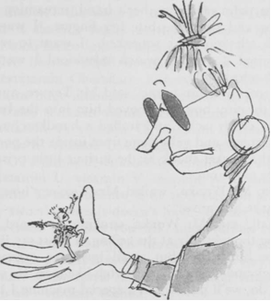
He was certainly not more than an inch tall.
'He's shrunk!' said Mr Teavee.
'Of course he's shrunk,' said Mr Wonka. 'What did you expect?'
'This is terrible!' wailed Mrs Teavee. 'What are we going to do?'
And Mr Teavee said, 'We can't send him back to school like this! He'll get trodden on! He'll get squashed!'
'He won't be able to do anything!' cried Mrs Teavee.
'Oh, yes I will!' squeaked the tiny voice of Mike Teavee. 'I'll still be able to watch television!'
'Never again,' shouted Mr Teavee. 'I'm throwing the television set right out the window the moment we get home. I've had enough of television!'
When he heard this, Mike Teavee threw into a terrible tantrum. He started jumping up and down on the palm of his mother's hand, screaming and yelling and trying to bite her fingers. 'I want to watch television!' he squeaked. 'I want to watch television! I want to watch television! I want to watch television!'
'Here! Give him to me!' said Mr Teavee, and he took the tiny boy and shoved him into the breast pocket of his jacket and stuffed a handkerchief on top. Squeals and yells came from inside the pocket, and the pocket shook as the furious little prisoner fought to get out.
'Oh, Mr Wonka,' wailed Mrs Teavee, 'how can we make him grow?'
'Well,' said Mr Wonka, stroking his beard and gazing thoughtfully at the ceiling, 'I must say that's a wee bit tricky. But small boys are extremely springy and elastic. They stretch like mad. So what we'll do, we'll put him in a special machine I have for testing the stretchiness of chewing-gum! Maybe that will bring him back to what he was.'
'Oh, thank you!' said Mrs Teavee.
'Don't mention it, dear lady.'
'How far d'you think he'll stretch?' asked Mr Teavee.
'Maybe miles,' said Mr Wonka. 'Who knows? But he's going to be awfully thin. Everything gets thinner when you stretch it.'
'You mean like chewing-gum?' asked Mr Teavee.
'Exactly.'
'How thin will he be?' asked Mrs Teavee anxiously.
'I haven't the foggiest idea,' said Mr Wonka. 'And it doesn't really matter, anyway, because we'll soon fatten him up again. All we'll have to do is give him a triple overdose of my wonderful Supervitamin Chocolate. Supervitamin Chocolate contains huge amounts of vitamin A and vitamin B. It also contains vitamin C, vitamin D, vitamin E, vitamin F, vitamin G, vitamin I, vitamin J, vitamin K, vitamin L, vitamin M, vitamin N, vitamin O, vitamin P, vitamin Q, vitamin R, vitamin T, vitamin U, vitamin V, vitamin W, vitamin X, vitamin Y, and, believe it or not, vitamin Z! The only two vitamins it doesn't have in it are vitamin S, because it makes you sick, and vitamin H, because it makes you grow horns on the top of your head, like a bull. But it does have in it a very small amount of the rarest and most magical vitamin of them all - vitamin Wonka.'
'And what will that do to him?' asked Mr Teavee anxiously.
'It'll make his toes grow out until they're as long as his fingers ...'
'Oh, no!' cried Mrs Teavee.
'Don't be silly,' said Mr Wonka. 'It's most useful. He'll be able to play the piano with his feet.'
'But Mr Wonka.'
'No arguments, please,' said Mr Wonka. He turned away and clicked his fingers three times in the air. An Oompa-Loompa appeared immediately and stood beside him. 'Follow these orders,' said Mr Wonka, handing the Oompa-Loompa a piece of paper on which he had written full instructions. 'And you'll find the boy in his father's pocket. Off you go! Good-bye, Mr Teavee! Good-bye, Mrs Teavee! And please don't look so worried! They all come out in the wash, you know; every one of them.'
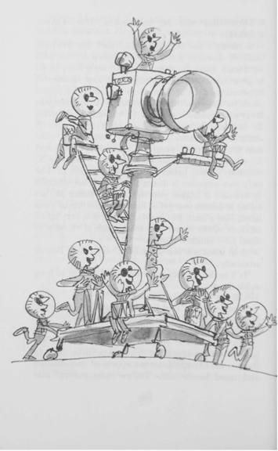
At the end of the room, the Oompa-Loompas around the giant camera were already beating their tiny drums and beginning to jog up and down to the rhythm.
'There they go again!' said Mr Wonka. 'I'm afraid you can't stop them singing.'
Little Charlie caught Grandpa Joe's hand, and the two of them stood beside Mr Wonka in the middle of the long bright room, listening to the Oompa-Loompas. And this is what they sang:
'The most important thing we've learned,
So far as children are concerned,
Is never, never, NEVER let
Them near your television set -
Or better still, just don't install
The idiotic thing at all.
In almost every house we've been,
We've watched them gaping at the screen.
They loll and slop and lounge about,
And stare until their eyes pop out.
Last week in someone's place we saw
A dozen eyeballs on the floor,
They sit and stare and stare and sit
Until they're hypnotized by it,
Until they're absolutely drunk
With all that shocking ghastly junk.
Oh yes, we know it keeps them still,
They don't climb out the window sill,
They never fight or kick or punch,
They leave you free to cook the lunch
And wash the dishes in the sink –
But did you ever stop to think,
To wonder just exactly what
This does to your beloved tot?
IT ROTS THE SENSES IN THE HEAD!
IT KILLS IMAGINATION DEAD!
IT CLOGS AND CLUTTERS UP THE MIND!
IT MAKES A CHILD SO DULL AND BLIND
HE CAN NO LONGER UNDERSTAND
A FANTASY, A FAIRYLAND!
HIS BRAIN BECOMES AS SOFT AS CHEESE!
HIS POWERS OF THINKING RUST AND FREEZE!
HE CANNOT THINK - HE ONLY SEES!
"All right!" you'll cry. "All right!" you'll say,
"But if we take the set away,
What shall we do to entertain
Our darling children! Please explain!"
We'll answer this by asking you,
"What used the darling ones to do?
How used they keep themselves contented
Before this monster was invented?"
Have you forgotten? Don't you know?
We'll say it very loud and slow:
THEY ... USED ... TO ... READ! They'd READ and READ,
AND READ and READ, and then proceed
TO READ some more. Great Scott! Gadzooks!
One half their lives was reading books!
The nursery shelves held books galore!
Books cluttered up the nursery floor!
And in the bedroom, by the bed,
More books were waiting to be read!
Such wondrous, fine, fantastic tales
Of dragons, gypsies, queens, and whales
And treasure isles, and distant shores
Where smugglers rowed with muffled oars,
And pirates wearing purple pants,
And sailing ships and elephants,
And cannibals crouching round the pot,
Stirring away at something hot.
It smells so good, what can it be?
Good gracious, it's Penelope.
The younger ones had Beatrix Potter
With Mr Toad, the dirty rotter,
And Squirrel Nutkin, Pigling Bland,
And Mrs Tiggy-Winkle and-
Just How The Camel Got His Hump,
And How The Monkey Lost His Rump,
And Mr Toad, and bless my soul,
There's Mr Rat and Mr Mole –
Oh, books, what books they used to know,
Those children living long ago!
So please, oh please, we beg, we pray,
Go throw your TV set away,
And in its place you can
A lovely bookshelf on the wall.
Then fill the shelves with lots of books,
Ignoring all the dirty looks,
The screams and yells, the bites and kicks,
And children hitting you with sticks
Fear not, because we promise you
That, in about a week or two
Of having nothing else to do,
They'll now begin to feel the need
Of having something good to read.
And once they start - oh boy, oh boy!
You watch the slowly growing joy
That fills their hearts. They'll grow so keen
They'll wonder what they'd ever seen
In that ridiculous machine,
That nauseating, foul, unclean.
Repulsive television screen!
And later, each and every kid
Will love you more for what you did.
P.S. Regarding Mike Teavee,
We very much regret that we
Shall simply have to wait and see
If we can get him back his height.
But if we can't - it serves him right.'
Chapter 28 - Only Charlie Left
'Which room shall it be next?' said Mr Wonka as he turned away and darted into the lift. 'Come on! Hurry up! We must get going! And how many children are there left now?'
Little Charlie looked at Grandpa Joe, and Grandpa Joe looked back at little Charlie.
'But Mr Wonka,' Grandpa Joe called after him, 'there's ... there's only Charlie left now.'
Mr Wonka swung round and stared at Charlie.
There was a silence. Charlie stood there holding tightly on to Grandpa Joe's hand.
'You mean you're the only one left?' Mr Wonka said, pretending to be surprised.
'Why, yes,' whispered Charlie. 'Yes.'
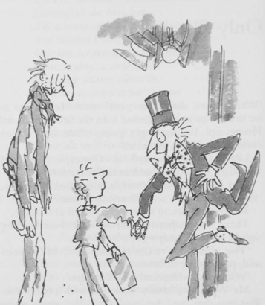
Mr Wonka suddenly exploded with excitement. 'But my dear boy,' he cried out, 'that means you've won!' He rushed out of the lift and started shaking Charlie's hand so furiously it nearly came off. 'Oh, I do congratulate you!' he cried. 'I really do! I'm absolutely delighted! It couldn't be better! How wonderful this is! I had a hunch, you know, right from the beginning, that it was going to be you! Well done, Charlie, well done! This is terrific! Now the fun is really going to start! But we mustn't dilly! We mustn't dally! There's even less time to lose now than there was before! We have an enormous number of things to do before the day is out! Just think of the arrangements that have to be made! And the people we have to fetch! But luckily for us, we have the great glass lift to speed things up! Jump in, my dear Charlie, jump in! You too, Grandpa Joe, sir! No, no, after you! That's the way! Now then! This time I shall choose the button we are going to press!' Mr Wonka's bright twinkling blue eyes rested for a moment on Charlie's face.
Something crazy is going to happen now, Charlie thought. But he wasn't frightened. He wasn't even nervous. He was just terrifically excited. And so was Grandpa Joe. The old man's face was shining with excitement as he watched every move that Mr Wonka made. Mr Wonka was reaching for a button high up on the glass ceiling of the lift. Charlie and Grandpa Joe both craned their necks to read what it said on the little label beside the button. It said ... UP AND OUT.
'Up and out,' thought Charlie. 'What sort of a room is that?'
Mr Wonka pressed the button.
The glass doors closed.
'Hold on!' cried Mr Wonka.
Then WHAM! The lift shot straight up like a rocket! 'Yippee!' shouted Grandpa Joe.
Charlie was clinging to Grandpa Joe's legs and Mr Wonka was holding on to a strap from the ceiling, and up they went, up, up, up, straight up this time, with no twistings or turnings, and Charlie could hear the whistling of the air outside as the lift went faster and faster. 'Yippee!' shouted Grandpa Joe again. 'Yippee! Here we go!'
'Faster!' cried Mr Wonka, banging the wall of the lift with his hand. 'Faster! Faster! If we don't go any faster than this, we shall never get through!'
'Through what?' shouted Grandpa Joe. 'What have we got to get through?'
'Ah-ha!' cried Mr Wonka, 'you wait and see! I've been longing to press this button for years! But I've never done it until now! I was tempted many times! Oh, yes, I was tempted! But I couldn't bear the thought of making a great big hole in the roof of the factory! Here we go, boys! Up and out!'
'But you don't mean ...' shouted Grandpa Joe, '... you don't really mean that this lift ...'
'Oh yes, I do!' answered Mr Wonka. 'You wait and see! Up and out!'
'But ... but ... but ... it's made of glass!' shouted Grandpa Joe. 'It'll break into a million pieces!'
'I suppose it might,' said Mr Wonka, cheerful as ever, 'but it's pretty thick glass, all the same.'
The lift rushed on, going up and up and up, faster and faster and faster ...
Then suddenly, CRASH! - and the most tremendous noise of splintering wood and broken tiles came from directly above their heads, and Grandpa Joe shouted, 'Help! It's the end! We're done for!' and Mr Wonka said, 'No, we're not! We're through! We're out!' Sure enough, the lift had shot right up through the roof of the factory and was now rising into the sky like a rocket, and the sunshine was pouring in through the glass roof. In five seconds they were a thousand feet up in the sky.
'The lift's gone mad!' shouted Grandpa Joe.
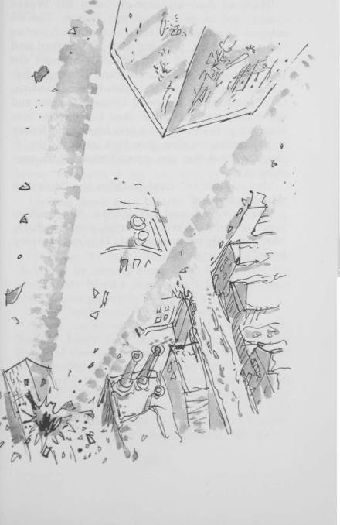
'Have no fear, my dear sir,' said Mr Wonka calmly, and he pressed another button. The lift stopped. It stopped and hung in mid-air, hovering like a helicopter, hovering over the factory and over the very town itself which lay spread out below them like a picture postcard! Looking down through the glass floor on which he was standing, Charlie could see the small far-away houses and the streets and the snow that lay thickly over everything. It was an eerie and frightening feeling to be standing on clear glass high up in the sky. It made you feel that you weren't standing on anything at all.
'Are we all right?' cried Grandpa Joe. 'How does this thing stay up?'
'Sugar power!' said Mr Wonka. 'One million sugar power! Oh, look,' he cried, pointing down, 'there go the other children! They're returning home!'
Chapter 29 - The Other Children Go Home
'We must go down and take a look at our little friends before we do anything else,' said Mr Wonka. He pressed a different button, and the lift dropped lower, and soon it was hovering just above the entrance gates to the factory.
Looking down now, Charlie could see the children and their parents standing in a little group just inside the gates.
'I can only see three,' he said. 'Who's missing?'
'I expect it's Mike Teavee,' Mr Wonka said. 'But he'll be coming along soon. Do you see the trucks?' Mr Wonka pointed to a line of gigantic covered vans parked in a line near by.
'Yes,' Charlie said. 'What are they for?'
'Don't you remember what it said on the Golden Tickets? Every child goes home with a lifetime's supply of sweets. There's one truckload for each of them, loaded to the brim. Ah-ha,' Mr Wonka went on, 'there goes our friend Augustus Gloop! D'you see him? He's getting into the first truck with his mother and father!'
'You mean he's really all right?' asked Charlie, astonished. 'Even after going up that awful pipe?'
'He's very much all right,' said Mr Wonka.
'He's changed!' said Grandpa Joe, peering down through the glass wall of the elevator. 'He used to be fat! Now he's thin as a straw!'
'Of course he's changed,' said Mr Wonka, laughing. 'He got squeezed in the pipe. Don't you remember? And look! There goes Miss Violet Beauregarde, the great gum-chewer! It seems as though they managed to de-juice her after all. I'm so glad. And how healthy she looks! Much better than before!'
'But she's purple in the face!' cried Grandpa Joe.
'So she is,' said Mr Wonka. 'Ah, well, there's nothing we can do about that.'
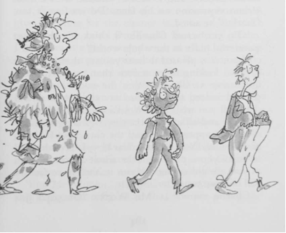
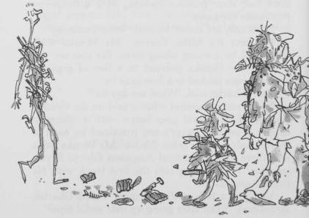
'Good gracious!' cried Charlie. 'Look at poor Veruca Salt and Mr Salt and Mrs Salt! They're simply covered with rubbish!'
'And here comes Mike Teavee!' said Grandpa Joe. 'Good heavens! What have they done to him? He's about ten feet tall and thin as a wire!'
'They've overstretched him on the gum-stretching machine,' said Mr Wonka. 'How very careless.'
'But how dreadful for him!' cried Charlie.
'Nonsense,' said Mr Wonka, 'he's very lucky. Every basketball team in the country will be trying to get him. But now,' he added, 'it is time we left these four silly children. I have something very important to talk to you about, my dear Charlie.' Mr Wonka pressed another button, and the lift swung upwards into the sky.

Chapter 30 - Charlie's Chocolate Factory
The great glass lift was now hovering high over the town. Inside the lift stood Mr Wonka, Grandpa Joe, and little Charlie.
'How I love my chocolate factory,' said Mr Wonka, gazing down. Then he paused, and he turned around and looked at Charlie with a most serious expression on his face. 'Do you love it too, Charlie?' he asked.
'Oh, yes,' cried Charlie, 'I think it's the most wonderful place in the whole world!'
'I am very pleased to hear you say that,' said Mr Wonka, looking more serious than ever. He went on staring at Charlie. 'Yes,' he said, 'I am very pleased indeed to hear you say that. And now I shall tell you why.' Mr Wonka cocked his head to one side and all at once the tiny twinkling wrinkles of a smile appeared around the corners of his eyes, and he said, 'You see, my dear boy, I have decided to make you a present of the whole place. As soon as you are old enough to run it, the entire factory will become yours.'
Charlie stared at Mr Wonka. Grandpa Joe opened his mouth to speak, but no words came out.
'It's quite true,' Mr Wonka said, smiling broadly now. 'I really am giving it to you. That's all right, isn't it?'
'Giving it to him?' gasped Grandpa Joe. 'You must be joking.'
'I'm not joking, sir. I'm deadly serious.'
'But ... but ... why should you want to give your factory to little Charlie?'
'Listen,' Mr Wonka said, 'I'm an old man. I'm much older than you think. I can't go on for ever. I've got no children of my own, no family at all. So who is going to run the factory when I get too old to do it myself? Someone's got to keep it going - if only for the sake of the Oompa-Loompas. Mind you, there are thousands of clever men who would give anything for the chance to come in and take over from me, but I don't want that sort of person. I don't want a grown-up person at all. A grown-up won't listen to me; he won't learn. He will try to do things his own way and not mine. So I have to have a child. I want a good sensible loving child, one to whom I can tell all my most precious sweet-making secrets - while I am still alive.'
'So that is why you sent out the Golden Tickets!' cried Charlie.
'Exactly!' said Mr Wonka. 'I decided to invite five children to the factory, and the one I liked best at the end of the day would be the winner!'
'But Mr Wonka,' stammered Grandpa Joe, 'do you really and truly mean that you are giving the whole of this enormous factory to little Charlie? After all...'
'There's no time for arguments!' cried Mr Wonka. 'We must go at once and fetch the rest of the family Charlie's father and his mother and anyone else that's around! They can all live in the factory from now on! They can all help to run it until Charlie is old enough to do it by himself! Where do you live, Charlie?'
Charlie peered down through the glass floor at the snow-covered houses that lay below. 'It's over there,' he said, pointing. 'It's that little cottage right on the edge of the town, the tiny little one ...'
'I see it!' cried Mr Wonka, and he pressed some more buttons and the lift shot down towards Charlie's house.
'I'm afraid my mother won't come with us,' Charlie said sadly.
'Why ever not?'
'Because she won't leave Grandma Josephine and Grandma Georgina and Grandpa George.'
'But they must come too.'
'They can't,' Charlie said. 'They're very old and they haven't been out of bed for twenty years.'
'Then we'll take the bed along as well, with them in it,' said Mr Wonka. 'There's plenty of room in this lift for a bed.'
'You couldn't get the bed out of the house,' said Grandpa Joe. 'It won't go through the door.'
'You mustn't despair!' cried Mr Wonka. 'Nothing is impossible! You watch!'
The lift was now hovering over the roof of the Buckets' little house.
'What are you going to do?' cried Charlie.
'I'm going right on in to fetch them,' said Mr Wonka.
'How?' asked Grandpa Joe.
'Through the roof,' said Mr Wonka, pressing another button.
'No!' shouted Charlie.
'Stop!' shouted Grandpa Joe.
CRASH went the lift, right down through the roof of the house into the old people's bedroom. Showers of dust and broken tiles and bits of wood and cockroaches and spiders and bricks and cement went raining down on the three old ones who were lying in bed, and each of them thought that the end of the world was come. Grandma Georgina fainted, Grandma Josephine dropped her false teeth, Grandpa George put his head under the blanket, and Mr and Mrs Bucket came rushing in from the next room.
'Save us!' cried Grandma Josephine.
'Calm yourself, my darling wife,' said Grandpa Joe, stepping out of the lift. 'It's only us.'
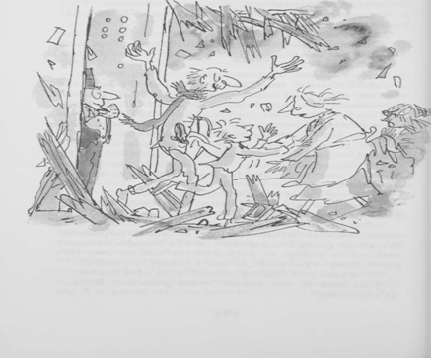
'Mother!' cried Charlie, rushing into Mrs Bucket's arms. 'Mother! Mother! Listen to what's happened! We're all going back to live in Mr Wonka's factory and we're going to help him to run it and he's given it all to me and ... and ... and ... and ...'
'What are you talking about?' said Mrs Bucket.
'Just look at our house!' cried poor Mr Bucket. 'It's in ruins!'
My dear sir,' said Mr Wonka, jumping forward and shaking Mr Bucket warmly by the hand, 'I'm so very glad to meet you. You mustn't worry about your house. From now on, you're never going to need it again, anyway.'
'Who is this crazy man?' screamed Grandma Josephine. 'He could have killed us all.'
'This,' said Grandpa Joe, 'is Mr Willy Wonka himself.'
It took quite a time for Grandpa Joe and Charlie to explain to everyone exactly what had been happening to them all day. And even then they all refused to ride back to the factory in the lift.
'I'd rather die in my bed!' shouted Grandma Josephine.
'So would I!' cried Grandma Georgina.
'I refuse to go!' announced Grandpa George.
So Mr Wonka and Grandpa Joe and Charlie, taking no notice of their screams, simply pushed the bed into the lift. They pushed Mr and Mrs Bucket in after it. Then they got in themselves. Mr Wonka pressed a button. The doors closed. Grandma Georgina screamed. And the lift rose up off the floor and shot through the hole in the roof, out into the open sky.
Charlie climbed on to the bed and tried to calm the three old people who were still petrified with fear. 'Please don't be frightened,' he said. 'It's quite safe. And we're going to the most wonderful place in the world!'
'Charlie's right,' said Grandpa Joe.
'Will there be anything to eat when we get there?' asked Grandma Josephine. I'm starving! The whole family is starving!'
'Anything to eat?' cried Charlie laughing. 'Oh, you just wait and see!'

