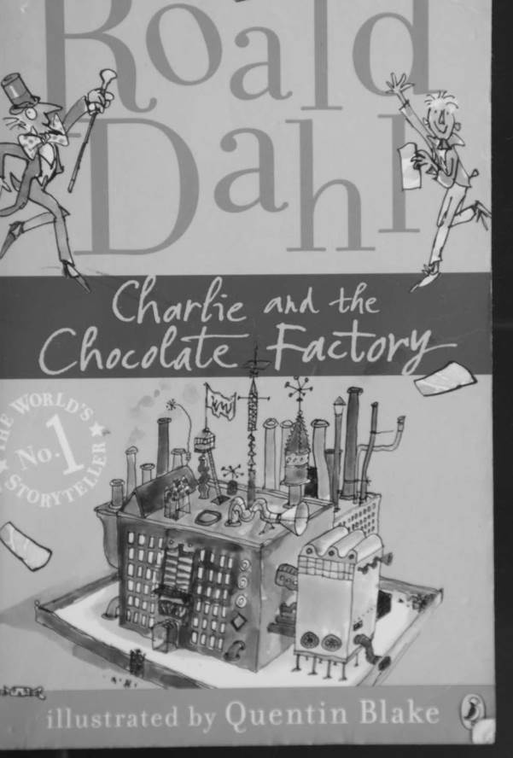

Charlie and the Chocolate Factory

by

Roald Dahl

This electronic copy of the original work is made under a Copyright Licensing Agency license by The Seeing Ear. It is for the personal use of a Print Disabled Person and may not be further copied, (including any electronic copying or transmission), or dealt with without permission, save as may be permitted by law.

Contents

Chapter 1 - Here Comes Charlie

Chapter 2 - Mr Willy Wonka's Factory

Chapter 3 - Mr Wonka and the Indian Prince

Chapter 4 - The Secret Workers

Chapter 5 - The Golden Tickets

Chapter 6 - The First Two Finders

Chapter 7 - Charlie's Birthday

Chapter 8 - Two More Golden Tickets Found

Chapter 9 - Grandpa Joe Takes a Gamble

Chapter 10 - The Family Begins to Starve

Chapter 11 - The Miracle

Chapter 12 - What It Said on the Golden Ticket

Chapter 13 - The Big Day Arrives

Chapter 14 - Mr Willy Wonka

Chapter 15 - The Chocolate Room

Chapter 16 - The Oompa-Loompas

Chapter 17 - Augustus Gloop Goes up the Pipe

Chapter 18 - Down the Chocolate River

Chapter 19 - The Inventing Room - Everlasting Gobstoppers and Hair Toffee

Chapter 20 - The Great Gum Machine

Chapter 21 - Good-bye Violet

Chapter 22 - Along the Corridor

Chapter 23 - Square Sweets That Look Round

Chapter 24 - Veruca in the Nut Room

Chapter 25 - The Great Glass Lift

Chapter 26 - The Television-Chocolate Room

Chapter 27 - Mike Teavee is Sent by Television

Chapter 28 - Only Charlie Left

Chapter 29 - The Other Children Go Home

Chapter 30 - Charlie's Chocolate Factory

Chapter 1 - Here Comes Charlie

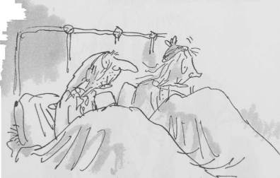

These two very old people are the father and mother of Mr Bucket. Their names are Grandpa Joe and Grandma Josephine.

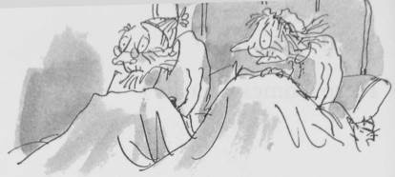

And these two very old people are the father and mother of Mrs Bucket. Their names are Grandpa George and Grandma Georgina.

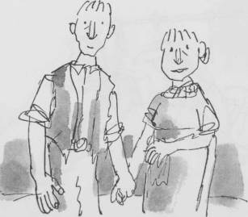

This is Mr Bucket. This is Mrs Bucket. Mr and Mrs Bucket have a small boy whose name is Charlie Bucket.

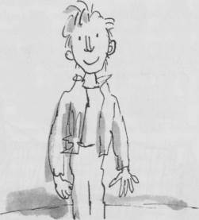

This is Charlie.

How d'you do? And how d'you do? And how d'you do again? He is pleased to meet you.

The whole of this family - the six grown-ups (count them) and little Charlie Bucket live together in a small wooden house on the edge of a great town.

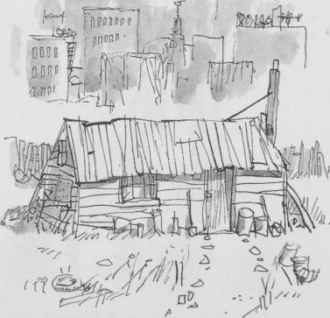

The house wasn't nearly large enough for so many people, and life was extremely uncomfortable for them all. There were only two rooms in the place altogether, and there was only one bed. The bed was given to the four old grandparents because they were so old and tired. They were so tired, they never got out of it.

Grandpa Joe and Grandma Josephine on this side, Grandpa George and Grandma Georgina on this side.

Mr and Mrs Bucket and little Charlie Bucket slept in the other room, upon mattresses on the floor.

In the summertime, this wasn't too bad, but in the winter, freezing cold draughts blew across the floor all night long, and it was awful.

There wasn't any question of them being able to buy a better house - or even one more bed to sleep in. They were far too poor for that.

Mr Bucket was the only person in the family with a job. He worked in a toothpaste factory, where he sat all day long at a bench and screwed the little caps on to the tops of the tubes of toothpaste after the tubes had been filled. But a toothpaste cap-screwer is never paid very much money, and poor Mr Bucket, however hard he worked, and however fast he screwed on the caps, was never able to make enough to buy one half of the things that so large a family needed. There wasn't even enough money to buy proper food for them all. The only meals they could afford were bread and margarine for breakfast, boiled potatoes and cabbage for lunch, and cabbage soup for supper.

Sundays were a bit better. They all looked forward to Sundays because then, although they had exactly the same, everyone was allowed a second helping.

The Buckets, of course, didn't starve, but every one of them - the two old grandfathers, the two old grandmothers, Charlie's father, Charlie's mother, and especially little Charlie himself - went about from morning till night with a horrible empty feeling in their tummies.

Charlie felt it worst of all. And although his father and mother often went without their own share of lunch or supper so that they could give it to him, it still wasn't nearly enough for a growing boy. He desperately wanted something more filling and satisfying than cabbage and cabbage soup. The one thing he longed for more than anything else was ... CHOCOLATE.

Walking to school in the mornings, Charlie could see great slabs of chocolate piled up high in the shop windows, and he would stop and stare and press his nose against the glass, his mouth watering like mad. Many times a day, he would see other children taking bars of creamy chocolate out of their pockets and munching them greedily, and that, of course, was pure torture.

Only once a year, on his birthday, did Charlie Bucket ever get to taste a bit of chocolate. The whole family saved up their money for that special occasion, and when the great day arrived, Charlie was always presented with one small chocolate bar to eat all by himself. And each time he received it, on those marvellous birthday mornings, he would place it carefully in a small wooden box that he owned, and treasure it as though it were a bar of solid gold; and for the next few days, he would allow himself only to look at it, but never to touch it. Then at last, when he could stand it no longer, he would peel back a tiny bit of the paper wrapping at one corner to expose a tiny bit of chocolate, and then he would take a tiny nibble - just enough to allow the lovely sweet taste to spread out slowly over his tongue. The next day, he would take another tiny nibble, and so on, and so on. And in this way, Charlie would make his sixpenny bar of birthday chocolate last him for more than a month.

But I haven't yet told you about the one awful thing that tortured little Charlie, the lover of chocolate, more than anything else. This thing, for him, was far, far worse than seeing slabs of chocolate in the shop windows or watching other children munching bars of creamy chocolate right in front of him. It was the most terrible torturing thing you could imagine, and it was this:

In the town itself, actually within sight of the house in which Charlie lived, there was an ENORMOUS CHOCOLATE FACTORY!

Just imagine that!

And it wasn't simply an ordinary enormous chocolate factory, either. It was the largest and most famous in the whole world! It was WONKA'S FACTORY, owned by a man called Mr Willy Wonka, the greatest inventor and maker of chocolates that there has ever been. And what a tremendous, marvellous place it was! It had huge iron gates leading into it, and a high wall surrounding it, and smoke belching from its chimneys, and strange whizzing sounds coming from deep inside it. And outside the walls, for half a mile around in every direction, the air was scented with the heavy rich smell of melting chocolate!

Twice a day, on his way to and from school, little Charlie Bucket had to walk right past the gates of the factory. And every time he went by, he would begin to walk very, very slowly, and he would hold his nose high in the air and take long deep sniffs of the gorgeous chocolatey smell all around him.

Oh, how he loved that smell!

And oh, how he wished he could go inside the factory and see what it was like!

Chapter 2 - Mr Willy Wonka's Factory

In the evenings, after he had finished his supper of watery cabbage soup, Charlie always went into the room of his four grandparents to listen to their stories, and then afterwards to say good night.

Every one of these old people was over ninety. They were as shrivelled as prunes, and as bony as skeletons, and throughout the day, until Charlie made his appearance, they lay huddled in their one bed, two at either end, with nightcaps on to keep their heads warm, dozing the time away with nothing to do. But as soon as they heard the door opening, and heard Charlie's voice saying, 'Good evening, Grandpa Joe and Grandma Josephine, and Grandpa George and Grandma Georgina,' then all four of them would suddenly sit up, and their old wrinkled faces would light up with smiles of pleasure - and the talking would begin. For they loved this little boy. He was the only bright thing in their lives, and his evening visits were something that they looked forward to all day long. Often, Charlie's mother and father would come in as well, and stand by the door, listening to the stories that the old people told; and thus, for perhaps half an hour every night, this room would become a happy place, and the whole family would forget that it was hungry and poor.

One evening, when Charlie went in to see his grandparents, he said to them, 'Is it really true that Wonka's Chocolate Factory is the biggest in the world?'

'True?' cried all four of them at once. 'Of course it's true! Good heavens, didn't you know that? It's about fifty times as big as any other!'

'And is Mr Willy Wonka really the cleverest chocolate maker in the world?'

'My dear boy,' said Grandpa Joe, raising himself up a little higher on his pillow, 'Mr Willy Wonka is the most amazing, the most fantastic, the most extraordinary chocolate maker the world has ever seen! I thought everybody knew that!'

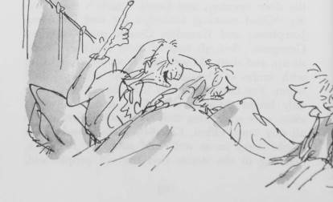

'I knew he was famous, Grandpa Joe, and I knew he was very clever.'

'Clever!" cried the old man. 'He's more than that! He's a magician with chocolate! He can make anything - anything he wants! Isn't that a fact, my dears?'

The other three old people nodded their heads slowly up and down, and said, 'Absolutely true. Just as true as can be.'

And Grandpa Joe said, 'You mean to say I've never told you about Mr Willy Wonka and his factory?'

'Never,' answered little Charlie.

'Good heavens above! I don't know what's the matter with me!'

'Will you tell me now, Grandpa Joe, please?'

'I certainly will. Sit down beside me on the bed, my dear, and listen carefully.'

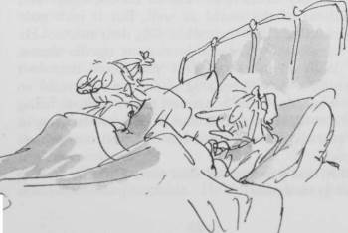

Grandpa Joe was the oldest of the four grandparents. He was ninety-six and a half, and that is just about as old as anybody can be. Like all extremely old people, he was delicate and weak, and throughout the day he spoke very little. But in the evenings, when Charlie, his beloved grandson, was in the room, he seemed in some marvellous way to grow quite young again. All his tiredness fell away from him, and he became as eager and excited as a young boy.

'Oh, what a man he is, this Mr Willy Wonka!' cried Grandpa Joe. 'Did you know, for example, that he has himself invented more than two hundred new kinds of chocolate bars, each with a different centre, each far sweeter and creamier and more delicious than anything the other chocolate factories can make!'

'Perfectly true!' cried Grandma Josephine. 'And he sends them to all the four corners of the earth! Isn't that so, Grandpa Joe?'

'It is, my dear, it is. And to all the kings and presidents of the world as well. But it isn't only chocolate bars that he makes. Oh, dear me, no! He has some really fantastic inventions up his sleeve, Mr Willy Wonka has! Did you know that he's invented a way of making chocolate ice cream so that it stays cold for hours and hours without being in the refrigerator? You can even leave it lying in the sun all morning on a hot day and it won't go runny!'

'But that's impossible!' said little Charlie, staring at his grandfather.

'Of course it's impossible!' cried Grandpa Joe. 'It's completely absurd! But Mr Willy Wonka has done it!'

'Quite right!' the others agreed, nodding their heads. 'Mr Wonka has done it.'

'And then again,' Grandpa Joe went on speaking very slowly now so that Charlie wouldn't miss a word, 'Mr Willy Wonka can make marshmallows that taste of violets, and rich caramels that change colour every ten seconds as you suck them, and little feathery sweets that melt away deliciously the moment you put them between your lips. He can make chewing-gum that never loses its taste, and sugar balloons that you can blow up to enormous sizes before you pop them with a pin and gobble them up.

'And, by a most secret method, he can make lovely blue birds' eggs with black spots on them, and when you put one of these in your mouth, it gradually gets smaller and smaller until suddenly there is nothing left except a tiny little pink sugary baby bird sitting on the tip of your tongue.'

Grandpa Joe paused and ran the point of his tongue slowly over his lips. 'It makes my mouth water just thinking about it,' he said.

'Mine, too,' said little Charlie. 'But please go on.'

While they were talking, Mr and Mrs Bucket, Charlie's mother and father, had come quietly into the room, and now both were standing just inside the door, listening.

'Tell Charlie about that crazy Indian prince,' said Grandma Josephine. 'He'd like to hear that.'

'You mean Prince Pondicherry?' said Grandpa Joe, and he began chuckling with laughter. 'Completely dotty!' said Grandpa George. 'But very rich,' said Grandma Georgina. 'What did he do?' asked Charlie eagerly. 'Listen,' said Grandpa Joe, 'and I'll tell you.'

Chapter 3 - Mr Wonka and the Indian Prince

'Prince Pondicherry wrote a letter to Mr Willy Wonka,' said Grandpa Joe, 'and asked him to come all the way out to India and build him a colossal palace entirely out of chocolate.'

'Did Mr Wonka do it, Grandpa?'

'He did, indeed. And what a palace it was! It had one hundred rooms, and everything was made of either dark or light chocolate! The bricks were chocolate, and the cement holding them together was chocolate, and the windows were chocolate, and all the walls and ceilings were made of chocolate, so were the carpets and the pictures and the furniture and the beds; and when you turned on the taps in the bathroom, hot chocolate came pouring out.

'When it was all finished, Mr Wonka said to Prince Pondicherry, "I warn you, though, it won't last very long, so you'd better start eating it right away."

'"Nonsense!" shouted the Prince. "I'm not going to eat my palace! I'm not even going to nibble the staircase or lick the walls! I'm going to live in it!"

'But Mr Wonka was right, of course, because soon after this, there came a very hot day with a boiling sun, and the whole palace began to melt, and then it sank slowly to the ground, and the crazy prince, who was dozing in the living room at the time, woke up to find himself swimming around in a huge brown sticky lake of chocolate.'

Little Charlie sat very still on the edge of the bed, staring at his grandfather. Charlie's face was bright, and his eyes were stretched so wide you could see the whites all around. .Is all this really true?' he asked. 'Or are you pulling my leg?'

'It's true!' cried all four of the old people at once. 'Of course it's true! Ask anyone you like!'

'And I'll tell you something else that's true,' said Grandpa Joe, and now he leaned closer to Charlie, and lowered his voice to a soft, secret whisper. 'Nobody ... ever ... comes ... out!'

'Out of where?' asked Charlie.

'And... nobody ... ever ... goes ... in.!'

'In where?' cried Charlie.

'Wonka's factory, of course!'

'Grandpa, what do you mean?'

'I mean workers, Charlie.'

'Workers?'

'All factories,' said Grandpa Joe, 'have workers streaming in and out of the gates in the mornings and evenings - except Wonka's! Have you ever seen a single person going into that place - or coming out?'

Little Charlie looked slowly around at each of the four old faces, one after the other, and they all looked back at him. They were friendly smiling faces, but they were also quite serious. There was no sign of joking or leg-pulling on any of them.

'Well? Have you?' asked Grandpa Joe.

'I ... I really don't know, Grandpa,' Charlie stammered. 'Whenever I walk past the factory, the gates seem to be closed.'

'Exactly!' said Grandpa Joe.

'But there must be people working there ... '

'Not people, Charlie. Not ordinary people, anyway.'

'Then who?' cried Charlie.

'Ah-ha ... That's it, you see ... That's another of Mr Willy Wonka's clevernesses.'

'Charlie, dear,' Mrs Bucket called out from where she was standing by the door, 'it's time for bed. That's enough for tonight.'

'But, Mother, I must hear ... '

'Tomorrow, my darling

'That's right,' said Grandpa Joe, 'I'll tell you the rest of it tomorrow evening.'

Chapter 4 - The Secret Workers

The next evening, Grandpa Joe went on with his story.

'You see, Charlie,' he said, 'not so very long ago there used to be thousands of people working in Mr Willy Wonka's factory. Then one day, all of a sudden, Mr Wonka had to ask every single one of them to leave, to go home, never to come back.'

'But why?' asked Charlie.

'Because of spies.'

'Spies?'

'Yes. All the other chocolate makers, you see, had begun to grow jealous of the wonderful sweets that Mr Wonka was making, and they started sending in spies to steal his secret recipes. The spies took jobs in the Wonka factory, pretending that they were ordinary workers, and while they were there, each one of them found out exactly how a certain special thing was made.'

'And did they go back to their own factories and tell?' asked Charlie.

'They must have,' answered Grandpa Joe, 'because soon after that, Fickelgruber's factory started making an ice cream that would never melt, even in the hottest sun.

'Then Mr Prodnose's factory came out with a chewing-gum that never lost its flavour however much you chewed it. And then Mr Slugworth's factory began making sugar balloons that you could blow up to huge sizes before you popped them with a pin and gobbled them up. And so on, and so on. And Mr Willy Wonka tore his beard and shouted, "This is terrible! I shall be ruined! There are spies everywhere! I shall have to close the factory!"'

'But he didn't do that!' Charlie said.

'Oh, yes he did. He told all the workers that he was sorry, but they would have to go home. Then, he shut the main gates and fastened them with a chain. And suddenly, Wonka's giant chocolate factory became silent and deserted. The chimneys stopped smoking, the machines stopped whirring, and from then on, not a single chocolate or sweet was made. Not a soul went in or out, and even Mr Willy Wonka himself disappeared completely.

'Months and months went by,' Grandpa Joe went on, 'but still the factory remained closed. And everybody said, "Poor Mr Wonka. He was so nice. And he made such marvellous things. But he's finished now. It's all over."

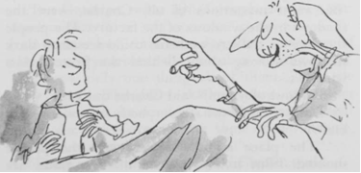

'Then something astonishing happened. One day, early in the morning, thin columns of white smoke were seen to be coming out of the tops of the tall chimneys of the factory! People in the town stopped and stared. "What's going on?" they cried. "Someone's lit the furnaces! Mr Wonka must be opening up again!" They ran to the gates, expecting to see them wide open and Mr Wonka standing there to welcome his workers back.

'But no! The great iron gates were still locked and chained as securely as ever, and Mr Wonka was nowhere to be seen.

'"But the factory is working!" the people shouted. "Listen! You can hear the machines! They're all whirring again! And you can smell the smell of melting chocolate in the air!"'

Grandpa Joe leaned forward and laid a long bony finger on Charlie's knee, and he said softly, 'But most mysterious of all, Charlie, were the shadows in the windows of the factory. The people standing on the street outside could see small dark shadows moving about behind the frosted glass windows.'

'Shadows of whom?' said Charlie quickly.

'That's exactly what everybody else wanted to know.

'"The place is full of workers!" the people shouted. "But nobody's gone in! The gates are locked! It's crazy! Nobody ever comes out, either!"

'But there was no question at all,' said Grandpa Joe, 'that the factory was running. And it's gone on running ever since, for these last ten years. What's more, the chocolates and sweets it's been turning out have become more fantastic and delicious all the time. And of course now when Mr Wonka invents some new and wonderful sweet, neither Mr Fickelgruber nor Mr Prodnose nor Mr Slugworth nor anybody else is able to copy it. No spies can go into the factory to find out how it is made.'

'But Grandpa, who,' cried Charlie, 'who is Mr Wonka using to do all the work in the factory?'

'Nobody knows, Charlie.'

'But that's absurd! Hasn't someone asked Mr Wonka?'

'Nobody sees him any more. He never comes out. The only things that come out of that place are chocolates and sweets. They come out through a special trap door in the wall, all packed and addressed, and they are picked up every day by Post Office trucks.'

'But Grandpa, what sort of people are they that work in there?'

'My dear boy,' said Grandpa Joe, 'that is one of the great mysteries of the chocolate-making world. We know only one thing about them. They are very small. The faint shadows that sometimes appear behind the windows, especially late at night when the lights are on, are those of tiny people, people no taller than my knee

'There aren't any such people,' Charlie said. Just then, Mr Bucket, Charlie's father, came into the room. He was home from the toothpaste factory, and he was waving an evening newspaper rather excitedly. 'Have you heard the news?' he cried. He held up the paper so that they could see the huge headline. The headline said:

WONKA FACTORY TO BE OPENED AT LAST TO LUCKY FEW

Chapter 5 - The Golden Tickets

'You mean people are actually going to be allowed to go inside the factory?' cried Grandpa Joe. 'Read us what it says - quickly!'

'All right,' said Mr Bucket, smoothing out the newspaper. 'Listen.'

Evening Bulletin

Mr Willy Wonka, the confectionery genius whom nobody has seen for the last ten years, sent out the following notice today:

I, Willy Wonka, have decided to allow five children - just five, mind you, and no more - to visit my factory this year. These lucky five will be shown around personally by me, and they will be allowed to see all the secrets and the magic of my factory. Then, at the end of the tour, as a special present, all of them will be given enough chocolates and sweets to last them for the rest of their lives! So watch out for the Golden Tickets! Five Golden Tickets have been printed on golden paper, and these five Golden Tickets have been hidden underneath the ordinary wrapping paper of five ordinary bars of chocolate. These five chocolate bars may be anywhere - in any shop in any street in any town in any country in the world - upon any counter where Wonka's Sweets are sold. And the five lucky finders of these five Golden Tickets are the only ones who will be allowed to visit my factory and see what it's like now inside! Good luck to you all, and happy hunting! (Signed Willy Wonka.)

'The man's dotty!' muttered Grandma Josephine.

'He's brilliant!' cried Grandpa Joe. 'He's a magician! Just imagine what will happen now! The whole world will be searching for those Golden Tickets! Everyone will be buying Wonka's chocolate bars in the hope of finding one! He'll sell more than ever before! Oh, how exciting it would be to find one!'

'And all the chocolate and sweets that you could eat for the rest of your life - free?' said Grandpa George. 'Just imagine that!'

'They'd have to deliver them in a truck!' said Grandma Georgina.

'It makes me quite ill to think of it,' said Grandma Josephine.

'Nonsense!' cried Grandpa Joe. 'Wouldn't it be something, Charlie, to open a bar of chocolate and see a Golden Ticket glistening inside!'

'It certainly would, Grandpa. But there isn't a hope,' Charlie said sadly. 'I only get one bar a year.'

'You never know, darling,' said Grandma Georgina. 'It's your birthday next week. You have as much chance as anybody else.'

'I'm afraid that simply isn't true,' said Grandpa George. 'The kids who are going to find the Golden Tickets are the ones who can afford to buy bars of chocolate every day. Our Charlie gets only one a year. There isn't a hope.'

Chapter 6 - The First Two Finders

The very next day, the first Golden Ticket was found. The finder was a boy called Augustus Gloop, and Mr Bucket's evening newspaper carried a large picture of him on the front page. The picture showed a nine-year-old boy who was so enormously fat he looked as though he had been blown up with a powerful pump. Great flabby folds of fat bulged out from every part of his body, and his face was like a monstrous ball of dough with two small greedy curranty eyes peering out upon the world. The town in which Augustus Gloop lived, the newspaper said, had gone wild with excitement over their hero. Flags were flying from all the windows, children had been given a holiday from school, and a parade was being organized in honour of the famous youth.

'I just knew Augustus would find a Golden Ticket,' his mother had told the newspapermen. He eats so many bars of chocolate a day that it was almost impossible for him not to find one. Eating is his hobby, you know. That's all he's interested in. But still, that's better than being a hooligan and shooting off zip guns and things like that in his spare time, isn't it? And what I always say is, he wouldn't go on eating like he does unless he needed nourishment, would he? It's all vitamins, anyway. What a thrill it will be for him to visit Mr Wonka's marvellous factory! We're just as proud as anything!'

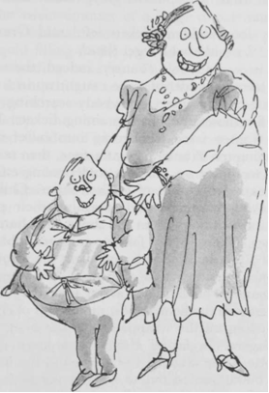

'What a revolting woman,' said Grandma Josephine.

'And what a repulsive boy,' said Grandma Georgina.

'Only four Golden Tickets left,' said Grandpa George. 'I wonder who'll get those.'

And now the whole country, indeed, the whole world, seemed suddenly to be caught up in a mad chocolate-buying spree, everybody searching frantically for those precious remaining tickets. Fully grown women were seen going into sweet shops and buying ten Wonka bars at a time, then tearing off the wrappers on the spot and peering eagerly underneath for a glint of golden paper. Children were taking hammers and smashing their piggy banks and running out to the shops with handfuls of money. In one city, a famous gangster robbed a bank of a thousand pounds and spent the whole lot on Wonka bars that same afternoon. And when the police entered his house to arrest him, they found him sitting on the floor amidst mountains of chocolate, ripping off the wrappers with the blade of a long dagger. In far-off Russia, a woman called Charlotte Russe claimed to have found the second ticket, but it turned out to be a clever fake. The famous English scientist, Professor Foulbody, invented a machine which would tell you at once, without opening the wrapper of a bar of chocolate, whether or not there was a Golden Ticket hidden underneath it. The machine had a mechanical arm that shot out with tremendous force and grabbed hold of anything that had the slightest bit of gold inside it, and for a moment, it looked like the answer to everything. But unfortunately, while the Professor was showing off the machine to the public at the sweet counter of a large department store, the mechanical arm shot out and made a grab for the gold filling in the back tooth of a duchess who was standing nearby. There was an ugly scene, and the machine was smashed by the crowd.

Suddenly, on the day before Charlie Bucket's birthday, the newspapers announced that the second Golden Ticket had been found. The lucky person was a small girl called Veruca Salt who lived with her rich parents in a great city far away. Once again Mr Bucket's evening newspaper carried a big picture of the finder. She was sitting between her beaming father and mother in the living room of their house, waving the Golden Ticket above her head, and grinning from ear to ear.

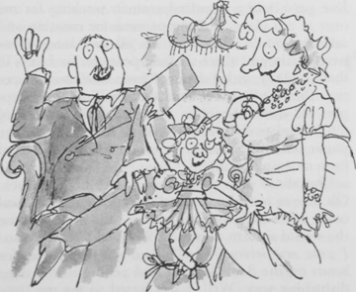

Veruca's father, Mr Salt, had eagerly explained to the newspapermen exactly how the ticket was found. 'You see, boys,' he had said, 'as soon as my little girl told me that she simply had to have one of those Golden Tickets, I went out into the town and started buying up all the Wonka bars I could lay my hands on. Thousands of them, I must have bought. Hundreds of thousands! Then I had them loaded on to trucks and sent directly to my own factory. I'm in the peanut business, you see, and I've got about a hundred women working for me over at my place, shelling peanuts for roasting and salting. That's what they do all day long, those women, they sit there shelling peanuts. So I says to them, "Okay, girls," I says, "from now on, you can stop shelling peanuts and start shelling the wrappers off these chocolate bars instead!" And they did. I had every worker in the place yanking the paper off those bars of chocolate full speed ahead from morning till night.

'But three days went by, and we had no luck. Oh, it was terrible! My little Veruca got more and more upset each day, and every time I went home she would scream at me, "Where's my Golden Ticket! I want my Golden Ticket!" And she would lie for hours on the floor, kicking and yelling in the most disturbing way. Well, I just hated to see my little girl feeling unhappy like that, so I vowed I would keep up the search until I'd got her what she wanted. Then suddenly ... on the evening of the fourth day, one of my women workers yelled, "I've got it! A Golden Ticket!" And I said, "Give it to me, quick!" and she did, and I rushed it home and gave it to my darling Veruca, and now she's all smiles, and we have a happy home once again.'

'That's even worse than the fat boy,' said Grandma Josephine.

'She needs a really good spanking,' said Grandma Georgina.

'I don't think the girl's father played it quite fair, Grandpa, do you?' Charlie murmured.

'He spoils her,' Grandpa Joe said. 'And no good can ever come from spoiling a child like that, Charlie, you mark my words.'

'Come to bed, my darling,' said Charlie's mother. 'Tomorrow's your birthday, don't forget that, so I expect you'll be up early to open your present.'

'A Wonka chocolate bar!' cried Charlie. 'It is a Wonka bar, isn't it?'

'Yes, my love,' his mother said. 'Of course it is.'

'Oh, wouldn't it be wonderful if I found the third Golden Ticket inside it?' Charlie said.

'Bring it in here when you get it,' Grandpa Joe said. 'Then we can all watch you taking off the wrapper.'

Chapter 7 - Charlie's Birthday

'Happy birthday!' cried the four old grandparents, as Charlie came into their room early the next morning.

Charlie smiled nervously and sat down on the edge of the bed. He was holding his present, his only present, very carefully in his two hands. WONKA'S WHIPPLE-SCRUMPTIOUS FUDGEMALLOW DELIGHT, it said on the wrapper.

The four old people, two at either end of the bed, propped themselves up on their pillows and stared with anxious eyes at the bar of chocolate in Charlie's hands.

Mr and Mrs Bucket came in and stood at the foot of the bed, watching Charlie.

The room became silent. Everybody was waiting now for Charlie to start opening his present. Charlie looked down at the bar of chocolate. He ran his fingers slowly back and forth along the length of it, stroking it lovingly, and the shiny paper wrapper made little sharp crackly noises in the quiet room.

Then Mrs Bucket said gently, 'You mustn't be too disappointed, my darling, if you don't find what you're looking for underneath that wrapper. You really can't expect to be as lucky as all that.'

'She's quite right,' Mr Bucket said.

Charlie didn't say anything.

"After all,' Grandma Josephine said, 'in the whole wide world there are only three tickets left to be found.'

'The thing to remember,' Grandma Georgina said, 'is that whatever happens, you'll still have the bar of chocolate.'

'Wonka's Whipple-Scrumptious Fudgemallow Delight!' cried Grandpa George. 'It's the best of them all! You'll just love it!'

'Yes,' Charlie whispered. 'I know.'

'Just forget all about those Golden Tickets and enjoy the chocolate,' Grandpa Joe said. 'Why don't you do that?'

They all knew it was ridiculous to expect this one poor little bar of chocolate to have a magic ticket inside it, and they were trying as gently and as kindly as they could to prepare Charlie for the disappointment. But there was one other thing that the grown-ups also knew, and it was this: that however small the chance might be of striking lucky, the chance was there.

The chance had to be there.

This particular bar of chocolate had as much chance as any other of having a Golden Ticket.

And that was why all the grandparents and parents in the room were actually just as tense and excited as Charlie was, although they were pretending to be very calm.

'You'd better go ahead and open it up, or you'll be late for school,' Grandpa Joe said.

'You might as well get it over with,' Grandpa George said.

'Open it, my dear,' Grandma Georgina said. 'Please open it. You're making me jumpy.'

Very slowly, Charlie's fingers began to tear open one small corner of the wrapping paper.

The old people in the bed all leaned forward, craning their scraggy necks.

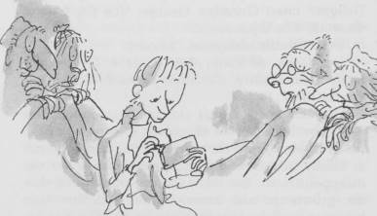

Then suddenly, as though he couldn't bear the suspense any longer, Charlie tore the wrapper right down the middle ... and on to his lap, there fell ... a light-brown creamy-coloured bar of chocolate.

There was no sign of a Golden Ticket anywhere.

'Well - that's that!' said Grandpa Joe brightly. 'It's just what we expected.'

Charlie looked up. Four kind old faces were watching him intently from the bed. He smiled at them, a small sad smile, and then he shrugged his shoulders and picked up the chocolate bar and held it out to his mother, and said, 'Here, Mother, have a bit. We'll share it. I want everybody to taste it.'

'Certainly not!' his mother said.

And the others all cried, 'No, no! We wouldn't dream of it! It's all yours!'

'Please,' begged Charlie, turning round and offering it to Grandpa Joe.

But neither he nor anyone else would take even a tiny bit.

'It's time to go to school, my darling,' Mrs Bucket said, putting an arm around Charlie's skinny shoulders. 'Come on, or you'll be late.'

Chapter 8 - Two More Golden Tickets Found

That evening, Mr Bucket's newspaper announced the finding of not only the third Golden Ticket, but the fourth as well. TWO GOLDEN TICKETS FOUND TODAY, screamed the headlines. ONLY ONE MORE LEFT.

'All right,' said Grandpa Joe, when the whole family was gathered in the old people's room after supper, Let's hear who found them.'

'The third ticket,' read Mr Bucket, holding the newspaper up close to his face because his eyes were bad and he couldn't afford glasses, 'the third ticket was found by a Miss Violet Beauregarde. There was great excitement in the Beauregarde household when our reporter arrived to interview the lucky young lady - cameras were clicking and flashbulbs were flashing and people were pushing and jostling and trying to get a bit closer to the famous girl. And the famous girl was standing on a chair in the living room waving the Golden Ticket madly at arm's length as though she were flagging a taxi.

She was talking very fast and very loudly to everyone, but it was not easy to hear all that she said because she was chewing so ferociously upon a piece of gum at the same time.

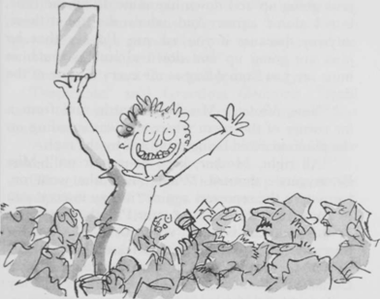

"I'm a gum chewer, normally," she shouted, "but when I heard about these ticket things of Mr Wonka's, I gave up gum and started on chocolate bars in the hope of striking lucky. Now, of course, I'm back on gum. I just adore gum. I can't do without it. I munch it all day long except for a few minutes at mealtimes when I take it out and stick it behind my ear for safekeeping. To tell you the truth, I simply wouldn't feel comfortable if I didn't have that little wedge of gum to chew on every moment of the day, I really wouldn't. My mother says it's not ladylike and it looks ugly to see a girl's jaws going up and down like mine do all the time, but I don't agree. And who's she to criticize, anyway, because if you ask me, I'd say that her jaws are going up and down almost as much as mine are just from yelling at me every minute of the day."

"Now, Violet," Mrs Beauregarde said from a far corner of the room where she was standing on the piano to avoid being trampled by the mob.

"All right, Mother, keep your hair on!" Miss Beauregarde shouted. "And now," she went on, turning to the reporters again, "it may interest you to know that this piece of gum I'm chewing right at this moment is one I've been working on for over three months solid. That's a record, that is. It's beaten the record held by my best friend, Miss Cornelia Prinzmetel. And was she furious! It's my most treasured possession now, this piece of gum is. At night-time, I just stick it on the end of the bedpost, and it's as good as ever in the mornings - a bit hard at first, maybe, but it soon softens up again after I've given it a few good chews. Before I started chewing for the world record, I used to change my piece of gum once a day. I used to do it in our lift on the way home from school. Why the lift? Because I liked sticking the gooey piece that I'd just finished with on to one of the control buttons. Then the next person who came along and pressed the button got my old gum on the end of his or her finger. Ha-ha! And what a racket they kicked up, some of them. You get the best results with women who have expensive gloves on. Oh yes, I'm thrilled to be going to Mr Wonka's factory. And I understand that afterwards he's going to give me enough gum to last me for the rest of my whole life. Whoopee! Hooray!"'

'Beastly girl,' said Grandma Josephine.

'Despicable!' said Grandma Georgina. 'She'll come to a sticky end one day, chewing all that gum, you see if she doesn't.'

'And who got the fourth Golden Ticket?' Charlie asked.

'Now, let me see,' said Mr Bucket, peering at the newspaper again. 'Ah yes, here we are. The fourth Golden Ticket,' he read, 'was found by a boy called Mike Teavee.'

'Another bad lot, I'll be bound,' muttered Grandma Josephine.

"Don't interrupt, Grandma,' said Mrs Bucket.

'The Teavee household,' said Mr Bucket, going on with his reading, 'was crammed, like all the others, with excited visitors when our reporter arrived, but young Mike Teavee, the lucky winner, seemed extremely annoyed by the whole business. "Can't you fools see I'm watching television?" he said angrily. "I wish you wouldn't interrupt!"

'The nine-year-old boy was seated before an enormous television set, with his eyes glued to the screen, and he was watching a film in which one bunch of gangsters was shooting up another bunch of gangsters with machine guns. Mike Teavee himself had no less than eighteen toy pistols of various sizes hanging from belts around his body, and every now and again he would leap up into the air and fire off half a dozen rounds from one or another of these weapons.



'"Quiet!" he shouted, when someone tried to ask him a question. "Didn't I tell you not to interrupt! This show's an absolute whiz-banger! It's terrific! I watch it every day. I watch all of them every day, even the rotten ones, where there's no shooting. I like the gangsters best. They're terrific, those gangsters! Especially when they start pumping each other full of lead, or flashing the old stilettos, or giving each other the one-two-three with their knuckledusters! Gosh, what wouldn't I give to be doing that myself! It's the life, I tell you! It's terrific!'"

'That's quite enough!' snapped Grandma Josephine. I can't bear to listen to it!'

'Nor me,' said Grandma Georgina. 'Do all children behave like this nowadays - like these brats we've been hearing about?'

'Of course not,' said Mr Bucket, smiling at the old lady in the bed. 'Some do, of course. In fact, quite a lot of them do. But not all.'

'And now there's only one ticket left,' said Grandpa George.

'Quite so,' sniffed Grandma Georgina. 'And just as sure as I'll be having cabbage soup for supper tomorrow, that ticket'll go to some nasty little beast who doesn't deserve it!'

Chapter 9 - Grandpa Joe Takes a Gamble

The next day, when Charlie came home from school and went in to see his grandparents, he found that only Grandpa Joe was awake. The other three were all snoring loudly.

'Ssshh!' whispered Grandpa Joe, and he beckoned Charlie to come closer. Charlie tiptoed over and stood beside the bed. The old man gave Charlie a sly grin, and then he started rummaging under his pillow with one hand; and when the hand came out again, there was an ancient leather purse clutched in the fingers. Under cover of the bedclothes, the old man opened the purse and tipped it upside down. Out fell a single silver sixpence. 'It's my secret hoard,' he whispered. 'The others don't know I've got it. And now, you and I are going to have one more fling at finding that last ticket. How about it, eh? But you'll have to help me.'

'Are you sure you want to spend your money on that, Grandpa?' Charlie whispered.

'Of course I'm sure!' spluttered the old man excitedly. 'Don't stand there arguing! I'm as keen as you are to find that ticket! Here - take the money and run down the street to the nearest shop and buy the first Wonka bar you see and bring it straight back to me, and we'll open it together.'

Charlie took the little silver coin, and slipped quickly out of the room. In five minutes, he was back.

"Have you got it?' whispered Grandpa Joe, his eyes shining with excitement.

Charlie nodded and held out the bar of chocolate. WONKA'S NUTTY CRUNCH SURPRISE, it said on the wrapper.

'Good!' the old man whispered, sitting up in the bed and rubbing his hands. 'Now - come over here and sit close to me and we'll open it together. Are you ready?'

'Yes,' Charlie said. 'I'm ready.'

'All right. You tear off the first bit.'

'No,' Charlie said, 'you paid for it. You do it all.'

The old man's fingers were trembling most terribly as they fumbled with the wrapper. 'We don't have a hope, really,' he whispered, giggling a bit. 'You do know we don't have a hope, don't you?'

'Yes,' Charlie said. 'I know that.'

They looked at each other, and both started giggling nervously.

'Mind you,' said Grandpa Joe, 'there is just that tiny chance that it might be the one, don't you agree?'

'Yes,' Charlie said. 'Of course. Why don't you open it, Grandpa?'

'All in good time, my boy, all in good time. Which end do you think I ought to open first?'

That corner. The one furthest from you. Just tear off a tiny bit, but not quite enough for us to see anything.'

'Like that?' said the old man.

'Yes. Now a little bit more.'

'You finish it,' said Grandpa Joe. 'I'm too nervous.'

'No, Grandpa. You must do it yourself.'

'Very well, then. Here goes.' He tore off the wrapper.

They both stared at what lay underneath. It was a bar of chocolate - nothing more.

All at once, they both saw the funny side of the whole thing, and they burst into peals of laughter.

'What on earth's going on!' cried Grandma Josephine, waking up suddenly.

'Nothing,' said Grandpa Joe. 'You go on back to sleep.'

Chapter 10 - The Family Begins to Starve

During the next two weeks, the weather turned very cold. First came the snow. It began very suddenly one morning just as Charlie Bucket was getting dressed for school. Standing by the window, he saw the huge flakes drifting slowly down out of an icy sky that was the colour of steel.

By evening, it lay four feet deep around the tiny house, and Mr Bucket had to dig a path from the front door to the road.

After the snow, there came a freezing gale that blew for days and days without stopping. And oh, how bitter cold it was! Everything that Charlie touched seemed to be made of ice, and each time he stepped outside the door, the wind was like a knife on his cheek.

Inside the house, little jets of freezing air came rushing in through the sides of the windows and under the doors, and there was no place to go to escape them. The four old ones lay silent and huddled in their bed, trying to keep the cold out of their bones. The excitement over the Golden Tickets had long since been forgotten. Nobody in the family gave a thought now to anything except the two vital problems of trying to keep warm and trying to get enough to eat.

There is something about very cold weather that gives one an enormous appetite. Most of us find ourselves beginning to crave rich steaming stews and hot apple pies and all kinds of delicious warming dishes; and because we are all a great deal luckier than we realize, we usually get what we want or near enough. But Charlie Bucket never got what he wanted because the family couldn't afford it, and as the cold weather went on and on, he became ravenously and desperately hungry. Both bars of chocolate, the birthday one and the one Grandpa Joe had bought, had long since been nibbled away, and all he got now were those thin, cabbagy meals three times a day.

Then all at once, the meals became even thinner.

The reason for this was that the toothpaste factory, the place where Mr Bucket worked, suddenly went bust and had to close down. Quickly, Mr Bucket tried to get another job. But he had no luck. In the end, the only way in which he managed to earn a few pennies was by shovelling snow in the streets. But it wasn't enough to buy even a quarter of the food that seven people needed. The situation became desperate. Breakfast was a single slice of bread for each person now, and lunch was maybe half a boiled potato.

Slowly but surely, everybody in the house began to starve.

And every day, little Charlie Bucket, trudging through the snow on his way to school, would have to pass Mr Willy Wonka's giant chocolate factory. And every day, as he came near to it, he would lift his small pointed nose high in the air and sniff the wonderful sweet smell of melting chocolate. Sometimes, he would stand motionless outside the gates for several minutes on end, taking deep swallowing breaths as though he were trying to eat the smell itself.

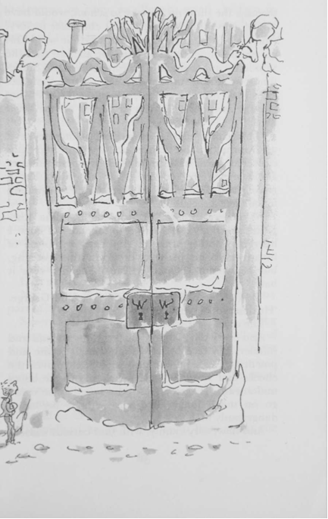

'That child,' said Grandpa Joe, poking his head up from under the blanket one icy morning, 'that child has got to have more food. It doesn't matter about us. We're too old to bother with. But a growing boy! He can't go on like this! He's beginning to look like a skeleton!'

'What can one do,' murmured Grandma Josephine miserably. 'He refuses to take any of ours. I hear his mother tried to slip her own piece of bread on to his plate at breakfast this morning, but he wouldn't touch it. He made her take it back.'

'He's a fine little fellow,' said Grandpa George. 'He deserves better than this.'

The cruel weather went on and on.

And every day, Charlie Bucket grew thinner and thinner. His face became frighteningly white and pinched. The skin was drawn so tightly over the cheeks that you could see the shapes of the bones underneath. It seemed doubtful whether he could go on much longer like this without becoming dangerously ill.

And now, very calmly, with that curious wisdom that seems to come so often to small children in times of hardship, he began to make little changes here and there in some of the things that he did, so as to save his strength. In the mornings, he left the house ten minutes earlier so that he could walk slowly to school, without ever having to run. He sat quietly in the classroom during break, resting himself, while the others rushed outdoors and threw snowballs and wrestled in the snow. Everything he did now, he did slowly and carefully, to prevent exhaustion.

Then one afternoon, walking back home with the icy wind in his face (and incidentally feeling hungrier than he had ever felt before), his eye was caught suddenly by something silvery lying in the gutter, in the snow. Charlie stepped off the kerb and bent down to examine it. Part of it was buried under the snow, but he saw at once what it was.

It was a fifty-pence piece!

Quickly he looked around him.

Had somebody just dropped it?

No - that was impossible because of the way part of it was buried.

Several people went hurrying past him on the pavement, their chins sunk deep in the collars of their coats, their feet crunching in the snow. None of them was searching for any money; none of them was taking the slightest notice of the small boy crouching in the gutter.

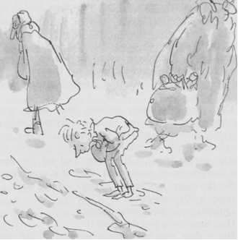

Then was it his, this fifty pence?

Could he have it?

Carefully, Charlie pulled it out from under the snow. It was damp and dirty, but otherwise perfect.

A WHOLE fifty pence!

He held it tightly between his shivering fingers, gazing down at it. It meant one thing to him at that moment, only one thing. It meant FOOD.

Automatically, Charlie turned and began moving towards the nearest shop. It was only ten paces away ... it was a newspaper and stationery shop, the kind that sells almost everything, including sweets and cigars ... and what he would do, he whispered quickly to himself... he would buy one luscious bar of chocolate and eat it all up, every bit of it, right then and there ... and the rest of the money he would take straight back home and give to his mother.

Chapter 11 - The Miracle

Charlie entered the shop and laid the damp fifty pence on the counter.

'One Wonka's Whipple-Scrumptious Fudge-mallow Delight,' he said, remembering how much he had loved the one he had on his birthday.

The man behind the counter looked fat and well-fed. He had big lips and fat cheeks and a very fat neck. The fat around his neck bulged out all around the top of his collar like a rubber ring. He turned and reached behind him for the chocolate bar, then he turned back again and handed it to Charlie. Charlie grabbed it and quickly tore off the wrapper and took an enormous bite. Then he took another ... and another ... and oh, the joy of being able to cram large pieces of something sweet and solid into one's mouth! The sheer blissful joy of being able to fill one's mouth with rich solid food!

'You look like you wanted that one, sonny,' the shopkeeper said pleasantly.

Charlie nodded, his mouth bulging with chocolate.

The shopkeeper put Charlie's change on the counter. 'Take it easy,' he said. 'It'll give you a tummy-ache if you swallow it like that without chewing.'

Charlie went on wolfing the chocolate. He couldn't stop. And in less than half a minute, the whole thing had disappeared down his throat. He was quite out of breath, but he felt marvellously, extraordinarily happy. He reached out a hand to take the change. Then he paused. His eyes were just above the level of the counter. They were staring at the silver coins lying there. The coins were all five-penny pieces. There were nine of them altogether. Surely it wouldn't matter if he spent just one more ...

I think,' he said quietly, 'I think ... I'll have just one more of those chocolate bars. The same kind as before, please.'

Why not?' the fat shopkeeper said, reaching behind him again and taking another Whipple-Scrumptious Fudgemallow Delight from the shelf. He laid it on the counter.

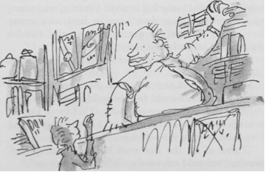

Charlie picked it up and tore off the wrapper ... and suddenly ... from underneath the wrapper ... there came a brilliant flash of gold.

Charlie's heart stood still.

'It's a Golden Ticket!' screamed the shopkeeper, leaping about a foot in the air. 'You've got a Golden Ticket! You've found the last Golden Ticket! Hey, would you believe it! Come and look at this, everybody! The kid's found Wonka's last Golden Ticket! There it is! It's right here in his hands!'

It seemed as though the shopkeeper might be going to have a fit. 'In my shop, too!' he yelled. 'He found it right here in my own little shop! Somebody call the newspapers quick and let them know! Watch out now, sonny! Don't tear it as you unwrap it! That thing's precious!'

In a few seconds, there was a crowd of about twenty people clustering around Charlie, and many more were pushing their way in from the street. Everybody wanted to get a look at the Golden Ticket and at the lucky finder.

'Where is it?' somebody shouted. 'Hold it up so all of us can see it!'

'There it is, there!' someone else shouted. 'He's holding it in his hands! See the gold shining!'

'How did he manage to find it, I'd like to know?' a large boy shouted angrily. 'Twenty bars a day I've been buying for weeks and weeks!'

'Think of all the free stuff he'll be getting too!' another boy said enviously. 'A lifetime supply!'

'He'll need it, the skinny little shrimp!' a girl said, laughing.

Charlie hadn't moved. He hadn't even unwrapped the Golden Ticket from around the chocolate. He was standing very still, holding it tightly with both hands while the crowd pushed and shouted all around him. He felt quite dizzy. There was a peculiar floating sensation coming over him, as though he were floating up in the air like a balloon. His feet didn't seem to be touching the ground at all. He could hear his heart thumping away loudly somewhere in his throat.

At that point, he became aware of a hand resting lightly on his shoulder, and when he looked up, he saw a tall man standing over him. 'Listen,' the man whispered. 'I'll buy it from you. I'll give you fifty pounds. How about it, eh? And I'll give you a new bicycle as well. Okay?'

'Are you crazy?' shouted a woman who was stand­ing equally close. 'Why, I'd give him two hundred pounds for that ticket! You want to sell that ticket for two hundred pounds, young man?'

'That's quite enough of that!' the fat shopkeeper shouted, pushing his way through the crowd and taking Charlie firmly by the arm. 'Leave the kid alone, will you! Make way there! Let him out!' And to Charlie, as he led him to the door, he whispered, 'Don't you let anybody have it! Take it straight home, quickly, before you lose it! Run all the way and don't stop till you get there, you understand?'

Charlie nodded.

'You know something,' the fat shopkeeper said, pausing a moment and smiling at Charlie, 'I have a feeling you needed a break like this. I'm awfully glad you got it. Good luck to you, sonny.'

'Thank you,' Charlie said, and off he went, running through the snow as fast as his legs would go. And as he flew past Mr Willy Wonka's factory, he turned and waved at it and sang out, 'I'll be seeing you! I'll be seeing you soon!' And five minutes later he arrived at his own home.

Chapter 12 - What It Said on the Golden Ticket

Charlie burst through the front door, shouting, 'Mother! Mother! Mother!''

Mrs Bucket was in the old grandparents' room, serving them their evening soup.

'Mother!' yelled Charlie, rushing in on them like a hurricane. 'Look! I've got it! Look, Mother, look! The last Golden Ticket! It's mine! I found some money in the street and I bought two bars of chocolate and the second one had the Golden Ticket and there were crowds of people all around me wanting to see it and the shopkeeper rescued me and I ran all the way home and here I am! IT'S THE FIFTH GOLDEN TICKET, MOTHER, AND I'VE FOUND IT!'

Mrs Bucket simply stood and stared, while the four old grandparents, who were sitting up in bed balancing bowls of soup on their laps, all dropped their spoons with a clatter and froze against their pillows.

For about ten seconds there was absolute silence in the room. Nobody dared to speak or move. It was a magic moment.

Then, very softly, Grandpa Joe said, 'You're pulling our legs, Charlie, aren't you? You're having a little joke?'

'I am not!' cried Charlie, rushing up to the bed and holding out the large and beautiful Golden Ticket for him to see.

Grandpa Joe leaned forward and took a close look, his nose almost touching the ticket. The others watched him, waiting for the verdict.

Then very slowly, with a slow and marvellous grin spreading all over his face, Grandpa Joe lifted his head and looked straight at Charlie. The colour was rushing to his cheeks, and his eyes were wide open, shining with joy, and in the centre of each eye, right in the very centre, in the black pupil, a little spark of wild excitement was slowly dancing. Then the old man took a deep breath, and suddenly, with no warning whatsoever, an explosion seemed to take place inside him. He threw up his arms and yelled 'Yippeeeeeeee!' And at the same time, his long bony body rose up out of the bed and his bowl of soup went flying into the face of Grandma Josephine, and in one fantastic leap, this old fellow of ninety-six and a half, who hadn't been out of bed these last twenty years, jumped on to the floor and started doing a dance of victory in his pyjamas.

'Yippeeeeeeeeee!' he shouted. 'Three cheers for Charlie! Hip, hip, hooray!'

At this point, the door opened, and Mr Bucket walked into the room. He was cold and tired, and he looked it. All day long, he had been shovelling snow in the streets.

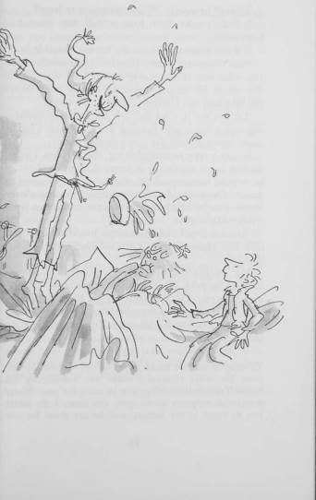

'Cripes!' he cried. 'What's going on in here?'

It didn't take them long to tell him what had happened.

'I don't believe it!' he said. 'It's not possible.'

'Show him the ticket, Charlie!' shouted Grandpa Joe, who was still dancing around the floor like a dervish in his striped pyjamas. 'Show your father the fifth and last Golden Ticket in the world!'

'Let me see it, Charlie,' Mr Bucket said, collapsing into a chair and holding out his hand. Charlie came forward with the precious document.

It was a very beautiful thing, this Golden Ticket, having been made, so it seemed, from a sheet of pure gold hammered out almost to the thinness of paper. On one side of it, printed by some clever method in jet-black letters, was the invitation itself from Mr Wonka.

'Read it aloud,' said Grandpa Joe, climbing back into bed again at last. 'Let's all hear exactly what it says.'

Mr Bucket held the lovely Golden Ticket up close to his eyes. His hands were trembling slightly, and he seemed to be overcome by the whole business. He took several deep breaths. Then he cleared his throat, and said, 'All right, I'll read it. Here we go:

'Greetings to you, the lucky finder of this Golden Ticket, from Mr Willy Wonka! I shake you warmly by the hand! Tremendous things are in store for you! Many wonderful surprises await you! For now, I do invite you to come to my factory and be my guest for one whole day - you and all others who are lucky enough to find my Golden Tickets. I, Willy Wonka, will conduct you around the factory myself, showing you everything that there is to see, and afterwards, when it is time to leave, you will be escorted home by a procession of large trucks. These trucks, I can promise you, will be loaded with enough delicious eatables to last you and your entire household for many years. If, at any time thereafter, you should run out of supplies, you have only to come back to the factory and show this Golden Ticket, and I shall be happy to refill your cupboard with whatever you want. In this way, you will be able to keep yourself supplied with tasty morsels for the rest of your life. But this is by no means the most exciting thing that will happen on the day of your visit. I am preparing other surprises that are even more marvellous and more fantastic for you and for all my beloved Golden Ticket holders - mystic and marvellous surprises that will entrance, delight, intrigue, astonish, and perplex you beyond measure. In your wildest dreams you could not imagine that such things could happen to you! Just wait and see! And now, here are your instructions: the day I have chosen for the visit is the first day in the month of February. On this day, and on no other, you must come to the factory gates at ten o'clock sharp in the morning. Don't be late! And you are allowed to bring with you either one or two members of your own family to look after you and to ensure that you don't get into mischief. One more thing - be certain to have this ticket with you, otherwise you will not be admitted.

(Signed) Willy Wonka.'

'The first day of February' cried Mrs Bucket. 'But that's tomorrow! Today is the last day of January. I know it is!'

'Cripes!' said Mr Bucket. 'I think you're right!'

'You're just in time!' shouted Grandpa Joe. 'There's not a moment to lose. You must start making preparations at once! Wash your face, comb your hair, scrub your hands, brush your teeth, blow your nose, cut your nails, polish your shoes, iron your shirt, and for heaven's sake, get all that mud off your pants! You must get ready, my boy! You must get ready for the biggest day of your life!'

'Now don't over-excite yourself, Grandpa,' Mrs Bucket said. 'And don't fluster poor Charlie. We must all try to keep very calm. Now the first thing to decide is this - who is going to go with Charlie to the factory?'

'I will!' shouted Grandpa Joe, leaping out of bed once again. 'I'll take him! I'll look after him! You leave it to me!'

Mrs Bucket smiled at the old man, then she turned to her husband and said, 'How about you, dear? Don't you think you ought to go?'

'Well ...' Mr Bucket said, pausing to think about it, 'no ... I'm not so sure that I should.'

'But you must.''

'There's no must about it, my dear,' Mr Bucket said gently. 'Mind you, I'd love to go. It'll be tremendously exciting. But on the other hand ... I believe that the person who really deserves to go most of all is Grandpa Joe himself. He seems to know more about it than we do. Provided, of course, that he feels well enough.'

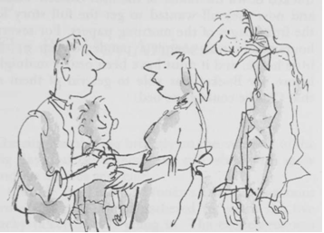

'Yippeeeeee!' shouted Grandpa Joe, seizing Charlie by the hands and dancing round the room.

'He certainly seems well enough,' Mrs Bucket said, laughing. 'Yes ... perhaps you're right after all. Perhaps Grandpa Joe should be the one to go with him. I certainly can't go myself and leave the other three old people all alone in bed for a whole day.'

'Hallelujah!' yelled Grandpa Joe. 'Praise the Lord!'

At that point, there came a loud knock on the front door. Mr Bucket went to open it, and the next moment, swarms of newspapermen and photographers were pouring into the house. They had tracked down the finder of the fifth Golden Ticket, and now they all wanted to get the full story for the front pages of the morning papers. For several hours, there was complete pandemonium in the little house, and it must have been nearly midnight before Mr Bucket was able to get rid of them so that Charlie could go to bed.

Chapter 13 - The Big Day Arrives

The sun was shining brightly on the morning of the big day, but the ground was still white with snow and the air was very cold.

Outside the gates of Wonka's factory, enormous crowds of people had gathered to watch the five lucky ticket holders going in. The excitement was tremendous. It was just before ten o'clock. The crowds were pushing and shouting, and policemen with arms linked were trying to hold them back from the gates.

Right beside the gates, in a small group that was carefully shielded from the crowds by the police, stood the five famous children, together with the grown-ups who had come with them.

The tall bony figure of Grandpa Joe could be seen standing quietly among them, and beside him, holding tightly on to his hand, was little Charlie Bucket himself.

All the children, except Charlie, had both their mothers and fathers with them, and it was a good thing that they had, otherwise the whole party might have got out of hand. They were so eager to get going that their parents were having to hold them back by force to prevent them from climbing over the gates. 'Be patient!' cried the fathers. 'Be still! It's not time yet! It's not ten o'clock!'

Behind him, Charlie Bucket could hear the shouts of the people in the crowd as they pushed and fought to get a glimpse of the famous children.

'There's Violet Beauregarde!' he heard someone shouting. 'That's her all right! I can remember her face from the newspapers!'

'And you know what?' somebody else shouted back. 'She's still chewing that dreadful old piece of gum she's had for three months! You look at her jaws! They're still working on it!'

'Who's the big fat boy?'

That's Augustus Gloop!'

'So it is!'

'Enormous, isn't he!'

'Fantastic!'

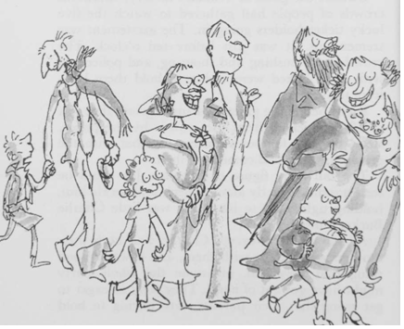

'Who's the kid with a picture of The Lone Ranger stencilled on his windcheater?'

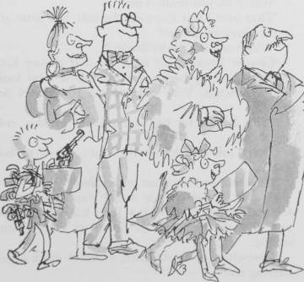

'That's Mike Teavee! He's the television fiend!'

'He must be crazy! Look at all those toy pistols he's got hanging all over him!'

'The one I want to see is Veruca Salt!' shouted another voice in the crowd. 'She's the girl whose father bought up half a million chocolate bars and then made the workers in his peanut factory unwrap every one of them until they found a Golden Ticket! He gives her anything she wants! Absolutely anything! She only has to start screaming for it and she gets it!'

'Dreadful, isn't it?'

'Shocking, I call it!'

'Which do you think is her?'

'That one! Over there on the left! The little girl in the silver mink coat!'

'Which one is Charlie Bucket?'

'Charlie Bucket? He must be that skinny little shrimp standing beside the old fellow who looks like a skeleton. Very close to us. Just there! See him?'

'Why hasn't he got a coat on in this cold weather?'

'Don't ask me. Maybe he can't afford to buy one.'

'Goodness me! He must be freezing!'

Charlie, standing only a few paces away from the speaker, gave Grandpa Joe's hand a squeeze, and the old man looked down at Charlie and smiled.

Somewhere in the distance, a church clock began striking ten.

Very slowly, with a loud creaking of rusty hinges, the great iron gates of the factory began to swing open.

The crowd became suddenly silent. The children stopped jumping about. All eyes were fixed upon the gates.

'There he is!' somebody shouted. 'That's him!'

And so it was!

Chapter 14 - Mr Willy Wonka

Mr Wonka was standing all alone just inside the open gates of the factory.

And what an extraordinary little man he was!

He had a black top hat on his head.

He wore a tail coat made of a beautiful plum-coloured velvet.

His trousers were bottle green.

His gloves were pearly grey.

And in one hand he carried a fine gold-topped walking cane.

Covering his chin, there was a small, neat, pointed black beard - a goatee. And his eyes - his eyes were most marvellously bright. They seemed to be sparkling and twinkling at you all the time. The whole face, in fact, was alight with fun and laughter.

And oh, how clever he looked! How quick and sharp and full of life! He kept making quick jerky little movements with his head, cocking it this way and that, and taking everything in with those bright twinkling eyes. He was like a squirrel in the quickness of his movements, like a quick clever old squirrel from the park.

Suddenly, he did a funny little skipping dance in the snow, and he spread his arms wide, and he smiled at the five children who were clustered near the gates, and he called out, 'Welcome, my little friends! Welcome to the factory!'

His voice was high and flutey. 'Will you come forward one at a time, please,' he called out, 'and bring your parents. Then show me your Golden Ticket and give me your name. Who's first?'

The big fat boy stepped up. 'I'm Augustus Gloop,' he said.

'Augustus!' cried Mr Wonka, seizing his hand and pumping it up and down with terrific force. 'My dear boy, how good to see you! Delighted! Charmed! Overjoyed to have you with us! And these are your parents? How nice! Come in! Come in! That's right! Step through the gates!'

Mr Wonka was clearly just as excited as everybody else.

'My name,' said the next child to go forward, 'is Veruca Salt.'

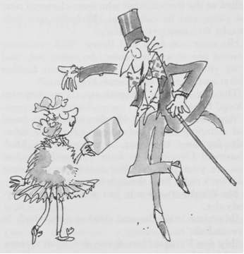

'My dear Veruca! How do you do? What a pleasure this is! You do have an interesting name, don't you? I always thought that a veruca was a sort of wart that you got on the sole of your foot! But I must be wrong, mustn't I? How pretty you look in that lovely mink coat! I'm so glad you could come! Dear me, this is going to be such an exciting day! I do hope you enjoy it! I'm sure you will! I know you will! Your father? How are you, Mr Salt? And Mrs Salt? Overjoyed to see you! Yes, the ticket is quite in order! Please go in!'

The next two children, Violet Beauregarde and Mike Teavee, came forward to have their tickets examined and then to have their arms practically pumped off their shoulders by the energetic Mr Wonka.

And last of all, a small nervous voice whispered, 'Charlie Bucket.'

'Charlie!' cried Mr Wonka. 'Well, well, well! So there you are! You're the one who found your ticket only yesterday, aren't you? Yes, yes. I read all about it in this morning's papers! Just in time, my dear boy! I'm so glad! So happy for you! And this? Your grandfather? Delighted to meet you, sir! Overjoyed! Enraptured! Enchanted! All right! Excellent! Is everybody in now? Five children? Yes! Good! Now will you please follow me! Our tour is about to begin! But do keep together! Please don't wander off by yourselves! I shouldn't like to lose any of you at this stage of the proceedings! Oh, dear me, no!'

Charlie glanced back over his shoulder and saw the great iron entrance gates slowly closing behind him. The crowds on the outside were still pushing and shouting. Charlie took a last look at them. Then, as the gates closed with a clang, all sight of the outside world disappeared.

'Here we are!' cried Mr Wonka, trotting along in front of the group. 'Through this big red door, please! That's right! It's nice and warm inside! I have to keep it warm inside the factory because of the workers! My workers are used to an extremely hot climate! They can't stand the cold! They'd perish if they went outdoors in this weather! They'd freeze to death!'

'But who are these workers?' asked Augustus Gloop.

'All in good time, my dear boy!' said Mr Wonka, smiling at Augustus. 'Be patient! You shall see everything as we go along! Are all of you inside? Good! Would you mind closing the door? Thank you!'

Charlie Bucket found himself standing in a long corridor that stretched away in front of him as far as he could see. The corridor was so wide that a car could easily have been driven along it. The walls were pale pink, the lighting was soft and pleasant.

'How lovely and warm!' whispered Charlie.

'I know. And what a marvellous smell!' answered Grandpa Joe, taking a long deep sniff. All the most wonderful smells in the world seemed to be mixed up in the air around them - the smell of roasting coffee and burnt sugar and melting chocolate and mint and violets and crushed hazelnuts and apple blossom and caramel and lemon peel ...

And far away in the distance, from the heart of the great factory, came a muffled roar of energy as though some monstrous gigantic machine were spinning its wheels at breakneck speed.

'Now this, my dear children,' said Mr Wonka, raising his voice above the noise, 'this is the main corridor. Will you please hang your coats and hats on those pegs over there, and then follow me. That's the way! Good! Everyone ready? Come on, then! Here we go!' He trotted off rapidly down the corridor with the tails of his plum-coloured velvet coat flapping behind him, and the visitors all hurried after him.

It was quite a large party of people, when you came to think of it. There were nine grown-ups and five children, fourteen in all. So you can imagine that there was a good deal of pushing and shoving as they hustled and bustled down the passage, trying to keep up with the swift little figure in front of them. 'Come on' cried Mr Wonka. 'Get a move on, please! We'll never get round today if you dawdle like this!'

Soon, he turned right off the main corridor into another slightly narrower passage.

Then he turned left.

Then left again.

Then right.

Then left.

Then right.

Then right.

Then left.

The place was like a gigantic rabbit warren, with passages leading this way and that in every direction.

'Don't you let go my hand, Charlie,' whispered Grandpa Joe.

'Notice how all these passages are sloping downwards!' called out Mr Wonka. 'We are now going underground! All the most important rooms in my factory are deep down below the surface!'

'Why is that?' somebody asked.

'There wouldn't be nearly enough space for them up on top!' answered Mr Wonka. 'These rooms we are going to see are enormous. They're larger than football fields! No building in the world would be big enough to house them! But down here, under­neath the ground, I've got all the space I want. There's no limit - so long as I hollow it out.'

Mr Wonka turned right.

He turned left.

He turned right again.

The passages were sloping steeper and steeper downhill now.

Then suddenly, Mr Wonka stopped. In front of him, there was a shiny metal door. The party crowded round. On the door, in large letters, it said:

THE CHOCOLATE ROOM

Chapter 15 - The Chocolate Room

'An important room, this!' cried Mr Wonka, taking a bunch of keys from his pocket and slipping one into the keyhole of the door. 'This is the nerve centre of the whole factory, the heart of the whole business! And so beautiful! I insist upon my rooms being beautiful! I can't abide ugliness in factories! In we go, then! But do be careful, my dear children! Don't lose your heads! Don't get over-excited! Keep very calm!'

Mr Wonka opened the door. Five children and nine grown-ups pushed their ways in - and oh, what an amazing sight it was that now met their eyes!

They were looking down upon a lovely valley. There were green meadows on either side of the valley, and along the bottom of it there flowed a great brown river.

What is more, there was a tremendous waterfall halfway along the river - a steep cliff over which the water curled and rolled in a solid sheet, and then went crashing down into a boiling churning whirlpool of froth and spray.

Below the waterfall (and this was the most astonishing sight of all), a whole mass of enormous glass pipes were dangling down into the river from somewhere high up in the ceiling! They really were enormous, those pipes. There must have been a dozen of them at least, and they were sucking up the brownish muddy water from the river and carrying it away to goodness knows where. And because they were made of glass, you could see the liquid flowing and bubbling along inside them, and above the noise of the waterfall, you could hear the never-ending suck-suck-sucking sound of the pipes as they did their work.

Graceful trees and bushes were growing along the riverbanks - weeping willows and alders and tall clumps of rhododendrons with their pink and red and mauve blossoms. In the meadows there were thousands of buttercups.

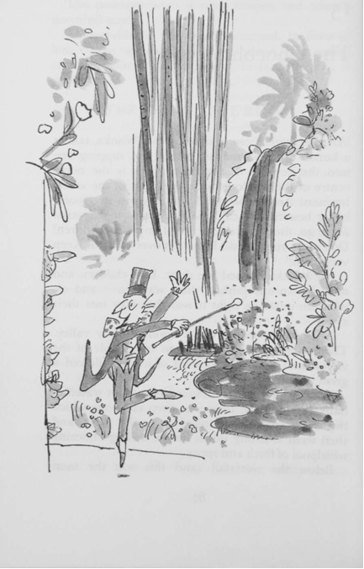

'There!' cried Mr Wonka, dancing up and down and pointing his gold-topped cane at the great brown river. 'It's all chocolate! Every drop of that river is hot melted chocolate of the finest quality. The very finest quality. There's enough chocolate in there to fill every bathtub in the entire country! And all the swimming pools as well! Isn't it terrific? And just look at my pipes! They suck up the chocolate and carry it away to all the other rooms in the factory where it is needed! Thousands of gallons an hour, my dear children! Thousands and thousands of gallons!'

The children and their parents were too flabbergasted to speak. They were staggered. They were dumbfounded. They were bewildered and dazzled.

They were completely bowled over by the hugeness of the whole thing. They simply stood and stared.

'The waterfall is most important!' Mr Wonka went on. 'It mixes the chocolate! It churns it up! It pounds it and beats it! It makes it light and frothy! No other factory in the world mixes its chocolate by waterfall! But it's the only way to do it properly! The only way! And do you like my trees?' he cried, pointing with his stick. 'And my lovely bushes? Don't you think they look pretty? I told you I hated ugliness! And of course they are all eatable! All made of something different and delicious! And do you like my meadows? Do you like my grass and my buttercups? The grass you are standing on, my dear little ones, is made of a new kind of soft, minty sugar that I've just invented! I call it swudge! Try a blade! Please do! It's delectable!'

Automatically, everybody bent down and picked one blade of grass - everybody, that is, except Augustus Gloop, who took a big handful.

And Violet Beauregarde, before tasting her blade of grass, took the piece of world-record-breaking chewing-gum out of her mouth and stuck it carefully behind her ear.

'Isn't it wonderful!' whispered Charlie. 'Hasn't it got a wonderful taste, Grandpa?'

'I could eat the whole field,' said Grandpa Joe, grinning with delight. 'I could go around on all fours like a cow and eat every blade of grass in the field!'

'Try a buttercup!' cried Mr Wonka. 'They're even nicer!'

Suddenly, the air was filled with screams of excitement. The screams came from Veruca Salt. She was pointing frantically to the other side of the river. "Look! Look over there!' she screamed. 'What is it? He's moving! He's walking! It's a little person! It's a little man! Down there below the waterfall!'

Everybody stopped picking buttercups and stared across the river.

'She's right, Grandpa!' cried Charlie. 'It is a little man! Can you see him?'

'I see him, Charlie!' said Grandpa Joe excitedly.

And now everybody started shouting at once.

'There's two of them!'

'My gosh, so there is!'

'There's more than two! There's one, two, three, four, five!'

'What are they doing?'

'Where do they come from?'

'Who are they?'

Children and parents alike rushed down to the edge of the river to get a closer look.

'Aren't they fantastic!'

'No higher than my knee!'

'Look at their funny long hair!'

The tiny men - they were no larger than medium-sized dolls - had stopped what they were doing, and now they were staring back across the river at the visitors. One of them pointed towards the children, and then he whispered something to the other four, and all five of them burst into peals of laughter.

'But they can't be real people,' Charlie said.

'Of course they're real people,' Mr Wonka an­swered. 'They're Oompa-Loompas.'