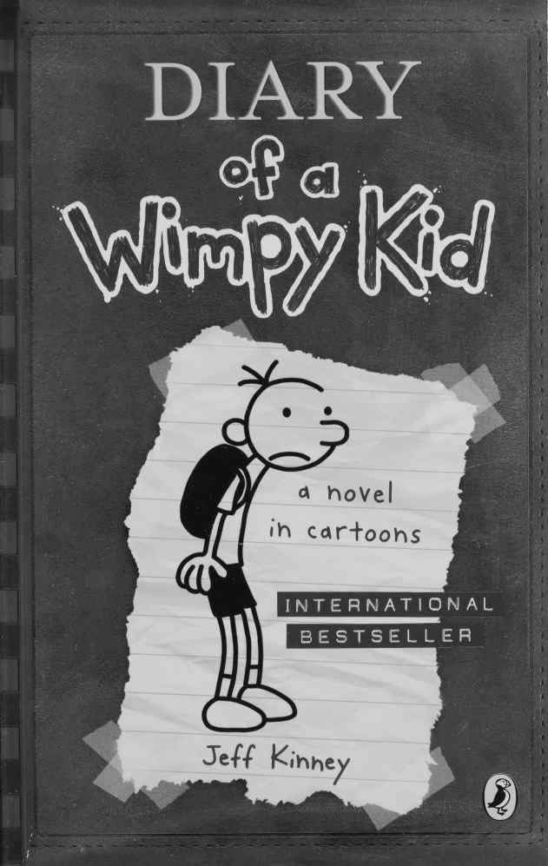

Diary of a Wimpy Kid
By
Jeff Kinney
This electronic copy of the original work is made under a Copyright Licensing Agency license by The Seeing Ear. It is for the personal use of a Print Disabled Person and may not be further copied, (including any electronic copying or transmission), or dealt with without permission, save as may be permitted by law.
Contents

JANUARY 107
FEBRUARY 122
MARCH 144
APRIL 152
MAY 161
JUNE 172

JANUARY
Wednesday
I found a way to have some fun with the Big Wheel Rowley got me for Christmas. I came up with this game where one guy rides down the hill and the other guy tries to knock him off with a football.
Rowley was the first one down the hill and I was the thrower.
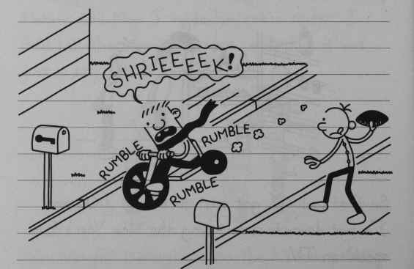
“SHRIEEEEK!”
Rumble rumble rumble
It’s a lot harder to hit a moving target than I thought. Plus, I didn’t get a lot of practice. It took Rowley, like, ten minutes to walk the Big Wheel back up the hill after every trip down.
136
Rowley kept asking to switch places and have me be the one who rides the Big Wheel, but I’m no fool. That thing was hitting thirty five miles an hour, and it didn’t have any brakes.
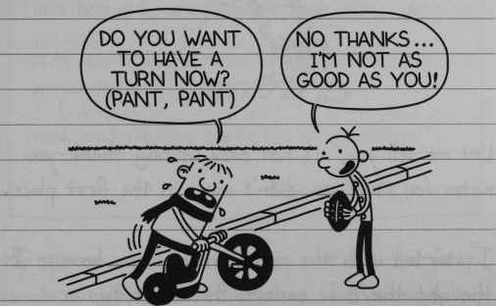
“Do you want to have a turn now?” Pant, pant.
“No thanks…I’m not as good as you!”
Anyway, I never did knock Rowley off the Big Wheel today. But I guess I have something to work at over the rest of Christmas vacation.
Thursday
I was heading up to Rowley’s today to play our Big Wheel game again, but Mom said I had to finish my Christmas thank-yous before I went out anywhere.
137
I thought I could just crank out my thank-you cards in half an hour, but when it came to actually writing them, my mind went blank.
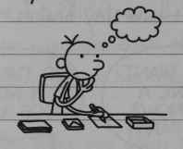
Let me tell you, it’s not easy writing thank-you notes for stuff you didn’t want in the first place.
I started with the non-clothes items, because I thought they’d be easiest. But after two or three cards, I realized I was practically writing the same thing every time.
So I wrote up a general form on the computer with blanks for the things that needed to change. Writing the cards from there was a breeze.
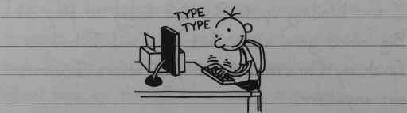
TYPE TYPE
138
Dear Aunt Lydia,
Thank you so much for the awesome ENCYLOPEDIA!
How did you know I wanted that for Christmas?
I love the way the ENCYCLOPEDIA looks on my SHELF!
All my friends will be so jealous that I have my own ENCYCLOPEDIA.
Thank you for making this the best Christmas ever!
Sincerely, Greg.
My system worked out pretty well for the first couple of gifts, but after that, not so much.
Dear Aunt Loretta
Thank you so much for the awesome PANTS!
How did you know I wanted that for Christmas?
I love the way the PANTS looks on my LEGS!
All my friends will be so jealous that I have my own PANTS.
Thank you for making this the best Christmas ever!
Sincerely, Greg.
139

Friday
I finally knocked Rowley off the Big Wheel today, but it didn’t happen the way I expected. I was trying to hit him on the shoulder, but I missed and the football went under the front tyre.
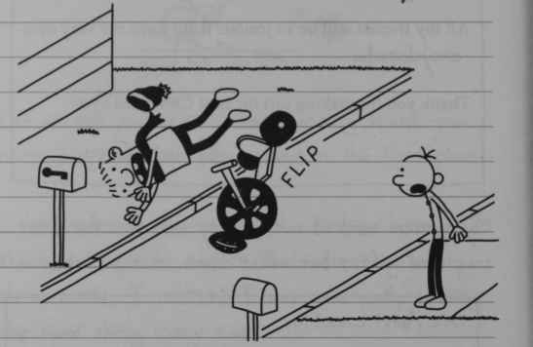
FLIP
Rowley tried to break his fall by sticking out his arms, but he landed pretty hard on his left hand. I figured he’d just shake it off and just get right back on the bike, but he didn’t.
I tried to cheer him up, but all the jokes that usually crack him up weren’t working.
140
So I knew he must be hurt pretty bad.
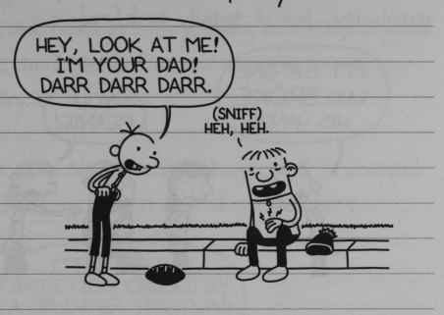
“Hey, look at me! I’m your Dad! Darr Darr Darr.”
SNIFF. “Heh Heh”

Monday
Christmas vacation is over, and now we’re back at school. And you remember Rowley’s Big Wheel accident? Well, he broke his hand, and now he has to wear a cast. And today, everyone was crowding around him like he was a hero or something.
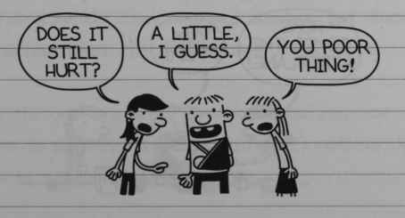
“Does it still hurt?”
“A little, I guess”
“You poor thing.”
141
I tried to cash in on some of Rowley’s new popularity, but it totally backfired.
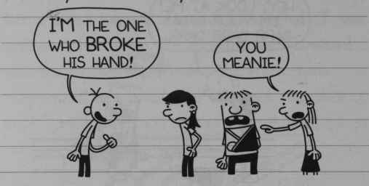
“I’m the one who broke his hand!”
“You meanie!”
At lunch a bunch of girls invited Rowley over to their table so they could FEED him.
What really ticks me off about that is that Rowley is right-handed, and it’s his LEFT hand that’s broken. So he can feed himself just fine.
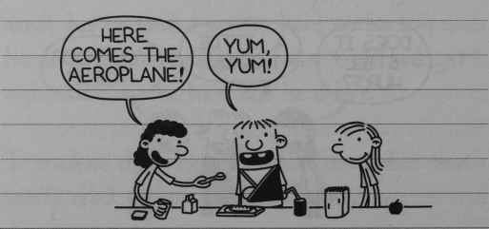
“Here comes the aeroplane!”
“Yum, yum!”
142
Tuesday
I realized Rowley’s injury thing is a pretty good racket, so I decided it was time for me to have an injury of my own.
I took some bandages from home and I wrapped up my hand to make it look like it was hurt.
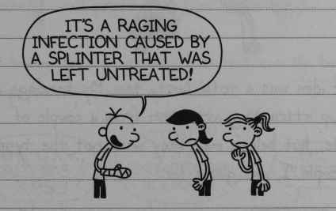
“It’s a raging infection caused by a splinter that was left untreated!”
I couldn’t figure out why the girls weren’t swarming me like they swarmed Rowley, but then I realized what the problem was.
See, the cast is a great gimmick because everyone wants to sign their name on it. But it’s not exactly easy to sign bandage with a pen.
143
So I came up with a solution that I thought was just as good.
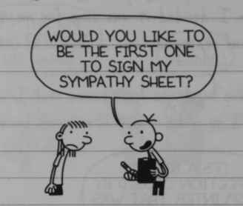
“Would you like to be the first one to sign my sympathy sheet?”
That idea was a total bust, too. My bandage did end up attracting attention from a couple of people, but believe me, they were not the type of people I was going for.
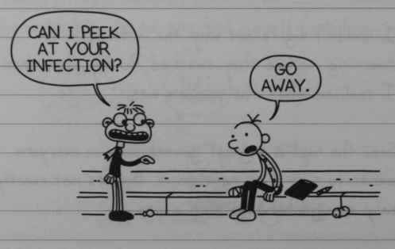
“Can I peek at your infection?”
“Go away”
144

Monday
Last week we started the third quarter at school, so now I have a whole bunch of new classes. One of the classes I signed up for is something called Independent Study.
I WANTED to sign up for Home Economics 2, because I was pretty good at Home Ec 1.
But being good at sewing does not exactly buy you popularity points at school.
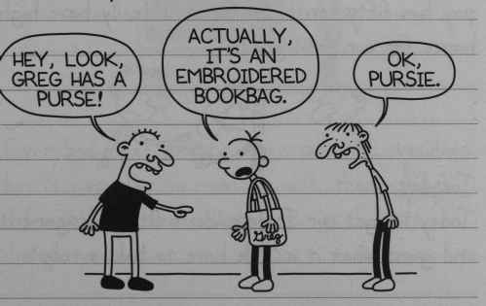
“Hey, look, Greg has a purse!”
“Actually, it’s an embroidered bookbag.”
“OK pursie.”
Anyway, this Independent Study thing is an experiment they’re trying out at our school for the first time.
145
The idea is that the class gets assigned a project, and then you have to work on it together with no teacher in the room for the whole quarter.
The catch is that when you’re done, everyone in your group gets the same grade. I found out that Ricky Fisher is in my class, which could be a big problem.
Ricky’s big claim to fame is that he’ll pick the gum off the bottom of a desk and chew it if you pay him fifty cents. So I don’t really have high hopes for our final grade.
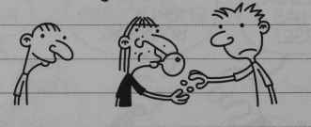

Tuesday
Today we got our Independent Study assignment, and guess what it is? We have to build a robot.
At first everybody kind of freaked out, because we thought we were going to have to build the robot from scratch.
146
But Mr Darnell told us we don’t have to build an actual robot. We just need to come up with ideas for what our robot might look like and what kind of things it would be able to do.
Then he left the room, and we were on our own. We started brainstorming right away. I wrote down a bunch of ideas on the blackboard.
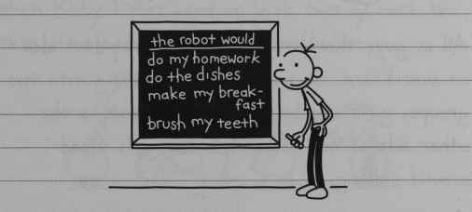
the robot would
do my homework
do the dishes
make my breakfast
brush my teeth
Everybody was pretty impressed with my ideas, but it was easy to come up with them. All I did was write down all the things I hate doing myself.
But a couple of the girls got up to the front of the room, and they had some ideas of their own. They erased my list and drew up their own plan.
147
They wanted to invent a robot that would give you dating advice and have ten types of lip gloss on its fingertips.
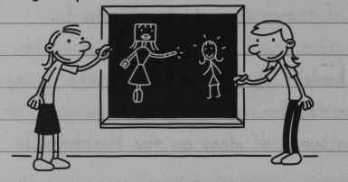
All us guys thought this was the stupidest idea we ever heard. So we ended up splitting into two groups, girls and boys. The boys went to the other side of the room while the girls stood around talking.
Now that we had all the serious workers in one place, we got to work. Someone had the idea that you can say your name to the robot and it can say it back to you.
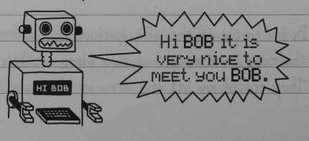
“Hi BOB it is very nice to meet you BOB”
148
But then someone else pointed out that you shouldn’t be able to use bad words for your name, because the robot shouldn’t be able to swear. So we decided we should come up with a list of all the bad words a robot shouldn’t be able to say.
We came up with all the regular bad words, but then Ricky Fisher came up with twenty more the rest of us had never even heard before.
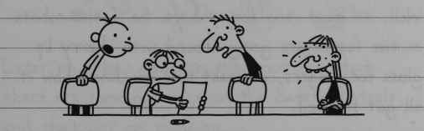
So Ricky ended up being one of the most valuable contributors on this project.
Right before the bell rang, Mr Darnell came back in the room to check our progress.
He picked up the piece of paper we were writing on and read it over.
149
To make a long story short, Independent Study is cancelled for the rest of the year.
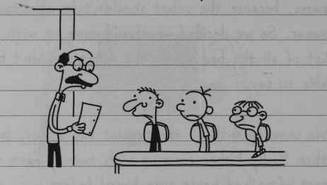
Well, at least it is for us boys. So if the robots of the future are going around with cherry lip gloss for fingers, at least you now know how it got started.

Thursday
In school today they had a general assembly and showed the movie “It’s Great to be Me”, which they show us every year.
The movie is all about how you should be happy with who you are and not change anything about yourself.
150
To be honest with you, I think that’s a really dumb message to be telling kids, especially the ones at my school.
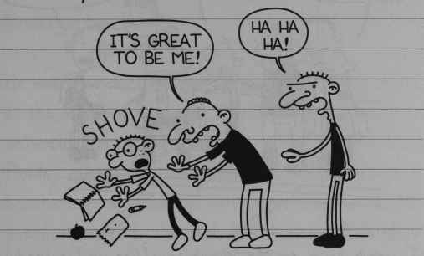
SHOVE
“It’s great to be me!”
“Ha ha ha!”
Later on they made an announcement that there are some openings on the Safety Patrols, and that got me thinking.
If someone picks on a Safety Patrol, it can get them suspended. The way I figure it, I can use any protection I can get.
Plus, I realized that maybe being in a position of authority could be good for me.
151
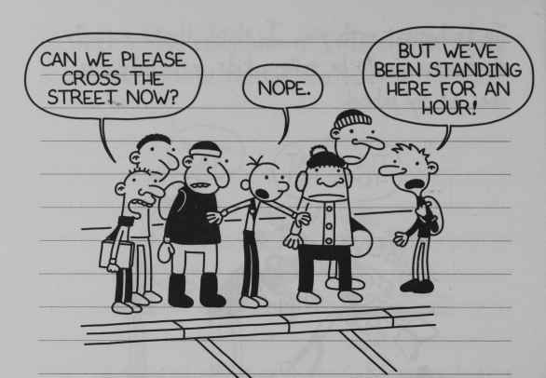
“Can we please cross the street now?”
“Nope”
“But we’ve been standing here for an hour!”
I went down to Mr Winsky’s office and signed myself up, and I got Rowley to sign up, too. I thought Mr Winsky would make us do a bunch of chin-ups or jumping jacks or something to prove we were up to the job, but he just handed us our belts and badges on the spot.
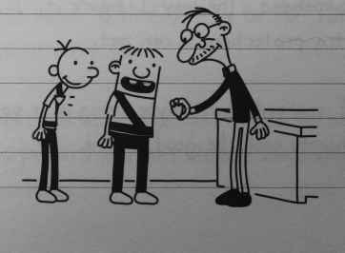
152
Mr Winsky said the openings were for a special assignment. Our school is right next to the elementary school, and they’ve got a half-day kindergarten there.
He wants us to walk the morning-session kids home in the middle of the day. I realized that would mean we would miss twenty minutes of Pre-Algebra. Rowley must have figured that out, too, because he started to speak up. But I gave him a wicked pinch underneath the desk before he could finish his sentence.
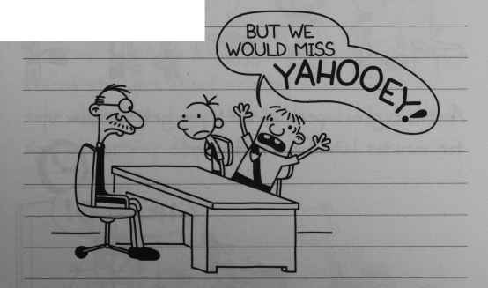
“But we would miss YAHOOEY!”
I couldn’t believe my luck. I was getting instant bully protection and a free pass from half of Pre-Algebra, and I didn’t even have to lift a finger.
153

Tuesday
Today was our first day as Safety Patrols. Me and Rowley don’t technically have stations like all the other Patrols, so that means we don’t have to stand out in the freezing cold for an hour before school.
But that didn’t stop us from coming to the cafeteria for the free hot chocolate they hand out to the other Patrols before homeroom.
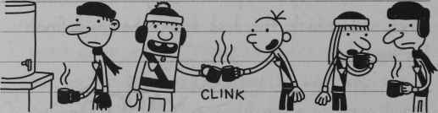
CLINK
Another great perk is you get to show up ten minutes late for first period.
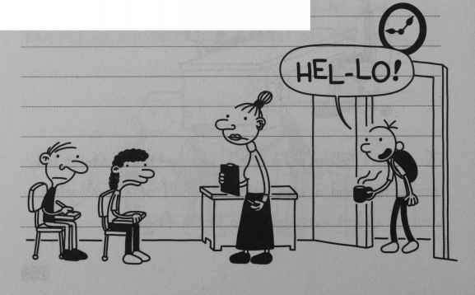
“HEL-LO!”
154
I’m telling you, I’ve got it made with this Safety Patrol thing.
At 12:15, me and Rowley left school and walked the kindergartners home. The whole trip ate up forty-five minutes, and there were only twenty minutes of Pre-Algebra left when we got back.
Walking the kids home was no sweat. But one of the kindergartners started to smell a little funny, and I think maybe he had an accident in his pants.
He tried to let me know about it, but I just stared straight ahead and kept walking. I’ll take these kids home, but believe me, I didn’t sign up for any diaper duty.
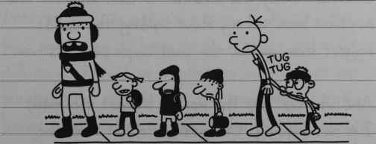
TUG TUG
155

FEBRUARY
Wednesday
Today it snowed for the first time this winter, and school was cancelled. We were supposed to have a test in Pre-Algebra, and I’ve kind of slacked off ever since I became a Safety Patrol. So I was psyched.
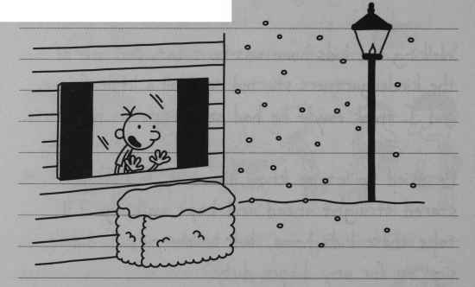
I called Rowley and told him to come over. Me and him have been talking about building the world’s biggest snowman for the past couple of years now.
And when I say the world’s biggest snowman, I’m not kidding. Our goal is to get into the “Guinness Book of World Records”.
156
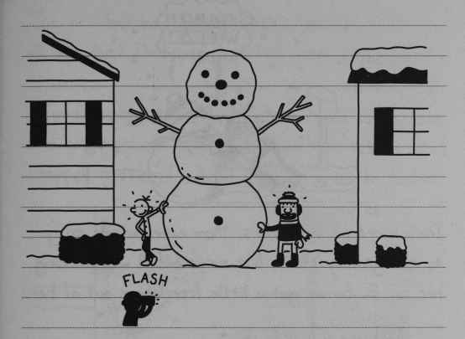
FLASH
But every time we’ve got serious about going for the record, all the snow has melted, and we’ve missed our window of opportunity. So this year I wanted to get started right away.
When Rowley came over, we started rolling the first snowball to make the base. I figured the base was going to have to be at least eight feet tall on its own if we wanted to have a shot at breaking the record. But the snowball got real heavy, and we had to take a bunch of breaks in between rolls so we could catch our breath.
157
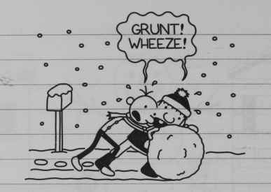
GRUNT! WHEEZE!
During one of our breaks, Mom came outside to go to the grocery store, but our snowball was blocking her car in. so we got a little free labour out of her.
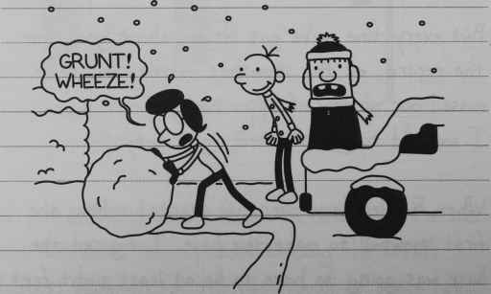
GRUNT! WHEEZE!
After our break, me and Rowley pushed that snowball until we couldn’t push it any further. But when we looked behind us we saw the mess we had made.
158
The snowball had got so heavy that it tore up all the turf Dad had just laid down last autumn. I was hoping it would snow a few more inches and cover up our tracks, but just like that, it stopped snowing.
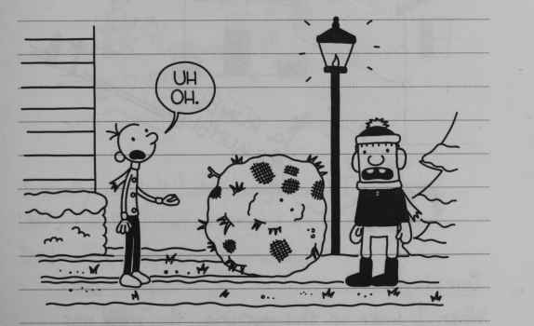
“Uh Oh”
Our plan to build the world’s biggest snowman was starting to fall apart. So I came up with a better idea for our snowball.
Every time it snows, the kids from Whirley Street use our hill for sledging, even though this isn’t their neighbourhood.
159
So tomorrow morning, when the Whirley Street kids come marching up our hill, me and Rowley are going to teach those guys a lesson.
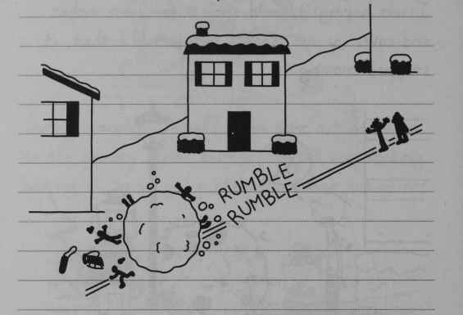
RUMBLE RUMBLE

Thursday
When I woke up this morning, the snow was already starting to melt. So I told Rowley to hurry up and get down to my house.
While I was waiting for Rowley to show up, I watched Manny trying to build a snowman out of the piddly crumbs of snow that were left over from our snowball.
160
It was actually kind of pathetic.
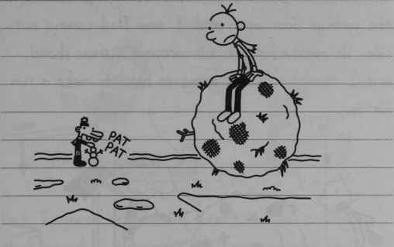
PAT PAT
I really couldn’t help doing what I did next. Unfortunately for me, right at that moment, Dad was at the front window.
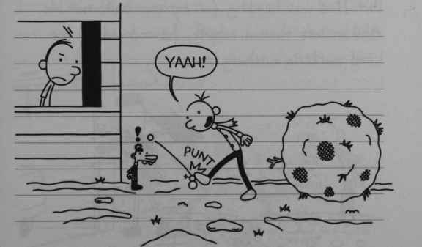
“Yaah!”
PUNT
161
Dad was ALREADY mad with me for tearing up the turf, so I knew I was in for it. I heard the garage door open and I saw Dad coming out-side. He marched right out carrying a snow shovel, and I thought I was going to have to make a run for it.
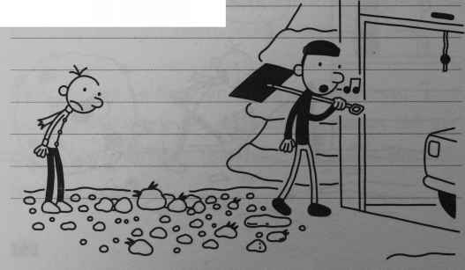
But Dad was heading for my snowball, not me. And in less than a minute he reduced all our hard work to nothing.
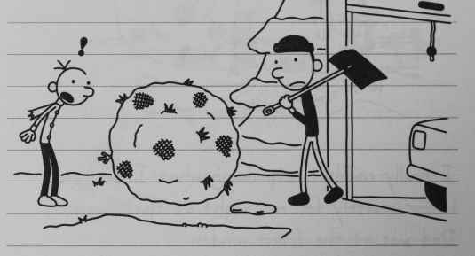
162
Rowley came by a few minutes later. I thought he might actually get a lick out of what happened.
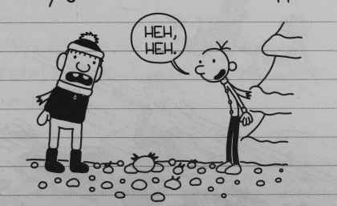
“Heh heh”
But I guess he had his heart set on rolling that snowball down the hill, and he was really mad. But get this: Rowley was mad at ME for what DAD did.
I told Rowley he was being a big baby, and we got in a shoving match. Right when it looked like we were going to get in an all-out fight, we got ambushed from the street.
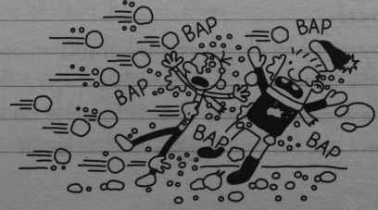
BAP BAP BAP BAP BAP
163
It was a hit-and-run by the Whirley Street kids.
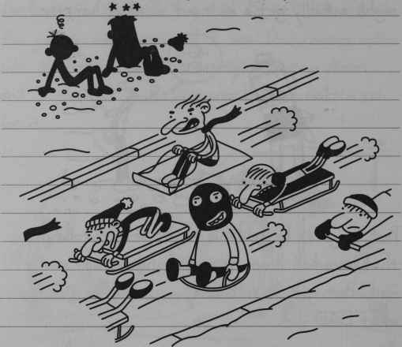
And if Mrs Levine, my English Teacher, was there, I’m sure she would have said the whole situation was “ironic”.

Wednesday
Today at school they announced there’s an opening for the cartoonist job in the school paper. There’s only one comic slot, and up until now this kid named Bryan Little has been hogging it all to himself.
164
Bryan has this comic called “Wacky Dawg”, and when it started off, it was actually pretty funny.
But lately, Bryan’s been using his strip to handle his personal business. I guess that’s why they gave him the axe.
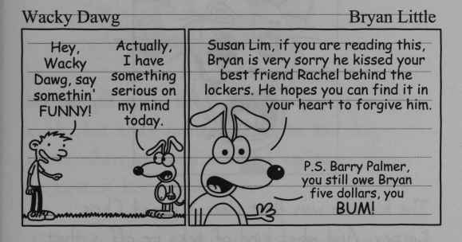
Wacky Dawg Bryan Little
“Hey Wacky Dawg, say somethin’ funny!”
“Actually, I have something serious on my mind today”
“Susan Lim, if you are reading this, Bryan is very sorry he kissed your best friend Rachel behind the lockers. He hopes you can find it in your heart to forgive him.
PS Barry Palmer, you still owe Bryan five dollars, you BUM!”
As soon as I heard the news, I knew I had to try out. “Wacky Dawg” made Bryan Little a celebrity at our school, and I wanted to get in on some of that kind of fame.
I had a taste of what it’s like to be famous at my school when I won honorable mention in this anti-smoking contest they had.
165
All I did was trace a picture from one of Rodrick’s heavy metal magazines, but luckily, no one ever found out.
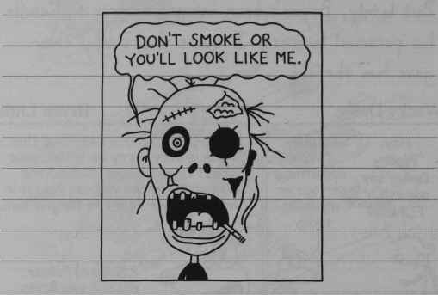
Don’t smoke or you’ll look like me.
The kid who won first place is named Chris Carney. And what kind of ticks me off is that Chris smokes at least a pack of cigarettes a day.
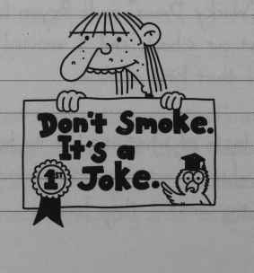
Don’t Smoke. It’s a Joke.
166

Thursday
Me and Rowley decided to team up and do a cartoon together. So after school today he came over to my house, and we got to work.
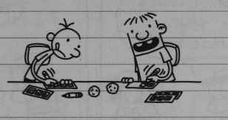
We banged out a bunch of characters real quick, but that turned out to be the easy part. When we tried to think up some jokes, we kind of hit a wall.
I finally came up with a good solution.
I made up a cartoon where the punch line of every strip is “Zoo-Wee Mama!”
That way we wouldn’t get bogged down with having to write actual jokes, and we could concentrate on the pictures.
167
For the first couple of strips, I did the writing and drew the characters, and Rowley drew the boxes around the pictures.
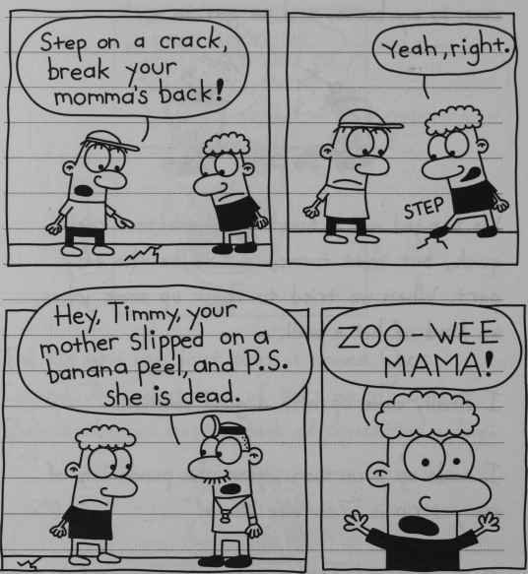
“Step on a crack, break your momma’s back!”
“Yeah, right,” STEP
“Hey, Timmy, your mother slipped on a banana peel, and P.S. she is dead”
“Zoo-Wee Mama!”
Rowley started complaining that he didn’t have enough to do, so I let him write a few of the strips.
168
But to be honest with you, there was a pretty obvious drop in quality once Rowley started doing the writing.
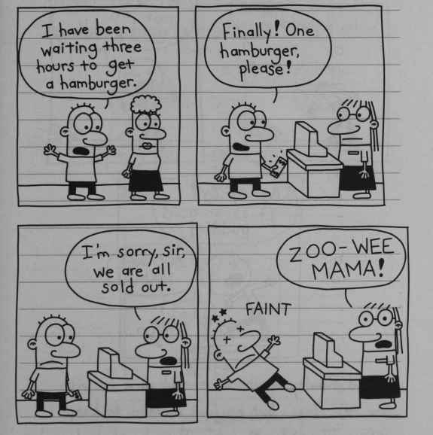
“I have been waiting three hours to get a hamburger”
“Finally! One hamburger please!”
“I’m sorry sir, we are all sold out.”
“Zoo-Wee Mama!”
Eventually I got kind of sick of the “Zoo-Wee Mama!” and I pretty much let Rowley take over the whole operation.
169
And believe it or not, Rowley’s drawing skills are worse than his writing skills.
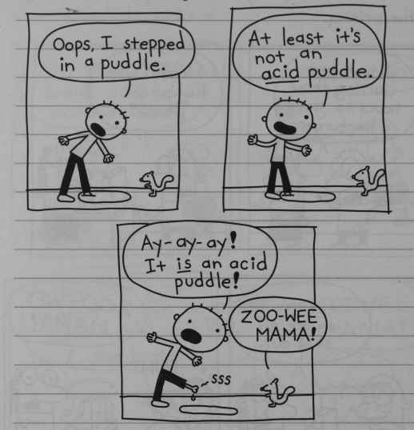
“Oops, I stepped in a puddle.”
“At least it’s not an acid puddle”
“Ay-ay-ay! It is an acid puddle!” SSS
“Zoo-Wee Mama!”
I told Rowley maybe we should come up with some new ideas, but he just wanted to keep writing “Zoo-Wee Mamas”. Then he packed up his comics and went home, which was fine by me. I don’t really want to be partnered up with a kid who doesn’t draw noses anyway.
170

Friday
After Rowley left yesterday, I really got to work on some comics. I came up with character called Creighton the Cretin, and I got on a roll.
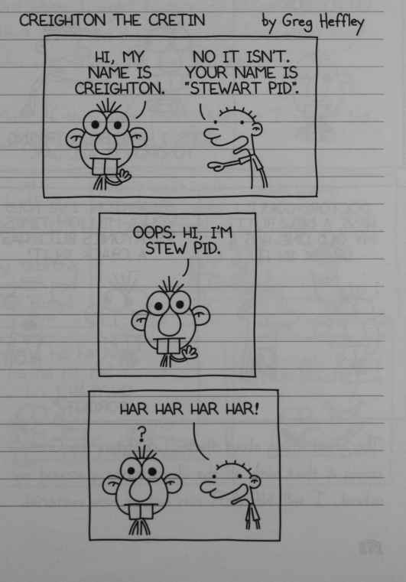
CREIGHTON THE CRETIN by Greg Heffley
“Hi, my name is Creighton”
“No it isn’t. Your name is Stewart Pid”.
“Oops. Hi, I’m Stew pid”
“Har har har har!”
171
I must’ve banged out twenty strips, and I didn’t even break a sweat.
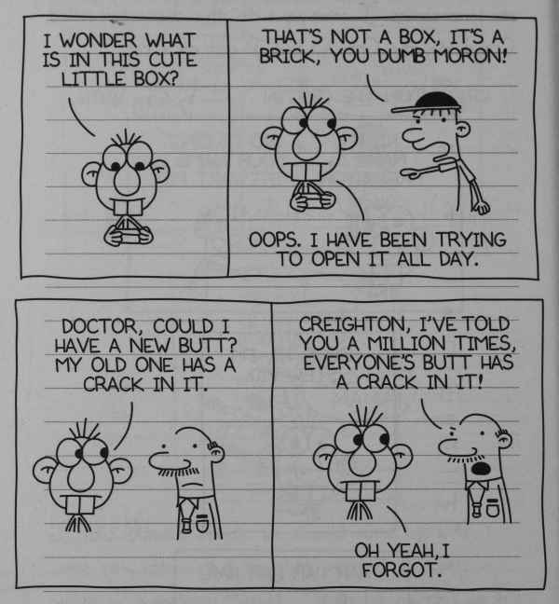
“I wonder what is in this cute little box?”
“That’s not a box, it’s a brick, you dumb moron!”
“Oops, I have been trying to open it all day.”
“Doctor, could I have a new butt? My old one has a crack in it.”
“Creighton, I’ve told you a million times, everyone’s butt has a crack in it!”
“Oh yeah. I forgot.”
The great thing about these “Creighton the Cretin” is that with all the idiots running around my school, I will NEVER run out of new material.
172
When I got to school today, I took my comics to Mr Ira’s office. He’s the teacher who runs the school newspaper.
But when I went to turn my strips in, I saw that there was a pile of comics from other kids who were trying out for the job.
Most of them were pretty bad, so I wasn’t too worried about the competition.
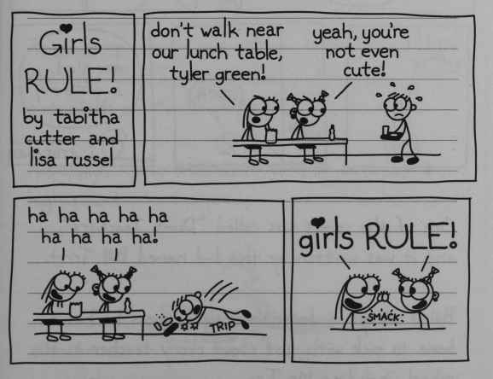
Girls RULE! by Tabitha cutter and lisa russel
“don’t walk near our lunch table, tyler green!”
“yeah, you’re not even cute!”
“ha ha ha ha ha ha ha ha ha!”
“girls RULE!” SMACK
I73
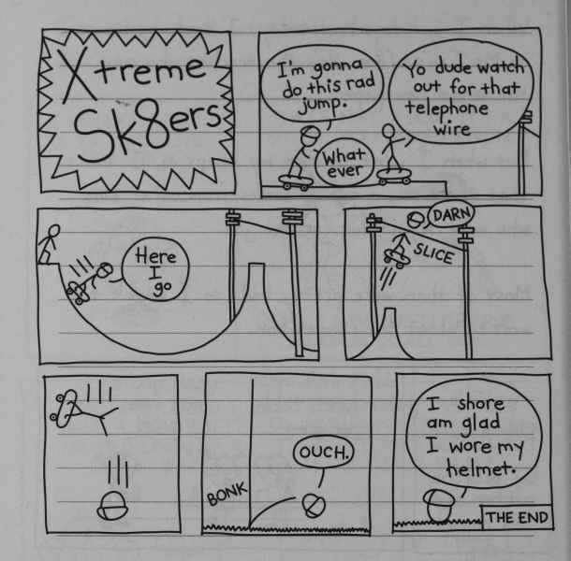
Xtreme Sk8ers
“I’m gonna do this rad jump”
“Yo dude watch out for that telephone wire”
“Whatever”
“Here I go”
“Darn” SLICE
BONK “Ouch.”
“I shore am glad I wore my helmet.” THE END
One of the comics was called “Dumb Teachers”, and it was written by this kid called Bill Tritt.
Bill is always in detention, so I guess he has a bone to pick with almost every teacher in the school, including Mr Ira.
174
So I’m not too worried about the chances of Bill’s comic getting in either.
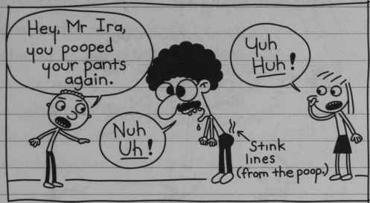
“Hey, Mr Ira, you pooped your pants again”
“Nuh Uh!” Stink lines (from the poop.)
“Yuh Huh!”
There were actually one or two decent comics in the tray. But I slipped them under a pile of paperwork on Mr Ira’s desk.
Hopefully, those ones won’t turn up until I’m in high school.
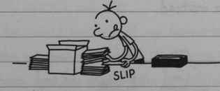
SLIP
175

Thursday
Today, during morning announcements, I got the news I was hoping for.
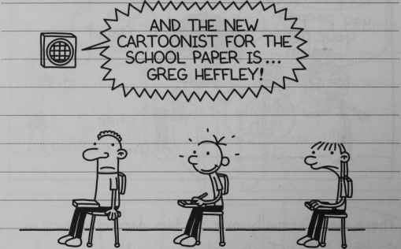
“And the new cartoonist for the school paper is… Greg Heffley!”
The paper came out today at lunch time, and everyone was reading it.
I really wanted to pick up a copy to see my name in print, but I decided to just play it cool for a while instead.
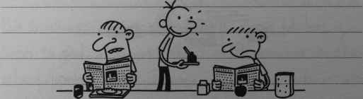
176
I sat at the end of the lunch table so there would be plenty of room for me to start signing autographs for my new fans. But nobody was coming over to tell me how great my comic was, and I started to get the feeling something was wrong.
I grabbed a paper and went into the bathroom to check it out. And when I saw my comic, I practically had a heart attack.
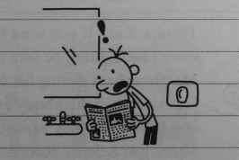
Mr Ira told me he had made some “minor edits” to my comic. I thought he just meant he fixed spelling mistakes and stuff like that, but he totally butchered it.
The comic he ruined was one of my favourite ones, too. In the original, Creighton the Cretin is taking a maths test, and he accidently eats it. And then the teacher yells at him for being such a moron.
177
By the time Mr Ira was done with it, you practically couldn’t recognize it as the same strip.
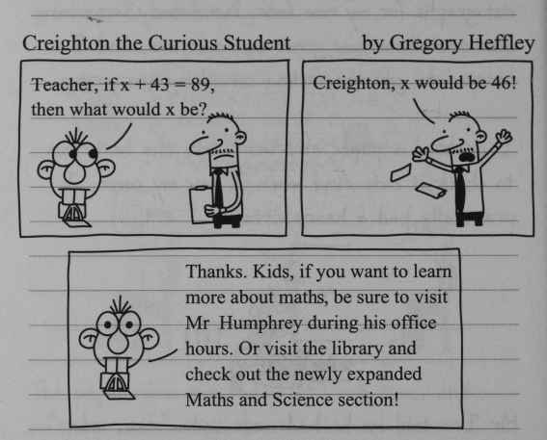
Creighton the Curious Student by Gregory Heffley
“Teacher, if x + 43 = 89, then what would x be?”
“Creighton, x would be 46!”
“Thanks. Kids, if you want to learn more about maths, be sure to visit Mr Humphrey during his office hours. Or visit the library and check out the newly expanded Maths and Science section!”
So I’m pretty sure I won’t be signing autographs any time soon.
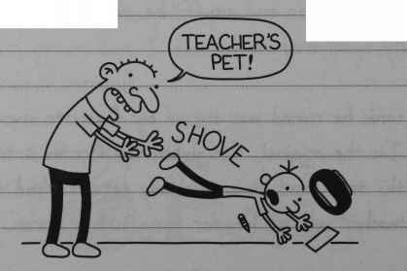
“Teacher’s pet!” SHOVE
178

MARCH
Me and Rowley were enjoying our hot chocolate in the cafeteria with the rest of the Patrols today, and there was an announcement on the loudspeaker.
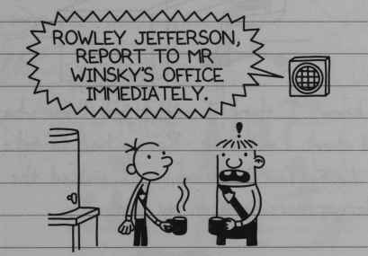
“Rowley Jefferson, report to Mr Winsky’s office immediately.”
Rowley went down to Mr Winsky’s office, and when Rowley came back fifteen minutes later, he looked pretty shaken up.
Apparently Mr Winsky got a call from a parent who said they witnessed Rowley “terrorizing” the kindergartners when he was supposed to be walking them home from school. And Mr Winsky was really mad about it.
179
Rowley said Mr Winsky yelled at him for about ten minutes and said his actions “disrespected the badge”.
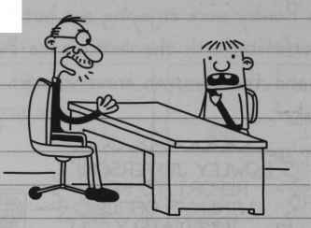
You know, I think I might just know what this is all about. Last week, Rowley had to take a quiz during fourth period, so I walked the kindergartners home on my own.
It had rained that morning, and there were a lot of worms on the pavement.. So I decided to have some fun with the kids.
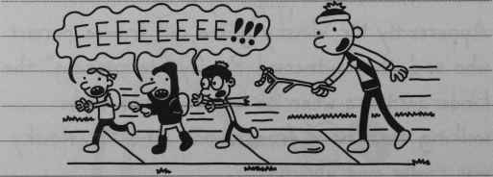
“EEEEEEEE!!!”
180
But some neighbourhood lady saw what I was doing, and she yelled at me from her front porch.
It was Mrs Irvine, who is friends with Rowley’s mom. She must have thought I was Rowley because I was borrowing his hat. And I wasn’t about to correct her, either.
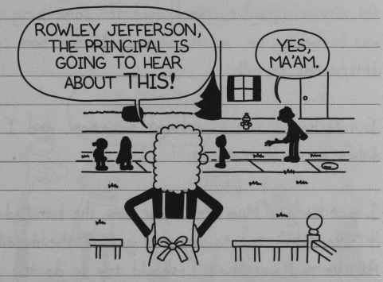
“Rowley Jefferson, the principal is going to hear about THIS!”
“Yes, ma’am.”
I forgot about the whole incident until today.
Anyway, Mr Winsky told Rowley he’s going to have to apologize to the kindergartners tomorrow morning, and that he’s suspended from Patrols for a week.
181
I knew I should probably tell Mr Winsky it was me who chased the kids with the worms. But I wasn’t ready to set the record straight just yet. I knew if I confessed, I’d lose my hot chocolate privileges. And that right there was enough to keep me quiet for the time being.
At dinner tonight, Mom could tell something was bothering me, so she came up to my room afterwards to talk.
I told her I was in a tough situation, and I didn’t know what to do.
I got to give Mom credit for how she handled it. She didn’t try to pry and get all the details. All she said was that I should try to do the “right thing”, because it’s our choices that make us who we are.
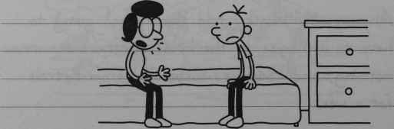
182
I figure that’s pretty decent advice. But I’m still not 100% sure what I’m going to do tomorrow.

Thursday
Well, I was up all night tossing and turning over this Rowley situation, but I finally made up my mind. I decided the right thing to do was to just let Rowley take one for the team this time around.
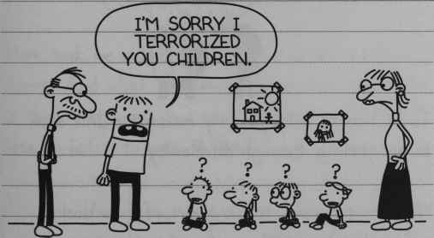
“I’m sorry I terrorized your children.”
On the way home from school, I came clean with Rowley and told him the whole truth about what happened, and how it was me who chased the kids with the worms.
183
Then I told him there were lessons we could both learn from this. I told him I learnt to be more careful about what I did in front of Mrs Irvine’s house, and that he learnt a valuable lesson, too, which is this: be careful about who you lend your hat to.
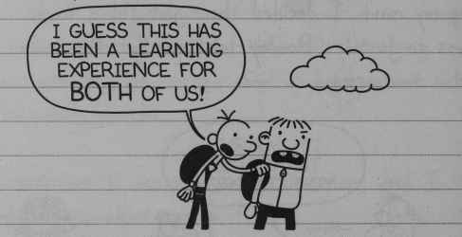
“I guess this has been a learning experience for BOTH of us!”
To be honest with you, my message didn’t seem to be getting through to Rowley.
We were supposed to hang out after school today, but he said he was just going to go home and take a nap.
I couldn’t really blame him. Because if I didn’t have my hot chocolate this morning, I wouldn’t have had much energy, either.
184
When I got home, Mom was waiting for me at the front door.
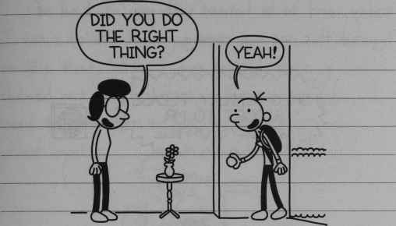
“Did you do the right thing?”
“Yeah!”
Mom took me out to get some ice cream as a special treat. And what this whole episode has taught me is that every once in a while, it’s not such a bad idea to listen to your mother.
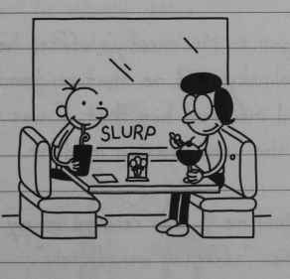
SLURP
185

Tuesday
There was another announcement on the loudspeaker today, and to be honest with you, I kind of figured this one was coming.
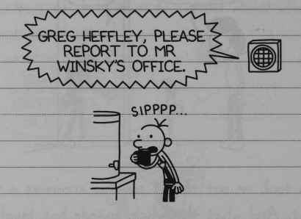
“Greg Heffley, please report to Mr Winsky’s office.”
SIPPP
I knew it was just a matter of time before I got busted for what happened last week.
When I got to Mr Winsky’s office, he was really mad. Mr Winsky told me that an “anonymous source” had informed him that I was the real culprit in the worm-chasing incident.
Then he told me I was relieved of my Safety Patrol duties “effective immediately”.
186
Well, it doesn’t take a detective to figure out that the anonymous source was Rowley.
I can’t believe Rowley went and backstabbed me like that. While I was sitting there getting chewed out by Mr Winsky, I was thinking, I need to remember to give my friend a lecture about loyalty.
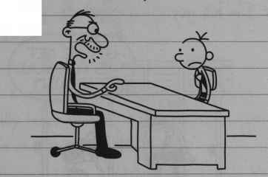
Later on today, Rowley got reinstated as a Patrol. And get this: he actually got a PROMOTION. Mr Winsky said Rowley had “exhibited dignity under false suspicion”.
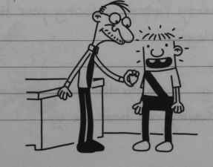
187
I thought about really letting Rowley have it for ratting me out like that, but then I realized something.
In June, all the officers in the Safety Patrols go on a trip to Six Flags, and they get to take along one friend. I need to make sure Rowley knows I’m his guy.
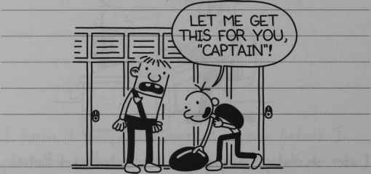
“Let me get this for you CAPTAIN!”

Tuesday
Like I said before, the worst part of getting kicked off Safety Patrols is losing your hot chocolate privileges.
Every morning, I go to the back door of the cafeteria so Rowley can hook me up.
188
But either my friend has gone deaf or he’s too busy kissing the other officer’s butts to notice me at the window.
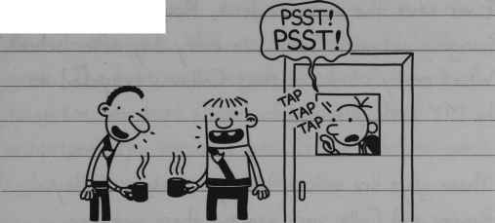
“Psst! PSST!”
TAP TAP TAP
In fact, now that I think of it, Rowley has been TOTALLY giving me the cold shoulder lately. And that’s really lame, because if I recall correctly, HE’S the one that sold ME out.
Even though Rowley has been a total jerk lately, I tried to break the ice with him today, anyway. But even THAT didn’t seem to work.
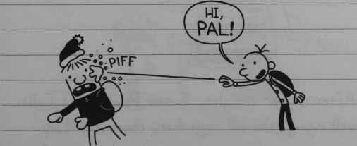
“Hi, PAL!”
PIFF
189

APRIL
Friday
Ever since the worm incident, Rowley has been hanging out with Colin Lee every day after school. What really stinks is that Colin is supposed to be MY backup friend.
Those guys are acting totally ridiculous. Today Rowley and Colin were wearing these matching T-shirts, and it made me just about want to vomit.
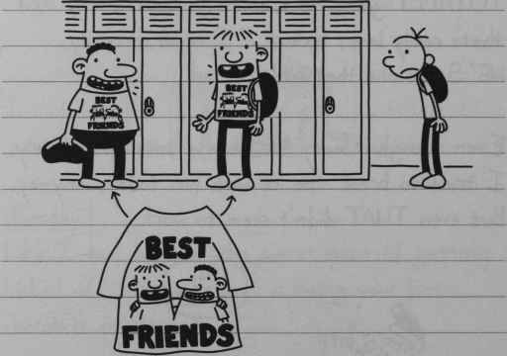
BEST FRIENDS
After dinner tonight, I saw Rowley and Colin walking up the hill together, chumming it up.
190
Colin had his overnight bag, so I knew they were going to have a sleepover at Rowley’s.
And I thought, Well, two can play at THAT game. The best way to get back at Rowley was to get a new best friend of my own. But unfortunately, the only person who came to mind at that moment was Fregley.
I went up to Fregley’s with my overnight bag so Rowley could see that I had other friend options, too.
When I got there, Fregley was in his front yard stabbing a kite with a stick. That’s when I started to think maybe this wasn’t the best idea after all.
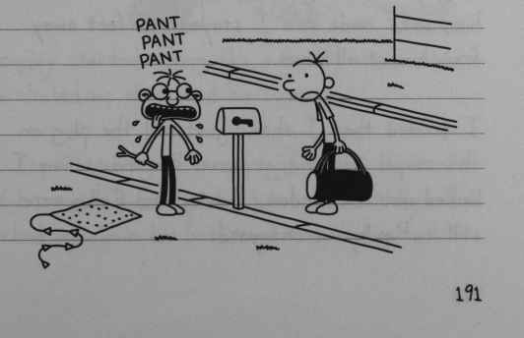
PANT PANT PANT
191
But Rowley was in his front yard , and he was watching me. So I knew there was no turning back.
I invited myself into Fregley’s house. His mom said she was excited to see Fregley with a “playmate”, which was a term I was not too enthusiastic about.
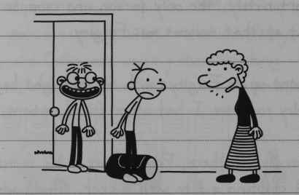
Me and Fregley went upstairs to his room. Fregley tried to get me to play Twister with him, so I made sure I stayed ten feet away from him at all times.
I decided I should just pull the plug on this stupid idea and go home. But every time I looked out the window, Rowley and Colin were still in Rowley’s front yard.
192
I didn’t want to leave until those guys went back inside. But things started to get out of hand with Fregley pretty quickly. When I was looking out the window, Fregley broke into my backpack and ate the whole bag of jelly beans I had in there.
Fregley’s one of these kids who’s not supposed to eat any sugar, so two minutes later he was bouncing off the walls.
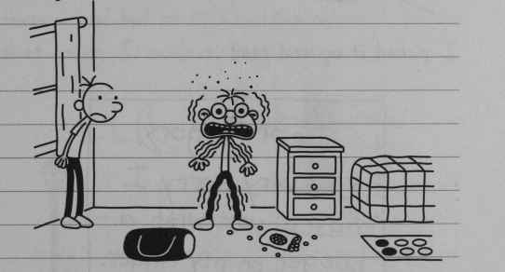
Fregley started acting like a total maniac, and he chased me all around his upstairs.
I kept thinking he was going to come down off his sugar high, but he didn’t. Eventually I locked myself into his bathroom to wait him out.
193
Around 11:30, it got quiet out in the hallway. That’s when Fregley slipped a piece of paper under the door.
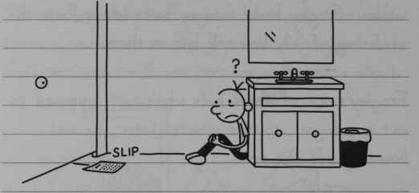
SLIP
I picked it up and read it.
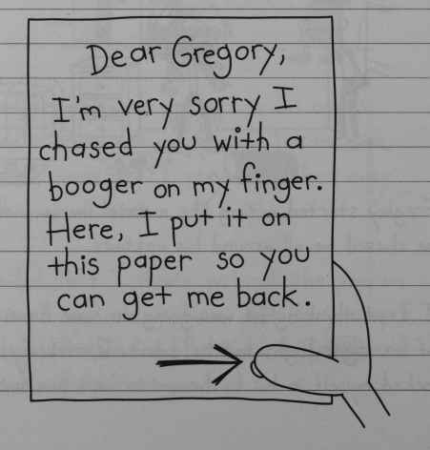
Dear Gregory, I’m very sorry I chased you with a booger on my finger. Here, I put it on this paper so you can get me back.
194
That’s the last thing I remember before I blacked out.
I came to my senses a few hours later. After I woke up, I cracked the door open, and I heard snoring coming from Fregley’s room. So I decided to make a run for it.
Mom and Dad were not happy with me for getting them out of bed at 2:00 in the morning. But by that point, I couldn’t really care less.
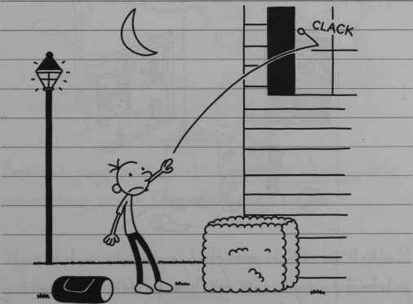
CLACK
195

Monday
Well, me and Rowley have officially been ex-friends for about a month now, and to be honest with you, I’m better off without him.
I’m glad I can just do whatever I want without having to worry about carrying all that dead weight around.
Lately I’ve been hanging out in Rodrick’s room after school and going through his stuff. The other day, I found one of his middle-school yearbooks.
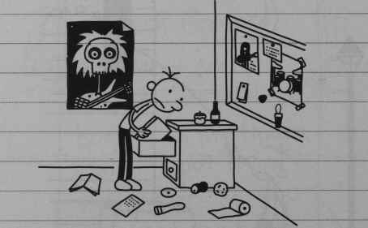
Rodrick wrote on everybody’s picture in his yearbook, so you can tell how he felt about all the kids in his grade.
196
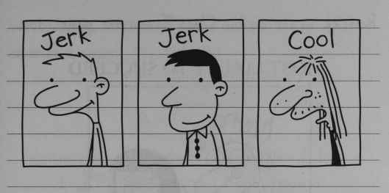
Jerk. Jerk. Cool
Every once in a while I see Rodrick’s old classmates around town. And I have to thank Rodrick for making church a lot more interesting.
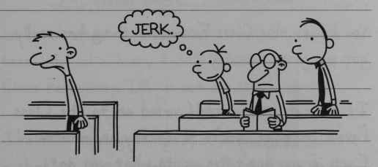
Jerk.
But the page in Rodrick’s yearbook that’s really interesting is the Class Favourites page.
That’s where they put pictures of the kids who get voted Most Popular and Most Talented and all that.
197
Rodrick wrote on his Class Favourites page’ too.
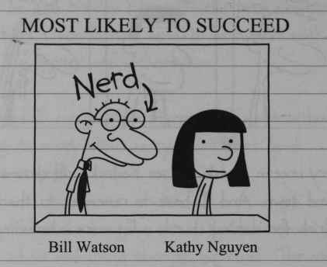
MOST LIKELY TO SUCCEED
Nerd
Bill Watson Kathy Nguyen
You know, this Class Favourites thing has really got my gears turning.
If you can get yourself voted on to the Class Favourites page, your practically an immortal. Even if you don’t live up to what you got picked for, it doesn’t really matter because it’s on permanent record.
People still treat Bill Watson like he’s something special, even though he ended up dropping out of high school.
198
We still run into him at the food barn every once in a while.
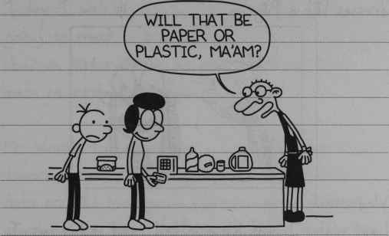
“Will that be paper or plastic, ma’am?”
So here’s what I’m thinking: this school year has been kind of a bust, but if I can get voted as a Class Favourite, I’ll go out on a high note.
I’ve been trying to think of a category I have a shot at. Most Popular and Most Athletic are definitely out, so I’m going to have to find something that’s a little more in reach.
At first I thought maybe I should wear really nice clothes for the rest of the year so I can get Best Dressed.
199
But that would mean I would have to get my picture taken with Jenna Stewart, and she dresses like a pilgrim.
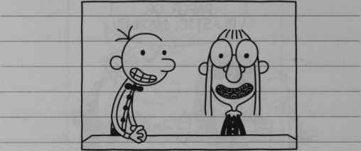

Wednesday
Last night I was lying in bed, and it hit me: I should go for Class Clown.
It’s not that I’m known for being real funny at school or anything, but if I can pull off one big prank right before voting, that could do it.
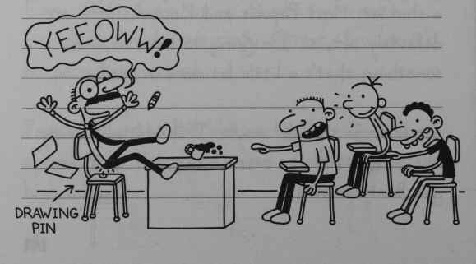
DRAWING PIN
“YEEOWW!”
200

MAY
Thursday
Today I was trying to figure out how I was going to sneak a drawing pin on to Mr Worth’s chair in History when he said something that made me re-think my plan.
Mr Worth told us he has a dentist’s appointment tomorrow, so we are going to have a substitute. Subs are like comic gold. You can say just about anything you want and you can’t get in trouble.
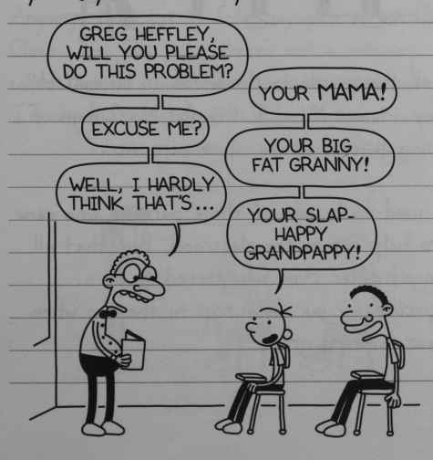
“Greg Heffley, will you please do this problem?”
“Your mama!”
“Excuse me?”
“Your big fat granny!”
“Well I hardly think that’s…”
“Your slap-happy grandpappy!”
201

Friday
I walked into my History class today, ready to execute my plan. But when I got to the door, guess who the substitute teacher was?
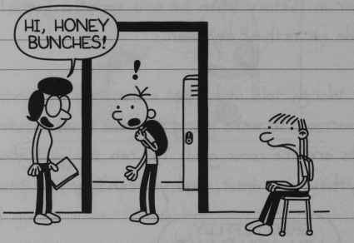
“Hi, Honey Bunches!”
Of all the people in the world to be our sub, today it was Mom. I thought Mom’s days of getting involved at my school were over.
She used to be one of those parents who came in to help out in the classroom. But that all changed after Mom volunteered to be a chaperone for our field trip to the zoo when I was in third grade.
202
Mom had prepared all sorts of material to help us kids appreciate the different exhibits, but all anyone wanted to do was watch the animals go to the bathroom.
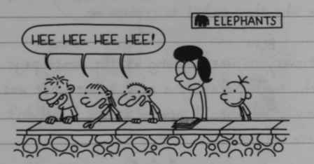
ELEPHANTS
“Hee hee hee hee!”
Anyway, Mom totally foiled my plan to win Class Clown. I’m just lucky there’s not a category called Biggest Mama’s Boy, because after today, I’d win that one in a landslide.
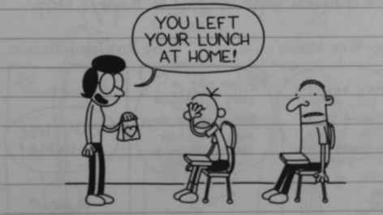
“You left your lunch at home!”
203

Wednesday
The school paper came out again today. I quit my job as school cartoonist after “Creighton the Curious Student” came out, and I didn’t really care who they picked to replace me.
But everyone was laughing at the comics page at lunch, so I picked up a copy to see what was so funny. And when I opened it up, I couldn’t believe my eyes.
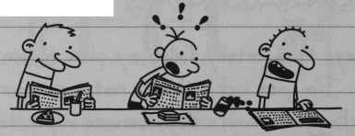
It was “Zoo-Wee Mama”. And of course Mr Ira didn’t change a single WORD of Rowley’s strip.
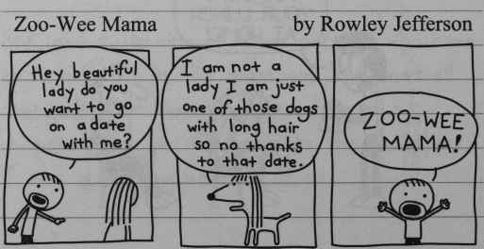
Zoo-Wee Mama by Rowley Jefferson
“Hey beautiful lady do you want to go on a date with me?”
“I am not a lady I am just one of those dogs with long hair so no thanks to that date.”
“Zoo-Wee Mama!”
204
So now Rowley’s getting all the fame that was supposed to be mine.
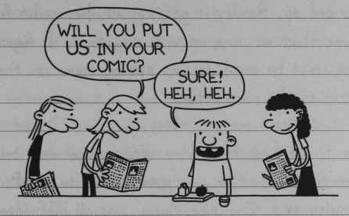
“Will you put us in your comic?”
“Sure! Heh, heh.”
Even the teachers are kissing Rowley’s butt. I almost lost my lunch when Mr Worth dropped his chalk in History class -
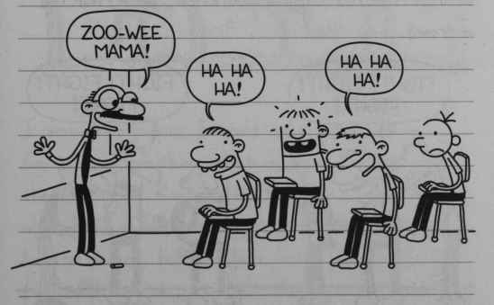
“Zoo-Wee Mama!”
“Ha ha ha!”
“Ha ha ha!”
205
Monday
This “Zoo-Wee Mama” thing has really got me worked up. Rowley is getting all the credit for a comic we came up with together. I figured the least he could do was put my name on the strip as co-creator.
So I went up to Rowley after school and told him that’s what he was gonna have to do. But Rowley said “Zoo-Wee Mama” was all HIS idea and that I didn’t have anything to do with it.
I guess we must’ve been talking pretty loud, because the next thing you knew, we attracted a crowd.
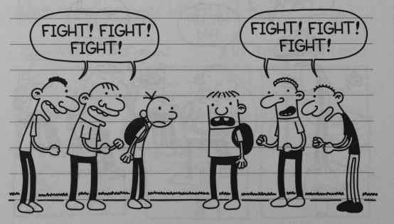
“FIGHT! FIGHT! FIGHT!”
“FIGHT! FIGHT! FIGHT!”
206
The kids at my school are ALWAYS itching to see a fight. Me and Rowley tried to walk away, but those guys weren’t going to let us go until they saw us throw some punches.
I’ve never been in a real fight before, so I didn’t know how I was supposed to stand or hold my fists or anything. And you could tell Rowley didn’t know what he was doing either, because he just started prancing around like a leprechaun.
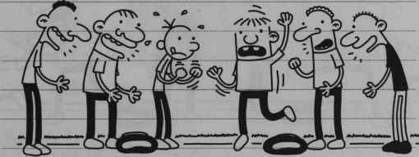
I was pretty sure I could take Rowley in a fight, but the thing that made me nervous was the fact that Rowley does karate. I don’t know what kind of hocus-pocus they teach in Rowley’s karate classes, but the last thing I needed was for him to lay me out right there on the ground.
207
Before me or Rowley made a move, there was a screeching sound in the school parking lot. A bunch of teenagers had stopped their pick-up truck, and they started piling out.
I was just happy that everyone’s attention was on the teenagers instead of me and Rowley. But all the other kids took off when the teenagers started heading our way.
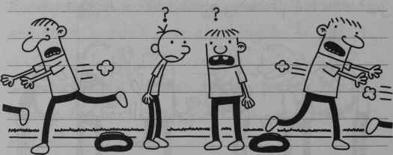
And then I realized that these teenagers looked awfully familiar.
That’s when it hit me. These were the same guys who chased me and Rowley around on Halloween night, and they had finally caught up with us.
208
But before we could make a run for it, we had our arms pinned behind our backs.
Those guys wanted to teach us a lesson for taunting them on Halloween night, and they started arguing over what they should do with us.
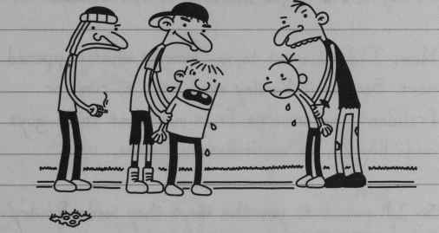
But to be honest with you, I was more concerned about something else. The Cheese was only a few feet from where we were standing on the basketball court, and it was looking nastier than ever.
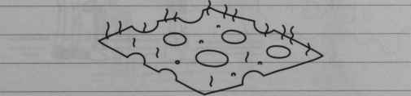
209
The big teenager must have caught my eye, because the next thing I knew, he was looking at the Cheese, too. And I guess that gave him the idea he was looking for.
Rowley got singled out first. The big kid grabbed Rowley and dragged him over to the Cheese.
Now, I don’t want to say exactly what happened next. Because if Rowley ever tries to run for President and someone finds out what these guys made him do, he won’t have a chance.
So I’ll put it to you this way: they made Rowley _ _ _ the Cheese.
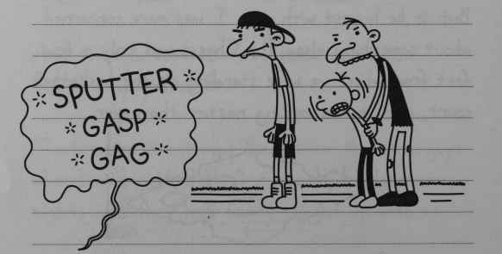
“SPUTTER GASP GAG”
210
I knew they were gonna make me do it, too. I started to panic, because I knew I wasn’t going to be able to fight my way out of this situation.
So I did some fast talking instead.
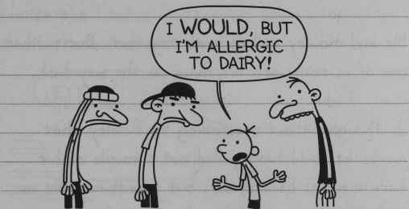
“I WOULD, but I’m allergic to dairy!”
And believe it or not, it actually worked.
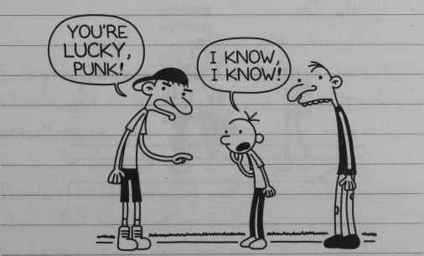
“You’re lucky, punk!”
“I know, I know!”
211
I guess the teenagers were satisfied they had made their point, because after they made Rowley finish off the rest of the Cheese, they let us go. They got back in their truck and took off down the road.
Me and Rowley walked home together. But neither one of us really said anything on the way back.
I thought about mentioning to Rowley that maybe he could have pulled out a couple of his karate moves back there, but something told me to hold off on that thought for right now.
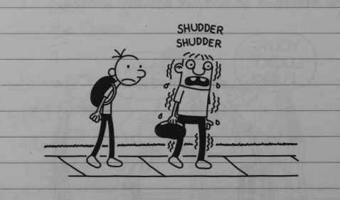
SHUDDER SHUDDER
212

Tuesday
At school today, the teachers let us outside after lunch.
It took about five seconds for someone to realize the Cheese was missing from its spot on the basketball court.
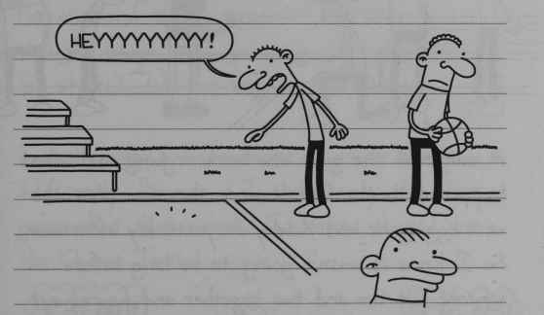
“Heyyyyyyyyy!
Everybody crowded around to look at where the Cheese used to be. Nobody could believe it was actually gone.
People started coming up with these crazy theories about what happened to it. Somebody said that maybe the Cheese grew legs and walked away.
213
It took all my self-control to keep my mouth shut. And if Rowley wasn’t standing right there, I honestly don’t know if I could have kept quiet.
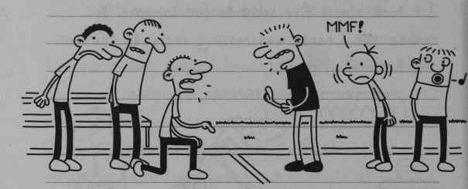
“Mmf!”
A couple of the guys who were arguing over what happened to the Cheese were the same ones who were egging me and Rowley on yesterday afternoon. So I knew it wasn’t going to be long before someone put two and two together and figured out that we must have had something to do with it.
Rowley was starting to panic, and I don’t blame him, either. If the truth ever came out about how the Cheese disappeared, Rowley would be finished. He’d have to move out of the state, and maybe even out of the country.
214
That’s when I decided to speak up.
I told everyone I knew what happened to the Cheese. I said I was sick of it being on the court, and I just decided to get rid of it once and for all.
For a second there, everyone just froze. I thought people were going to start thanking me for what I did, but boy, was I wrong.
I really wish I had worded my story a little differently. Because if I threw away the Cheese, guess what that meant? It meant that I have the Cheese Touch.
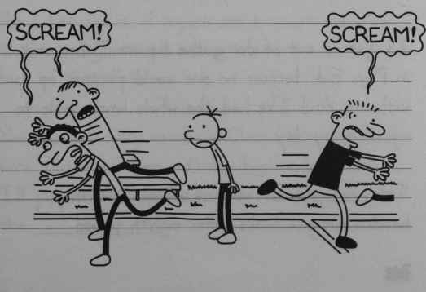
“Scream!”
“Scream!”
215

JUNE
Friday
Well, if Rowley appreciated what I did for him last week, he hasn’t said it. But we’ve started hanging out after school again, so I guess that means me and him are back to normal.
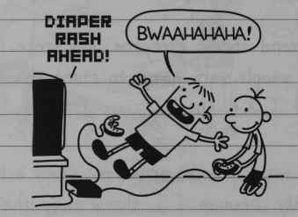
DIAPER RASH AHEAD
“Bwaahahaha!”
I can honestly say that so far, having the Cheese Touch hasn’t been all that bad.
It got me out of doing the Square Dance unit in Phys Ed, because no one would partner up with me. And I’ve had the whole lunch table to myself every day.
Today was the last day of school, and they handed out yearbooks after eighth period.
216
I flipped to the Class Favourites page, and here’s the picture that was waiting for me.
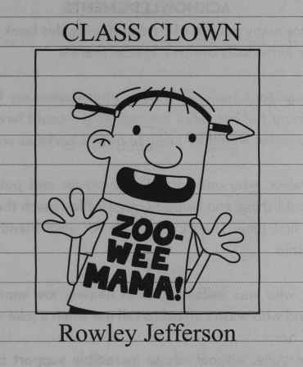
CLASS CLOWN
Zoo-Wee Mama!
Rowley Jefferson
All I can say is, if anyone wants a free yearbook, they can dig one out of the trash can in the back of the cafeteria.
You know, Rowley can have Class Clown for all I care. But if he ever gets too big for his britches, I’ll just remind him that he was the guy who ate the _ _ _ _ _ _.
217
