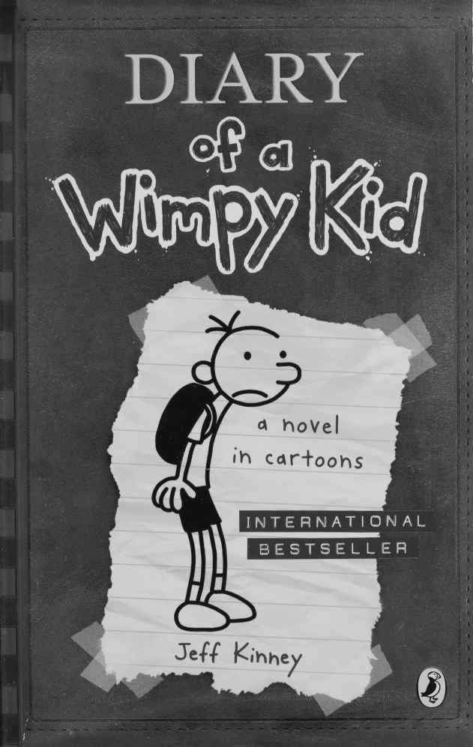

Diary of a Wimpy Kid
By
Jeff Kinney
This electronic copy of the original work is made under a Copyright Licensing Agency license by The Seeing Ear. It is for the personal use of a Print Disabled Person and may not be further copied, (including any electronic copying or transmission), or dealt with without permission, save as may be permitted by law.
Contents

NOVEMBER 62
DECEMBER 83

NOVEMBER
Thursday
On the bus ride into school today, we passed by Gramma’s house. It got rolled with toilet paper last night, which I guess was no surprise.
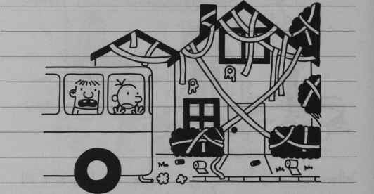
I do feel a little bad, because it looked like it was gonna take a long time to clean up. But on the bright side, Gramma is retired, so she probably didn’t have anything planned for today anyway.

Wednesday
In third period, Mr Underwood, our Phys Ed teacher, announced that the boys will be doing a wrestling unit for the next six weeks.
76
If there’s one thing most boys in my school are into, it’s professional wrestling. So Mr Underwood might as well have set off a bomb.
Lunch comes right after Phys Ed, and the cafeteria was a complete madhouse.
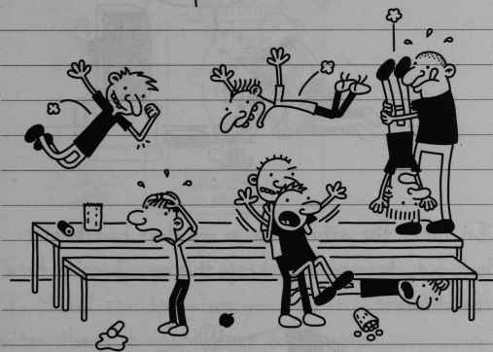
I don’t know what the school is thinking having a wrestling unit.
But I decided if I don’t want to get twisted into a pretzel for the next month and a half, I’d better do my homework on this wrestling business.
77
So I rented a couple of video games to learn some moves. And you know what? After a while I was really starting to get the hang of it.
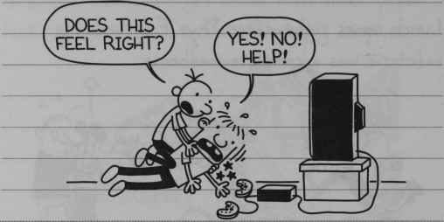
“Does this feel right?”
“Yes! No! Help!”
In fact, the other kids in my class had better look out, because if I keep this up, I could be a real threat.
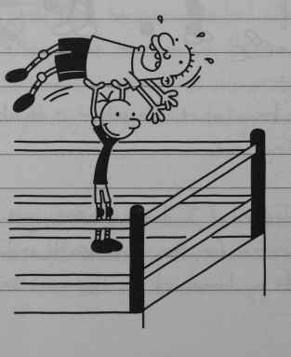
78
Then again, I better make sure I don’t do TOO good. This kid named Preston Mudd got named Athlete of the Month for being the best player in the basketball unit, so they put his picture up in the hallway.
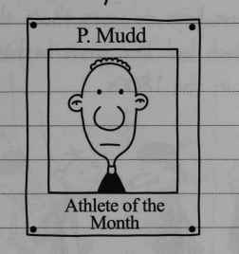
P Mudd
Athlete of the Month
It took people about five seconds to realize what “P Mudd” sounded when you said it out loud, and after that, it was all over for Preston.
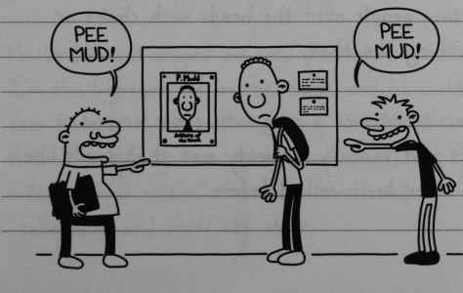
“Pee Mud!”
“Pee Mud!”
79

Thursday
Well I found out today that the kind of wrestling Mr Underwood is teaching is COMPLETELY different from the kind they do on TV.
First of all, we have to wear these things called “singlets”, which look like those bathing suits they used to wear in the 1800s.
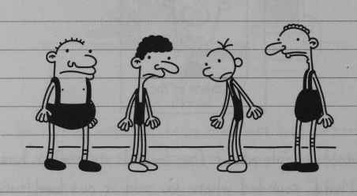
And second of all, there are no pile drivers or hitting people over the head with chairs or anything like that.
There’s not even a ring with ropes around it. It’s just basically a sweaty mat that smells like it’s never been washed before.
80
Mr Underwood started asking for volunteers so he could demonstrate some wrestling holds, but there was no way I was going to raise my hand.
Me and Rowley tried to hide out in the back of the gym near the curtain, but that’s where the girls were doing their gymnastic unit.
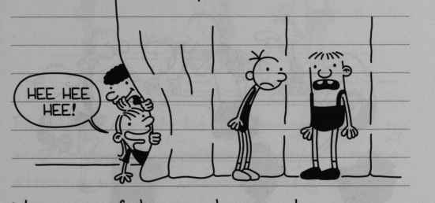
“Hee Hee Hee!”
We got out of there in a hurry, and we went back to where the rest of the guys were.
Mr Underwood singled me out, probably because I’m the lightest kid in the class, and he could toss me around without straining himself. He showed everybody how to do all these things called a “half nelson” and a “reversal” and a “takedown” and stuff like that.
81
When he was doing this one move called the “fireman’s carry”, I felt a breeze down below and I could tell my singlet wasn’t doing a good job keeping me covered up.
That’s when I thanked my lucky stars the girls were on the other side of the gym.
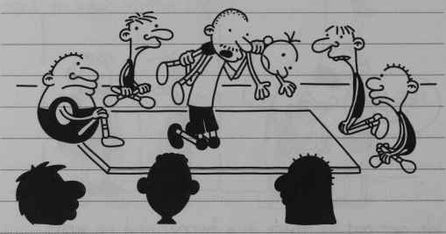
Mr Underwood divided us up into weight groups. I was pretty happy about that at first, because it meant I wasn’t going to have to wrestle kids like Benny Wells, who can bench press 250 pounds.

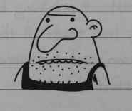
82
But then I found out who I DID have to wrestle, and I would have traded for Benny Wells in a heartbeat.
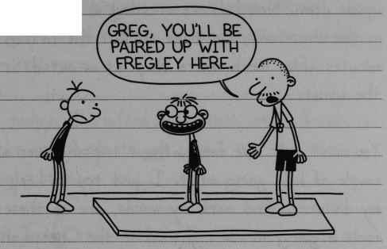
“Greg, you’ll be paired up with Fregley here”.
Fregley was the only kid light enough to be in my weight class. And apparently Fregley was paying attention when Mr Underwood was giving instructions, because he pinned me every which way you could imagine. I spent my seventh period getting WAY more familiar with Fregley than I ever wanted to be.
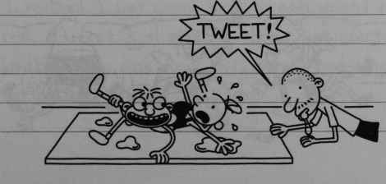
TWEET!
83

Tuesday
This wrestling unit has totally turned our school upside down. Now kids are wrestling in the hallways, in the classrooms, you name it. But the fifteen minutes after lunch where they let us outside is the worst.
You can’t walk five feet without tripping over a couple of kids going at it. I just try to keep my distance. And mark my words, one of these fools is going to roll right on to the Cheese and start the Cheese Touch all over again.
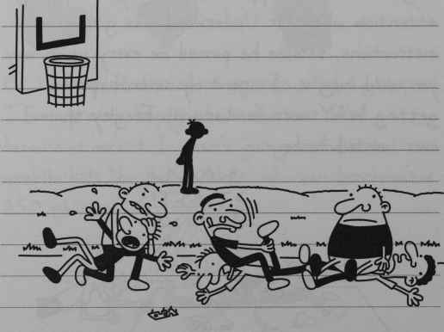
84
My other big problem is that I have to wrestle Fregley every single day. But this morning I realized something. If I can move out of Fregley’s weight class, I won’t have to wrestle him any more.
So today, I stuffed my clothes with a bunch of socks and shirts to get myself into the next weight class.
But I was still too light to move up.
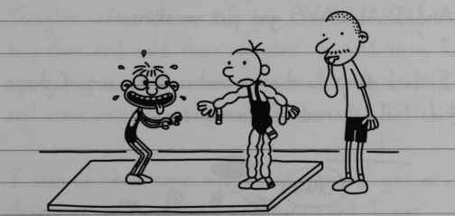
I realized I was gonna have to gain weight for real. At first I thought I should just start loading up on junk food, but then I had a much better idea.
85
I decided to gain my weight in MUSCLE, not fat.
I’ve never been all that interested in getting into shape before, but this wrestling unit has made me rethink things.
I figure if I bulk up now, it could actually come in handy down the road.
The football unit is coming in the spring, and they split the teams up into shirts and skins. And I ALWAYS get put in the skins.
I think they do that to make all the out-of-shape kids feel ashamed of themselves.
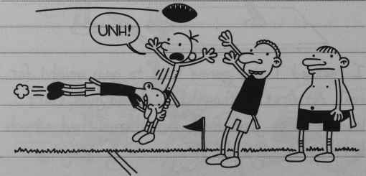
“Unh!”
86
If I can pack on some muscle now, it’ll be a whole different story next April.
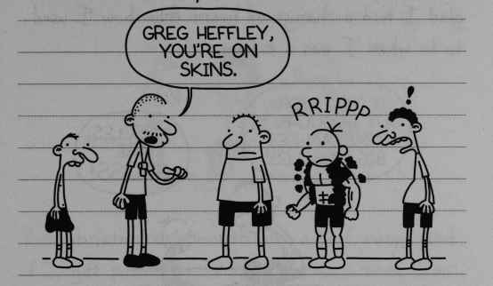
“Greg Heffley, you’re on Skins”.
RRIPPP
Tonight, after dinner, I got Mom and Dad together and told them my plan. I told them I was going to need some serious exercise equipment, and some weight-gain powder, too.
I showed them some muscle magazines I got at the store so they could see how ripped I was going to be.
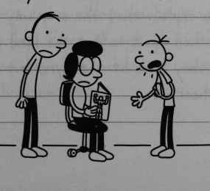
87
Mom didn’t really say anything at first, but Dad was pretty enthusiastic. I think he was just glad I had a change of heart from how I used to be when I was a kid -
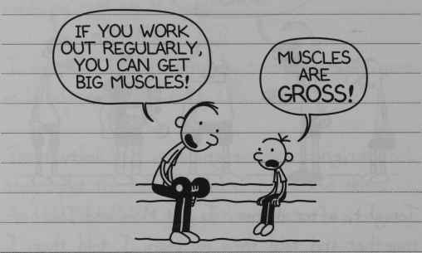
“If you work out regularly, you can get big muscles!”
“Muscles are GROSS!”
But Mom said if I wanted a weight set, I was going to have to prove that I could stick with an exercise regime. She said I could do that by doing sit-ups and jumping jacks for two weeks.
I had to explain that the only way to get totally bulked up is to get the kind of high-tech machines they have at the gym, but Mom didn’t want to hear it.
88
Then Dad said if I wanted a bench press, I should keep my fingers crossed for Christmas.
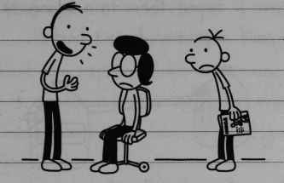
But Christmas is a month and a half away. And if I get pinned by Fregley one more time, I’m gonna have a nervous breakdown.
So it looks like Mom and Dad aren’t going to be any help. And that means I’m going to have to take matters into my own hands, as usual.

Saturday
I couldn’t wait to start my weight-training programme today. Even though Mom wouldn’t let me get the equipment I needed, I wasn’t going to let that hold me back.
89
So I went into the fridge and emptied out the milk and orange juice and filled the jugs with sand. Then I taped them to a broomstick, and I had myself a pretty decent barbell.
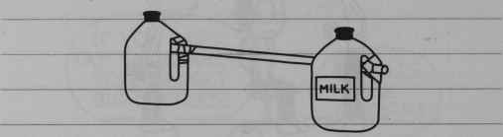
MILK
After that, I made a bench press out of an ironing board and some boxes. Once I had that all set, I was ready to do some serious lifting.
I needed a spotting partner, so I called Rowley. And when he showed up at my door wearing some ridiculous getup, I knew I had made a mistake inviting him.
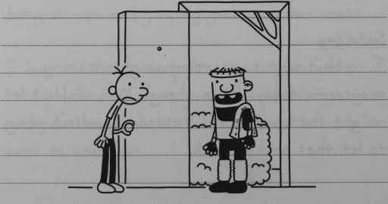
90
I made Rowley use the bench press first, mostly because I wanted to see if the broomstick was going to hold up.
He did about five reps, and he was ready to quit, but I wouldn’t let him. That’s what a good training partner is for, to push you beyond your limits.
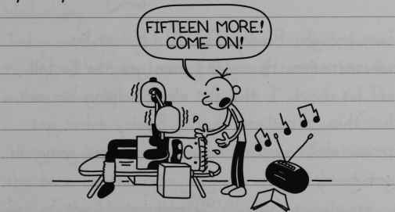
“Fifteen more! Come on!”
I knew Rowley wasn’t going to be as serious about weight lifting as I was, so I decided to try out an experiment to test his dedication.
In the middle of Rowley’s set, I went and got this phony nose and moustache Rodrick has in his junk drawer.
91
And right when Rowley had the barbell in the “down” position, I leaned over and looked at him.
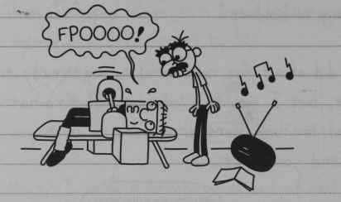
“Fpoooo!”
Sure enough, Rowley TOTALLY lost his concentration. He couldn’t even get the barbell off his chest. I thought about helping him out, but then I realized that if Rowley didn’t get serious about working out, he was never going to get to my level.
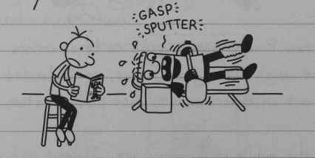
“Gasp, Splutter”
I eventually had to rescue him because he started biting the milk jug to let the sand leak out.
92
After Rowley got off the bench press, it was time for my set. But Rowley said he didn’t feel like working out any more, and he went home.
You know, I figured he’d pull something like that. But I guess you can’t expect everyone to have the same dedication as you.

Wednesday
Today in Geography we had a quiz, and I have to say, I’ve been looking forward to this one for a long time.
The quiz was on state capitals, and I sit in the back of the room, right next to this giant map of the United States. All the capitals are written in big red print, so I knew I had this one in the bag.
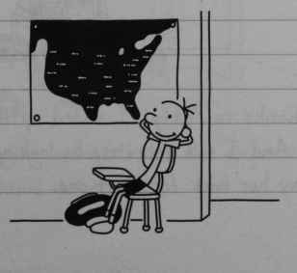
93
But right before the test got started, Patty Farrell piped up from the front of the room.
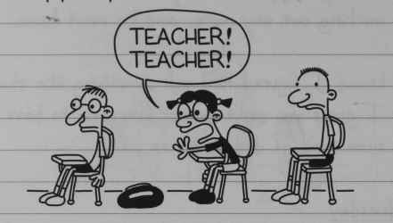
“Teacher! Teacher”
Patty told Mr Ira that he should cover up the United States map before we got started.
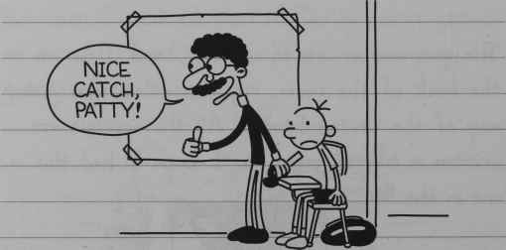
“Nice catch, Patty!”
So thanks to Patty, I ended up flunking the quiz. And I will definitely be looking for a way to pay her back for that one.
94

Thursday
Tonight Mom came up to my room, and she had a flyer in her hand. As soon as I saw it I knew EXACTLY what it was.
It was an announcement that the school is having tryouts for a winter play. Man. I should have thrown that thing out when I saw it on the kitchen table.
I BEGGED her not to make me sign up. Those school plays are always musicals, and the last thing I need is to have to sing a solo in front of the whole school.
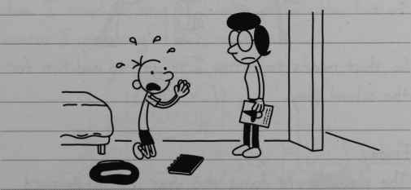
But all my begging seemed to do was to make Mom more sure I should do it.
95
Mom said the only way I was going to be “well rounded” was by trying different things.
Dad came in my room to see what was going on. I told Dad that Mom was making me sign up for the school play, and that if I had to start going to play practices, it would totally mess up my weight-lifting schedule.
I knew that would make Dad take my side. Dad and Mom argued for a few minutes, but Dad was no match for Mom.
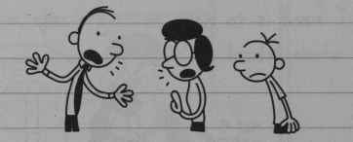
So that means tomorrow I’ve got to audition for the new play.

Friday
The play they’re doing this year is “The Wizard of Oz”. A lot of kids came wearing costumes for the parts they were trying out for.
96
I’ve never even seen the movie, so for me, it was like walking into a freak show.
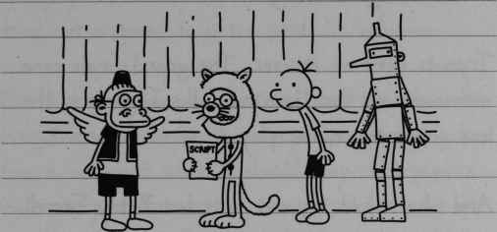
Mrs Norton, the music director, made everyone sing “My Country ‘Tis of Thee” so she could hear our singing voices. I did my singing tryouts with a bunch of other boys whose moms made them come, too. I tried to sing as quietly as possible, but of course, I got singled out, anyway.
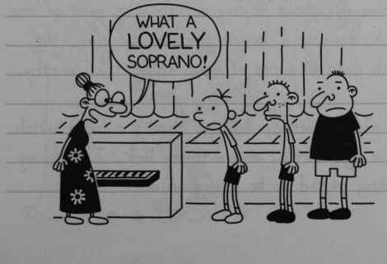
“What a LOVELY” soprano!”
97
I have no idea what a “soprano” is, but from the way some of the girls were giggling, I knew it wasn’t a good thing.
Tryouts went on forever. The grand finale came with auditions for Dorothy, who I guess is the lead character of the play.
And who should try out first but Patty Farrell.
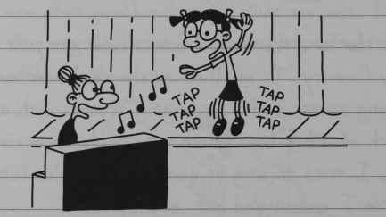
Tap tap tap. Tap tap tap.
I thought about trying out for the part of the Witch, because I hear that in the play, the Witch does all sorts of mean things to Dorothy.
But then somebody told me there’s a Good Witch and a Bad Witch, and with my luck, I’d end up getting picked to be the good one.
98

Monday
I was hoping Mrs Norton would just cut me from the play, but today she said that everyone who tried out is going to get a part. So lucky me.
Mrs Norton showed “The Wizard of Oz” movie so everyone would know the story. I was trying to figure out what part I should play, but pretty much every character has to sing or dance at one point or another. But about halfway through the movie, I figured out what part I wanted to sign up for. I’m, going to sign up to be a Tree, because 1) they don’t have to sing and 2) they get to bean Dorothy with apples.
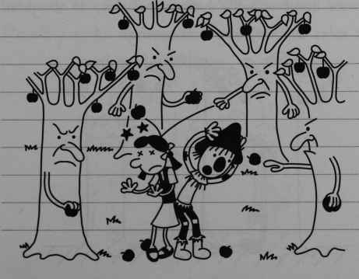
99
Getting to peg Patty Farrell with apples in front of a live audience would be my dream come true. I may have to thank Mom for making me do this play once it’s all over.
After the movie ended, I signed up to be a Tree. Unfortunately, a bunch of other guys had the same idea as me, so I guess there are a lot of guys who have a bone to pick with Patty Farrell.

Wednesday
Well, like Mom always says, be careful what you wish for. I got picked to be a Tree, but I don’t know if that’s such a good thing. The Tree costumes don’t actually have arm holes, so I guess that rules out any apple- throwing.
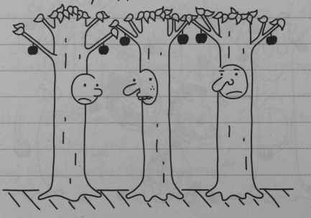
100
I should probably feel lucky that I got a speaking part at all. They had too many kids trying out, and not enough roles, so they had to start making up characters.
Rodney James tried out to be the Tin Man, but he got stuck with being the Shrub.
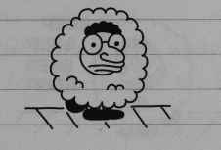

Friday
Remember how I said I was lucky to get a speaking part? Well, today I found out I only have one line in the whole play. I say it when Dorothy picks an apple off my branch.
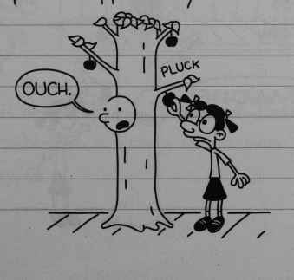
PLUCK
“Ouch.”
101
That means I have to go to a two-hour practice every day just so I can say one stupid word.
I’m starting to think Rodney James got a better deal as the Shrub. He found a way to sneak a video game into his costume, and I’ll bet that really makes the time go by.
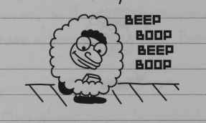
Beep boop beep boop
So now I’m trying to think of ways to get Mrs Norton to kick me out of the play. But when you only have one word to say, it’s really hard to mess up your lines.
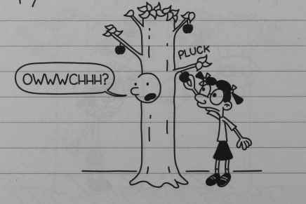
PLUCK
“Owwwchhh?”
102

DECEMBER
Thursday
The play is only a couple of days away, and I have no idea how we’re going to pull this thing off.
First of all, nobody has bothered to learn their lines, and that’s all Mrs Norton’s fault.
During rehearsal, Mrs Norton whispers everyone’s lines to them from the side of the stage.
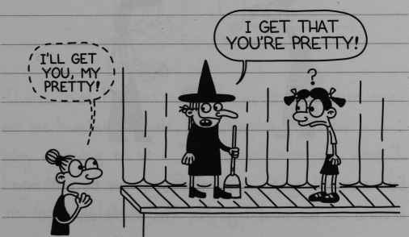
“I’ll get you, my pretty!”
“I get that you’re pretty”
I wonder how it’s going to go next Tuesday when Mrs Norton is sitting at her piano thirty feet away.
103
Another thing that’s screwing everything up is that Mrs Norton keeps adding new scenes and new characters.
Yesterday she brought in this first-grader to play Dorothy’s dog, Toto. But today, the kid’s mom came in and said she wanted her child to walk around on two legs, because crawling around on all fours would be too “degrading”.
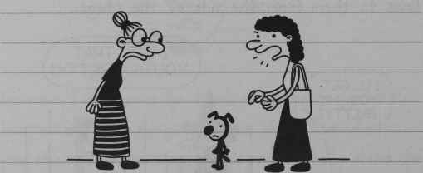
So now we’ve got a dog that’s gonna be walking around on his hind legs for the whole show.
But the worst change is that Mrs Norton actually wrote a song that us TREES have to sing. She said everyone “deserves” a chance to sing in the play.
104
So today we spent an hour learning the worst song that’s ever been written.
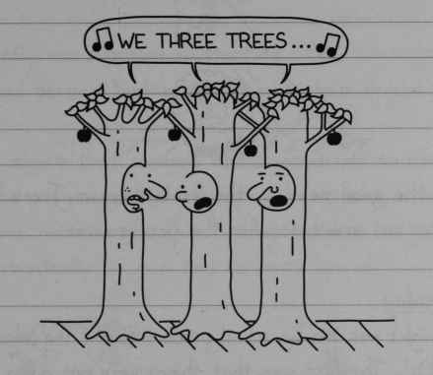
“We three trees…”
Thank God Rodrick won’t be in the audience to see me humiliate myself. Mrs Norton said the play is going to be a “semiformal occasion”, and I know there’s no way Rodrick is going to wear a tie for a middle school play.
But today wasn’t all bad. Towards the end of practice, Archie Kelly tripped over Rodney James and chipped his tooth because he couldn’t stick his arms out to break his fall.
105
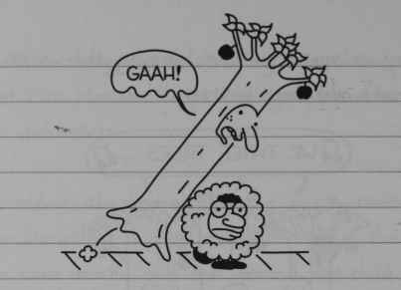
“Gaah!”
So the good news is, they’re letting us TREES carve out arm holes for the performance.

Tuesday
Tonight was the big school production of “The Wizard of Oz”. The first sign that things were not going to go well happened before the play even started.
I was peeking through the curtain to check out how many people showed up to see the play, and guess who was standing right up the front? My brother Rodrick, wearing a clip-on tie.
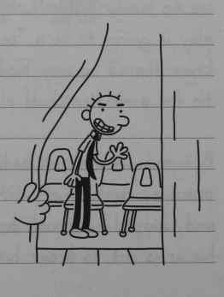
106
He must have found out I was singing, and he couldn’t resist the chance to see me embarrass myself.
The play was supposed to start at 8:00, but it got delayed because Rodney James had stage fright.
You’d figure that someone whose job it was to sit on the stage and do nothing could just suck it up for one performance. But Rodney wouldn’t budge, and eventually his mom had to carry him off.
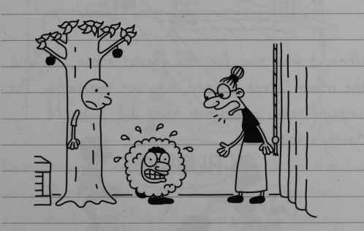
The play finally got started around 8:30. Nobody could remember their lines, just like I predicted, but Mrs Norton kept things moving along with her piano.
107
The kid who played Toto brought a stool and a pile of comics on to the stage, and that totally ruined the whole “dog” effect.
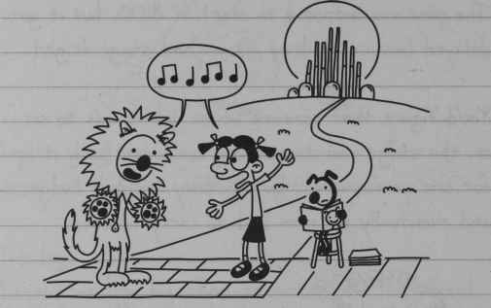
When it was time for the forest scene, me and the other Trees hopped into our positions. The curtain rose, and when they did, I heard Manny’s voice.
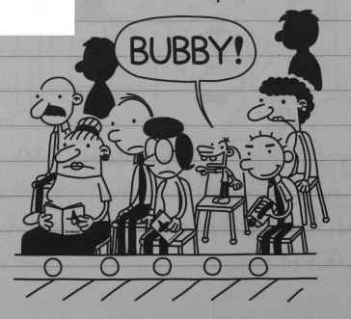
“Bubby!”
108
Great. I have been able to keep that nickname quiet for five years, and now all of a sudden the whole town knew it. I could feel about 300 pairs of eyeballs pointed my way.
So I did some quick ad-libbing and I was able to deflect the embarrassment over to Archie Kelly.
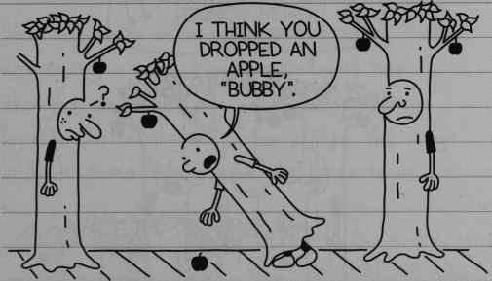
“I think you dropped an apple, BUBBY”
But the major embarrassment was still on the way. When I hear Mrs Norton playing the first few bars of “We Three Trees”, I felt my stomach jump.
I looked out at the audience and I noticed Rodrick was holding a video camera.
109
I knew that if I sang the song and Rodrick recorded it, he would keep the tape forever and use it to humiliate me for the rest of my life.
I didn’t know what to do, so when the time came to start singing, I just kept my mouth shut.
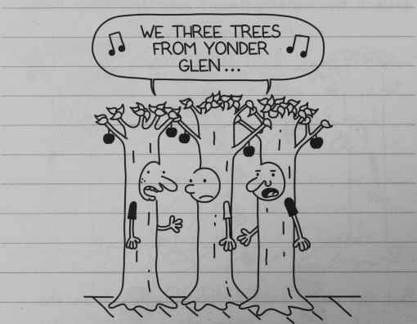
“We three trees from yonder glen…”
For a few seconds there, things went OK. I figured out that if I didn’t technically sing the song, then Rodrick wouldn’t have anything to hold over my head. But after a few seconds, the other Trees noticed I wasn’t singing.
110
I guess they must’ve thought I knew something that they didn’t, so they stopped singing, too.
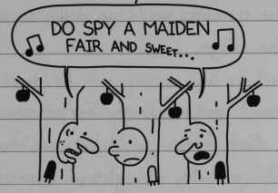
“Do spy a maiden fair and sweet…”
Now the three of us were just standing there, not saying a word. Mrs Norton must have thought we forgot the words to the song, because she came over to the side of the stage and whispered the rest of the lyrics to us.
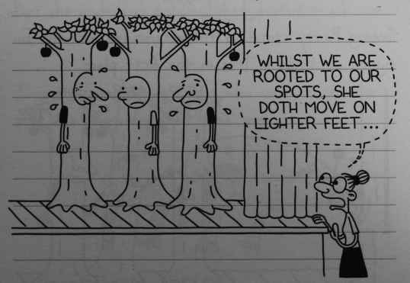
“Whilst we are rooted to our spots, she doth move on lighter feet…”
111
The song is only about three minutes long, but to me it felt like an hour and a half. I was just praying the curtains would go down so we could hop off the stage.
That’s when I noticed Patty Farrell standing in the wings. And if looks could kill, us Trees would be dead. She probably thought we were ruining her chances of making it to Broadway or something.
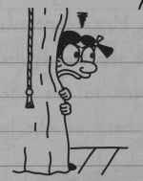
Seeing Patty standing there reminded me why I signed up to be a tree in the first place.
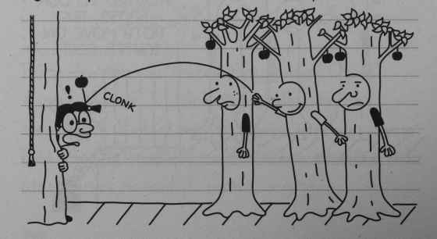
Clonk
112
Pretty soon, the rest of the Trees started throwing apples too. I think even Toto got in on the act.
Somebody knocked the glasses off of Patty’s head, and one of the lenses broke. Mrs Norton had to shut down the play after that, because Patty can’t see two feet in front of her without her glasses.
After the play was over, my family went home together. Mom had brought a bouquet of flowers, and I guess they were supposed to be for me. But she ended up tossing them in the trash can on the way out of the door.
I just hope that everyone who came to see the play was as entertained as I was.
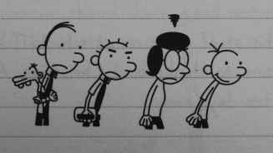
113

Wednesday
Well, if one good thing came out of the play, it’s that I don’t have to worry about the “Bubby” nickname any more.
I saw Archie Kelly getting hassled in the hallway after fifth period today, so it looks like I can finally start to breathe a little easier.
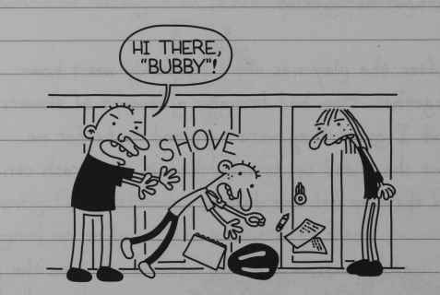
“Hi there, BUBBY!”
Shove
Sunday
With all this stuff going on at school, I haven’t even had time to think about Christmas. And it’s less than ten days away.
114
In fact, the only thing that tipped me off that Christmas was coming was when Rodrick put his wish list up on the refrigerator.
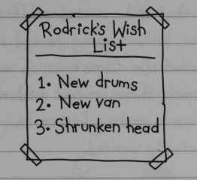
Rodrick’s Wish List
1. New drums
2. New van
3. Shrunken head
I usually make a big wish list every year, but this Christmas, all I want is this video game called “Twisted Wizard”.
Tonight Manny was going through the Christmas catalogue, picking out all the stuff he wants with a big red marker. Manny was circling every single toy in the catalogue. He was even circling really expensive things like a giant motorized car and things like that.
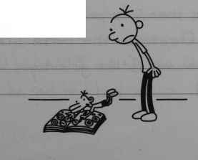
115
So I decided to step in and give him some good big-brotherly advice.
I told him that if he circled stuff that was too expensive, he was going to end up with a bunch of clothes for Christmas. I said that he should just pick three or four medium priced gifts so he would end up with a couple of things he actually wanted.
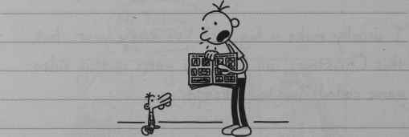
But of course, Manny just went back to circling everything again. So I guess he’ll just have to learn the hard way.
When I was seven, the only thing I really wanted for Christmas was a Barbie Dream House. And NOT because I like girl’s toys, like Rodrick said.
116
I just thought it would be a really awesome fort for my toy soldiers.
When Mom and Dad saw my wish list that year, they got in a big fight over it. Dad said there was no way he was getting me a doll’s house, but Mom said it was healthy for me to “experiment” with whatever kind of toys I wanted to play with.
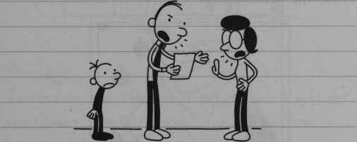
Believe it or not, Dad actually won the argument. Dad told me to start my wish list over and pick some toys that were more “appropriate” for boys.
But I have a secret weapon when it comes to Christmas. My Uncle Charlie always gets me whatever I want. I told him I wanted the Barbie Dream House, and he said he’d hook me up.
117
On Christmas, when Uncle Charlie gave me my gift, it was NOT what I asked for. He must’ve walked into the toy store and picked up the first thing he saw that had the word “Barbie” on it.
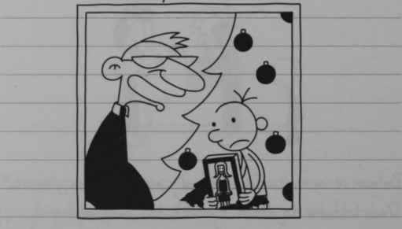
Dad wasn’t real happy when he saw what Uncle Charlie got me. He told me to either throw it out or give it away to charity.
But I kept it anyway. And OK, I admit maybe I took it out and played with it once or twice.
118
That’s how I ended up in the emergency room two weeks later with a pink Barbie shoe stuck up my nose. And believe me, Rodrick has never let me hear the end of THAT.
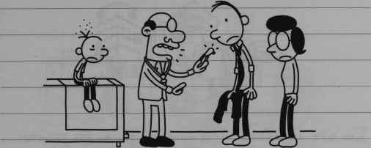

Thursday
Tonight me and Mom went out to get a gift for the Giving Tree at church. The Giving Tree is basically a Secret Santa kind of thing where you get a gift for someone who is needy.
Mom picked out a red wool sweater for our Giving Tree guy.
I tried to talk Mom into getting something a little cooler, like a TV or slushie machine or something like that.
119
Because imagine if all you got at Christmas was a wool sweater.
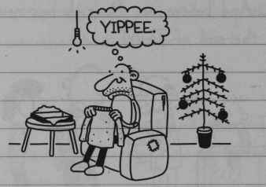
“Yippee”
I’m sure our Giving Tree guy will throw his sweater in the trash, along with the ten cans of yams we sent his way during the Thanksgiving Food Drive.

Christmas
When I woke up this morning and went downstairs, there were about a million gifts under the Christmas tree. But when I started digging around, there were hardly any gifts with my name on them.
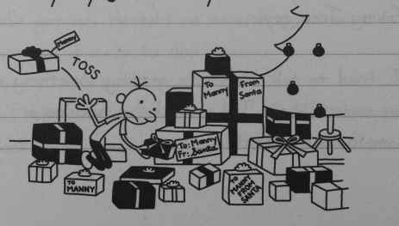
Toss
120
But Manny made out like a bandit. He got EVERY single thing he circled on the catalogue, no lie. So I’ll bet he’s glad he didn’t listen to me.
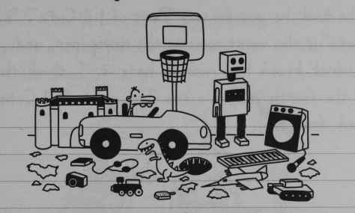
I did find a couple of things with my name on them, but they were mostly books and socks and stuff like that.
I opened my gifts in the corner behind the couch, because I don’t like opening gifts near Dad. Whenever someone opens a gift, Dad swoops right in and cleans up after them.
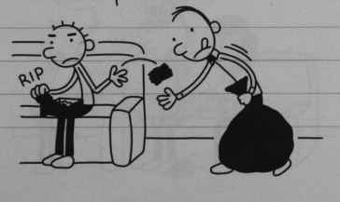
Rip
121
I gave Manny a toy helicopter and I gave Rodrick a book about rock bands. Rodrick gave me a book, too, but of course he didn’t wrap it. The book he got me was “Best of L’il Cutie”. ”L’il Cutie” is the worst comic in the newspaper, and Rodrick knows how much I hate it. I think this is the fourth year in a row I’ve got a “L’il Cutie” book from him.
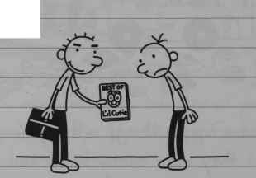
I gave Mom and Dad their gifts. I get them the same kind of thing every year, but parents eat that stuff up.
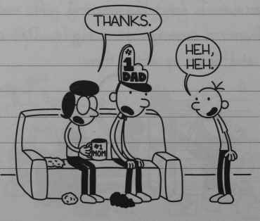
“Thanks”.
“Heh, heh”.
122
The rest of the relatives started showing up around 11:00, and Uncle Charlie came at noon.
Uncle Charlie brought a big trash bag full of gifts, and he pulled my present out of the top of the bag.
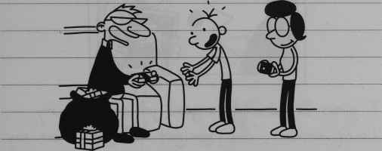
The package was the exact right size and shape to be a twisted wizard game, so I knew Uncle Charlie came through for me. Mom got the camera ready and I tore open my gift.
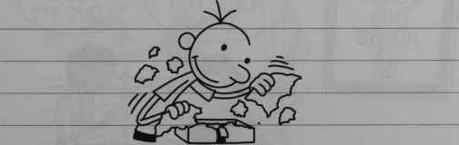
123
But it was just an 8 x 10 picture of Uncle Charlie.
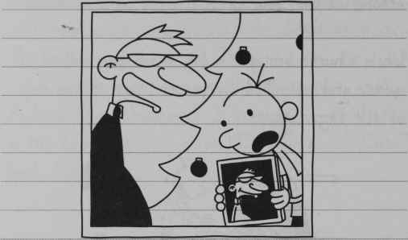
I guess I didn’t do a good job of hiding my disappointment, and Mom got mad. All I can say is, I’m glad I’m still a kid, because if I had to act happy about the kind of gifts adults get, I don’t think I could pull it off.
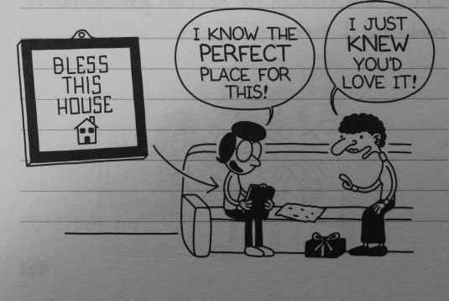
BLESS THIS HOUSE
“I know the perfect place for this!”
“I just knew you’d love it!”
124
I went up to my room to take a break for a while. A couple minutes later, Dad knocked on my door. He told me he had my gift for me out in the garage, and the reason it was out there was because it was too big to wrap.
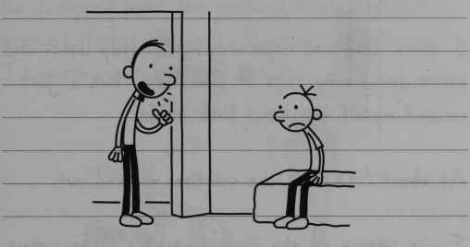
And when I walked down to the garage, there was a brand new weight set.
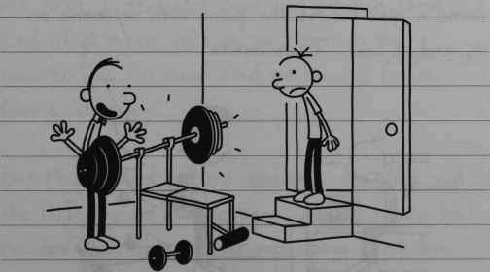
125
That thing must have cost a fortune. I didn’t have the heart to tell Dad that I kind of lost interest in the whole weight-lifting thing when the wrestling unit ended last week. So I just said “thanks” instead.
I think Dad was expecting me to drop down and do some reps or something, but I just excused myself and went back inside.
At about 6:00, all the relatives cleared out.
I was sitting on the couch watching Manny play with his toys, feeling pretty sorry for myself. Then Mom came up to me and said that she found a gift behind the piano with my name on it, and it said, “From Santa”.
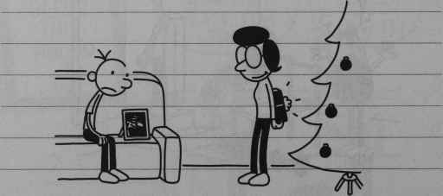
126
The box was way too big for Twisted Wizard, but Mom pulled the same “big box” trick on me last year when she got me a memory card for my video game system.
So I ripped open the package and pulled out my present. Only this wasn’t Twisted Wizard, either. It was a giant red wool sweater.
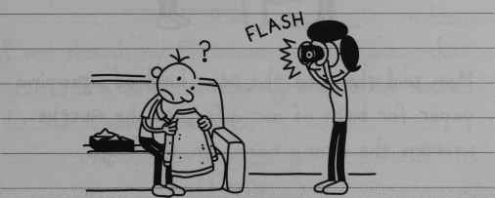
FLASH
At first I thought Mom was playing some kind of practical joke on me, because this sweater was the same kind we bought for our Giving Tree guy.
But Mom seemed pretty confused, too. She said she DID buy me a video game, and that she had no idea what the sweater was doing in my box.
127
And then I figured it out. I told Mom there must have been some kind of mix-up, and I got the Giving Tree guy’s gift, and he got mine.
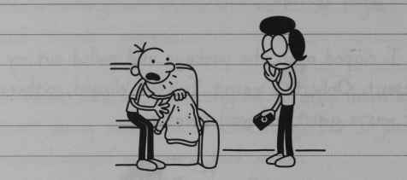
Mom said she used the same kind of wrapping paper for both our gifts, so she must’ve written the wrong names on the tags.
But then Mom said that this was really a good thing, because the Giving Tree guy was probably really happy he got such a great gift.
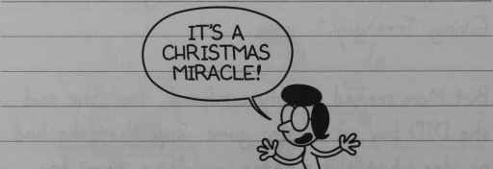
“It’s a Christmas miracle!”
128
I had to explain that you need a game system and a TV to play Twisted Wizard, so the game was totally useless to him.
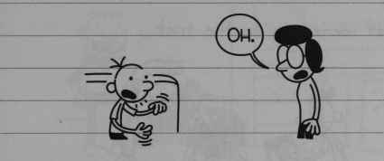
“Oh”
Even though my Christmas was not going that great, I’m sure it was a whole lot worse for the Giving Tree guy.
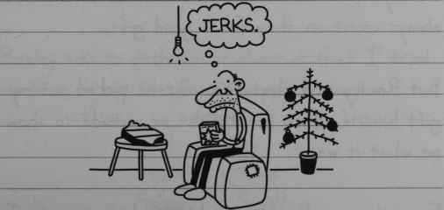
“Jerks”
I kind of decided to throw in the towel for this Christmas, and I headed up to Rowley’s house.
129
I forgot to get a gift for Rowley, so I just slapped a bow on the “L’il Cutie” book Rodrick gave me.
And that seemed to do the trick.
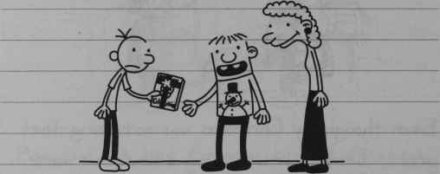
Rowley’s parents have a lot of money, so I can always count on them for a good gift.
But Rowley said that this year he picked out my gift himself. Then he brought me outside to show me what it was.
From the way Rowley was hyping his present, I thought he must have got me a big-screen TV or a motorcycle or something.
130
But once again, I let my hopes get too high.
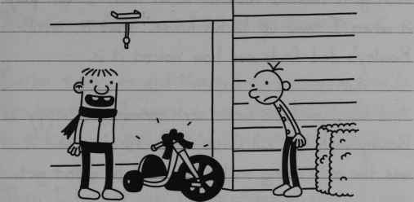
Rowley got me a Big Wheel. I guess I would have thought this was a cool gift when I was in third grade, but I have no idea what I’m supposed to do with one now.
Rowley was so enthusiastic about it that I tried my best to act like I was happy anyway.
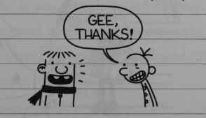
“Gee, thanks!”
We went back inside, and Rowley showed me his Christmas loot.
131
He sure got a lot more stuff than I did. He even got Twisted Wizard, so at least I can play it when I come up to his house. That is, until Rowley’s dad finds out how violent it is.
And boy, you have never seen someone as happy as Rowley with his “L’il Cutie” book. His mom said it was the only thing on his list he didn’t get.
Well, I’m glad SOMEONE got what they wanted today.
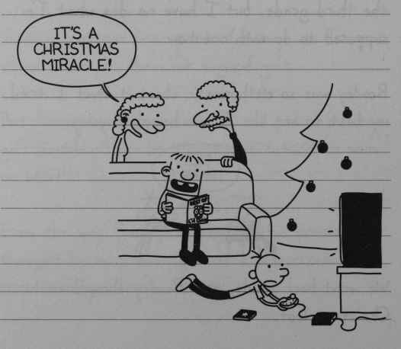
“It’s a Christmas miracle!”
132

New Year’s Eve
In case you’re wondering what I’m doing in my room at 9:00pm on New Year’s Eve, let me fill you in.
Earlier today, me and Manny were horsing around in the basement. I found a tiny black ball of thread on the carpet, and I told Manny it was a spider.
Then I held it over him pretending that I was going to make him eat it.
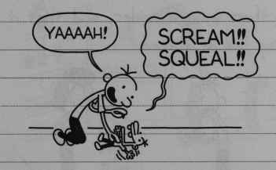
“Yaaaah!”
“Scream!! Squeal!!”
Right when I was about to let Manny go, he slapped my hand and made me drop the thread. And guess what? That fool swallowed it.

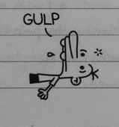
“Gulp”
133
Well, Manny completely lost his mind. He ran upstairs to where Mom was, and I knew I was in big trouble.
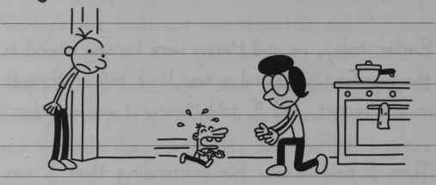
Manny told Mom I made him eat a spider. I told her there was no spider, and that it was just a tiny ball of thread.
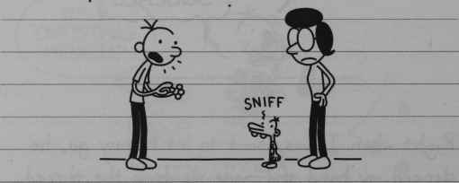
Sniff
Mom brought Manny over to the kitchen table. Then she put a seed, a raisin and a grape on a plate and told Manny to point to the thing that was closest in size to the piece of thread he swallowed.
134
Manny took a while to look over the things on the plate.
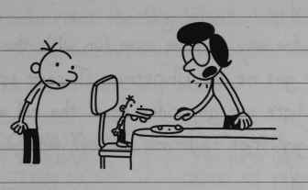
Then he walked over to the refrigerator and pulled out an orange.
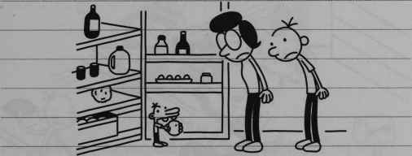
So that’s why I got sent to bed at 7:00 and I’m not downstairs watching the New Year’s Eve special on TV.
And that’s why my only New Year’s resolution is never to play with Manny again.
135

