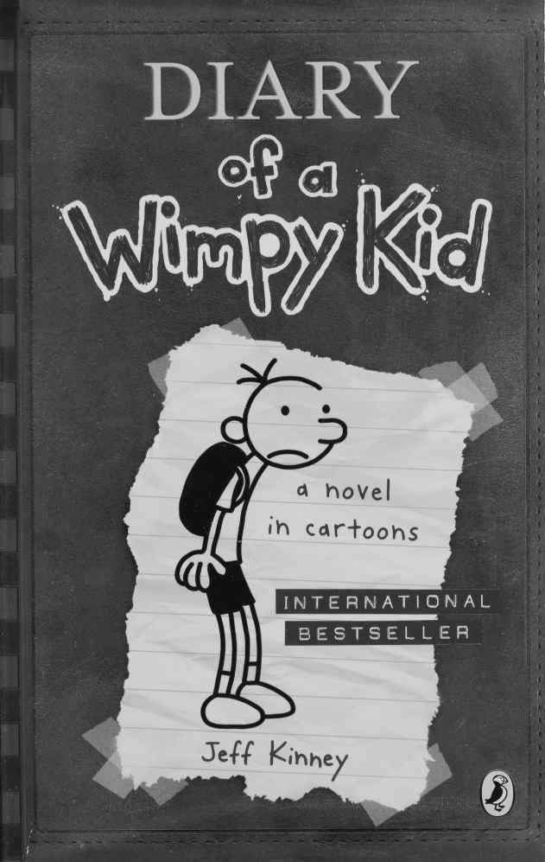

Diary of a Wimpy Kid
By
Jeff Kinney
This electronic copy of the original work is made under a Copyright Licensing Agency license by The Seeing Ear. It is for the personal use of a Print Disabled Person and may not be further copied, (including any electronic copying or transmission), or dealt with without permission, save as may be permitted by law.
Contents
SEPTEMBER 4
OCTOBER 42

SEPTEMBER
Tuesday
First of all, let’s get something straight: this is a JOURNAL, not a diary. I know what it says on the cover, but when Mom went out to buy this thing I SPECIFICALLY told her to get one that didn’t say “diary” on it.
Great. All I need is for some jerk to catch me carrying this book around and get the wrong idea.
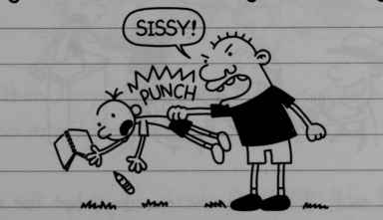
“Sissy!”
The other thing I want to clear up right away is that this was MOM’S idea, not mine.
But if she thinks I’m going to write down my “feelings” in here or whatever, she’s crazy. So just don’t expect me to be all “Dear Diary” this and “Dear Diary” that.
1
The only reason I agreed to do this at all is because I figure later on when I’m rich and famous, I’ll have better things to do than answer peoples stupid questions all day long. So this book is gonna come in handy.
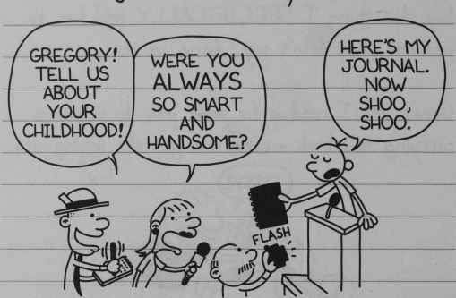
“Gregory! Tell us about your childhood!”
“Were you always so smart and handsome?”
“Here’s my Journal. Now shoo, shoo.”
Like I said, I’ll be famous one day, but for now I’m stuck in middle school with a bunch of morons.
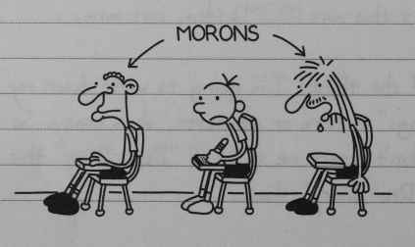
Morons
2
Let me just say for the record that I think middle school is the dumbest idea ever invented. You’ve got kids like me who haven’t hit their growth spurt yet mixed in with these gorillas who need to shave twice a day.
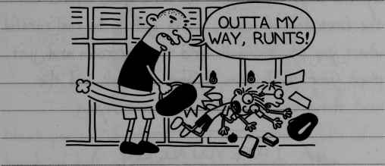
“Outta my way, runts!”
And then they wonder why bullying is such a big problem in middle school.
If it was up to me, grade levels would be based on height, not age. But then again, I guess that would mean kids like Chirag Gupta would still be in the first grade.
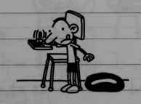
3
Today is the first day of school, and right now we’re just waiting around for the teacher to hurry up and finish the seating charts. So I figured I might as well write in this book to pass the time.
By the way, let me give you some good advice. On the first day of school you’ve got to be real careful where you sit. You walk into the classroom and just plunk your stuff down on any old desk and the next thing you know the teacher is saying -
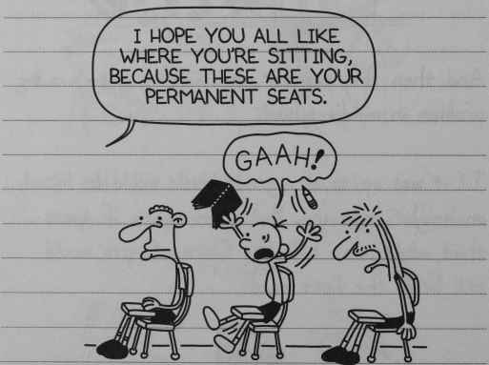
“I hope you all like where you are sitting, because those are your permanent seats”
“Gaah!”
So in this class I got stuck with Chris Hosey in front of me and Lionel James at the back of me.
4
Jason Brill came in late and almost sat to my right, but luckily I stopped that from happening at the last second.
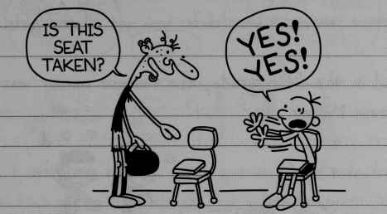
“Is this seat taken?”
“Yes! Yes!”
Next period, I should just sit in the middle of a bunch of hot girls as soon as I step in the room. But I guess if I do that it just proves I didn’t learn anything from last year.
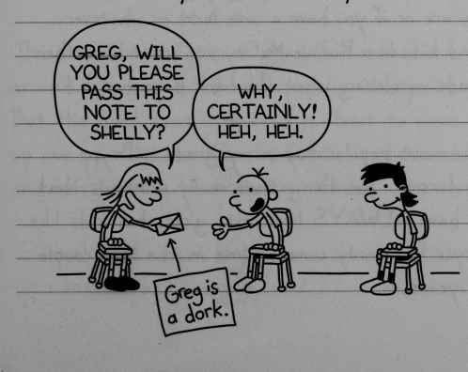
“Greg, will you please pass this note to Shelly?”
“Why, certainly! Heh, Heh.”
NOTE: “Greg is a dork”
5
Man, I don’t know WHAT is up with girls these days. It used to be a whole lot simpler back in elementary school. The deal was, if you were the fastest runner in your class, you got all the girls.
And in the fifth grade, the fastest runner was Ronnie McCoy.
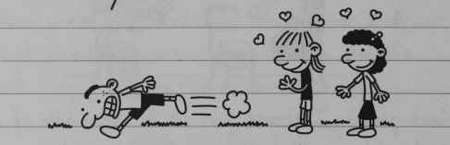
Nowadays it’s a whole lot more complicated. Now it’s about the kind of clothes you wear or how rich you are or if you have a cute butt or whatever.
And kids like Ronnie McCoy are scratching their heads wondering what the heck happened.
The most popular boy in my grade is Bryce Anderson. The thing that really stinks is that I have ALWAYS been into girls, but kids like Bryce have only come around in the last couple of years.
6
I remember how Bryce used to act back in elementary school.
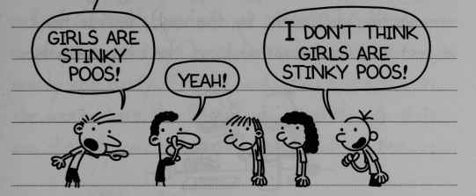
“Girls are stinky poos!”
“Yeah!”
“I don’t think girls are stinky poos!”
But of course now I don’t get any credit for sticking with the girls all this time.
Like I said, Bryce is the most popular kid in our grade, so that leaves all the rest of us guys scrambling for the other spots.
The best I can figure is that I’m somewhere around 52nd or 53rd most popular this year.
But the good news is that I’m about to move up one spot because Charlie Davies is above me, and he’s getting his braces next week.
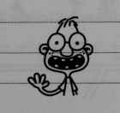
7
I try to explain all this popularity stuff to my friend Rowley (who is probably hovering around the 150 mark by the way), but I think it just goes in one ear and out the other with him.
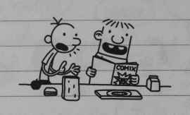

Wednesday
Today we had Phys Ed, so the first thing I did when I got outside was sneak off to the basketball court to see if the Cheese was still there. And sure enough, it was.
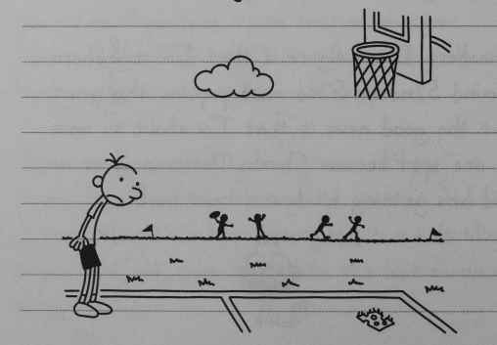
8
That piece of Cheese has been sitting on the court since last spring. I guess it must’ve dropped out of someone’s sandwich or something. After a couple of days, the Cheese started getting all mouldy and nasty. Nobody would play basketball on that court where the Cheese was, even though that was the only court that had a hoop with a net.
Then one day this kid named Darren Walsh touched the Cheese with his finger, and that’s what started this thing called the Cheese Touch. It’s basically like the Cooties. If you get the Cheese Touch, you’re stuck with it until you pass it on to someone else.
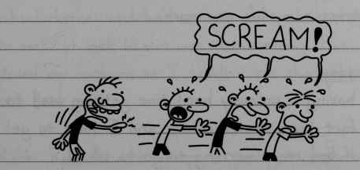
“SCREAM!”
The only way to protect yourself from the Cheese Touch is to cross your fingers.
9
But it’s not that easy remembering to keep your fingers crossed every moment of the day. I ended up taping mine together so they’d stay crossed all the time. I got a D in handwriting, but it was totally worth it.
This one kid named Abe Hall got the Cheese Touch in April, and nobody would even come near him for the rest of the year. This summer Abe moved away to California and took the Cheese Touch with him.
I just hope someone doesn’t start the Cheese Touch up again, because I don’t need that kind of stress in my life any more.

Thursday
I’m having a seriously hard time getting used the fact that summer is over and I have to get out of bed every morning to go to school.
My summer did not exactly get off to a great start thanks to my older brother Rodrick.
10
A couple of days into summer vacation, Rodrick woke me up in the middle of the night. He told me I slept through the whole summer, but that luckily I woke up just in time for the first day of school.
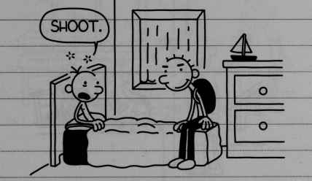
“Shoot”
You might think I was pretty dumb for falling for that one, but Rodrick was dressed up in his school clothes and he’d set my alarm clock ahead to make it look like it was morning. Plus he closed my curtains so I couldn’t see that it was still dark out.
After Rodrick woke me up, I just got up and went downstairs to make myself some breakfast, like I do every morning on a school day.
11
But I guess I must have made a pretty big racket because the next thing I knew, Dad was downstairs, yelling at me for eating Cheerios at 3:00 in the morning.
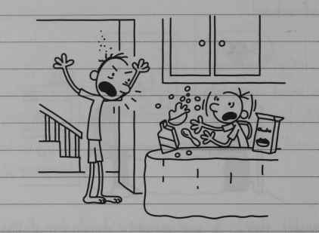
It took me a minute to figure out what the heck was going on.
After I did, I told Dad that Rodrick had played a trick on me, and HE was the one who should be getting yelled at.
Dad walked down to the basement to chew Rodrick out, and I tagged along. I couldn’t wait to see Rodrick get what was coming to him.
12
But Rodrick covered up his tracks pretty good. And to this day, I’m sure Dad thinks I’ve got a screw loose or something.
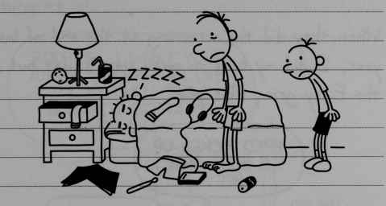
ZZZZZ

Friday
Today at school we got assigned to reading groups.
They don’t come right out and tell you if you’re in the Gifted group or the Easy group, but you can figure it out right away by looking at the covers of the books they hand out.

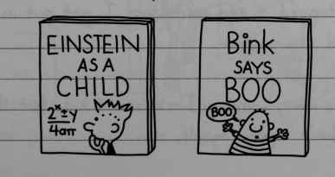
Einstein as a Child
Bink says Boo
13
I was pretty disappointed to find out I got put in the Gifted group, because that just means a lot of extra work.
When they did the screening at the end of last year, I did my best to make sure I got put in the Easy group this year.
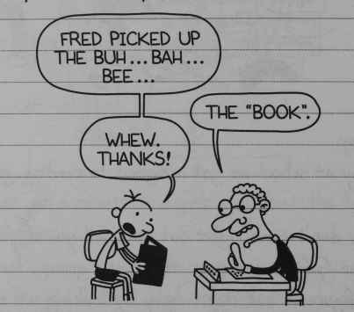
“Fred picked up the buh…bah…bee…”
“The BOOK”
“Whew. Thanks!”
Mom is real tight with our principal, so I’ll bet she stepped in and made sure I got put in the Gifted group again.
14
But if there’s one thing I learnt from Rodrick, it’s to set people’s expectations real low so you end up surprising them by practically doing nothing at all.
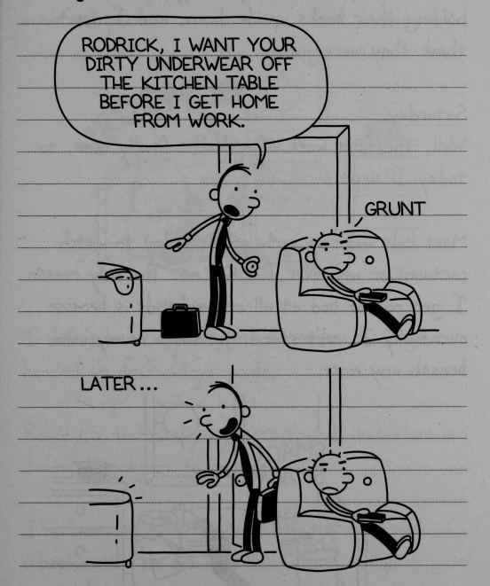
“Rodrick, I want your dirty underwear off the kitchen table before I get home from work”,
“Grunt”
Later…
15
Actually, I’m kind of glad my plan to get put in the Easy group didn’t work.
I saw a couple of the “Bink says Boo” kids holding their books upside down, and I don’t think they were joking.

Saturday
Well, the first week of school is finally over, so today I slept in.
Most kids wake up early on Saturday to watch cartoons or whatever, but not me. The only reason I get out of bed at all on weekends is because eventually I can’t stand the taste of my own breath any more.
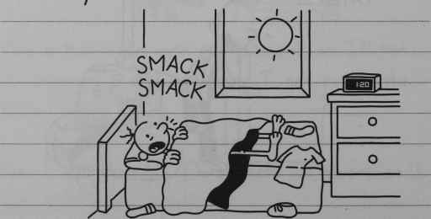
Smack Smack
16
Unfortunately, Dad wakes up at 6:00 in the morning no matter WHAT day of the week it is, he is not real considerate of the fact that I am trying to enjoy my Saturday like a normal person.
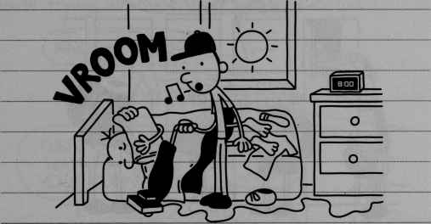
VROOM
I didn’t have anything to do today so I just headed up to Rowley’s house.
Rowley is technically my best friend, but that is definitely subject to change.
I’ve been avoiding Rowley since the first day of school, when he did something that really annoyed me.
17
We were getting our stuff from our lockers at the end of the day, and Rowley came up to me and said -
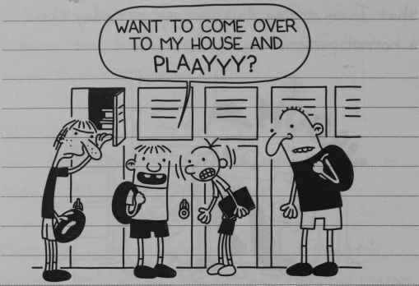
“Want to come over to my house and PLAAYYY?”
I have told Rowley at least a billion times that now we’re in middle school you’re supposed to say “hang out”, not “play”. But no matter how many noogies I give him, he always forgets the next time.
I’ve been trying to be a lot more careful about my image ever since I got to middle school. But having Rowley around is definitely not helping.
18
I met Rowley a few years ago when he moved into my neighbourhood.
His mom bought him this book called “How to Make Friends in New Places”, and he came to my house trying all these dumb gimmicks.
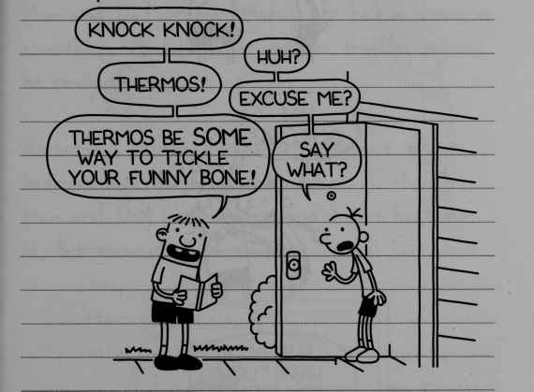
“Knock Knock!”
“Huh?”
“Thermos!”
“Excuse me?”
Thermos be some way to tickle your funny bone!”
“Say what?”
I guess I kind of felt sorry for Rowley, and I decided to take him under my wing.
It’s been great having him around, mostly because I get to use all the tricks Roderick pulls on ME.
19
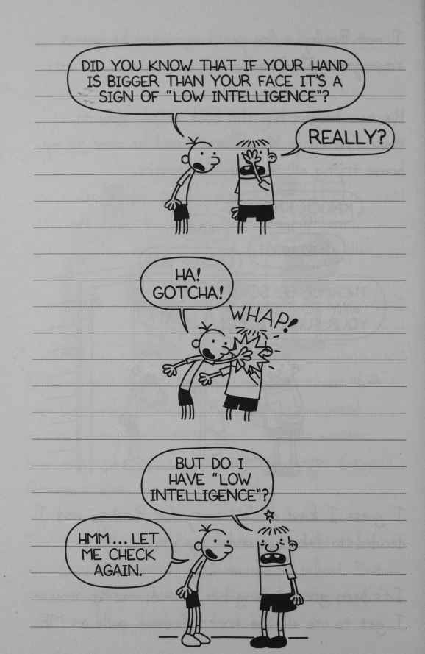
“Did you know that if your hand is bigger than your face it’s a sign of low intelligence?”
“Really?”
“Ha gotcha!” WHAP!
“But do I have low intelligence?”
Hmm…let me check again.
20

Monday
You know how I said I play all sorts of pranks on Rowley? Well, I have a little brother named Manny, and I could NEVER get away with pulling any of that stuff on him.
Mom and Dad protect Manny like he’s a prince or something. And he never gets in trouble even if he really deserves it.
Yesterday, Manny drew a self-portrait on my bedroom door in permanent marker. I thought Mom and Dad were really going to let him have it, but as usual, I was wrong.
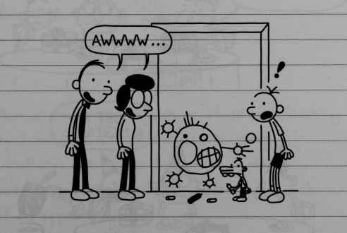
“Awwww…”
21
But the thing that bugs me the most about Manny is the nickname he has for me. When he was a baby, he couldn’t pronounce “brother”, so he started calling me “Bubby”. And he STILL calls me that now even though I keep trying to get Mom and Dad to make him stop.
Luckily, none of my friends have found out yet, but believe me, I have had some really close calls.
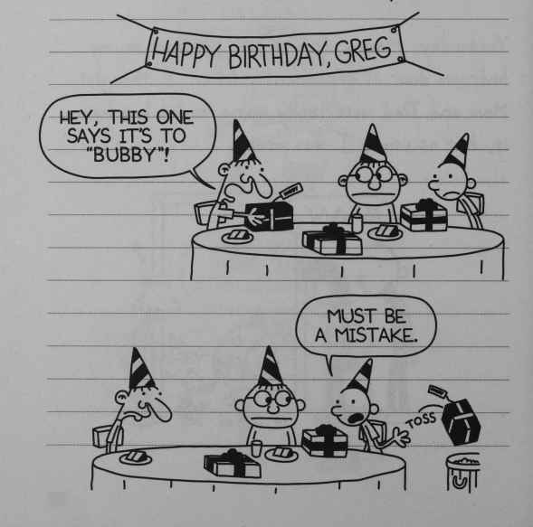
HAPPY BIRTHDAY GREG
“Hey, this one says it’s to Bubby!”
“Must be a mistake”
22
Mom makes me help get Manny ready for school in the morning. After I make Manny his breakfast, he carries his cereal bowl into the family room and sits on his plastic potty.
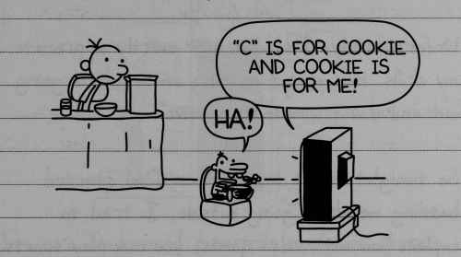
“C” IS FOR COOKIE AND COOKIE IS FOR ME!
“Ha!”
And when it’s time for him to go to day care, he gets up and dumps whatever he didn’t eat right in the toilet.
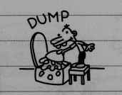
DUMP
Mom is always getting on me about not finishing my breakfast. But if she had to scrape cornflakes out of a plastic potty every morning, she wouldn’t have much of an appetite either.
23

Tuesday
I don’t know if I mentioned this before, but I am SUPER good at video games. I’ll bet I could beat anyone in my grade head-to-head.
Unfortunately Dad does not exactly appreciate my skills. He’s always getting on me about going out and doing something “active”.
So tonight after dinner when Dad started hassling me about going outside, I tried to explain how with video games, you can play sports like football and soccer, and you don’t even get all hot and sweaty.
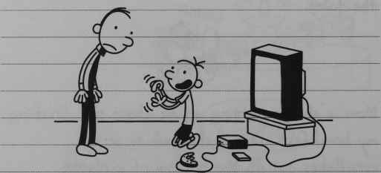
But as usual, Dad didn’t see my logic.
24
Dad is a pretty smart guy in general but when it comes to common sense, sometimes I wonder about him.
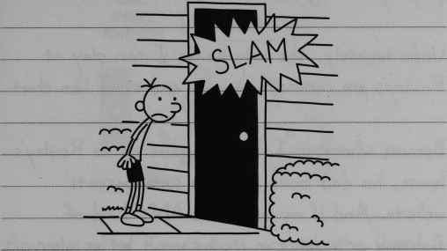
SLAM
I’m sure Dad would dismantle my game system if he could figure out how to do it. But luckily, the people who make these things make them parent-proof.
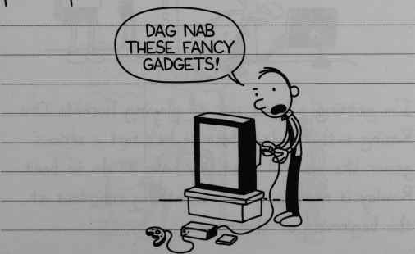
“Dag Nab these fancy gadgets!”
25
Every time Dad kicks me out of the house to do something sporty, I just go up to Rowley’s and play my video games there.
Unfortunately, the only games I can play at Rowley’s are car-racing games and stuff like that.
Because whenever I bring a game up to Rowley’s house, his dad looks it up on some parents’ website. And if my game has ANY kind of fighting or violence in it, he won’t let us play.
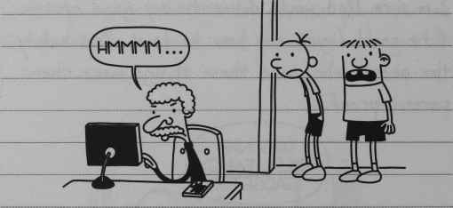
“Hmmmm…”
I’m getting a little sick of playing Formula One Racing with Rowley, because he’s not a serious gamer like me. All that you have to do to beat Rowley is name your car something ridiculous at the beginning of the race.
26
And then when you pass Rowley’s car, he just falls to pieces.
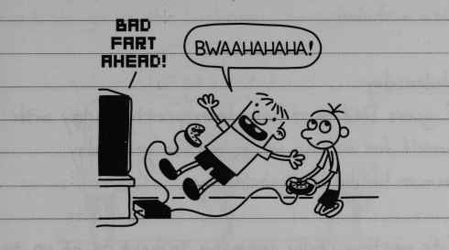
BAD FART AHEAD
“Bwaahahahaha!”
Anyway, after I got done mopping the floor with Rowley today, I headed home. I ran through the neighbour’s sprinkler a couple times to make it look like I was all sweaty, and that seemed to do the trick for Dad.
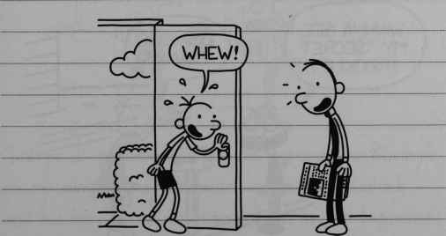
“Whew!”
27
But my trick kind of backfired, because as soon as Mom saw me, she made me go upstairs and take a shower.

Wednesday
I guess Dad must have been pretty happy with himself for making me go outside yesterday, because he did it again today.
It’s getting really annoying having to go up to Rowley’s every time I want to play a video game. There’s this weird kid named Fregley who lives halfway between my house and Rowley’s, and Fregley is always hanging out in his front yard. So it’s pretty hard to avoid him.
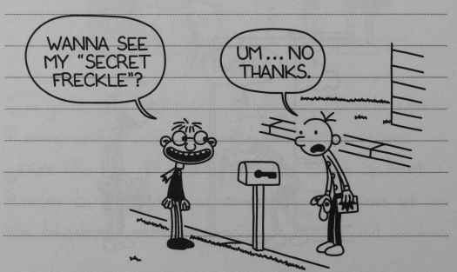
“Wanna see my secret freckle?”
“Um…no thanks”
28
Fregley is in my Phys Ed class at school, and he has this whole made-up language. Like when he needs to go to the bathroom he says -
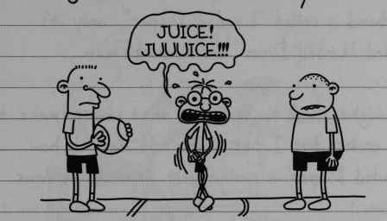
“Juice! Juuuice!!!”
Us kids have pretty much figured Fregley out by now, but I don’t think the teachers have really caught on yet.
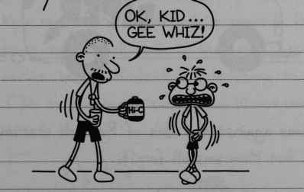
“Ok, kid…gee whiz!”
Today I probably would have gone up to Rowley’s on my own anyway, because my brother Rodrick and his band were practicing down in the basement.
29
Rodrick’s band is REALLY awful, and I can’t stand being home when they’re having rehearsals.
His band is called “Loaded Diaper”, only it’s spelled “Loded Diper” on Rodrick’s van.
You might think he spelled it that way to make it look cooler, but I bet if you told Rodrick how “Loaded Diaper” is really spelt, it would be news to him.
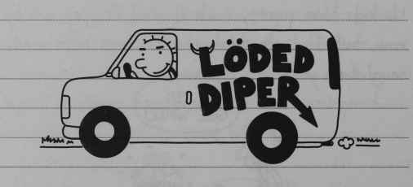
LODED DIPER
Dad was against the idea of Rodrick starting a band but Mom was all for it.
She’s the one who bought Rodrick his first drum set.
30
I think Mom has this idea that we’re all going to learn to play instruments and then become one of those family bands like you see on TV.
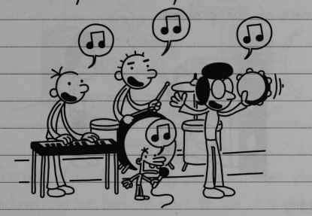
Dad really hates heavy metal, and that’s the kind of music Rodrick and his band play. I don’t think Mom really cares what Rodrick plays or listens to, because to her, all music is the same. In fact, earlier today, Rodrick was listening to one of his CDs in the family room, and Mom came in and started dancing.

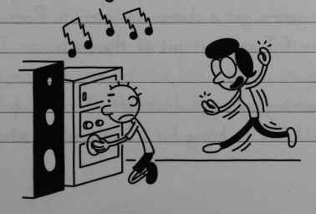
31
That really bugged Rodrick, so he drove off to the store and came back fifteen minutes later with some headphones. And that pretty much took care of the problem.
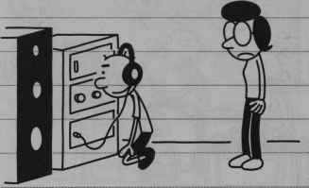

Thursday
Yesterday Rodrick got a new heavy metal CD, and it had one of those “Parental Warning” stickers on it.
I have never got to listen to one of those “Parental Warning” CDs, because Mom and Dad never let me buy them at the mall. So I realized that the only way I was gonna get a chance to listen to Rodrick’s CD was if I snuck it out of the house.
This morning, after Rodrick left, I called up Rowley and told him to bring his CD player to school.
32
Then I went down to Rodrick’s room and took the CD off his rack.
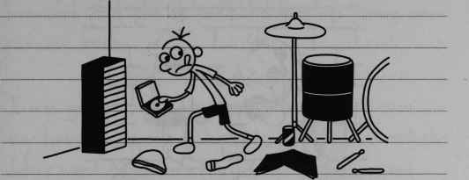
You’re not allowed to bring personal music players to school, so we had to wait to use it until after lunch when the teachers let us outside. As soon as we got the chance, me and Rowley snuck around the back of the school and loaded up Rodrick’s CD.
But Rowley forgot to put batteries in his CD player, so it was pretty much worthless.
Then I came up with this great idea for a game. The object was to put the headphones on your head and then try to shake them off without using your hands.
33
The winner was whoever could shake the headphones off in the shortest amount of time.
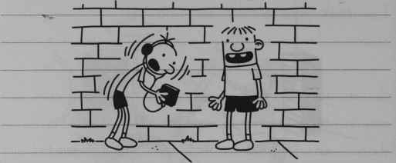
I had the record with seven and a half seconds, but I think I might have shook some of my fillings loose with that one.
Right in the middle of our game, Mrs Craig came around the corner and caught us red-handed. She took the music player away from me and started chewing us out.
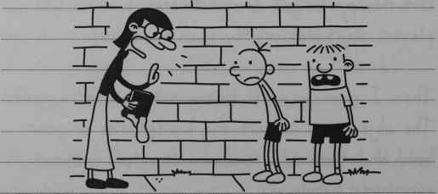
34
But I think she had the wrong idea about what we were doing back there. She started telling us that rock and roll is “evil” and how it’s going to ruin our brains.
I was going to tell her that there weren’t even any batteries in the CD player, but I could tell she didn’t want to be interrupted. So I just waited until she was done, and then said, “Yes, ma’am”
But right when Mrs Craig was about to let us go, Rowley started blubbering about how he doesn’t want rock and roll to ruin his “brains”.
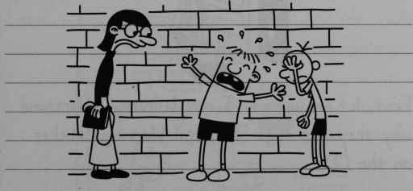
Honestly, sometimes I don’t know about that boy.
35

Friday
Well, now I’ve gone and done it.
Last night, after everyone was in bed, I snuck downstairs to listen to Rodrick’s CD on the stereo in the family room.
I put Rodrick’s new headphones on and cranked up the volume REALLY high. Then I hit “play”.
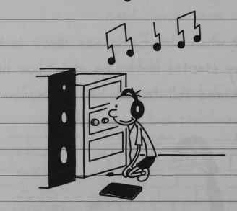
First, let me say I can definitely understand why they put that “Parental Warning” sticker on the CD.
But I only got to hear about thirty seconds of the first song before I got interrupted.
36
It turns out I didn’t have the headphones plugged into the stereo. So the music was actually coming through the SPEAKERS, not the headphones.
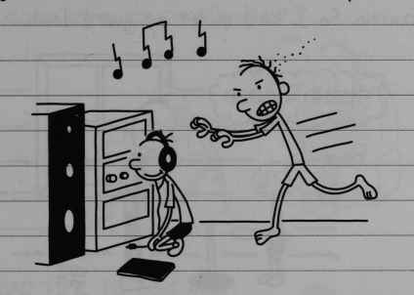
Dad marched me up to my room and shut the door behind him, and then he said -
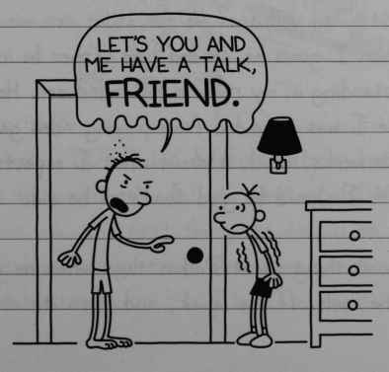
“Lets you and me have a talk, FRIEND”
37
Whenever Dad says “Friend” that way, you know you’re in trouble. The first time Dad said “friend” like that to me I didn’t get he was being sarcastic. So I kind of let my guard down.
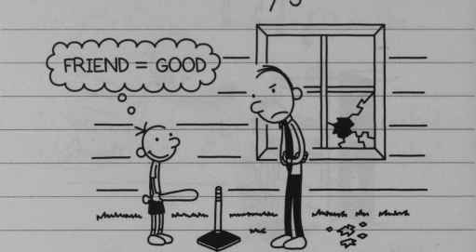
FRIEND = GOOD
I don’t make that mistake any more.
Tonight, Dad yelled at me for about ten minutes, and then I guess he decided he’d rather be in bed than standing in my room in his underwear. He told me I was grounded from playing video games for two weeks, which is about what I expected. I guess I should be glad that’s all he did.
The good thing about Dad is that when he gets mad, he cools off real quick, and then it’s over.
38
Usually, if you mess up in front of Dad, he just throws whatever he’s got in his hands at you.
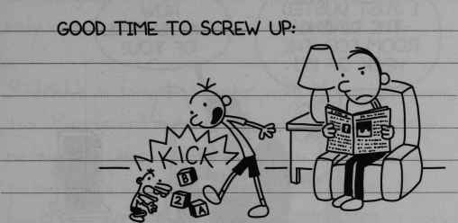
Good time to screw up:
KICK
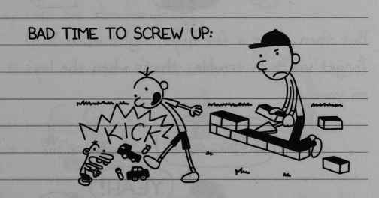
Bad time to screw up:
KICK
Mom has a TOTALLY different style when it comes to punishment.
If you mess up and Mom catches you, the first thing she does is to take a few days to figure out what your punishment should be.
39
And while you’re waiting, you do all these nice things to try to get off easier.
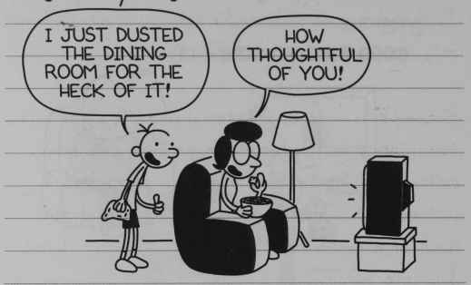
“I just dusted the dining room for the heck of it”
“How thoughtful of you”
But then after a few days, right when YOU forget you’re in trouble, that’s when she lays it on you.
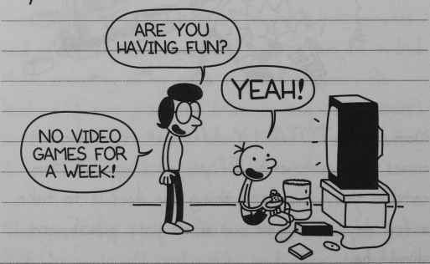
“Are you having fun?”
“Yeah!”
“No video games for a week!”
40

Monday
This video game ban is a whole lot tougher than I thought it would be. But at least I’m not the only one in the family who’s in trouble.
Rodrick’s in some hot water with Mom right now, too. Manny got hold of one of Rodrick’s heavy metal magazines, and one of the pages had a picture of a woman in a bikini lying across the hood of a car. And then Manny brought it into day care for show-and-tell.
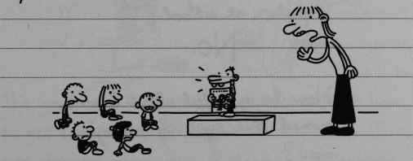
Anyway, I don’t think Mom was too happy about getting that phone call.
I saw the magazine myself and it honestly wasn’t anything to get worked up over. But Mom doesn’t allow that kind of stuff in the house.
41
Rodrick’s punishment was that he had to answer a bunch of questions Mom had written out for him.
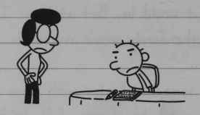
Did owning this magazine make you a better person?
No.
Did it make you more popular at school?
No.
How do you feel about having owned this type of magazine now?
I feel ashamed.
Do you have anything you want to say to women for having owned this type of magazine?
I’m sorry, women.
42

Wednesday
I’m still grounded from using video games, so Manny has been using my system. Mom went out and bought a whole bunch of educational video games and watching Manny play them is like torture.
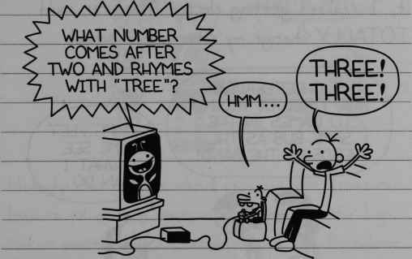
What number comes after two and rhymes with “tree”?
“Hmm…”
“Three! Three!”
The good news is that I finally figured out how to get some of my games past Rowley’s dad. I just put one of my disks in Manny’s “Discovering the Alphabet” case, and that’s all it takes.
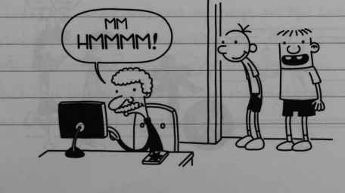
“Mm Hmmm!”
43

Thursday
At school today they announced that student government elections are coming up. To be honest with you, I’ve never had any interest in student government. But when I started thinking about it, I realized getting elected Treasurer could TOTALLY change my situation at school.
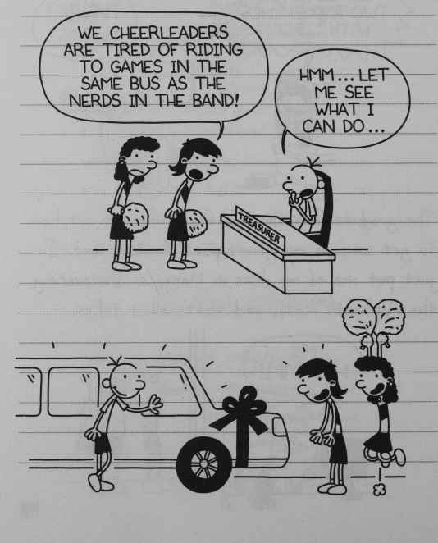
“We cheerleaders are tired of riding to games in the same bus as the nerds in the band.”
“Hmm…let me see what I can do”
44
And even better…
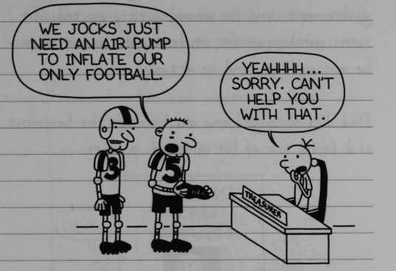
“We jocks just need an air pump to inflate our only football”
“Yeahhhh…sorry. Can’t help you with that.”
Nobody ever thinks about running for Treasurer because all anyone ever cares about are the big-ticket positions like President and Vice President. So I figure if I sign up tomorrow, the Treasurer job is pretty much mine for the taking.

Friday
Today, I went and put my name on the list to run for Treasurer. Unfortunately, this kid called Marty Porter is running for Treasurer, too, he’s really brainy at maths. So this might not be as easy as I thought.
45
I told Dad I was running for student government, and he seemed pretty excited. It turns out he ran for student government when he was my age, and he actually won.
Dad dug through some old boxes in the basement and found one of his campaign posters.
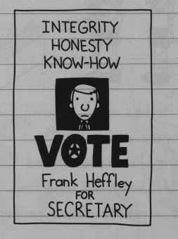
INTEGRITY, HONESTY, KNOW-HOW
VOTE Frank Heffley for SECRETARY
I thought the poster idea was pretty good, so I asked Dad to drive me to the store to get some supplies. I loaded up on poster board and markers, and I spent the rest of the night making all my campaign stuff. So let’s just hope these posters work.
46

Monday
I brought my posters in to school today, and I have to say, they came out pretty good.
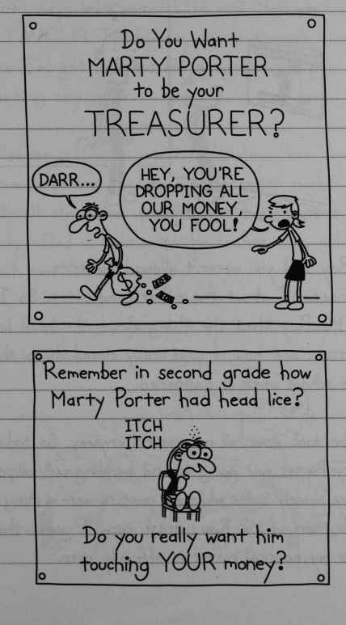
Do you want MARTY PORTER to be your TREASURER?
“Darr…”
“Hey, you’re dropping all our money, you fool!”
Remember in second grade how Marty Porter had head lice?
ITCH ITCH
Do you really want him touching YOUR money?
47
I started hanging my posters up as soon as I got in. But they were only up for about three minutes before Vice Principal Roy spotted them.
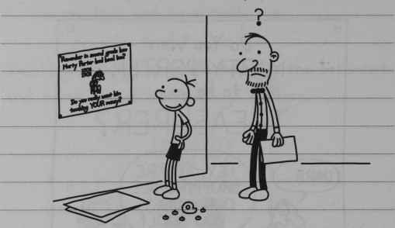
Mr Roy said you weren’t allowed to write “fabrications” about the other candidates. So I told Mr Roy that the thing about the head lice was true, and how it practically closed down the whole school when it happened.
But he took down all my posters anyway. So today, Marty Porter was going around handing out lollipops to buy himself votes while my posters were sitting at the bottom of Mr Roy’s trash can. I guess this means my political career is officially over.
48

OCTOBER
Monday
Well, it’s finally October, and there are only thirty days left until Halloween. Halloween is my FAVOURITE holiday, even though Mom says I’m getting too old to go trick-or-treating any more.
Halloween is Dad’s favourite holiday too, but for a different reason. On Halloween night, while all the other parents are handing out candy, Dad is hiding in the bushes with a big trash can full of water.
And if any teenagers pass by our driveway, he drenches them.
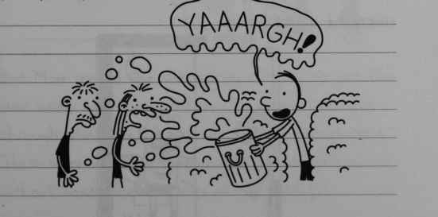
“YAAARGH!”
49
I’m not sure Dad really understands the concept of Halloween. But I’m not gonna be the one who spoils his fun.
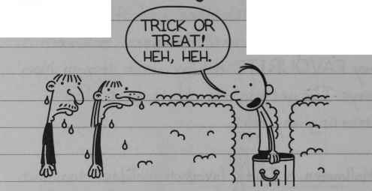
“Trick or treat! Heh, Heh.”
Tonight was the opening night of the Crossland High School haunted house, and I got Mom to agree to take me and Rowley.
Rowley showed up at my house wearing his Halloween costume from last year. When I called him earlier I told him to just wear regular clothes, but of course he didn’t listen.
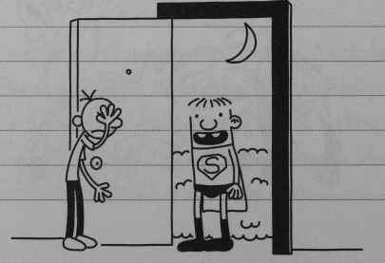
50
I tried not to let it bother me too much, though. I’ve never been allowed to go to the Crossland haunted house before, and I wasn’t going to let Rowley ruin it for me. Rodrick has told me all about it, and I’ve been looking forward to this for about three years.
Anyway, when we got to the entrance, I started having second thoughts about going in.
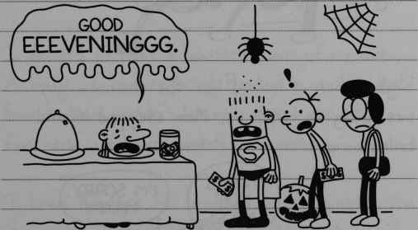
“Good EEEVENINGGG.”
But Mom seemed like she was in a hurry to get this over with, and she moved us along. Once we were through the gate, it was one scare after another. There were vampires jumping out at you and people without heads and all sorts of crazy stuff.
51
But the worst part was this area called Chainsaw Alley. There was this big guy in a hockey mask and he had a REAL chainsaw. Rodrick told me the chainsaw had a rubber blade, but I wasn’t taking any chances.
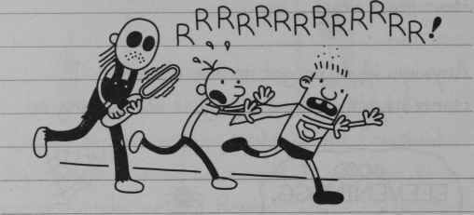
RRRRRRRRRRRRR!
Right when it looked like the chainsaw guy was going to catch us, Mom stepped in and baled us out.
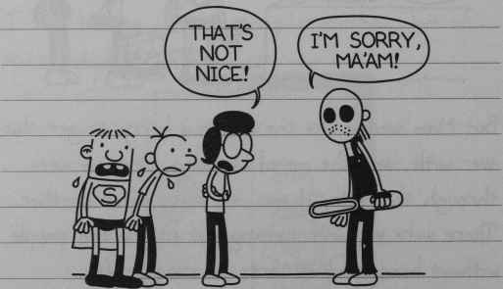
“That’s not nice!”
“I’m sorry, ma’am!”
52
Mom made the chainsaw guy show us where the exit was, and that was the end of our haunted-house experience right there. I guess it was a little embarrassing when Mom did that, but I’m willing to let it go this one time.

Saturday
The Crossland haunted house really got me thinking. Those guys were charging five bucks a pop, and the line stretched halfway around the school.
I decided to make a haunted house of my own. Actually, I had to bring Rowley in on the deal, because Mom wouldn’t let me convert our first floor into a full-out haunted mansion.
I knew Rowley’s Dad wouldn’t be crazy about the idea, either, so we decided to build the haunted house in his basement and just not mention it to his parents.
Me and Rowley spent most of the day coming up with an awesome plan for our haunted house.
53
Here was our final plan:
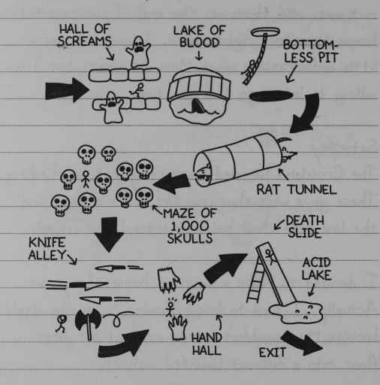
HALL OF SCREAMS
LAKE OF BLOOD
BOTTOMLESS PIT
RAT TUNNEL
MAZE OF 1000 SKULLS
KNIFE ALLEY
HAND HALL
DEATH SLIDE
ACID LAKE
EXIT
I don’t mean to brag or anything, but what we came up with was WAY better than the Crossland High School haunted house.
We realized we were gonna need to get the word out that we were doing this thing, so we got some paper and made up a bunch of flyers.
54
I’ll admit maybe we stretched the truth a little in our advertisement, but we had to make sure people actually showed up.
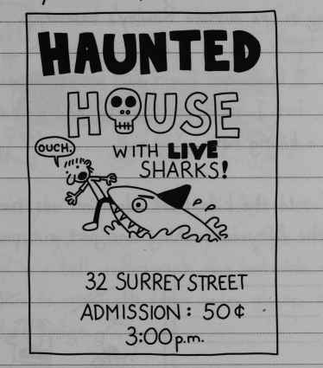
HAUNTED HOUSE with LIVE sharks!
“Ouch”
32 Surrey St
Admission: 50¢
3:00pm
By the time we finished putting the flyers up around the neighbourhood and got back to Rowley’s basement, it was already 2:30, and we hadn’t even started putting the actual haunted house together yet.
So we had to cut some corners from our original plan.
55
When 3:00 rolled around, we looked outside to see if anyone had showed up. And sure enough, there were about twenty neighbourhood kids waiting in line outside Rowley’s basement.
Now, I know our flyers said admission was fifty cents’ but I could see that we had a chance to make a killing here. So I told the kids the admission was two bucks, and the fifty-cent thing was just a typo.
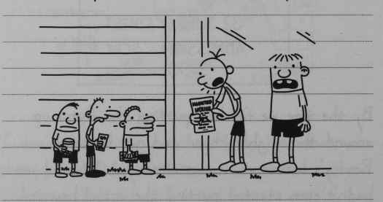
The first kid to cough up his two bucks Shane Snella. He paid his money and we let him inside, and me and Rowley took our positions in the Hall of Screams.
56
The Hall of Screams was basically a bed with me and Rowley on either side of it.
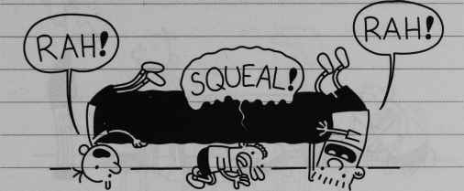
“RAH!”
“SQUEAL!”
“RAH!”
I guess maybe we made the Hall of Screams a little too scary, because halfway through, Shane curled up in a ball underneath the bed. We tried to get him to crawl out from under there, but he wouldn’t budge.
I started thinking about all the money we were losing with this kid clogging up the Hall of Screams, and I knew we had to get him out of there, quick.
Eventually, Rowley’s dad came downstairs. At first I was happy to see him, because I thought he could help us to drag Shane out from under the bed and get out haunted house cranking again.
57
But Rowley’s dad wasn’t really in a helpful mood.
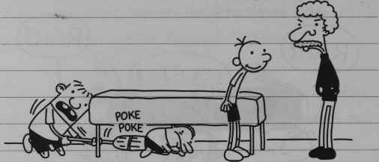
Poke poke
Rowley’s dad wanted to know what we were doing, and why Shane Snella was curled up under the bed.
We told him the basement was a haunted house, and that Shane Snella actually PAID for us to do this to him. But Rowley’s dad didn’t believe us.
I admit that if you looked around, it didn’t really look like a haunted house. All we had time to put together was the Hall of Screams and the Lake of Blood, which was just Rowley’s old baby pool with half a bottle of ketchup in it.
58
I tried to show Rowley’s dad our original plan to prove that we really were running a legitimate operation, but he still didn’t seem convinced.
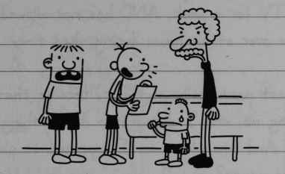
And to make a long story short, that was the end of our haunted house.

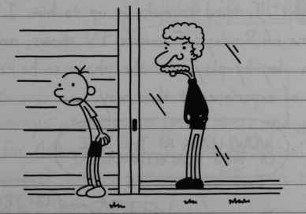
The good news is, since Rowley’s dad didn’t believe us, he didn’t make us refund Shane’s money. So at least we cleared two bucks today.
59

Sunday
Rowley ended up getting grounded for that whole haunted house mess yesterday. He’s not allowed to watch TV for a week, AND he’s not allowed to have me over at his house during that time.
That last part really isn’t fair, because that’s punishing me, and I didn’t even do anything wrong. And now where am I supposed to play my video games?
Anyway, I felt kind of bad for Rowley. So tonight, I tried to make it up to him. I turned on one of Rowley’s favourite TV shows, and I did a play-by-play over the phone so he could kind of experience it that way.
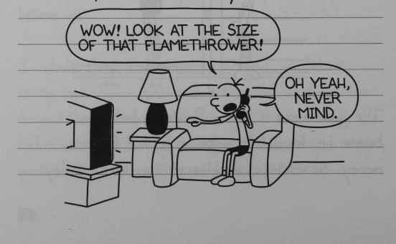
“Wow! Look at the size of that flame thrower!”
“Oh yeah, never mind”
60
I did my best to keep up with what was going on on the screen, but to be honest with you, I’m not sure if Rowley was getting the full effect.
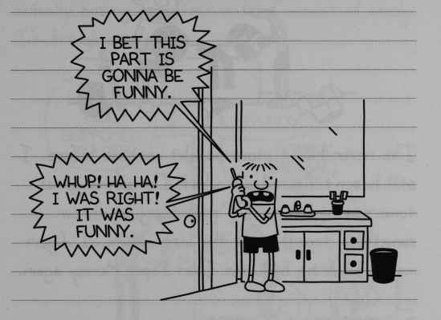
“I bet this part is gonna be funny.
Whup! Ha Ha! I was right! It was funny”

Tuesday
Well Rowley’s grounding is finally over, and just in time for Halloween, too. I went up to his house to check out his costume, and I have to admit, I’m a little jealous.
Rowley’s Mom got him this knight costume that’s WAY cooler than his costume from last year.
61
His knight outfit came with a helmet and a shield and a real sword and EVERYTHING.
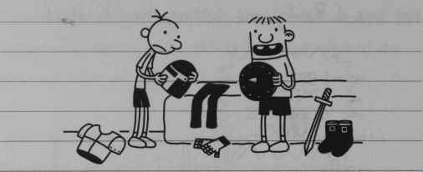
I’ve never had a store-bought costume before. I still haven’t figured out what I’m gonna go as tomorrow night, so I’ll probably just throw something together at the last minute. I figure maybe I’ll bring back the Toilet Paper Mummy again.
But I think it’s supposed to rain tomorrow night, so that might not be the smartest choice.
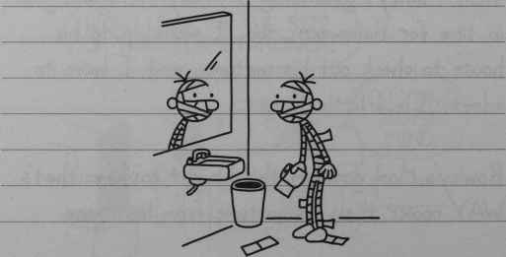
62
In the past few years, the grown-ups in my neighbourhood have been getting cranky about my lame costumes, and I’m starting to think it’s actually starting to have an effect on the amount of candy I’m bringing in.
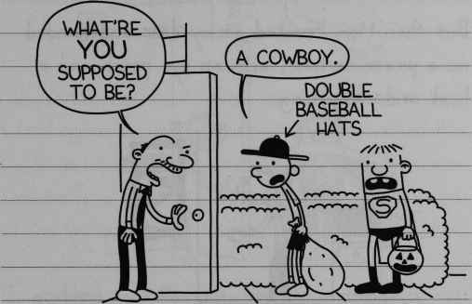
“What’re you supposed to be?”
“A cowboy”
Double baseball hats
But I don’t really have time to put together a good costume, because I’m in charge of planning out the best route for me and Rowley to take tomorrow night.
This year I’ve come up with a plan that’ll get us at least twice the candy we scored last year.
63

Halloween
About an hour before we were supposed to start trick-or-treating, I still didn’t have a costume. At that point I was seriously thinking about going as a cowboy for the second year in a row.
But then Mom knocked on my door and handed me a pirate costume, with an eye patch and a hook and everything.
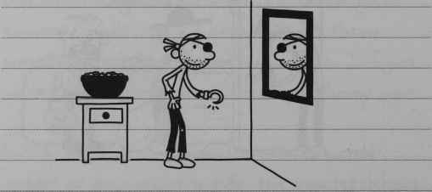
Rowley showed up around 6:30 wearing his knight costume, but it didn’t look ANYTHING like it looked yesterday.
Rowley’s Mom made all these safety improvements to it, and you couldn’t even tell what he was supposed to be any more.
64
She cut out a big hole in front of the helmet so he could see better, and covered him up in all this reflective tape. She made him wear his winter coat underneath everything, and she replaced his sword with a glow stick.
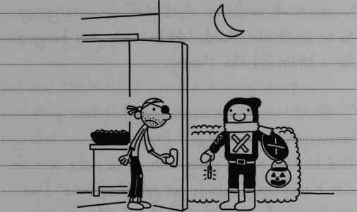
I grabbed my pillowcase, and me and Rowley started to head out. But Mom stopped us before we could get to the door.
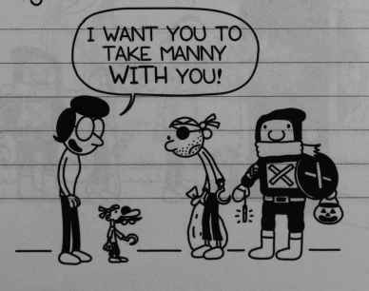
“I want you to take Manny with you”
65
Man, I should have known there was a catch when Mom gave me that costume.
I told Mom there was no WAY we were taking Manny with us, because we were going to hit 152 houses in three hours. And plus, we were going to be on Snake Road, which is way too dangerous for a little kid like Manny.
I should never have mentioned that last part, because the next thing I knew, Mom was telling Dad he had to go along with us to make sure we didn’t step foot outside our neighbourhood. Dad tried to squirm out of it, but once Mom makes up her mind, there’s no way you can change it.
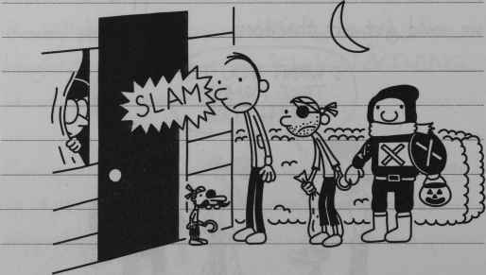
SLAM
66
Before we even got out of our driveway, we ran into our neighbour Mr Mitchell and his kid Jeremy. So of course THEY tagged along with us.
Manny and Jeremy wouldn’t trick-or-treat at any houses with spooky decorations on them, so that ruled out pretty much every house on our block.
Dad and Mr Mitchell started talking about football or something, and every time one of them wanted to make a point, they’d stop walking.
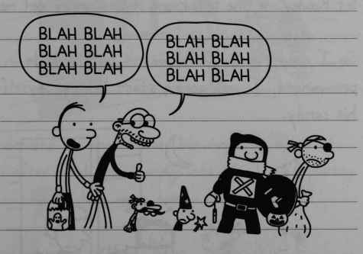
“BLAH BLAH, BLAH BLAH, BLAH BLAH”
“BLAH BLAH, BLAH BLAH, BLAH BLAH”
So we were hitting only about one house every twenty minutes.
67
After a couple of hours, Dad and Mr Mitchell took the kids home.
I was glad, because that meant me and Rowley could take off. My pillowcase was almost empty so I wanted to make up as much time as possible.
A little while later, Rowley told me he needed a “potty break”. I made him hold off for another forty-five minutes. But by the time we got to my gramma’s house, it was pretty clear that if I didn’t let Rowley use the bathroom, it was gonna get messy.
So I told Rowley if he wasn’t back outside in one minute, I was gonna start helping myself to his candy.
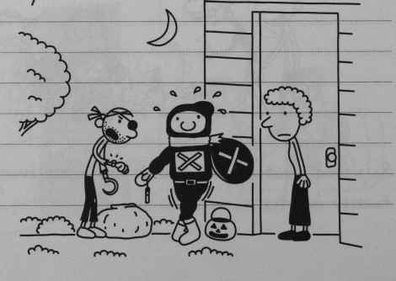
68
After that, we headed back out on the road. But it was already 10:30, and I guess that’s when most grown-ups decide Halloween is over.
You can kind of tell because that’s when they start coming to the door in their pyjamas and giving you the evil eye.
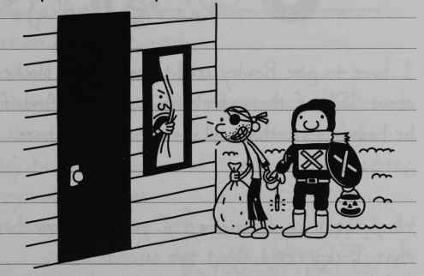
We decided to head home. We made up a lot of time after Dad and Manny left, so I was pretty satisfied with how much candy we took in.
When we were halfway home, this pickup truck came roaring down the street with a bunch of high-school kids in it.
69
The kid in the back was holding a fire extinguisher, and when the truck passed by us, he opened fire.
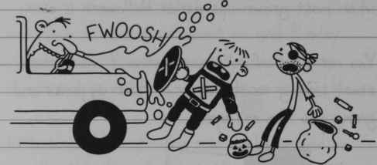
FWOOSH
I have to give Rowley credit, because he blocked about 95% of the water with his shield. And if he hadn’t done that, all our candy would have got soaked.
When the truck drove away, I yelled out something that I regretted about two seconds later.
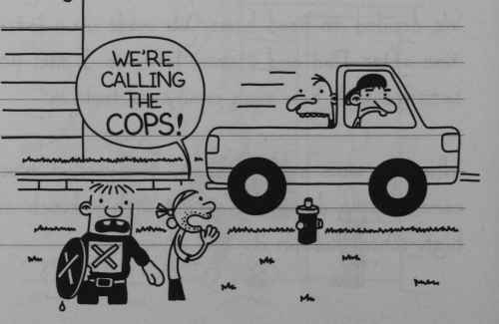
“We’re calling the cops!”
70
The driver slammed on the brakes and he turned his truck around. Me and Rowley started running, but those guys were right on our heels.
The only place I could think of that was safe was Gramma’s house, so we cut through a couple of backyards to get there. Gramma was in bed already, but I know she keeps a key under the mat on her front porch.
Once we got inside, I looked out the window to see if those guys had followed us, and sure enough, they had. I tried to trick them into leaving, but they wouldn’t budge.
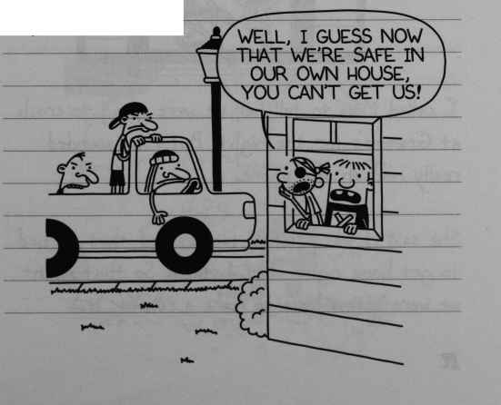
“Well, I guess now that we’re safe in our own house, you can’t get us!”
71
After a while, we realized the teenagers were going to wait us out, so we decided we were just gonna have to spend the night at Gramma’s. That’s when we started getting cocky, making monkey noises at the teenagers and whatnot.
Well, at least I was making monkey noises. Rowley was kind of making owl noises, but I guess it was the same general idea.
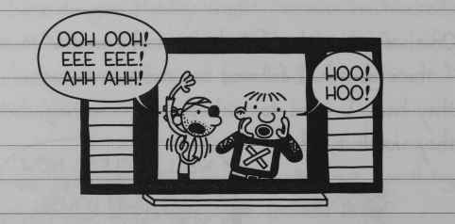
“Ooh ooh! Eee eee! Ahh ahh!”
“Hoo! Hoo!”
I called Mom to tell her we were going to crash at Gramma’s for the night. But Mom sounded really mad on the phone.
She said it was a school night, and that we had to get home right that instant. So that meant we were gonna have to make a run for it.
72
I looked out the window, and this time, I didn’t see the truck. But I knew those guys were hiding somewhere and were just trying to draw us out.
So we snuck out the back door, hopped over Gramma’s fence and ran all the way to Snake Road. I figured our chances were better there as there aren’t any streetlights.
Snake Road is scary enough on its own without having a truckload of teenagers hunting you down. Every time we saw a car coming, we dived into the bushes. It must’ve taken us a half hour to go 100 yards.
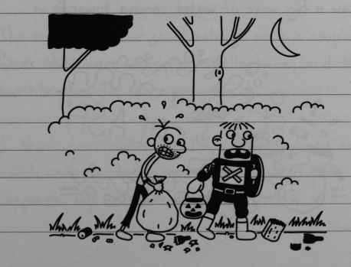
73
But believe it or not, we made it all the way home without getting caught. Neither one of us let our guard down until we got to my driveway.
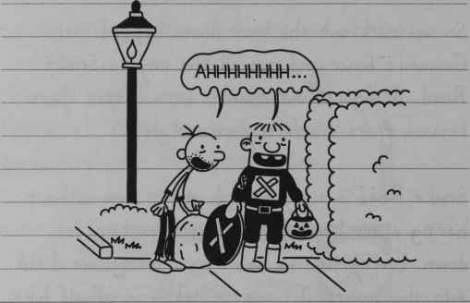
“Ahhhhhhhh…”
But right then there was this awful scream, and we saw a big wave of water coming towards us.
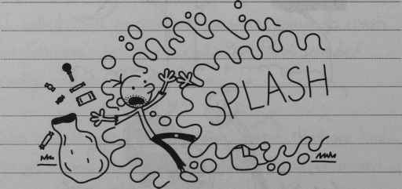
SPLASH
74
Man, I forgot ALL about Dad, and we totally paid the price for it.
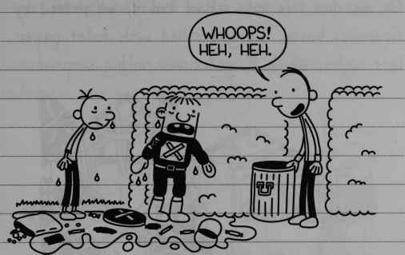
“Whoops! Heh, heh.”
When me and Rowley got inside, we laid out all our candy on the kitchen table.
The only things we could salvage were a couple of mints that were wrapped in cellophane, and the toothbrushes Dr Garrison gave us.
I think next Halloween I’ll just stay home and mooch some Butterfingers from the bowl Mom keeps on top of the refrigerator.
75

