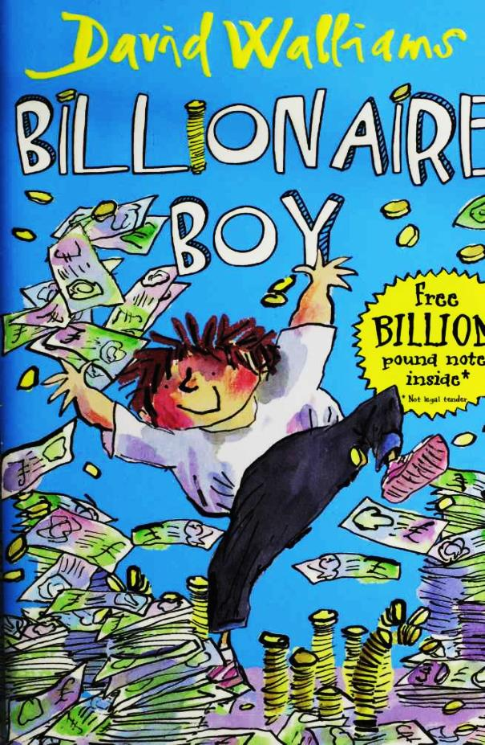

Billionaire Boy

By

David Walliams

Illustrated by Tony Ross

This electronic copy of the original work is made under a Copyright Licensing Agency license by The Seeing Ear. It is for the personal use of a Print Disabled Person and may not be further copied, (including any electronic copying or transmission), or dealt with without permission, save as may be permitted by law.

Contents

1 Meet Joe Spud 9

2 Bum Boy 17

3 Who's the Fattiest? 24

4 "Loo Rolls?" 31

5 Out of Date Easter Eggs 35

6 The Grubbs 40

7 Gerbils on Toast 46

8 The Witch 52

9 "Finger?" 57

10 Dog Spit 63

11 Camping Holiday 67

12 Page 3 Stunna 71

13 New Girl 78

14 The Shape of a Kiss 82

15 Nip and Tuck 85

16 Peter Bread 89

17 A Knock on the Toilet Door 93

18 The Vortex 3000 97

19 A Baboon's Bottom 100

20 A Beach Ball Rolled in Hair 103

21 A GCSE in Make-Up 107

22 A New Chapter 111

23 Canal Boat Weekly 114

24 The Rajmobile 119

25 Broken 122

26 A Blizzard of Banknotes 126

Postscript 130

# 6 The Grubbs

"Oi! BLOB!" came a shout from behind them.

"Just keep walking," said Bob.

Joe turned to look around and glimpsed a pair of twins. They looked terrifying - like gorillas in human suits. These must be the dreaded Grubbs Bob had talked about.

"Don't look round," said Bob. "I'm serious. Just keep walking."

Joe was beginning to wish he was luxuriating in the safety of the back seat of his chauffeur-driven Rolls Royce, rather than walking to the bus stop.

77

"FATSO!"

As Joe and Bob walked faster, they could hear footsteps behind them. Although it was still early, the winter sky was blackening. The street lamps flickered on and blotches of yellow light spilled onto the wet ground.

"Quick, let's run down here," said Bob. The boys dashed down an alley, and hid behind a giant green wheely bin that was parked at the back of a Bella Pasta.

"I think we've lost them," whispered Bob.

"Are those the Grubbs?" asked Joe.

"Shh. Keep your voice down!"

"Sorry," whispered Joe.

"Yeah, it's the Grubbs."

"The ones who bully you?"

"That's them. They're identical twins. Dave and Sue Grubb."

78

"Sue? One of them's a girl?" Joe could swear that when he'd turned around and seen the twins following them, both of them had thick facial hair.

"Sue's a girl, yes," said Bob, as if Joe was some kind of idiot.

"Then they can't be identical," whispered Joe. "I mean, if one's a boy and one's a girl."

"Well, yes, but no one can tell them apart."

Suddenly Joe and Bob heard footsteps coming closer and closer.

"I can smell fat boys!" came a voice from the other side of the bin. The Grubbs wheeled the bin away to reveal the two boys crouching behind it. Joe took his first good look at the pair. Bob was right. The Grubbs were identical. They both had matching crew-cuts, hairy knuckles and moustaches. All of which seemed unfortunate for both of them.

79

Let's play spot the difference with the Grubbs.

Can you spot the ten differences between these two?

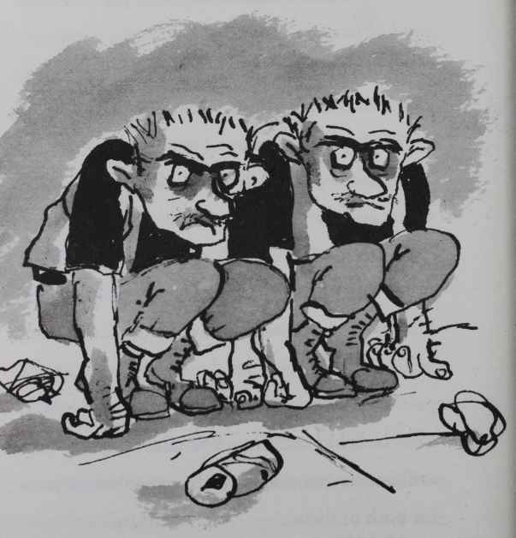

80

No you can't. They are exactly the same.

A gust of cold wind hummed through the alley. An empty can trundled past on the ground. Something twitched in the bushes.

"How was the cross-country run without your kit today Blob?" chuckled one Grubb.

"I knew that was you two!" Bob replied angrily. "So what did you do with it?"

"It's in the canal!" chuckled the other.

"Now give us your chocolate." Even hearing their voices didn't give any clues as to who was Dave and who was Sue. Both their voices wavered high and low in one sentence.

"I'm taking some home for my mum," protested Bob.

"I don't care," said the other Grubb.

"Give us it you little *****," said the other one.

I have to confess, reader, that the **** bit was a swear word. Other swear words include ****,

81

******** and of course the incredibly rude ************************ if you don't know any swear words it's best to ask a parent or teacher or other responsible adult to make a list for you.

For example, here are some of the rude words I know:

Puttock

Krunter

Noog

Smagger

Mingmong

Klazbo

Furp

Fedger

Nadgers

Blimblam

Coobdrizz

82

Trunt

Joofer

Klootzak

Bullmunter

Gunder

Whizzplop

Huppeltrut

Bwatter

Lopcrock

Moozer

Frink

Dangle Spangles

Boola Boola

Burmnop

Oodplops

Lingpoop

Twutter

Ploomfizz

Lumweed

83

Moomers

Blamfan

Pognots

Voogan Bits

Zucky zuck

Sming

Kumbo Drops

Poot Puddle

Kungo

Bimbim

Paffer

Goollyging

Nonkey

Humbum

Ponk

Hool

Blunkers

Pumpum

Minki

84

Gruntbunt

Poob

Drazz

Nockynooters

Luzzer

Plimplam

Vart

All of those words are so rude I wouldn't dream of putting them in this book.

"Don't pick on him!" said Joe. Then he instantly regretted drawing attention to himself again as the Grubbs took a step towards him.

"Or what?" said either Dave or Sue, their breath toxic from a bag of Skips they had recently snatched from a little girl in year five.

"Or . . ." Joe searched his mind for something to say that would crush these bullies forever. "Or I'll be very disappointed with you both."

85

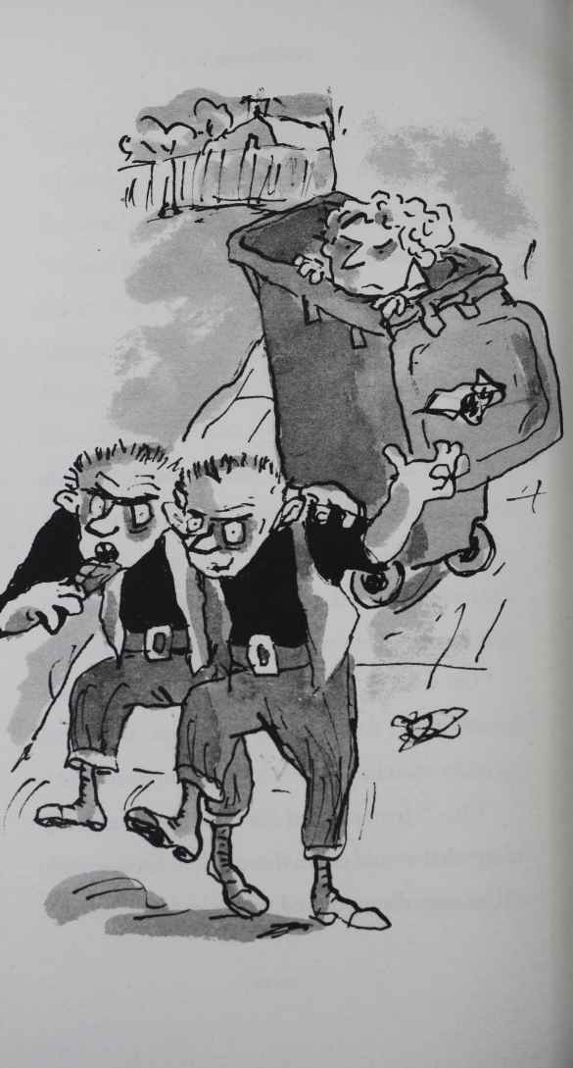

86

That wasn't it.

The Grubbs laughed. They snatched what was left of the Cadbury s Dairy Milk bar from Bob s hand and then grabbed his arms. They lifted him up and, as Bob yelled for help, they deposited him into the wheely bin. Before Joe could say anything else the Grubbs were stomping off down the road laughing, with their mouths full of stolen chocolate.

Joe dragged a wooden crate over, then stood on it to give himself more height. He leaned down into the bin and caught hold of Bob under the armpits. With a great heave, he started to pull his heavy friend out of the bin.

"Are you OK?" he asked, as he strained to take Bob's weight.

"Oh, yeah. They do this to me most days," said Bob. He pulled some spaghetti and parmesan cheese out of his curly hair - some of

87

it might have been there since the last time the Grubb twins deposited him in a bin.

"Well, why don't you tell your mum?"

"I don't want to make her worry about me. She's got enough to worry about already," replied Bob.

"Maybe you should tell a teacher then."

"The Grubbs said if I ever told anyone that they would really beat me up. They know where I live and even if they got expelled they could still find me," said Bob. He looked like he was about to cry. Joe didn't like to see his new friend upset. "One day, I'll get them back. I will. My dad always used to say the best way to beat bullies is to stand up to them. One day I will."

Joe looked at his new friend. Standing there in his underwear, covered in scraps of Italian food. He thought of Bob standing up to the Grubbs. The fat boy would get massacred.

88

But maybe there's another way, he thought. Maybe I can get the Grubbs off his back forever.

He smiled. He still felt bad about paying Bob to come last in the race. Now he could make up for it. If his plan worked, he and Bob were going to be more than just friends. They'd be best *f*riends.

89

# 7 Gerbils on Toast

"I bought you something," said Joe. He and Bob were sitting on the bench in the playground, watching the more agile kids play football.

"Just because you are a billionaire, doesn't mean you have to buy me anything," said Bob.

"I know, but . . ." Joe brought a large bar of Dairy Milk out of his bag. Bob's eyes couldn't help but light up a little.

"We can share it," said Joe, before snapping off a tiny square of chocolate. Then breaking that tiny square in half.

90

Bob's face fell.

"I'm only joking!" said Joe. "Here." He handed Bob the bar to help himself.

"Oh, no," said Bob.

"What?" said Joe.

Bob pointed. The Grubbs were walking slowly across the playground towards them, right through the games of football. Not that anyone dared to complain.

"Quick, let's make a run for it," said Bob.

"Where?"

"The dining room. They wouldn't dare go in there. No one does."

"Why?"

"You'll see."

When they burst into the dining room it was completely empty, aside from a lone dinner lady.

The Grubbs burst in a few paces behind them,

91

their genders still uncertain.

"If you aren't eating, get out!' shouted Mrs Trafe.

"But Mrs Trafe . . .?" said either Dave or Sue.

"I SAID 'OUT'!"

The twins reluctantly retreated, as Joe and Bob tentatively made their way to the serving counter.

Mrs Trafe was a large, smiley soul, of dinner-lady age. Bob had explained on the way to the canteen that she was nice enough, but her food was truly revolting. The kids in the school would rather die than eat anything she cooked. In fact they probably would die if they ate anything she cooked.

"Who's that, then?" said Mrs Trafe, peering at Joe.

"This is my friend, Joe," said Bob.

Despite the vile smell in the canteen, Joe felt

92

warmth spread through him. No one had ever called him their friend before!

"Now what would you like today, boys?" Mrs Trafe said with a warm smile. "I have a very nice badger and onion pie. Some deep-fried rust. Or for the vegetarians I have jacket potatoes with sock cheese."

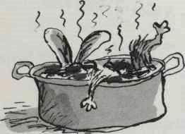

"Mmm, it all looks so nice," said Bob, lying, as the Grubbs stared in at them through the grimy windows.

Mrs Trafe's cooking was truly unspeakable. A typical week's menu for the school canteen looked like this:

93

Monday

Soup of the day – wasp

Gerbils on toast

Or

Hair lasagne (vegetarian option)

Or

Brick cutlet

All served with deep-fried cardboard

Dessert - A slice of sweat cake

Tuesday

Soup of the day - Caterpillar consommé

Macaroni snot (vegetarian option)

Or

Road-kill bake

Or

Slipper frittata

All served with spider's web salad

Dessert - Toenail ice cream

94

Wednesday

Soup of the day - Cream of hedgehog

Parrot kedgeree (may contain nuts)

Or

Dandruff risotto

Or

Bread sandwich (slice of bread between two slices of bread)

Or

Char-grilled kitten (healthy option)

Or

Soil Bolognese

All served with either boiled wood or deep fried iron filings

Dessert - Squirrel dropping tart with cream or ice cream

95

Thursday: Indian Day

Soup of the Day – Turban

To start - Paper poppadoms (A4 or A3 sizes) with chutney

Main course - Wet-wipe tandoori (vegan)

Or

Moth korma (spicy)

Or

Newt vindaloo (very spicy)

All served with bogey bhajis

Dessert - a refreshing sand sorbet

96

Friday

Soup of the day - Terrapin

Pan-fried otter steaks

Or

Owl quiche (kosher)

Or

Boiled poodle (not suitable for vegetarians)

All served with a slice of gravy

Dessert - Mouse mousse

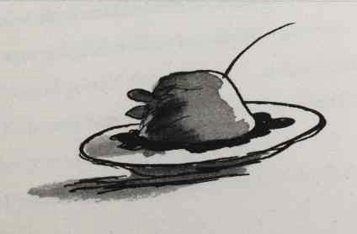

97

"It's so hard to choose . . ." said Bob, desperately scouring the trays of food for something edible. *

"Mmm, I think we will just have two jacket potatoes please."

"Is there any chance I could have it without the sock cheese?" pleaded Joe.

Bob looked hopefully at Mrs Trafe.

"I could sprinkle on some ear-wax shavings if you prefer? Or a showering of dandruff?" offered Mrs Trafe with a smile.

"Mmm, I think I will just have it totally plain please," said Joe.

"Some boiled mould on the side perhaps? You are growing boys . . ." offered Mrs Trafe, wielding a serving spoon of something green and unspeakable.

"I’m on a diet, Mrs Trafe," said Joe.

"Me too," said Bob.

"That's a shame, boys," said the dinner lady

98

dolefully. "I have a smashing dessert on today. Jellyfish and custard."

"My absolute favourite too!" said Joe. "Never mind."

He took his tray to one of the empty tables and sat down. As he put his knife and fork into the potato he realised that Mrs Trafe had forgotten to cook it.

"How are your spuds?" called Mrs Trafe across the hall.

"Delicious, thank you, Mrs Trafe," Joe called back, as he pushed his raw potato round the plate. It was still covered in soil and he noticed a maggot burrowing out of it. "I hate it when they are too well done. This is perfect!"

"Good good!" she said.

Bob was trying to chew his but it was so utterly inedible he started crying.

"Something the matter, boy?" called Mrs Trafe.

99

"Oh no, it's so delicious that these are tears of joy!" said Bob.

DDDDDDDDD rrrrrrrrrriiiiiiiiiiiiiNNNNNNNNNNGGGGGGGGGGG!

Once again, that wasn't your doorbell, reader. That was the bell to signal the end of lunch.

Joe let out a sigh of relief. Dinner hour was over.

"Oh, what a shame, Mrs Trafe," said Joe. "We have to go to our Maths lesson now."

Mrs Trafe limped over and inspected their plates.

"You've hardly touched them!" she said.

"Sorry. It was just so filling. And really really tasty though," said Joe.

"Mmm," seconded Bob, still crying.

"Well it doesn't matter. I can put them in the

100

fridge for you and you can finish them off tomorrow."

Joe and Bob shared a horrified look.

"Really, I don't want you to go to any trouble," said Joe.

"No trouble at all. See you then. And I've got some specials tomorrow. It's the anniversary of the bombing of Pearl Harbour, so it's Japanese day. I'm doing my armpit hair sushi, followed by tadpole tempura . . . Boys . . .? Boys . . .?"

"I think the Grubbs have gone," said Bob as they sneaked out of the canteen. "I've just got to use the bog."

"I'll wait for you," said Joe. He leaned against the wall, as Bob disappeared through a door. Usually Joe would have said that the lavatories were smelly - and he'd have been horrified to have to use them, after the privacy of his own en-en-suite bathroom, with emperor-size bath.

101

But the truth was that the toilets didn't smell as bad as the canteen.

Suddenly Joe sensed two figures looming behind him. He didn't need to turn round. He knew it was the Grubbs.

"Where is he?" said one.

"He's in the boys' loo, but you can't go in there," said Joe. "Well, not both of you, anyway."

"Where's the chocolate bar?" asked the other.

"Bob's got it," said Joe.

"Well, we'll wait for him then," said the Grubb.

The other Grubb turned to Joe, a deadly look in its eye. "Now give us a pound. Unless you want a dead arm, that is."

Joe gulped. "Actually . . . I'm glad I bumped into you two guys, well, guy and a girl, obviously."

102

"Obviously," said Dave or Sue. "Give us a pound."

"Wait," said Joe. "It's just . . . I wondered if —"

"Give him a dead arm, Sue," said a Grubb, revealing for perhaps the first time which of the twins was male and which was female. But then the Grubbs grabbed Joe and spun him around, and he lost track again.

"No! Wait," said Joe. "The thing is, I want to make you two an offer . . ."

103

# 8 The Witch

DDDDDDDrrrrrrrriiiiiiiiiiNNNNNNNGGGGGGGGG!

"The bell is a signal for me, not you!" said Miss Spite sharply. Teachers love saying that. It's one of their catchphrases, as I'm sure you know. The all-time top ten of teachers' catchphrases goes like this:

At ten . . . "Walk, don't run!"

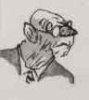

A non-mover at nine . . . "Are you chewing?"

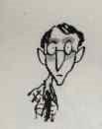

104

Up three places to eight . . . "I can still hear talking."



A former number one at seven . . . "It doesn't need discussion."

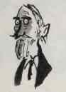

A new entry at six . . . "How many times do you need to be told?"

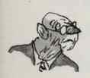

Down one place at five . . . "Spelling!"

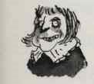

Another non-mover at four . . . "I will not tolerate litter!"

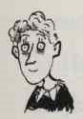

New at three . . . "Do you want to pass your GCSEs?"

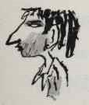

Just missing the top spot at two . . . "Would you do that at home?"

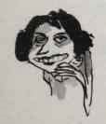

105

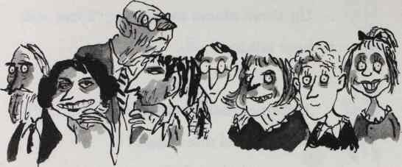

And still at number one . . . "It's not just yourself you've let down, but the whole school."

***

Taking the History lesson was Miss Spite. Miss Spite smelt of rotten cabbage. That was the nicest thing about her. She was one of the schools most feared teachers. When she smiled she looked like a crocodile that was about to eat you. Miss Spite loved nothing more than giving out punishments, once suspending a girl for dropping a pea on the floor of the school canteen. "That pea could have had someone's eye out!" she had yelled.

Kids at the school had fun thinking up

106

nicknames for their teachers. Some were fond, others cruel. Mr Paxton the French teacher was 'Tomato', as he had a big round red face like a tomato. The headmaster, Mr Dust, was called 'The Tortoise' as he looked like one. He was very old, extremely wrinkly, and walked impossibly slowly. The deputy head, Mr Underhill, was 'Mr Underarms', as he ponged a bit, especially in the summer. And Mrs MacDonald, the biology teacher, was called either 'The Bearded Lady' or even 'Hairy Maclary from Donaldson's Dairy' as she . . . well, I imagine you can guess why.

But the kids just called Miss Spite 'The Witch'. It was the only name that really ever fitted and was passed down through generations of pupils at the school.

All the kids she taught passed their exams though. They were too scared not to.

"We still have the small matter of last night's

107

Homework.” Miss Spite announced with an evil relish that suggested she was desperate for someone to have failed to do it.

Joe reached his hand into his bag. Disaster. His exercise book wasn't there. He had spent all night writing this intensely boring 500-word essay about some old dead Queen, but in the rush to get to school on time he must have left it on his bed.

Oh, no, he thought. Oh no no no no no . . .

Joe looked over at Bob, but all his friend could do was grimace sympathetically.

Miss Spite stalked the classroom like a Tyrannosaurus Rex deciding which little creature it was going to eat first. To her evident disappointment, a field of grubby little hands held aloft essay after essay. She gathered them up, before stopping at Spud.

"Miss . . .?" he stammered.

108

"Yeeeessss Ssspppuuudddd?" said Miss Spite, drawing out her words as long as possible so she could relish this delicious moment.

"I did do it, but . . ."

"Oh yes, of course you did it!" The Witch cackled. All the other pupils except Bob sniggered too. There was nothing more pleasurable than seeing someone else get into trouble.

"I left it at home."

"Litter duty!" the teacher snapped.

"I am not lying, Miss. And my dad will be at home today, I could —"

"I should have known. Your father is clearly penniless and on the dole, sitting at home watching daytime TV - much as you will no doubt be doing in ten years' time. Yes . . .?"

Joe and Bob couldn't help but share a smirk at this.

"Er . . ." said Joe. "If I called him and asked

109

him to run the essay over here would you believe me?

Miss Spite smiled broadly. She was going to enjoy this.

"Spud, I will give you fifteen minutes exactly to place said essay in my hand. I hope your father is quick."

"But —" started Joe.

"No 'buts' boy. Fifteen minutes."

"Well thank you Miss," said Joe sarcastically.

"You're quite welcome," said the Witch. "I like to think that everyone gets a fair chance to rectify their errors in my class."

She turned to the rest of the class. "The rest of you are dismissed," she said.

Kids started to spill out into the corridor. Miss Spite leaned after them and screamed, "Walk, don't run!"

Miss Spite couldn't resist another catchphrase.

110

She was the queen of the catchphrase. And now she couldn't stop.

"It doesn't need discussion!" she called after her pupils, randomly. Miss Spite was on a roll now. "Are you chewing?" she howled down the corridor to a passing school inspector.

"Fifteen minutes, Miss?" said Joe.

Miss Spite studied her little antique watch. "Fourteen minutes, fifty one seconds, in point of fact."

Joe gulped. Was Dad going to be able to get there that fast?

# 9 "Finger?"

"Finger?" asked Bob, as he offered half of his Twix to his friend.

"Thank you, mate," said Joe. They stood in a quiet corner of the playground and contemplated Joe s bleak fate.

"What are you going to do?"

"I dunno. I texted my dad. But there's no way he can get here in fifteen minutes. What can I do?"

A few ideas raced through Joe s mind.

He could invent a time machine and travel

112

back in time and remember not to forget his homework. It might be a bit hard to do though, as if time machines had ever been invented then maybe someone would have come back from the future and prevented Piers Morgan's birth.

Joe could go back to the classroom and tell Miss Spite that 'the tiger had eaten it’ This would only be half a lie, as they did have a private zoo and a tiger. Called Geoff. And an alligator called Jenny.

Become a nun. He would have to live in a nunnery and spend his days saying prayers and singing hymns and doing general religious stuff. On the one hand the nunnery would give him sanctuary from Miss Spite and he did look good in black, but on the other hand it might get a bit boring.

Go and live on another planet. Venus is nearest, but it might be safer to go to Neptune.

113

Live the rest of his life underground. Perhaps even start a tribe of below-the-surface-of- the-earth dwellers and create a whole secret society of people who all owed Miss Spite some homework.

Have plastic surgery and change his identity. Then live the rest of his life as an old lady called Winnie.

Become invisible. Joe wasn't sure how this might be achieved.

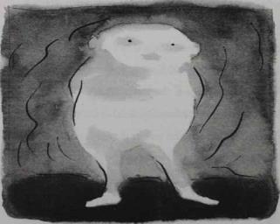

114

Run to the local bookshop and buy a copy of How to Learn Mind Control in Ten Minutesby Professor Stephen Haste and very quickly hypnotise Miss Spite into thinking he had already given her his homework.

Disguise himself as a plate of spaghetti Bolognese.

Bribe the school nurse into telling Miss Spite he had died.

Hide in a bush for the rest of his life. He could survive on a diet of worms and grubs.

Paint himself blue and claim to be a Smurf.

***

Joe had barely had time to consider these options when two familiar shadows loomed behind them.

"Bob," said one of them, in a voice neither high nor low enough to determine its gender.

The boys turned around. Bob, tired of

115

fighting, simply handed them his slightly nibbled finger of Twix.

"Don't worry," he whispered to Joe. "I've concealed a large number of Smarties down my sock."

"We don't want your Twix," said Grubb number one.

"No?" said Bob. His mind started racing. Could the Grubbs possibly know about the Smarties?

"No, we wanted to say we are very sorry for bullying you," said Grubb number two.

"And as a peace gesture we would like to invite you round for tea," prompted Grubb number one.

"Tea?" asked Bob, incredulous.

"Yes, and maybe we can all play Hungry Hippos together," continued Grubb number two.

Bob looked at his friend, but Joe just shrugged.

116

"Thank you, guys, I mean guy and girl, obviously . . ."

"Obviously," said an unidentified Grubb.

". . .but I am a bit busy tonight," continued Bob.

"Maybe another time," said a Grubb, as the twins lolloped off.

"That was weird," said Bob, retrieving some Smarties that now had a faint taste of sock. "I couldn't imagine a night when I would want to go and play Hungry Hippos with those two. Even if I lived until I was a hundred."

"Yeah, how strange . . ." said Joe. He glanced away quickly.

At that moment, a deafening roar silenced the playground. Joe looked up. A helicopter was hovering overhead. Very quickly all the football games broke up, and the kids raced out of the way of the descending aircraft. Items from

117

hundreds of packed lunches were whisked up in the air by the force of the blades. Packets of Quavers, a mint-chocolate Aero, even a Müller Fruit Corner danced about in the whirling air, before smashing to the ground as the engine shut down and the blades slowed to a stop.

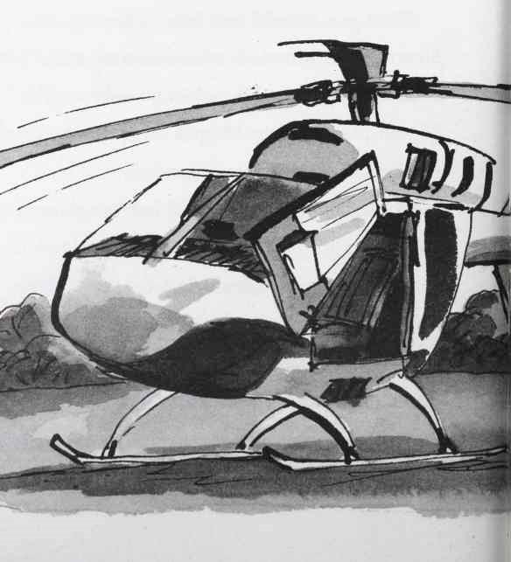

118

Mr Spud leaped out of the passenger seat and raced across the playground holding the essay.

Oh no! thought Joe.

Mr Spud was wearing a brown toupee that he held on to his head with both hands, and an all-in-one gold jumpsuit with 'BUM AIR’

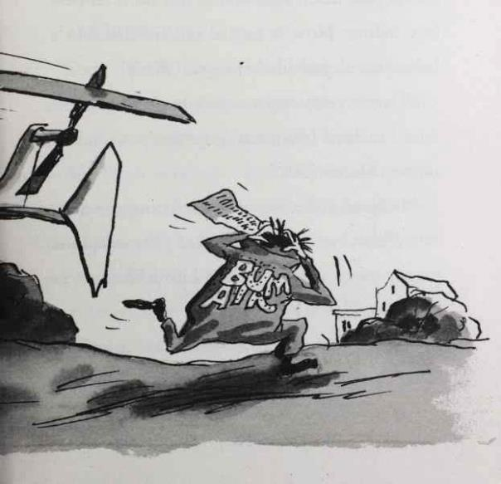

119

emblazoned on the back in sparkly letters. Joe felt like he was going to die of embarrassment. He tried to hide himself behind one of the older kids. However, he was too fat and his dad spotted him.

"Joe! Joe! There you are!" shouted Mr Spud.

All the other kids stared at Joe Spud. They hadn't paid much attention to this short fat new boy before. Now it turned out his dad had a helicopter. A real-life helicopter! Wow!

"Here's your essay, son. I hope that's OK. And I realised I forgot to give you your dinner money. Here's £500."

Mr Spud pulled out a wad of crisp new £50 notes from his zebra-skin wallet. Joe pushed the money away, as all the other kids looked on in envy.

"Shall I pick you up at 4pm son?" asked Mr Spud.

120

"It's OK, thanks, Dad, I'll just get the bus," muttered Joe, looking down at the ground.

"You can pick me up in your helicopter, mate!" said one of the older boys.

"And me!" shouted another.

"And me!"

"Me!"

"ME!!"

"PICK ME!!!"

Soon all the kids in the playground were shouting and waving to get this short, fat, gold-jumpsuited man's attention.

Mr Spud laughed. "Maybe you can invite some of your friends over at the weekend and they can all have a helicopter ride!" he pronounced with a smile.

A huge cheer echoed around the playground.

"But Dad . . ." That was the last thing Joe wanted. For everyone to see how monstrously

121

expensive their house was and how much crazy stuff they owned. He checked his plastic digital watch. He had less than 30 seconds to go.

"Dad, I gotta run," blurted out Joe. He snatched the essay out of his father s hands and raced into the main school building as fast as his short fat legs would take him.

Running up the staircase, he raced past the unfeasibly old headmaster, who was making his way down on a Stannah Stairlift. Mr Dust looked at least 100 years old, but was probably older. He was more suited to being an exhibit in the Natural History Museum than administrating a school, but he was harmless enough.

"Walk, don't run!" he mumbled. Even very old teachers are fond of catchphrases.

Hurling himself along the corridor to the classroom where Miss Spite was waiting, Joe realised half the school was following him. He

122

even heard someone shout, "Hey, Bumfresh Boy!"

Unnerved, he pushed on, bursting into the classroom. The witch was holding her watch in her hand.

"I've got it, Miss Spite!" proclaimed Joe.

"You are five seconds late!" she proclaimed.

"You have got to be kidding Miss!" Joe couldn't believe anyone could be so mean. He glanced back behind him and saw hundreds of pupils were staring at him through the glass. Such was the eagerness to catch a glimpse of the richest boy in the school, or perhaps even the world, noses were pushed up against the glass so they looked like a tribe of pig-children.

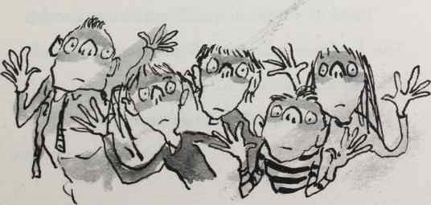

123

"Litter duty!" said Miss Spite.

"But Miss —"

"A week's litter duty!"

"Miss —"

"One month's litter duty!"

Joe decided to say nothing this time and sloped across the classroom. He closed the door behind him. In the corridor hundreds of little pairs of eyes were still staring at him.

"Oi! Billionaire Boy!" came a deep voice from the back. It was one of the older boys, but Joe couldn't tell which one. In the sixth form all the boys had moustaches and Ford Fiestas. All the little mouths laughed.

"Lend us a million quid!" someone shouted. The laughter was now deafening. The noise clouded the air.

My life is officially over, thought Joe.

124

# 10 Dog Spit

As Joe scurried across the playground to the dining room, all the other kids swarmed around him. Joe kept his head down. He didn't like this instant superstardom at all. Voices whirled around him.

"Hey, Bum Boy! I'll be your best friend!"

"My bike got nicked. Buy us a new one mate."

"Lend us a fiver . . ."

"Let me be your bodyguard!"

"Do you know Justin Timberlake?"

"Me granny needs a new bungalow, give us a hundred grand will ya?"

125

"How many helicopters have you got?"

“Why do you bother going to school anyway, you are rich!"

“Can I have your autograph?"

"Why don't you have a massive party at yours on Saturday night?"

“Can I have a lifetime's supply of bog rolls?”

“Why don’t you buy the school and sack all the teachers?”

“Can you just buy me a bag of maltesers? All right then one Malteser? You are sooo mean!”

126



127

Joe started running. The crowd started running too. Joe slowed down. The crowd slowed down too. Joe turned and walked in the other direction. The crowd turned and walked in the other direction.

A little ginger-haired girl tried to grab his bag, and he thumped her hand away with his fist.

"Ow! My hand is probably broken," she cried. "I am going to sue you for ten million pounds!"

"Hit me!" said another voice.

"No me! Hit me!" said another.

A tall boy with glasses had a better idea. "Kick me in the leg and we can settle out of court for two million! Please?"

Joe sprinted into the school dining room. That was one place that was guaranteed to be empty at lunchtime. Joe struggled to force the double doors back on the tsunami of schoolchildren, but

128

it was no use. They burst through, flooding the room.

"FORM AN ORDERLY QUEUE!" shouted the dinner lady, Mrs Trafe. Joe walked up to the serving counter.

"Now what would you like today, young Joe?" she said with a warm smile. "I have a very stinging nettle soup to start today."

"I am not that hungry today, maybe I’ll go straight to a main course Mrs Trafe."

"It's chicken breast."

"Ooh, that sounds nice."

"Yes it comes in a dog spit sauce. Or for vegetarians I have deep fried Blu-tack."

Joe gulped. "Mmm, it's so hard to decide. See, I had some dog spit only last night."

"That's a shame. I’ll give you a plate of the fried Blu-Tack then," said the dinner lady, as she dumped a lump of something blue and greasy

129

and vomit-inducing on to Joe's plate.

"If you ain't having lunch then get out!" cried Mrs Trafe at the crowd still cowering at the doors.

"Spud's dad has got a helicopter Mrs Trafe," came a voice from the back.

"He's super-rich!" came another.

"He's changed!" came a third.

"Just give me a dead arm, Spud, and I will take a quarter of a million," came a tiny voice from the back.

"I SAID OUT!" shouted Mrs Trafe. The crowd reluctantly retreated, and contented themselves with staring at Joe through the grimy windows.

With his knife he removed the batter from the blue lump underneath. Now that raw potato seemed like food of the gods. After a few moments Mrs Trafe limped over to his table.

130

"Why are they all staring at you like that?" she asked kindly, as she slowly slumped her heavy frame down next to him.

"Well, it's a long story Mrs Trafe."

"You can tell me, pet," said Mrs Trafe. "I'm a school dinner lady. I reckon I've heard it all."

"Right, well . . ." Joe finished chewing the large lump of Blu-Tack he had in his mouth, and told the old dinner lady everything. About how his father had invented 'Bumfresh', how they now lived in a massive mansion, how they once had an orang-utan as a butler (she was very jealous of that bit), and how no one would have guessed a thing had his stupid dad not landed his stupid helicopter in the playground.

All the time he talked, the other kids continued to stare through the windows at him like he was an animal in the zoo.

"I am so sorry, Joe," said Mrs Trafe. "It must

131

be awful for you. You poor thing. Well not poor exactly, but you know what I mean."

"Thank you Mrs Trafe." Joe was surprised anyone would ever feel sorry for someone who had everything. "It's not easy. I don't know who to trust any more. All the kids in the school seem to want something from me now."

"Yeah, I bet," said Mrs Trafe, bringing out an M&S sandwich from her bag.

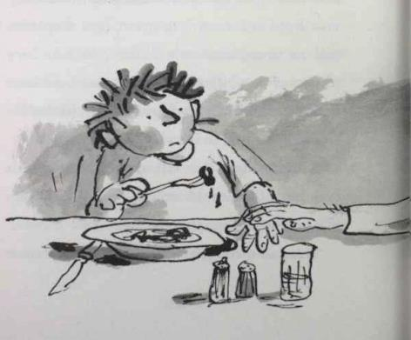

132

"You bring a packed lunch?" asked Joe, surprised.

"Oh yes, I wouldn't eat this filth. It's disgusting," she said. Her hand crept across the table and rested on his.

"Well, thanks for listening Mrs Trafe."

"That's OK, Joe. I am here for you anytime. You know that - anytime." She smiled. Joe smiled too. "Now . . ." said Mrs Trafe. "I just need ten thousand quid for a hip replacement . . ."

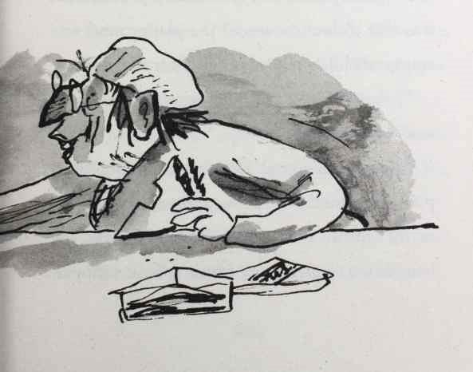

133

# 11 Camping Holiday

"You missed a bit," said Bob.

Joe bent down and picked up another piece of litter from the playground and put it in the bin liner Miss Spite had so generously provided. It was five o'clock now and the playground was empty of children. Only their litter remained.

"I thought you said you were going to help me," accused Joe.

"I am helping you! There's another bit." Bob pointed to another sweet wrapper that was lying on the asphalt, as he munched a bag of crisps. Joe bent down to pick it up. It was a Twix wrapper.

134

Probably the one he himself had dropped on the ground earlier that day.

"Well I guess everyone knows how rich you are now, Joe," said Bob. "Sorry about that."

"Yeah, I guess so."

"I suppose now all the kids at the school are going to want to be your friend . . ." said Bob, quietly. When Joe looked at him, Bob turned away.

"Maybe," Joe smiled. "But it means more that we were friends before everyone knew."

Bob grinned. "Cool," he said. Then he pointed to the ground at his feet. "You missed another bit there, Joe."

"Thanks, Bob," sighed Joe, as he bent down again, this time to pick up the crisp packet his friend had just dropped.

"Oh, no," said Bob.

"What's the matter?"

135

"Grubbs!" "Where?"

"Over by the bike shed. What do they want?" Lurking behind the shed were the twins. When they spotted Joe and Bob, they waved.

"I don't know what was worse," continued Bob. "Being bullied by them or being invited around for tea."

"HELLO, BOB!" shouted one Grubb, as they started lolloping towards them.

"Hello, Grubbs," Bob called back wearily. Inexorably, the two bullies reached where the two boys were standing.

"We have been thinking," continued the other. "We are going on a camping trip at the weekend. Would you like to come?"

Bob looked at Joe for help. A camping holiday with these two was not an inviting invitation.

136

"Oh, what a terrible shame," said Bob. "I am busy this weekend."

"Next weekend?" asked Grubb one.

"That one too, I'm afraid."

"The one after that?" asked the other.

"Completely . . ." stammered Bob, ". . .chock full of things I’ve got to do. So sorry. It sounds so much fun. Anyway, see you two tomorrow, sorry, I would love to chat but I have to help Joe with his litter duty. Bye!"

"Any weekend next year?" asked the first Grubb.

Bob stopped. "Um . . . er . . . um . . . next year is, really busy for me. So I'd really really love to but I am so so sorry . . ."

"How about the year after?" asked Grubb Two. "Any free weekends? We have a lovely tent.

Bob couldn't keep it in any longer. "Look.

137

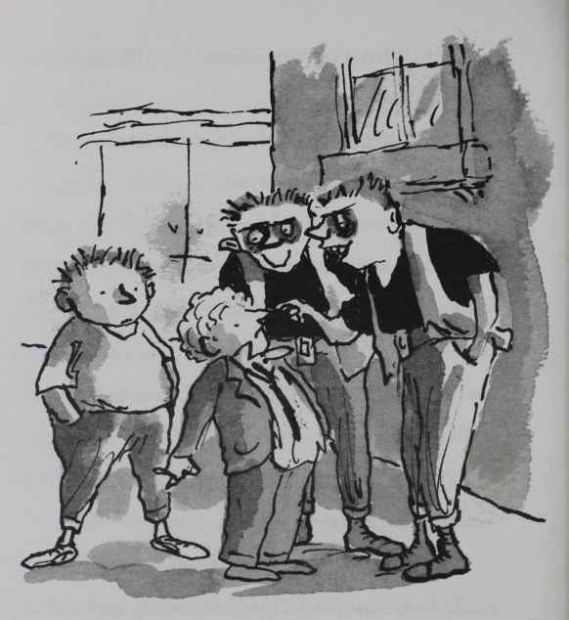

One day you're bullying me, the next you are inviting me to spend the weekend with you in a tent! What on earth is going on?"

The Grubbs looked to Joe for help. "Joe?" said one of them.

138

"We thought it would be easy being nice to Blob.” said the other. "But he just says no to everything. What do you want us to do, Joe?"

Joe coughed, not very subtly. But the Grubbs didn't seem to get the hint.

"You paid them not to bully me, didn't you?" demanded Bob.

"No," replied Joe unconvincingly.

Bob turned to the Grubbs. "Did he?" he demanded.

"Noyes . . ." said the Grubbs. "We mean yesno."

"How much did he pay you?"

The Grubbs looked at Joe for help. But it was too late. They were all busted.

"Ten pounds each," said a Grubb. "And we saw the helicopter, Spud. We're not stupid. We want more cash."

"Yeah!" continued the other. "And you're

139

going in the bin, Joe, unless you give us eleven pounds each. First thing tomorrow."

The Grubbs stomped off.

Bob's eyes filled with angry tears. "You think money is the answer to everything don't you?"

Joe was baffled. He had paid off the Grubbs to help Bob. He was utterly perplexed as to why his friend was so upset. "Bob, I was just trying to help you, I didn't—"

"I am not some charity case, you know."

"I know that, I was just . . ."

"Yes?"

"I just didn't want to see you put in the bin again."

"Right," said Bob. "So you thought it would be better if the Grubbs were really weird and friendly and going on about camping trips."

"Well, they sort of came up with the camping trip on their own. But yes."

140

Bob shook his head. "I can't believe you. You're such a . . . such a . . . spoiled brat!"

"What?" said Joe. "I was just helping you out! Would you really rather be put in the bin and have your chocolate stolen?"

"Yes!" shouted Bob. "Yes, I would! I'll fight my own battles, thank you!"

"Suit yourself," said Joe. "Have fun being dumped in the bin."

"I will," replied Bob before storming off.

"Loser!" shouted Joe, but Bob didn't turn back.

Joe stood alone. A sea of litter surrounded him. He stabbed at a Mars wrapper with his litter stick. He couldn't believe Bob. He thought he'd found a friend, but all he'd really found was a selfish, bad tempered, ungrateful . . . Ploomfizz.

141