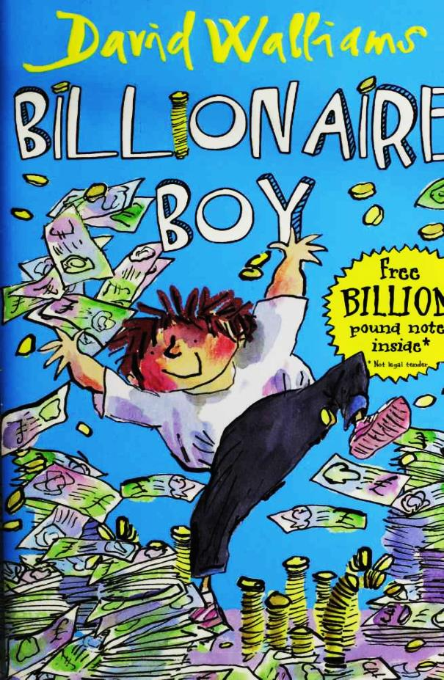

Billionaire Boy

By

David Walliams

Illustrated by Tony Ross

This electronic copy of the original work is made under a Copyright Licensing Agency license by The Seeing Ear. It is for the personal use of a Print Disabled Person and may not be further copied, (including any electronic copying or transmission), or dealt with without permission, save as may be permitted by law.

Contents

1 Meet Joe Spud 9

2 Bum Boy 17

3 Who's the Fattiest? 24

4 "Loo Rolls?" 31

5 Out of Date Easter Eggs 35

6 The Grubbs 40

7 Gerbils on Toast 46

8 The Witch 52

9 "Finger?" 57

10 Dog Spit 63

11 Camping Holiday 67

12 Page 3 Stunna 71

13 New Girl 78

14 The Shape of a Kiss 82

15 Nip and Tuck 85

16 Peter Bread 89

17 A Knock on the Toilet Door 93

18 The Vortex 3000 97

19 A Baboon's Bottom 100

20 A Beach Ball Rolled in Hair 103

21 A GCSE in Make-Up 107

22 A New Chapter 111

23 Canal Boat Weekly 114

24 The Rajmobile 119

25 Broken 122

26 A Blizzard of Banknotes 126

Postscript 130

**21** **A GCSE in Make-Up**

"DAD!" screamed Joe. He had never been this angry before, and hoped he never would be again. He ran into the pool room to confront his father.

Mr Spud nervously straightened his toupee as his son approached.

Joe stood in front of his dad hyperventilating. He was too angry to speak.

"I am sorry, son. I thought that's what you wanted. A friend. I just wanted to make things better for you at school. I got that teacher you hated sacked too. All I had to do was buy the

224

headmaster a motorbike."

"So . . . You got an old lady sacked from her job . . . And then, and then . . . you . . . paid a girl to like me . . ."

"I thought that's what you wanted."

"What?"

"Listen, I can buy you another friend," said Mr Spud.

"YOU DON'T GET IT DO YOU?" screamed Joe. "Some things can't be bought."

"Like what?"

"Like friendship. Like feelings. Like love!"

"Actually, that last one can," offered Sapphire, still unable to lift her hand.

"I hate you Dad, I really do," shouted Joe.

"Joe, please," pleaded Mr Spud. "Look, please calm down. How about a nice little cheque for five million quid?"

"Ooh, yes please," said Sapphire.

225

"I don't want any more of your stupid money.” sneered Joe.

"But son . . ." spluttered Mr Spud.

"The last thing I want to do is end up like you . . . A middle-aged man with some brain-dead teenage fiancee!"

"Excuse me, I've got a GCSE in make-up," said Sapphire angrily.

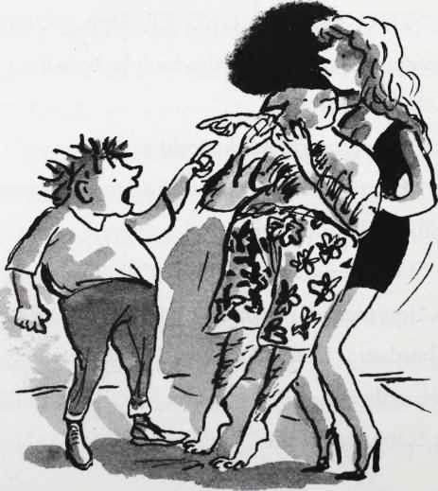

226

"I never want to see either of you again!" said Joe. He ran out of the room, pushing the vomiting lady out of his way and into the pool as he did so. Then he slammed the huge door behind him. One of the mural tiles from Mr Spud's thong fell off the wall and smashed onto the floor.

"JOE! JOE! WAIT!" shouted Mr Spud.

Joe dodged past the hordes of guests and ran up to his room, shutting the door firmly behind him. There wasn't a lock, so he grabbed a chair and wedged it under the door handle so it wouldn't open. As the beat of the music thumped through the carpet, Joe grabbed a bag and started filling it with clothes. He didn't know where he was going, so wasn't sure what he needed. All he knew was that he didn't want to be in this ridiculous house for another minute. He grabbed a couple of his favourite books

227

(The Boy in the Dress and Mr Stink, both of which he found hilarious and yet heart-warming).

Then he looked on his shelf at all his expensive toys and gadgets. His eyes were drawn to the little loo-roll rocket that his dad had given him when he still worked at the factory. He remembered it was a present for his eighth birthday. His mum and dad were still together then and Joe thought it might have been the last time he was truly happy.

As his hand reached out to take it there was a loud thump on the door.

"Son, son, let me in . . ."

Joe didn't say a word. He had nothing more he wanted to say to the man. Whoever his dad had been was lost years ago.

"Joe, please," said Mr Spud. Then there was a pause.

228

TTTTHHHHHUUUUUMMMMMPPPPP.

Joe's dad was trying to force the door open.

"Open this door!"

TTTTTTTTTTTHHHHHHHHHHHHHHHHHUUUUUUUUUUUMMMMMMMPPPPPPPPPPP.

"I've given you everything!" He was putting all his weight behind it now, and the chair legs heroically dug themselves deeper into the carpet. He made one last try.

229

TTTTTTTTTTTTTTHHHHHHHHHHHHHHHHHHHHHUUUUUUUUUUUUUUUMMMMMMMMMMMMMMMMMMPPPPPPPPPPPPPPPPPPPPPPPPPPPPPP.

Joe then heard a much smaller thump as his dad gave in and leaned his body against the door. This was followed by a squeak as his bulk slid down the door, and a few whimpering cries. Then the light in the gap under the door was blocked. His dad must have been slumped on the floor.

Spud Junior felt unbearably guilty. He knew all he needed to do to stop his dad's pain was open that door. He put his hand on the chair for a moment. If I open that door now, he thought, nothing is going to change.

Joe took a deep breath, lifted his hand, grabbed his bag and walked to the window. He

230

opened it slowly so his dad wouldn't hear, and then climbed onto the windowsill. Joe took one last look at his bedroom before jumping out into the darkness, and a new chapter.

231

# 22 A New Chapter

Joe ran as fast as he could - which wasn't that fast, in all honesty. But it felt fast to him. He ran down the long, long drive. Dodged past the guards. Jumped over the wall. Was that wall to keep people out or keep him in? He'd never thought about it before. But there wasn't time to think about it now. Joe had to run. And keep running.

Joe didn't know where he was running to. All he knew was where he was running from. He couldn't live in that stupid house with his stupid dad for one moment longer. Joe ran down the

232

road. All he could hear was his own breath, getting faster and faster. There was a faint taste of blood in his mouth. Now he wished he had tried harder in the school cross-country run.

It was late now. After midnight. The lamp posts pointlessly illuminated the empty little town. Reaching the town centre, Joe slowed to a stop. A lone car crouched in the road. Realising he was alone, Joe suddenly felt a shiver of fear. The reality of his great escape dawned on him. He looked at his reflection in the window of the darkened KFC. A chubby twelve-year-old boy with nowhere to go looked back at him. A police car rolled past slowly and silently. Was it looking for him? Joe hid behind the big plastic bin. The smell of fat and ketchup and hot cardboard was so stomach-churning it almost made him choke. Joe covered his mouth to stifle the sound. He didn't want the policemen to discover him.

233

The police car turned a corner and Joe ventured out into the street. Like a hamster that had escaped from its cage, he kept close to the edges and corners. Could he go to Bob's? No, thought Joe. In the exhilaration of meeting Lauren or whatever her stupid name really was, he had badly let down his only friend. Mrs Trafe had been a sympathetic ear, but it turned out she was after his money all along.

How about Raj ? Yes, thought Joe. He could go and live with the purple-bottomed newsagent. Joe could set up camp behind the fridge. Hidden safely there, Joe could read Nuts magazine all day, and feast on slightly out of date confectionery. He couldn't imagine a more charmed life.

Joe's mind was racing, and soon his legs were too. He crossed the road and turned left. Raj's shop was only a few streets away now.

234

Somewhere above him in the black air he heard a distant whirr. The whirr became louder. More of a buzz. Then a drone.

It was a helicopter. A searchlight danced across the streets. Mr Spud's voice came out of a loudspeaker.

"JOE SPUD, THIS IS YOUR DAD SPEAKING. GIVE YOURSELF UP. I REPEAT, GIVE YOURSELF UP."

Joe dashed into the entrance of The Body Shop. The searchlight had just missed him. The smell of pineapple and pomegranate body wash and dragonfruit foot scrub pleasingly tickled its way up his nostrils. Hearing the helicopter passing overhead, Joe dashed to the other side of the street, and crept past Pizza Hut, and then Pizza Express, before seeking sanctuary in the doorway of a Domino's Pizza. Just as he stepped out to make a dash past Bella Pasta, the

235

helicopter whooshed back overhead. Suddenly Joe Spud was caught in the dead centre of the searchlight.

"DON'T MOVE. I REPEAT, DON'T MOVE,” the voice thundered.

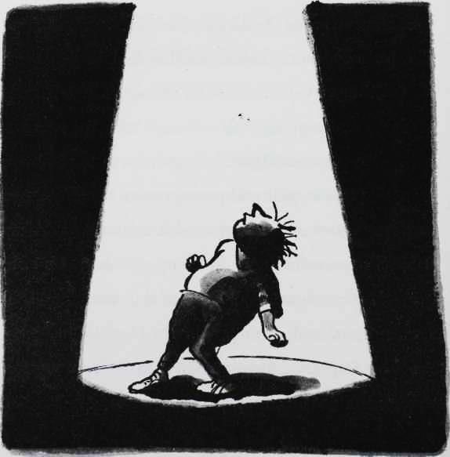

236

Joe looked up into the light as his body trembled from the force of the rotor blades. "Shove off!” he shouted. "I repeat, shove off!”

"COME HOME NOW, JOE."

"No."

"JOE, I SAID . . ."

"I heard what you said and I’m not coming home. I’m not ever coming home," shouted Joe. Standing there in the bright light he felt like he was on stage in a particularly dramatic school play. The helicopter whirred overhead for a moment as the loudspeaker crackled in silence.

Then Joe made a run for it, dashing down an alley behind Argos, through the NCP car park, and round the back of Superdrug. Soon the helicopter was nothing more than a distant buzz, no louder than the sleepless birds.

Arriving at Raj's, Joe knocked gently on the metal shutters. There was no answer, so he

237

banged this time until the shutters shook with the force of his fists. Still no answer. Joe looked at his watch. It was two o'clock in the morning. No wonder Raj wasn't in his shop.

It looked like Joe would have to be the very first billionaire to ever sleep rough.

238

# 23 Canal Boat Weekly

"What are you doing in there?"

Joe wasn't sure if he was awake, or simply dreaming that he was awake. He certainly couldn't move. His body felt stiff with cold, and every part of him ached. Joe couldn't open his eyes yet, but knew without doubt that he hadn't woken up between the silk sheets of his four-poster bed.

"I said, what are you doing in there?" came the voice again. Joe frowned, puzzled. His butler didn't have an Indian accent. Joe struggled to unglue eyes that had been stuck together with

239

sleep. He saw a big smiley face hovering over his.

It was Raj's.

"Why are you here at this ungodly hour, Master Spud?" asked the kindly newsagent.

As dawn was beginning to glow through the gloom, Joe took in his surroundings. He had climbed into a skip outside Raj's shop and fallen asleep. Some bricks had been his pillow, a piece of tarpaulin his duvet, and a dusty old wooden door his mattress. No wonder every part of his body ached.

"Oh, er, hello Raj," croaked Joe.

"Hello Joe. I was just opening up my shop and heard some snoring. There you were. I was quite surprised, I must tell you."

"I don't snore!" protested Joe.

"I regret to inform you that you do. Now would you be so kind as to climb out of the skip and step inside my shop, I think we need to

240

talk,” said Raj, in a deadly serious tone.

Oh no*,* thought Joe, now I'm in trouble with Raj.

Although Raj was adult in age and size, he was nothing like a parent or a teacher, and it was really difficult to get into trouble with him. Once one of the girls from Joe's school had been caught trying to steal a bag of Wotsits from the newsagent and Raj had banned her from his shop for all of five minutes.

The dusty billionaire clambered out of the skip. Raj fashioned him a stool from a stack of Heat magazines, and wrapped a copy of the Financial Times over his shoulders like it was a big pink boring blanket.

"You must have been outside in the cold all night, Joe. Now, you must eat some breakfast. A nice hot mug of Lilt perhaps?"

"No thanks," said Joe.

241

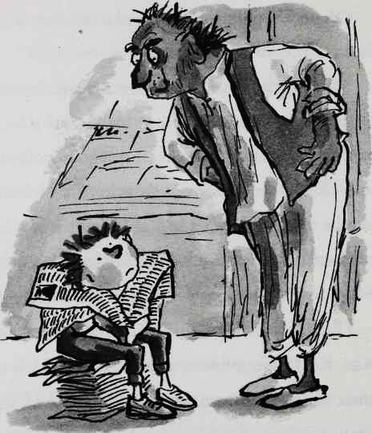

"Two Rolo eggs, poached?" Joe shook his head.

"You need to eat, boy. A toasted Galaxy bar? "No thanks."

242

"A hearty bowl of Pickled Onion Monster Munch perhaps? With warm milk?"

"I am really not hungry, Raj," said Joe.

"Well, my wife has put me on a strict diet so I am only allowed fruit for breakfast now," announced Raj as he unwrapped a Terry's Chocolate Orange. "Now, are you going to tell me why you slept in a skip last night?"

"I ran away from home," announced Joe.

"I guessed that much," slurred Raj, chewing away on multiple segments of Terry's Chocolate Orange. "Oooh, pips," he said before spitting something into the palm of his hand. "The question is, why?"

Joe looked ill at ease. He felt the truth shamed him as much as his dad. "Well you know that girl I brought in here the day we got some ice lollies?"

"Yes, yes! You know I said I had seen her

243

somewhere before? Well, she was on TV last night! On an advert for Pot Noodle Snacks! So did you finally kiss her?" exclaimed an excited Raj.

"No. She was only pretending to like me. My dad paid her to be my friend."

"Oh dear," said Raj. His smile fell from his face. "That's not right. That's not right at all."

"I hate him," said Joe hotly.

"Please don't say that, Joe," said Raj, shocked.

"But I do," said Joe, turning to Raj with fire in his eyes. "I hate his guts."

"Joe! You must stop talking like this right now. He is your father."

"I hate him. I never want to see him again for as long as I live."

Tentatively, Raj reached out and put his hand on Joe's shoulder. Joe's anger immediately turned to sadness, and with his head bowed he began to

244

weep into his own lap. His body shook involuntarily as the waves of tears ebbed and flowed through him.

"I can understand your pain, Joe, I really can," ventured Raj. "I know from what you said that you really liked that girl, but I guess your dad was, well . . . just trying to make you happy."

"It's all that money," said Joe, barely audible through the tears. "It's ruined everything, I even lost my only friend over it."

"Yes, I haven't seen you and Bob together for a while. What happened?"

"I've behaved like an idiot too. I said some really mean things to him."

"Oh dear."

"We fell out when I paid some bullies to leave him alone. I thought I was helping him, but he got all angry about it."

Raj nodded slowly. "You know, Joe . . ." he

245

said slowly. "It doesn't sound as though what you did to Bob is so very different to what your father did to you."

"Maybe I am a spoiled brat,” Joe told Raj. "Just like Bob said."

"Nonsense," said Raj. "You did a stupid thing, and you must apologise. But if Bob has any sense, he will forgive you. I can see that your heart was in the right place. You meant well."

"I just wanted them to stop bullying him!" Joe said. "I just thought, if I gave them money . . ."

"Well, that's no way to beat bullies, young man."

"I know that now," admitted Joe.

"If you give them money they'll just come back and back for more."

"Yes, yes, but I was only trying to help him."

"You have to realise money can't solve

246

everything, Joe. Maybe Bob would have stood up to the bullies himself, eventually. Money is not the answer! You know I was once a very rich man?"

"Really?!" said Joe, instantly embarrassed that he sounded a little too surprised. He sniffed and wiped his wet face on his sleeve.

"Oh, yes," replied Raj. "I once owned a large chain of newsagent shops."

"Wow! How many shops did you have, Raj?"

"Two. I was taking home literally hundreds of pounds a week. If I wanted anything I would simply have it. Six Chicken McNuggets? I would have nine! I splashed out on a flash brand new second-hand Ford Fiesta. And I would think nothing of returning a DVD to Blockbuster a day late and thus incurring a £2.50 fine!"

247

"So, um, yeah, that sounds like quite a rollercoaster ride," said Joe, not sure what else to say. "What went wrong?"

"Two shops meant I was working very long hours, young Joe, and I forgot to spend time with the one person I really loved. My wife. I would buy her lavish gifts. Boxes of After Eight mints, a gold-plated necklace from the Argos catalogue, designer dresses from George at Asda. I thought that was the way to make her happy, but all she really wanted was to spend time with me," concluded Raj with a sad smile.

"That’s all I want!" exclaimed Joe. "To just spend time with my dad. I don't care about all the stupid money," said Joe.

"Come on, I am sure your father loves you very much, he'll be worried sick. Let me take you home," said Raj.

Joe looked at Raj and managed a little smile.

248

"OK. But can we stop off at Bob's on the way? I really need to talk to him."

"Yes, I think you are right. Now, I believe I have his address somewhere as his mum gets the Mirror delivered," said Raj as he began to flick through his address book. "Or is it the Telegraph ? Or is it Canal Boat Weekly? I never can remember. Ah, here we are. Flat 112. The Winton Estate."

"That's miles away," said Joe.

"Don't worry, Joe. We will take the Rajmobile!"

249

# 24 The Rajmobile

"This is the Rajmobile?" asked Joe.

He and Raj were looking at a tiny girl's tricycle. It was pink and had a little white basket on the front and would have been too small for a girl of six.

"Yes!" said Raj proudly.

When Raj had mentioned the Rajmobile, Joe's mind had conjured up images of Batman's Batmobile or James Bond's Aston Martin, or at least Scooby Doo's van.

"It's a little small for you, don't you think?" he asked.

"I bought it on eBay for £3.50, Joe. It looked

250

a lot bigger in the photograph. I think they had a midget stand next to it in the picture! Still, at that price, quite a bargain."

Reluctantly, Joe sat in the basket at the front, as Raj took his place on the saddle.

"Hold on tight, Joe! The Rajmobile is quite a beast!" said Raj, before he started pedalling, and the trike trundled off slowly, squeaking with every turn of the wheels.

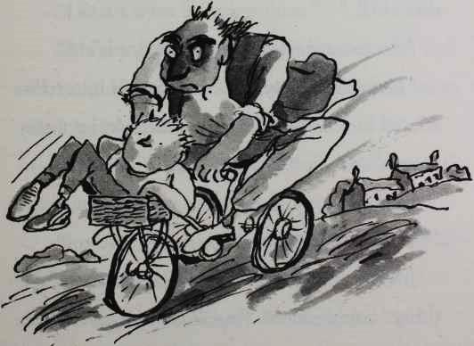

251

DRING.

That wasn't . . . Oh, I think I've done that joke too many times now.

"Hello?" said a kindly but sad-looking lady at the door of Flat 112.

"Are you Bob's mum?" asked Joe.

"Yes," said the woman. She squinted at him.

"You must be Joe," she said, in a not-very- friendly tone. "Bob has told me all about you."

"Oh," squirmed Joe. "I'd like to see him, if that's OK."

"I'm not sure he'll want to see you."

"It's really important," said Joe. "I know I've treated him badly. But I want to make up for it. Please."

Bob's mum sighed, then opened the door. "Come in then," she said.

Joe followed her into the little flat. The whole thing could have fitted into his en-suite

252

bathroom. The building had definitely seen better days. Wallpaper was peeling off the walls, and the carpet was worn in places. Bob's mum led Joe along the corridor to Bob's room and knocked on his door.

"What?" came Bob's voice.

"Joe is here to see you," replied Bob's mum.

"Tell him to get lost."

Bob's mum looked at Joe, embarrassed.

"Don't be rude, Bob. Open the door."

"I don't want to talk to him."

"Maybe I should go?" whispered Joe, half turning towards the front door. Bob's mum shook her head.

"Open this door at once, Bob. You hear me? At once!"

Slowly the door opened. Bob was still in his pyjamas, and stood staring at Joe.

"What do you want?" he demanded.

253

"To talk to you," replied Joe.

"Go on then, talk."

"Shall I make you two some breakfast?" asked Bob's mum.

"No, he's not staying," replied Bob.

Bobs mum's tutted and disappeared into the kitchen.

"I just came to say I’m sorry," spluttered Joe.

"It's a bit late for that, isn't it?" said Bob.

"Look, I am so, so sorry for all the things I said."

Bob was defiant in his anger. "You were really nasty."

"I know, I’m sorry. I just couldn't work out why you were so upset with me. I only gave the Grubbs money because I wanted to make things easier for you —"

"Yes, but —"

"I know, I know," said Joe hurriedly. "I realise

254

now it was the wrong thing to do. I'm just explaining how I felt at the time."

"A true friend would have stuck up for me. Supported me. Instead of just flashing their money around to make the problem go away."

"I am an idiot, Bob. I know that now. A great big fat stinking idiot."

Bob smiled a little, though he was clearly trying hard not to.

"And you were right about Lauren, of course," continued Joe.

"About her being a fake?"

"Yes, I found out my dad was paying her to be my friend," said Joe.

"I didn't know that. That must have really hurt."

Joe's heart ached, as he remembered how much pain he had felt at the party last night. "It did. I really liked her."

255

"I know. You forgot who your real friends were."

Joe felt so guilty. "I know . . . I’m so sorry. I do really like you, Bob. I really do. You're the only kid at school who ever liked me for me, not just my money."

"Let's not fall out again. Eh Joe?" Bob smiled.

Joe smiled too. "All I ever really wanted was a friend."

"You're still my friend, Joe. You always will be."

"Listen," Joe said. "I’ve got something for you. A present. To say sorry."

"Joe!" said Bob, frustrated. "Look, if it's a new Rolex or a load of money I don't want it, all right?"

Joe smiled. "No, it's just a Twix. I thought we could share it."

Joe pulled out the chocolate bar and Bob

256

chuckled. Joe chuckled too. He opened the packet and handed Bob one of the fingers. But just as Joe was about to scoff the chocolate and caramel topped biscuit . . .

"Joe?" called Bob's mum from the kitchen. "You better come quickly. Your dad is on the TV . . ."

257

# 25 Broken

Broken. That's the only word that could describe how Joe's dad looked. He was standing outside Bumfresh Towers, in his dressing gown. Mr Spud addressed the camera, his eyes red from crying.

"I've lost everything," he said slowly, his whole face shattered with emotion. "Everything. But all I want is my son back. My beautiful boy."

Then the tears welled up in Mr Spud and he had to catch his breath.

Joe looked over at Bob and his mum. They stood in the kitchen staring at the screen. "What

258

does he mean? He's lost everything?"

"It was just on the news," she replied. "Everyone is suing your dad. Bumfresh has made everyone's bottom go purple."

"What?" replied Joe. He turned back to the TV.

"If you are watching out there, son . . . Come home. Please. I beg you. I need you. I miss you so much . . ."

Joe reached out and touched the screen. He could feel tears welling in the corners of his eyes. A little hiss of static danced on his fingertips.

"You'd better go to him," said Bob.

"Yeah," said Joe, too shocked to move.

"If you and your dad need anywhere to stay, you are both welcome here," said Bob's mum.

"Yeah, of course," chimed in Bob.

"Thanks so much. I'll tell him," said Joe. "Look, I've gotta go."

259

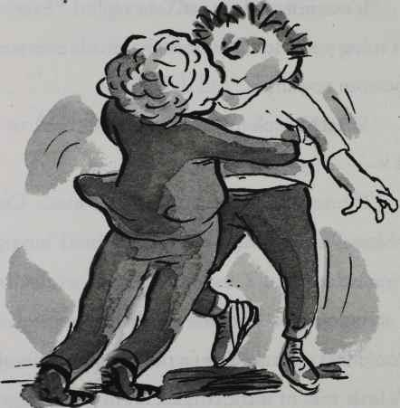

"Yeah,” said Bob. He opened his arms and gave Joe a hug. Joe couldn't remember the last time anyone had hugged him. It was one thing money couldn't buy. Bob was a brilliant hugger too. He was all squidgy.

"I'll see you later, I suppose," said Joe.

260

"I'll make a Shepherd's Pie," said Bob's mum with a smile.

"My dad loves Shepherd's Pie," replied Joe.

"I remember," said Bob's mum. "Me and your dad were at school together."

"Really?" asked Joe.

"Yes, he had a bit more hair and a bit less money back then!" she joked.

Joe allowed himself a little laugh. "Thank you so much."

The lift was out of order so Joe raced down the stairs, bouncing off the walls as he did so. He ran out into the car park where Raj was waiting.

"Bumfresh Towers, Raj. And step on it!"

Raj pedalled hard and the trike trundled off down the street. They passed a rival newsagent's shop and Joe clocked the headlines on the papers in racks outside. Dad was on every front page.

261

BUMFRESH SCANDAL said The Times.

BILLIONAIRE SPUD FACING RUIN ran theTelegraph.

BUMFRESH IS HARMFUL TO BOTTOMS exclaimed the Express.

IS YOUR BOTTOM PURPLE? enquired the Guardian.

BUMFRESH PURPLE BOTTOM NIGHT­MARE! screamed the Mirror.

QUEEN HAS BABOON'S BUM claimed the Mail.

BUM HORROR yelled the Daily Star.

POSH SPICE CHANGES HAIRSTYLE announced the Sun.

***

Well, nearly every front page. "You were right, Raj!" said Joe, as they sped up the high street.

"About what in particular?" replied the

262

newsagent, as he mopped the sweat from his brow.

"About Bumfresh. It has made everyone's bottom go purple!"

"I told you so! Did you inspect yours?"

So much had happened since Joe had left Raj's shop yesterday afternoon he had completely forgotten. "No."

"Well?" prompted the newsagent.

"Pull over!"

"What?"

"I said, 'pull over'!"

Raj swerved the Rajmobile on to the verge. Joe leaped off, looked over his shoulder and pulled down the back of his trousers a little.

"Well?" asked Raj.

Joe looked down. Two great purple swollen cheeks stared back at him. "It's purple!"

Let's have another look at Raj's graph. If Joe's

263

bottom was added to it, it would look like this:

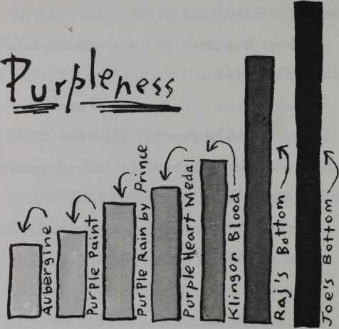

(Ascending order of Purpleness Table 2:

Aubergine

Purple Paint

Purple Rain by Prince

Purple Heart Medal

Klingon Blood

Raj’s Bottom)

Joe’s Bottom

In short Joe's bum was very very very very very very very very very very very very very very very very very very very very very very very very very very very very very very very very very very very very very very very very very very very very very very very very very very very very very very very very very very very

264

very very very very very very very very very very very very very very very very very very very very very very very very very very . . .  . . .purple.

Joe pulled up his trousers and jumped back on the Rajmobile. "Let's go!"

As they approached Bumfresh Towers, Joe saw that there were hundreds of journalists and camera crews waiting outside the gates of his house. As they approached, all the cameras turned to them, and hundreds of flashes went off. They were blocking their entrance and Raj had no choice but to stop the trike.

"You are live on Sky News! How do you feel now your father faces financial ruin?"

Joe was too shocked to reply, but still men in raincoats continued to shout questions at him.

"BBC News. Is there going to be a compensation

265

package for the millions of people around the world whose bums have gone purple?"

"CNN. Do you think your father will face criminal charges?"

Raj cleared his throat. "If I may make a short statement gentlemen."

All the cameras turned to the newsagent and there was hushed silence for a moment.

"At Raj's shop in Bolsover Street I am doing a very special offer on Frazzles. Buy ten packets get one free! For a limited time only."

The journalists all sighed loudly and muttered their annoyance.

Ding ding!

Raj rang the bell on his trike and the sea of reporters parted, to let him and Joe through.

"Thank you so much!" chirped Raj with a smile. "And I have some out of date Lion Bars at half price! Only slightly mouldy!"

266

# 26 A Blizzard of Banknotes

As Raj pedalled hard up the long driveway, Joe was shocked to see that there was already a fleet of lorries parked up by the front door. An army of bulky men in leather jackets were carrying out all of his dad's paintings and chandeliers and diamond-encrusted golf clubs. Raj stopped the bike and Joe leaped out of the basket and ran up the huge stone steps. Sapphire was hurrying out in a pair of impossibly high heels, laden with a huge suitcase and numerous handbags.

"Out of my way!" she hissed.

"Where's my dad?" demanded Joe.

267

"I dunno and I don't care! The idiot has lost all of his money!"

As she ran down the steps the heel of her shoe broke off and she took a tumble. The case crashed on the stone floor and broke open. A blizzard of banknotes swirled into the air. Sapphire began screaming and crying, and as mascara ran down her cheeks she leaped up, trying desperately to catch them. Joe looked back at her with a mixture of anger and pity.

He then raced into the house. It was now completely bare of any belongings. Joe fought past the bailiffs and sprinted up the grand spiral staircase. He passed a couple of burly men making off with hundreds of miles of his Scalextric track. For a millisecond Joe felt a pang of regret, but he carried on running and burst through the door to his dad s bedroom. The

268

room was white and bare, almost serene in its emptiness. Hunched on a bare mattress with his back to the door was his dad, wearing only a vest and a pair of boxer shorts, his fat hairy arms and legs contrasting with his bald head. They had even taken his toupee.

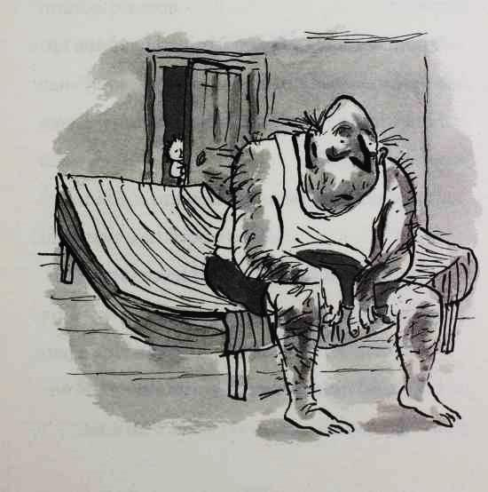

269

"Dad!" shouted Joe.

"Joe!" Dad turned around. His face was red and raw from crying. "My boy, my boy! You came home."

"I’m sorry I ran away, Dad."

"I am so upset I hurt you with all that business with Lauren. I just wanted to make you happy."

"I know, I know, I forgive you, Dad." Joe sat down next to his father.

"I've lost everything. Everything. Even Sapphire's gone."

"I am not sure she was the one, Dad."

"No?"

"No," replied Joe as he tried not to shake his head too hard.

"No, maybe not," said Dad. "Now we've got no house, no money, no private jet. What are we gonna do, son?"

270

Joe reached into his trouser pocket and pulled out a cheque. "Dad?"

"Yes, my boy?"

"The other day I was going through my pockets and I found this."

Dad studied it. It was the one he had written his son for his birthday. For two million pounds.

"I never paid it in," said Joe excitedly. "You can have it back. Then you can buy us somewhere to live, and still have loads of money left over."

Dad looked up at his son. Joe wasn't sure if his father was happy or sad.

"Thank you so much, boy. You are a great lad, you really are. But I am sorry to say this cheque is worthless."

"Worthless?" Joe was shocked. "Why?"

"Because I have no money left in my bank

271

account.” explained Dad. "There are so many law suits against me the banks have frozen all my accounts. I'm bankrupt now. If you had paid it in when I gave it to you, we would still have two million pounds."

Joe felt a little bit frightened that somehow he had done the wrong thing. "Are you angry with me, Dad?"

Dad looked at Joe and smiled. "No, I'm pleased you didn't cash it in. All that money never really made us happy, did it?"

"No," said Joe. "In fact it made us sad. And I am sorry too. You brought my homework to school and I shouted at you for embarrassing me. Bob was right, I havebehaved like a spoiled brat at times."

Dad chuckled. "Well, just a little!"

Joe bumjumped along closer to his dad. He needed a hug.

272

At that moment two burly bailiffs entered the room. "We've got to take the mattress,” announced one.

The Spuds offered no resistance, and stood up to let the men carry the last item out of the room.

Dad leaned over and whispered into his son's ear. "If there's anything you want to grab from your room, boy, I'd do it now."

"I don't need anything, Dad," replied Joe.

"There must be something. Designer shades, a gold watch, your iPod . . ."

They watched as the two men carried the mattress out of Mr Spud's bedroom. It was now completely bare.

Joe thought for a moment. "There is something," he said. He disappeared out of the room.

Mr Spud moved over to the window. He watched helpless as the leather-jacketed men

273

carried out everything he owned, silver cutlery, crystal vases, antique furniture, everything . . . and loaded it into the trucks.

In a few moments Joe reappeared.

"Did you manage to grab anything?" asked Dad eagerly.

"Just one thing."

Joe opened his hand and showed his dad the sad little loo-roll rocket.

"But why?" said Dad. He couldn't believe his son had kept the old thing, let alone chosen it as the one thing he wanted to save from the house.

"It's the best thing you ever gave me," said Joe.

Dad's eyes clouded over with tears. "But it's just a loo roll with a bit of another loo roll stuck to it," he spluttered.

"I know," said Joe. "But it was made with

274

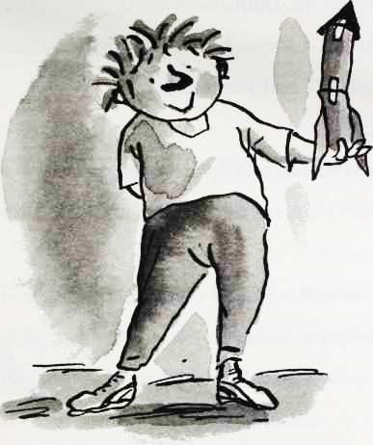

love. And it means more to me than all that expensive stuff you bought me."

Dad shook with uncontrollable emotion, and wrapped his short fat hairy arms around his son. Joe put his short, fat, less-hairy arms around his dad. He rested his head on his dad's chest. He felt that it was wet with tears.

275

"I love you, Dad."

"Ditto . . . I mean, I love you too, son."

"Dad . . . ?" said Joe tentatively. "Yes?"

"Do you fancy Shepherd's Pie for tea?"

"More than anything in the world," said Dad with a smile.

Father and son held each other tight.

Finally, Joe had everything he could ever need.

276

# Postscript

So what happened to all the characters in the story?

Mr Spud liked Bob's mum's Shepherd's Pie so much that he married her. And now they have it every night for their tea.

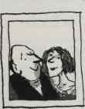

Joe and Bob not only stayed best friends - when their parents got married they became stepbrothers too.

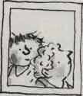

Sapphire got engaged to a Premier League football team.



Raj and Mr Spud began working on a number of ideas together that

277

they hoped would make them zillionaires. The five-fingered Kit Kat. The queen-size Mars Bar (in between king and normal size). Vindaloo-flavoured Polo mints. At time of writing none of these ideas have made them a penny.

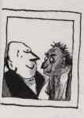

No one ever worked out which Grubb was a he and which Grubb was a she. Not even their mum or dad. They were sent to a boot camp in America for juvenile delinquents.

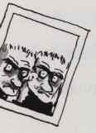

The headmaster, Mr Dust, retired from the school on his hundredth birthday. He now races motorbikes full time.

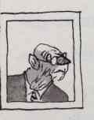

Miss Spite the history teacher got her job back and gave Joe litter duty every day for the rest of his life.

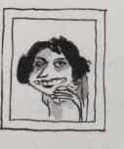

278

The unfortunately named teacher Peter Bread changed his name. To Susan Jenkins. Which didn't really help.

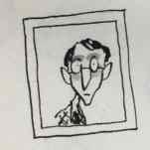

Lauren continued her acting career, the only highlight of which was a part in the TV hospital drama Casualty. As a dead body.

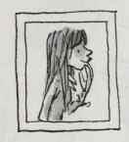

The headmaster's secretary, Mrs Chubb, never did get out of her chair.

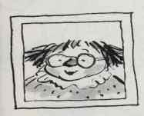

The Queen's bum remained purple. She showed it to everyone in the country when she gave her yearly speech to the nation on Christmas Day, calling it her 'anus horribilis'.

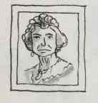

And finally, Mrs Trafe released a best-selling cook book, 101 Recipes with Bat Sick. Available from HarperCollins.

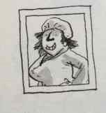

279