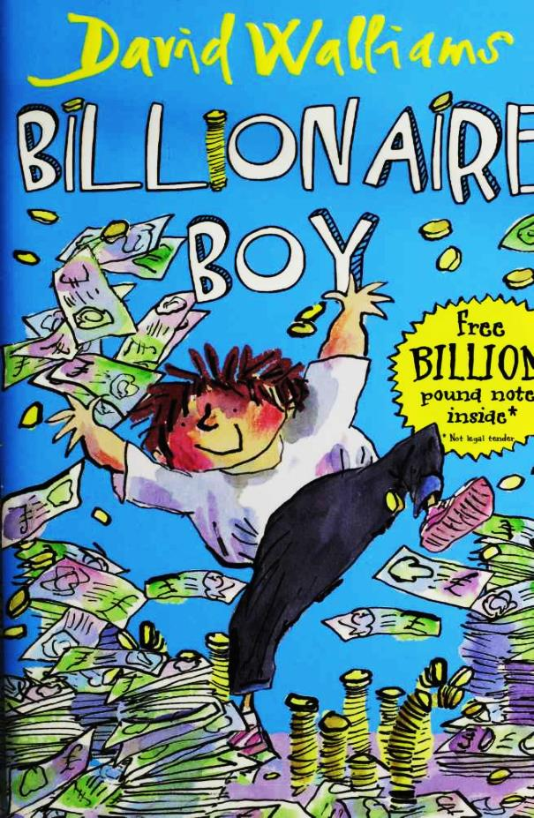

Billionaire Boy

By

David Walliams

Illustrated by Tony Ross

This electronic copy of the original work is made under a Copyright Licensing Agency license by The Seeing Ear. It is for the personal use of a Print Disabled Person and may not be further copied, (including any electronic copying or transmission), or dealt with without permission, save as may be permitted by law.

Contents

1 Meet Joe Spud 9

2 Bum Boy 17

3 Who's the Fattiest? 24

4 "Loo Rolls?" 31

5 Out of Date Easter Eggs 35

6 The Grubbs 40

7 Gerbils on Toast 46

8 The Witch 52

9 "Finger?" 57

10 Dog Spit 63

11 Camping Holiday 67

12 Page 3 Stunna 71

13 New Girl 78

14 The Shape of a Kiss 82

15 Nip and Tuck 85

16 Peter Bread 89

17 A Knock on the Toilet Door 93

18 The Vortex 3000 97

19 A Baboon's Bottom 100

20 A Beach Ball Rolled in Hair 103

21 A GCSE in Make-Up 107

22 A New Chapter 111

23 Canal Boat Weekly 114

24 The Rajmobile 119

25 Broken 122

26 A Blizzard of Banknotes 126

Postscript 130

# 12 Page 3 Stunna

". . . and the Witch still made me do litter duty!" said Joe. He was sitting with his dad at one end of the highly polished thousand-seater dining-room table waiting for his dinner. Impossibly large diamond candelabras hung overhead, and paintings that weren't very nice but cost millions of pounds adorned the walls.

"Even after I dropped your homework off in the chopper?" said Mr Spud, angrily.

"Yeah, it was so unfair!" replied Joe.

"I did not invent a double sided moist/dry toilet tissue for my son to be put on litter duty!"

142

"I know,” said Joe. "That Miss Spite is such a cow!

"I am going to fly to the school tomorrow and give that teacher of yours a piece of my mind!"

"Please don't, Dad! It was embarrassing enough when you turned up today!"

"Sorry, son," said Mr Spud. He looked a little hurt, which made Joe feel guilty. "I was just trying to help."

Joe sighed. "Just don't do it again, Dad. It's so awful everyone knowing I am the son of the Bumfresh man."

"Well, I can't help that, boy! That's how I made all this money. That's why we are living in this big house."

"Yeah . . . I guess," said Joe. "Just don't come turning up in your Bum Air helicopter or anything, yeah?"

"OK," said Mr Spud. "So, how's that friend

143

of yours working out?"

"Bob? He's not really my friend any more," replied Joe. He hung his head a little.

"Why's that?" asked Mr Spud. "I thought you and him were getting on really well?"

"I paid off these bullies to help him," said Joe. "They were making his life a misery, so I gave them some cash to leave him alone."

"Yeah, so?"

"Well, he found out. And then, get this, he got all upset. He called me a spoiled brat!"

"Why?"

"How do I know? He said he'd rather get bullied than have me help him."

Mr Spud shook his head in disbelief. "Bob sounds a bit of a fool to me. The thing is, when you've got money like we do, you meet a lot of ungrateful people. I reckon you're better off without this Bob character. It sounds like he

144

doesn't understand the importance of money. If he wants to be miserable, let him."

"Yeah," agreed Joe.

"You'll make another friend at school, son," said Mr Spud. "You're rich. People like that. The sensible ones, anyway. Not like this idiot Bob."

"I'm not so sure," said Joe. "Not now everyone knows who I am."

"You will Joe. Trust me," said Mr Spud with a smile.

The immaculately attired butler entered the dining room through the vast oak panelled double doors. He did a little theatrical cough to get his master's attention. "Miss Sapphire Stone, gentlemen."

Mr Spud swiftly put on his ginger toupee as Page 3 stunna Sapphire clip-clopped into the room in her impossibly high heels.

"Sorry I'm late, I was just at the tanning

145

salon,” she announced.

This was evident. Sapphire had fake tan smeared over every inch of her skin. She was now orange. As orange as an orange, if not orangier. Think of the orangiest person you've ever met, then times their orangeness by ten. As if she didn't look frightful enough already, she was wearing a lime green mini-dress and clutching a shocking pink handbag.

"What's she doing here?" demanded Joe.

"Be nice!" mouthed Dad.

"Nice pad," said Sapphire, looking round admiringly at the paintings and chandeliers.

"Thank you. It's just one of my seventeen homes. Butler, please tell Chef that we want our dinner now. What are we having tonight?"

"Foie gras, Sir," replied the butler.

"What's that?" asked Mr Spud.

"Specially fattened goose liver, Sir."

146

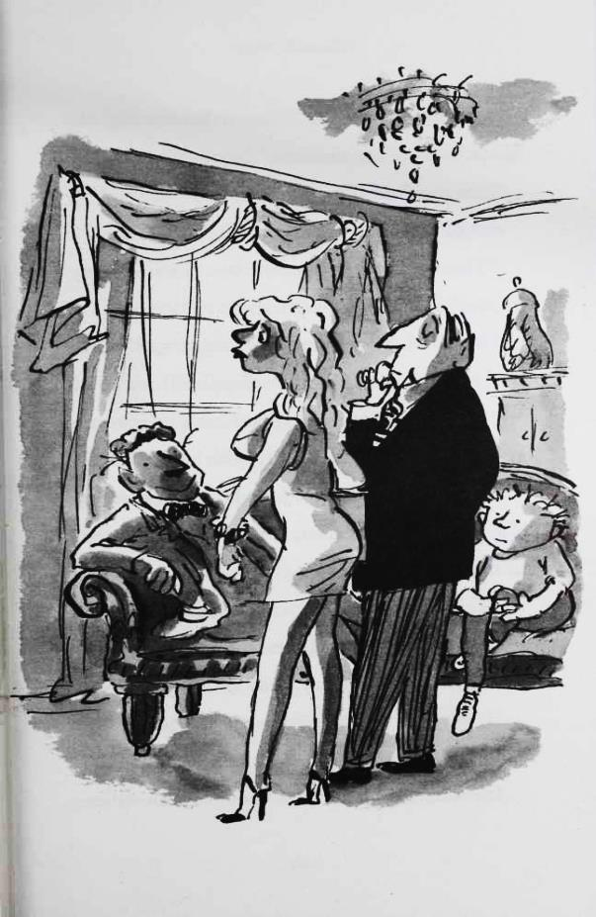

147

Sapphire grimaced. "I'll just have a bag of crisps."

"Me too!" said Joe.

"And me!" said Mr Spud.

"Three packets of potato crisps coming right up, Sir," sneered the butler.

"You look beautiful tonight, my angel!" said Mr Spud, before approaching Sapphire for a kiss.

"Don't smudge me lip liner!" said Sapphire, as she repelled him forcefully with her hand.

Mr Spud was clearly a little hurt, but tried to hide it. "Please take a seat. I see you brought the new Dior handbag I sent you."

"Yeah, but this bag comes in eight colours," she complained. "One for each day of the week. I thought you were gonna buy me all eight."

"I will, my sweet princess . . ." spluttered Mr Spud.

Joe stared at his dad. He couldn't believe he

148

had fallen for such a wrong'un.

"Dinner is served," announced the butler.

"Here, my beautiful angel of love, take a seat," said Mr Spud, as the butler pulled out a chair for her.

Three waiters entered the room carrying silver trays. They carefully placed the plates down on the table. The butler nodded and the waiters lifted the silver covers to reveal three packets of Salt n' Vinegar crisps. The trio started eating. Mr Spud initially attempted to eat his crisps with his knife and fork to appear posh, but soon gave up.

"Now me birfday's only eleven months away," said Sapphire. "So I've made a little wish- list of presents you are going to buy me . . ."

Her fingernails were so long and fake she could barely fish the piece of paper from her pink handbag. It was like watching one of those grabber machines at the fair where you never win

149

anything. Eventually she grasped it and passed it over to Mr Spud. Joe looked over his dad's shoulder and read what she had scribbled.

Sapphire's Birfday Wish-List

A solid gold Rolls Royce convertible

A million pounds in cash

500 pairs of Versace sunglasses

A holiday home in Marbella (large)

A bucket of diamonds

A unicorn

A box of Ferrero Rocher chocolates (large)

A great big massive like really big yacht

A large tank of topical fish* (I think she must mean tropical fish, rather than fish that are up on the news and current affairs.)

‘Beverly Hills Chihuahua' on DVD’

150

5000 bottles of Chanel perfume

Another million pounds in cash

Some gold

Lifetime subscription to OK magazine

A private jet (new please, not second-hand)

A talking dog

General expensive stuff

100 designer dresses (I don't mind which ones as long as they are expensive. Any ones I don't like me mum can flog down the market)

A pint of semi-skimmed milk

Belgium

***

"Of course I will get all these things for you, my angel sent from heaven," slobbered Mr Spud.

"Thanks, Ken," said Sapphire, her mouth full of crisps.

"It's Len," corrected Dad.

151

"Oh, sorry, yeah! LOL! Len! Silly me!" she said.

"You can't be serious!" said Joe. "You're not really going to buy her all that stuff are you?"

Mr Spud gave Joe an angry look. "Why not, son?" he said, trying to control his temper.

"Yeah, why not, you little git?" said Sapphire. Definitely not controlling hertemper.

Joe hesitated for a moment. "It's plain to see you're only with my dad for the money."

"Don't talk to your mother like that!" shouted Mr Spud.

Joe's eyes nearly popped out of his head. "She's not my mother, she's your stupid girlfriend and she's only seven years older than me!"

"How dare you!" fumed Mr Spud. "Say sorry."

Joe defiantly remained silent.

152

"I said, 'say sorry’!" shouted Mr Spud.

"No!" shouted Joe.

"Go to your rooms!"

Joe pushed back his chair, making as much of a clatter as possible, and stomped upstairs, as the staff pretended not to see.

He sat on the edge of his bed and cradled himself in his arms. It was a long, long time since anyone had hugged him, so he hugged himself. He squeezed his own sobbing plumpness. He was beginning to wish that Dad had never invented 'Bumfresh' and they were all still living in the council flat with Mum. After a few moments, there was a knock on the door. Joe sat in defiant silence.

"It’s your dad.”

"Go away!” shouted Joe.

Mr Spud opened the door and sat down next to his son on the bed. He nearly slid off the

153

bedspread onto the floor. Silk sheets may look nice, but they aren't very practical.

Mr Spud bumjumped a little nearer to his son.

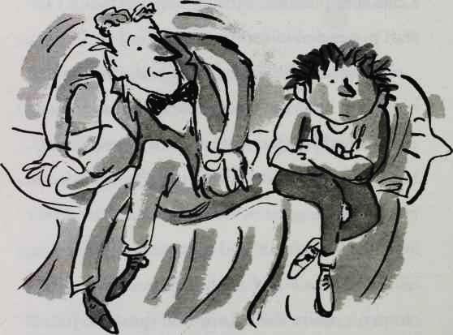

"I don't like to see my little Spud like this. I know you don't like Sapphire, but she makes me happy. Can you understand that?"

"Not really," said Joe.

154

"And I know you had a tough day at school too. With that teacher, the Witch, and with that ungrateful boy, Bob. I'm sorry. I know how much you wanted a friend, and I know I didn't make it any easier. I will have a quiet word with the headmaster. Try and sort things out for you if I can."

"Thanks, Dad." Joe sniffed. "I'm sorry I was crying." He hesitated for a moment. "I do love you, Dad."

"Ditto, son, ditto," replied Mr Spud.

155

# 13 New Girl

The half-term holidays came and went, and when Joe returned to school on the Monday morning he found he wasn't the centre of attention any more. There was a new girl at school, and because she was soooooooo pretty everyone was talking about her. When Joe walked into his classroom there she was, like a giant unexpected present.

"So what's the first lesson today?" she asked as they walked across the playground.

"Sorry?" spluttered Joe.

"I said, 'what's the first lesson today?'"

156

the new girl repeated.

"I know, it's just . . . you're really talking to me?" Joe couldn't believe it.

"Yes, I am talking to you," she laughed. "I'm Lauren."

"I know." Joe wasn't sure if the fact that he had remembered her name made him sound suave or like a stalker.

"What's your name?" she asked.

Joe smiled. At last there was someone at the school who knew nothing about him.

"My name is Joe," he said to Lauren.

"Joe what?" asked Lauren.

Joe didn't want her to know that he was the Bumfresh billionaire. "Erm, Joe Potato."

"Joe Potato?" she asked, more than a little surprised.

"Yes . . ." stammered Joe. In the moment he had been too overwhelmed by her beauty to be

157

able to come up with a better alternative to 'Spud'.

"Unusual name, Potato," said Lauren. "Yes, I suppose it is. It is actually spelt with an 'e' at the end. Joe Potatoe. So it's not quite the vegetable 'potato'. That would be ridiculous! Ha ha!"

Lauren tried to laugh too, but she was looking at Joe a little oddly. Oh no, thought Joe. I only met this girl one minute ago and she already thinks I’m nuts. He quickly tried to change the subject. "We've got Maths next with Mr Crunch," he said. "OK."

"And then we've got History with Miss Spite."

"I hate History, it's so boring."

"You'll hate it even more with Miss Spite. She's a good teacher, I suppose, but all us kids

158



hate her. We call her The Witch'!"

"That's so funny!" said Lauren, giggling.

Joe felt ten feet tall.

Bob bobbed into view. "Er . . . Hi Joe."

"Oh, hi Bob," Joe replied. The two former friends hadn't seen each other over the half term. Joe had spent his days alone racing around and around his racetrack in a new Formula One car his dad had bought him. And Bob had spent most of the week in a bin. Wherever Bob was the

159

Grubbs seemed to find him, lift him up by his ankles and deposit him in the nearest skip. Well, that was what Bob had said he wanted.

Joe had missed Bob, but this wasn't good timing. Right now he was talking to the prettiest girl in the school, maybe even the prettiest girl in the whole of the local area!

"I know we haven't seen each other in a while. But . . . well . . . I've been thinking about what we said when you were doing litter duty . . ." stammered Bob.

"Yeah?"

Bob seemed a little taken aback by Joe's impatient tone, but pressed on. "Well, I am sorry we fell out, and I would like us to be friends again. You could move your desk back so that —"

"Do you mind if I talk to you later, Bob?" said Joe. "I am quite busy right now."

160

"But —" began Bob, a wounded expression on his face.

Joe ignored it. "I'll see you around," he said.

Bob marched off ahead.

"Who was that? A friend of yours?" enquired Lauren.

"No no no, he's not my friend," replied Joe. "Bob's his name, but he's so fat everyone calls him 'Blob'!"

Lauren laughed again. Joe felt a tiny bit sick, but he was so pleased to be making the pretty new girl laugh that he pushed the feeling all the way down inside him.

For the duration of the maths class Lauren kept on looking over at Joe. It put him right off his algebra. In History she was definitely gazing in his direction too. As Miss Spite droned on and on about the French revolution, Joe started to daydream about kissing Lauren. She was so very

161

pretty that Joe wanted to kiss her more than anything. However, being only twelve Joe had never kissed a girl before, and had no idea how to make it happen.

"And the name of the king of France in 1789 was . . .? Spud?"

"Yes, Miss?" Joe stared at Miss Spite, horrified. He hadn't been listening at all.

"I asked you a question, boy. You haven't been paying attention, have you? Do you want to pass your exam?"

"Yes, Miss. I was listening . . ." stammered Joe.

"What is the answer then, boy?" demanded Miss Spite. "Who was the king of France in 1789?"

Joe had no idea. He was pretty sure it wasn't King Kevin II, or King Craig IV, or King Trevor the Great, because kings didn't tend to have names like that.

162

"I am waiting,” pronounced Miss Spite. The bell rang. I’m saved! thought Joe.

"The bell is a signal for me, not you!" pronounced Miss Spite. Of course she was going to say that. She lived to say that. It would probably be written on her tombstone. Lauren was sitting behind where Miss Spite was standing, and she suddenly waved at Joe to get his attention. He was confused for a moment, then realised she was trying to help him by miming the answer. First she acted out someone going to the bathroom.

"King Toilet the . . .?" offered Joe.

The class all burst out laughing. Lauren shook her head. Joe had another try. "King Lavatory?"

They laughed again.

"King Bog?"

They laughed even harder this time.

"King Loo . . .? Ah, King Louis the . . ."

163

"Yes, boy?" Miss Spite continued her interrogation. Behind her Lauren mimed numbers with her fingers.

"King Louis the fifth, the tenth, the fifteenth, sixteen! King Louis the sixteenth!" declared Joe.

Lauren mimed a little clap.

"That's right, Spud," said a suspicious Miss Spite, before turning to the board and writing on it. "King Louis the sixteenth."

Stepping out into the spring sunshine, Joe turned to Lauren. "You totally saved my butt in there."

"That's OK. I like you." She smiled.

"Really . . .?" asked Joe.

"Yes!"

"Well, then, I wonder if . . ." Joe stumbled over his words. "If, well . . ."

"Well, what . . .?"

"If you, well, I mean you probably wouldn't,

164

in fact you definitely wouldn't, I mean, why would you? You are so pretty and I am just a big lump, but . . ." The words were spiralling out of his mouth in all directions now, and Joe was beginning to blush fiercely with embarrassment. "Well, if you wanted to . . ."

Lauren took over the speaking for a bit. "If I wanted to go for a walk in the park after school and maybe grab an ice lolly? Yes, I would love to."

"Really?" Joe was incredulous.

"Yes, really."

"With me?"

"Yes, with you, Joe Potatoe."

Joe was a hundred times happier than he could ever remember. It didn't even matter that Lauren thought his last name was Potatoe.

165

# 14 The Shape of a Kiss

"Oi!”

it had all been going perfectly. Joe and Lauren had been sitting on a park bench eating their lollies from Raj's shop. Raj could see Joe was trying to impress this girl, and so made a ridiculous fuss of him, giving him a one-penny discount on their lollies, and offering Lauren a free browse of Nowmagazine.

At last, though, they had escaped the newsagent s shop and found a quiet corner of the park, where they had been talking and talking as the melted red goo of their lollies dribbled down

166

their fingers. They spoke about everything except Joe's family life. Joe didn't want to lie to Lauren. He already liked her too much for that. So when she asked him what his parents did he just told her his dad worked in 'human waste management' and unsurprisingly Lauren didn't enquire any further. Joe desperately didn't want Lauren to know how ridiculously rich he was. Having observed how Sapphire shamelessly used his dad, he knew only too well how money could ruin things.

Everything was perfect . . . until the sound of that "Oi!" spoiled everything.

The Grubb twins had been hanging around by the swings aching for someone to tell them off. Unfortunately for them, the police, the park-keeper and the local vicar were all otherwise engaged. So when one of them spotted Joe they bounced over grinning, no doubt hoping to relieve their boredom by making

167

someone else’s life a misery for a bit.

"Oi! Give us some more money or we'll put you in a bin!"

"Who are they talking to?" whispered Lauren.

"Me," said Joe reluctantly.

"Money!" said a Grubb. "Now!"

Joe reached into his pocket. Maybe if he gave them each a £20 note they would leave him alone, for today at least.

"What are you doing, Joe?" asked Lauren.

"I just thought . . ." he stammered.

"What's it to you?" said Grubb One.

Joe looked down at the grass, but Lauren handed Joe what was left of her lolly and rose from the bench. The Grubbs shifted around uneasily. They weren't expecting a thirteen- year-old girl to literally stand up to them.

"Sit down!" said Grubb Two, as he or she put his or her hand on Lauren's shoulder to force her

168

down onto the bench. Lauren, however, grabbed his or her hand and twisted it behind his or her back, and then pushed him or her to the ground. The other Grubb charged her, so Lauren leaped into the air and kung-fu kicked him or her to the ground. Then the other

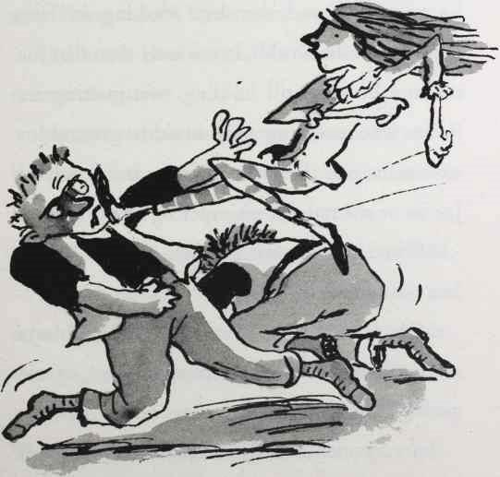

169

one leaped up and tried to grab her, but she karate-chopped him or her on his or her shoulder and he or she raced off screaming in pain.

It really is quite hard writing this when you don't know someone's gender.

Joe felt it was about time he did something so he stood up and, his legs shaking in fear, approached the Grubb. It was only then that Joe realised he was still holding two melting ice lollies. The remaining twin stood its ground for a moment, and then when Lauren stood behind Joe he or she ran off, whimpering like a dog.

"Where did you learn to fight like that?" said Joe, astounded.

"Oh, I've just done a few martial arts classes, here and there," replied Lauren, a little unconvincingly.

Joe reckoned he might have found his dream

170

girl. Not only could Lauren be his girlfriend, she could be his bodyguard too!

They walked through the park. Joe had walked through it many times before, but today it seemed more beautiful than ever. As the sunlight danced through the leaves on the trees on this Autumn afternoon, for a moment everything in Joe's life seemed perfect.

"I'd better head home," Lauren said, as they neared the gate.

Joe tried to hide his disappointment. He could have strolled round the park with Lauren forever.

"Can I buy you lunch tomorrow?" he asked.

Lauren smiled. "You don't have to buy me anything. I'd love to have lunch with you, though, but I'm paying, you understand?"

"Well, if you really want to," said Joe. Wow. This girl was too good to be true.

171

"What's the school canteen like?" said Lauren.

How could Joe find the words? "Um, well, it's . . . it's great if you are on a very strict diet."

"I love healthy food!" said Lauren. That wasn't quite what Joe meant, but it was the best place at school for a date as it was guaranteed to be quiet.

"See you tomorrow then," said Joe. He closed his eyes and made his lips the shape of a kiss. And waited.

"See you tomorrow Joe," said Lauren, before skipping off down the path. Joe opened his eyes and smiled. He couldn't believe it! He had nearly kissed a girl!

172

# 15 Nip and Tuck

There was something very peculiar about Mrs Trafe today. She looked the same but different. As Joe and Lauren approached the serving counter, Joe realised what had changed.

The loose skin on her face had been lifted.

Her nose was smaller.

Her teeth were capped.

The lines on her forehead had been erased.

Her eye bags had disappeared.

Her wrinkles had gone.

Her breasts were much, much bigger.

But she was still limping.

173

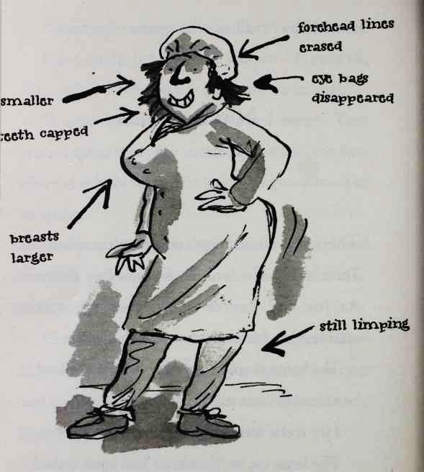

"Mrs Trafe, you look really . . . different . . ." Joe said, staring at her.

"Do I?" replied the old dinner lady with mock innocence. "Now, what do you two fancy today?

174

Roast bat with all the trimmings? Soap soufflé? Cheese and polystyrene pizza?"

"It's hard to choose . . ." faltered Lauren.

"You are new, are you, girl?" asked Mrs Trafe.

"Yes, I just joined the school yesterday," replied Lauren, surveying the dishes, and trying to work out which one was the least horrible.

"Yesterday? That's strange. I'm sure I've seen you somewhere before," said the dinner lady, studying Lauren's perfect face. "You look very familiar."

Joe butted in. "Did you have the hip replacement operation yet, Mrs Trafe?" He was becoming increasingly suspicious. "The one I gave you the money for a couple of weeks ago," he whispered, so Lauren wouldn't hear.

Mrs Trafe began to jabber nervously. "Um, well, no, not yet dear, why don't you have a large slice of my very tasty underpant flan . . . ?"

175

"You spent the money I gave you on plastic surgery, didn't you?" hissed Joe.

A bead of sweat trickled down her face and plopped into her badger snot soup.

"I am sorry, Joe, I just, well, I just always wanted to have a few things done . . ." pleaded the dinner lady.

Joe was so furious he felt he had to leave instantly. "Lauren, we're going," he announced, and she followed as he stormed out of the dining room. Mrs Trafe limped after them.

"If you could just lend me another £5000, Joe, I promise I'll have it done this time!" she called after him.

When Lauren finally caught up with Joe, he was sitting alone in the far corner of the playground. She gently put her hand on his head to comfort him.

176

"What was all that about lending her £5000?" she asked.

Joe looked at Lauren. There was no way of avoiding telling her now. "My dad is Len Spud," he said sorrowfully. "'The Bumfresh billionaire'. My name's not Potatoe. I just said that so you wouldn't know who I was. The truth is, we're stupidly rich. But when people find out . . . it tends to ruin everything."

"You know what, some of the other kids told me this morning," said Lauren.

Joe's sadness lifted for a moment. He reminded himself that Lauren had still gone for an ice lolly with him yesterday when she thought he was just Joe. Maybe it wouldn't ruin things this time. "Why didn't you say anything?" he asked.

"Because it doesn't matter. I don't care about all that. I just like you," she said.

177

Joe was so happy he wanted to cry. It's strange how sometimes you can be so happy it goes all the way around to sadness. "I really like you too."

Joe moved closer to Lauren. This was the moment to kiss! He closed his eyes and pushed his lips together.

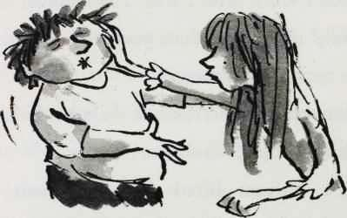

"Not here in the playground, Joe!" Lauren pushed him away laughing.

Joe felt embarrassed he had even tried. "I'm sorry." He quickly changed the subject. "I was just trying to do something kind for that old bag, and she goes and gets her knockers done!"

178

"I know, it's unbelievable."

"It's not the money, I don't care about the money . . ."

"No, it's that she took your generosity for granted," offered Lauren.

Joe looked up to meet her gaze. "Exactly!"

"Come on," said Lauren. "I think what you need is some chips. I'll buy you some."

The local chippy was bursting with kids from the comprehensive. It was against the rules to leave the school premises at lunchtime, but the food in the canteen was so abhorrent there wasn't much choice. The Grubbs were at the front of the queue, but fled as soon as they saw Lauren, leaving their battered sausages sizzling on the counter.

The pair stood outside on the pavement and ate their chips. Joe couldn't remember the last time he had enjoyed such a simple pleasure. It

179

must have been when he was really, really little. Before the Bumfresh billions came and changed everything. Joe wolfed his chips down, and noticed Lauren had barely touched hers. He was still hungry, but wasn't sure whether their relationship had advanced to the point where he could start helping himself to her food. That was normally after a few years of marriage, and they weren't even engaged yet.

"Have you finished with yours?" he ventured.

"Yes," she replied. "I don't want to eat too much. I am working next week."

"Working? Doing what?" said Joe.

Lauren suddenly looked very flustered. "What did I say?"

"I thought you said you were working."

"Yeah yeah yeah, I am working." She paused, and then took a breath. "Just in a shop . . ."

Joe wasn't convinced. "So why would you

180

need to be thin to work in a shop?"

Lauren looked uncomfortable. "It's a very narrow shop," she said. She checked her watch. "We've got double Maths in ten minutes. We'd better go."

Joe frowned. There was something strange going on here . . .

181

# 16 Peter Bread

"The Witch is dead!" sang a spotty little boy. "Ding-dong, the wicked witch is dead!" It wasn't even registration time yet, but already the news was spreading across the school like flu.

"What do you mean?" asked Joe as he took his seat in his classroom. On the other side of the class, he could see Bob, looking over at him with a pained expression. Probably jealous about Lauren, thought Joe.

"Haven't you heard?" said another even spottier little boy behind him. "Spite's been sacked!"

182

"Why?" asked Joe.

"Who cares?!" said a slightly less spotty boy. "No more boring History lessons!"

Joe smiled, then frowned. He hated Miss Spite and her tedious lessons like everybody else, but wasn't sure she had done anything to deserve losing her job. Even though she was horrible, she was actually a good teacher.

"Spite's been sacked," blurted Joe to Lauren as she walked in.

"Yes, I heard," she replied. "It's brilliant news, isn't it?"

"Erm, well, I suppose so," said Joe.

"I thought that's what you wanted? You said you couldn't stand her."

"Yes, but . . ." Joe hesitated for a moment. "I just feel a bit, you know, sorry for her."

Lauren pulled a dismissive face.

Meanwhile, a gang of fierce-looking girls were

183

sat on desks at the back of the class. The smallest of the group was pushed over in Lauren's direction as the others looked on smirking.

"Got any Pot Noodles then?" she asked, much to the amusement of the gang.

Lauren shot a look at Joe. "I don't know what you mean," she protested.

"Don't lie," said the girl. "You look different in it, but I well reckon it's you."

"I have no idea what you're talking about," said Lauren, a little flustered.

Before Joe could speak a young man in old man's clothes entered the classroom and took his position uncertainly by the blackboard. "Simmer down please," he said quietly. No one in the classroom took any notice, except Joe.

"I said, 'simmer down please' . . ."

The new teacher's second sentence was barely more audible than the first. Still none of the other

184

kids took any notice. In fact, if anything they started making even more noise than before.

"That's better," said the little man, trying to make the best of it. "Now, as you may know Miss Spite isn't here today —"

"Yeah, she's been given the boot!" shouted a loud fat girl.

"Well, that's not . . . well, yes, it is true . . ." the teacher continued in his faint monotone. "Now I am going to be taking over from Miss Spite as your form teacher, and also to teach you History and English. My name is Mr Bread." He began writing his name neatly on the board. "But you can call me Peter."

Suddenly there was quiet, as thirty little brains whirred.

"Pita Bread!" proclaimed a ginger-haired boy from the back. A huge wave of laughter crashed over the classroom. Joe had tried to give this

185

poor man a chance, but he couldn't help but laugh.

"Please, please, can I have some quiet?" pleaded the unfortunately named teacher. But there was no use. The whole class was in uproar. The new form teacher had committed the biggest blunder any teacher can make - having a silly name. This is a serious point. If you have a name like any of those in the list below it is very, very important you don't become a teacher:

Sue Doku

Tom Atoe

Justin Case

Neil Down

Will Ing

Bob Head

Terry Daktul

Clare Voyant

186

Mel Formed

Rachel Prejudice

Mona Lott

Herbie Hind

Ima Hogg

Carol Singer

Dick Tate

Don Keigh

Rhoda Camel

Robin Banks

Felix Cited

Gerry Atrick

Bea O’Problem

Mya Bumreeks

Anita Bath

Sue Age

Marcus Absent

Al Gebra

Barbara Blacksheep

187

Kitty Litter

Mary Christmas

Jim Class

Doris Closed

Doris Locked

Wayne Dear

Dan Druff

Humphrey Dumpty

Stan Dupp

Cliff Hanger

Hugh Idiot

Lee King

Manuel Labour

Ruth Less

Willie Mammoth

Marsha Mellow

Walter Melon

Hazel Nut

Luke Out

188

Stu Pidd

Lolly Popp

Chuck Up

***

Seriously. Don't even consider it. The kids in your class will make your life a living hell.

Now, back to the story . . .

"Right," said the unfortunately named teacher. "I am going to take the register. Adams?"

"Don't forget Tara Mosalata!" shouted a skinny blonde-haired boy. The laughter swept up again.

"I did ask for quiet," said Mr Bread, pathetically.

"Or Ted Ziki!" hollered another kid. The laughter was deafening now.

Peter Bread put his head in his hands. Joe could almost feel sorry for him. This grey little

189

man's life was going to be an utter misery from this day forward.

Oh, no, thought Joe. We're all going to fail our exams.

190

# 17 A Knock on the Toilet Door

There are a number of things you don't want to hear when you sit on the toilet.

A fire alarm.

An earthquake.

The roar of a hungry lion in the cubicle next door.

A large group of people shouting 'Surprise!' to you.

The sound of the entire toilet block being demolished by a giant wrecking ball.

The clicking sound of someone taking a photograph.

191

The sound of an electric eel swimming up the U-bend.

Someone drilling a hole in the wall.

JLS singing. (Admittedly that wouldn't be welcome at any time.)

A knock on the door.

That last one was exactly what Joe heard at break time when he took a seat in the boys' toilet.

RATTATTAT.

To be clear, that isn't a knock at your door, readers. It's a knock on Joe's toilet door.

"Who is it?" asked Joe, irritated.

"It's Bob," replied . . . yes, you've guessed correctly: Bob.

"Go away, I'm busy," said Joe.

"I need to talk to you."

Joe pulled the chain, and opened the door. "What do you want?" he said angrily as he made

192

his way to the sink. Bob trailed after him munching on a bag of crisps. It was only an hour since he'd been eating chips like everyone else, but obviously Bob got hungry very easily.

"You shouldn't eat crisps in a toilet, Bob."

"Why not?"

"Because . . . because . . . I don't know, because the crisps wouldn't like it." Joe whacked the tap on to wash his hands. "Anyway, what do you want?"

Bob put the bag in his trouser pocket and stood behind his former friend. He looked into Joe's eyes in the mirror. "It's Lauren."

"What about her?" Joe had known it. Bob was just jealous.

Bob looked away for a second and took a deep breath. "I don't think you should trust her," he said.

Joe turned around, shaking with fury. "Whatdid you say?" he shouted.

193

Bob stepped away, taken aback. "I just think she's . . ."

"SHE'S WHAT?"

"She's fake."

"Fake?" Joe felt white-hot with fury.

"Lots of the other kids reckon she's an actress. They said she's in some advert, or something. And I saw her out with this other boy at the weekend."

"What?"

"Joe, I think she's just pretending to like you." Joe put his face next to Bob's. He hated being this angry. It was scary being so out of control.

"SAY THAT AGAIN . . ."

Bob backed away. "Look, I'm sorry, I don't want a fight, I am just telling you what I saw."

"You're lying."

"I'm not!"

194

"You're just jealous because Lauren likes me, and you're a fatty with no friends at all."

"I'm not jealous, I'm just worried for you, Joe. I don't want you to get hurt."

"Yeah?" said Joe. "You sounded reallyworried about mewhen you called me a spoiled brat."

"Honestly, I —"

"Just leave me alone, Bob. We're not friends any more. I felt sorry for you and talked to you and that was that."

"What did you just say? You felt 'sorry for me'?" Bob's eyes were wet with tears.

"I didn't mean . . ."

"What, because I'm fat? Because the other kids bully me? Because my dad's dead?" Bob was shouting now.

"No . . . I just . . . I didn't mean . . ." Joe didn't know what he meant. He reached into his pocket and pulled out a wad of £50 notes, and offered

195

them to Bob. "Look, I’m sorry, here you go. Buy your mum something nice."

Bob knocked the money out of Joe's hand and the notes fell onto the damp floor. "How dare you?"

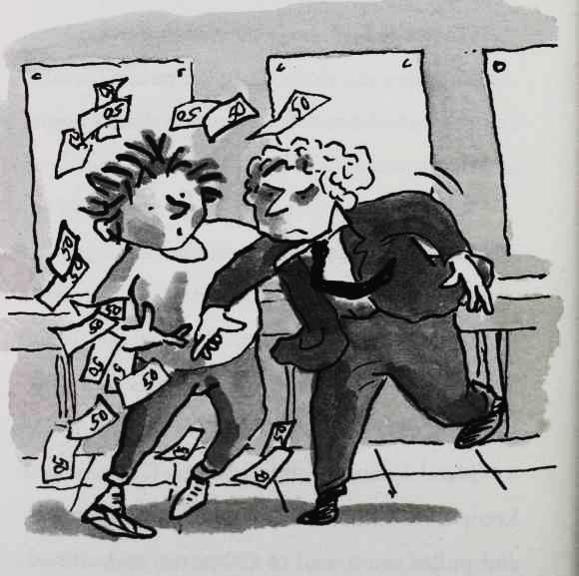

196

"What have I done now?" protested Joe. "What's the matter with you, Bob? I’m just trying to help you."

"I don't want your help. I don't want to ever speak to you again!"

"Fine!"

"And you are the one people should feel sorry for. You're pathetic." Bob stormed out.

Joe sighed, then got down on his knees and started picking up the wet bank notes.

***

"That's ridiculous!" said Lauren later, with a laugh. "I'm not an actress. I don't think I'd even get a part in the school play!"

Joe tried to laugh too, but he couldn't quite. They sat together on the bench in the playground, shivering slightly at the cold. Joe found it hard to say the next sentence. He did and didn't want to know the answer. He took a

197

deep breath. "Bob said he saw you with some other boy. Is that true?"

"What?" said Lauren.

"At the weekend. He said he saw you out with someone else." Joe looked straight at her, trying to read her face. For a moment she seemed to retreat to the back of her eyes.

"He's a liar," she said after a moment.

"I thought so," said Joe, relieved.

"A big fat liar," she continued. "I can't believe you were ever friends with him."

"Well, it was only for a bit," squirmed Joe. "I don't like him anymore."

"I hate him. Lying pig. Promise me you won't ever speak to him again," said Lauren urgently.

"Well . . ."

"Promise, Joe."

198

"I promise,' he replied. A wicked wind whipped through the playground.

199

# 18 The Vortex 3000

Lauren didn't think the petition to get Miss Spite reinstated was going to be popular.

And she was right.

By the end of the day Joe had only got three signatures - his, Lauren's and Mrs Trafe's. The dinner lady had only signed it because Joe had agreed to try one of her Hamster Dropping Tartlets. It tasted worse than it sounded. Despite having what was essentially not much more than a blank sheet of paper, Joe still felt it was worth presenting his petition to the headmaster. He didn't like Miss Spite one bit, but he didn't

200

understand why she had been sacked. Despite everything, she was a good teacher, certainly a lot better than Naan Bread, or whatever his stupid name was.

"Hello, children!" said the headmaster's secretary brightly. Mrs Chubb was a very fat jolly lady who always wore glasses with brightly coloured frames. She was always sitting in the headmaster's office behind her desk. In fact, no one had ever seen her stand up. It was not inconceivable that she was so big she was permanently wedged into her chair.

"We are here to see the headmaster, please," declared Joe.

"We have a petition for him," added a supportive Lauren, holding the piece of paper in her hand demonstratively.

"A petition! What fun!" beamed Mrs Chubb.

"Yes, it's to get Miss Spite her job back," said

201

Joe in a manly way that he hoped might impress Lauren. For a moment he toyed with the idea of thumping his fist on the desk to add emphasis, but he didn't want to topple over any of Mrs Chubb's abundant collection of lucky gonks.

"Oh, yes. Miss Spite, wonderful teacher. Don't understand that at all, but children I am sorry to say you have just missed Mr Dust."

"Oh, no," said Joe.

"Yes, he just left. Oh, look, there he goes." She pointed one of her bejewelled sausage fingers to the car park. Joe and Lauren peered through the glass. The headmaster was edging his way along at a snail's pace with his Zimmer frame.

"Slow down, Mr Dust, you'll do yourself a mischief!" she called after him. Then she turned back to Joe and Lauren. "He can't hear me. Well in truth he can't hear a thing! Do you want to

202

leave that little petition thing with me?" She angled her head and studied it for a moment. "Oh dear, it looks like all the signatures have fallen off."

"We were hoping for more," said Joe, weakly.

"Well if you run you might just catch him!" said Mrs Chubb.

Joe and Lauren shared a smile, and walked slowly out to the car park. To their surprise Mr Dust had abandoned his Zimmer frame and was clambering astride a shiny new Harley Davidson motorbike. It was the brand new jet-powered Vortex 3000. Joe recognised it, because his dad had a small collection of 300 motorbikes and was always showing his son brochures of new ones he was going to buy. The superbike, at £250,000, was the most expensive motorbike ever produced. It was wider than a car, taller than a lorry, and blacker than a black hole. It shone

203

with a very different chrome to that of the headmaster s Zimmer frame.

"Headmaster!" called Joe, but he was too late. Mr Dust had already put on his helmet and revved the engine. He put the beast into gear and

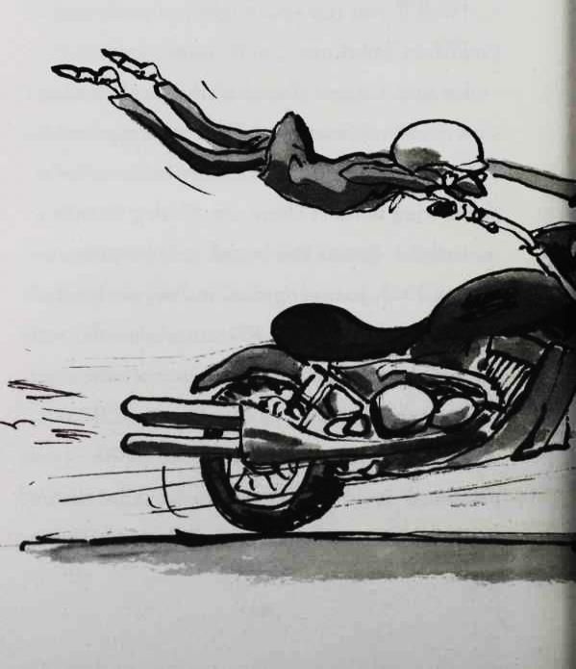

204

it roared past the other teachers' humble cars at a hundred miles an hour. It went so fast that the Headmaster was clinging on by his hands, his little old legs dangling up in the air behind him.

"YYYIIIiipppppppppeeeeeeeee!" cried the Headmaster as he and his preposterous machine disappeared off into the distance, becoming a dot on the horizon in a matter of seconds.

205

"There is something very strange going on," said Joe to Lauren. "The Witch gets the sack, the headmaster gets a £250,000 motorbike . . ."

"Joe, you're being silly! It's just coincidence!" laughed Lauren. "Now, am I still invited for dinner tonight?" she added, rapidly changing the subject.

"Yes yes yes," said Joe eagerly. "How about I meet you outside Raj's in an hour?"

"Cool. See you in a bit."

Joe smiled too, and watched her walk away.

But that bright golden glow that surrounded Lauren in Joe's mind was beginning to darken. Suddenly something felt very wrong . . .

206

# 19 A Baboon's Bottom

"Maybe your headmaster is simply having a mid-life crisis," pronounced Raj.

Stopping off at the newsagent's shop on the way home from school, Joe had told Raj about the curious events of the day.

"Mr Dust is about a hundred. He's got to be more than mid-way through his life!" said Joe.

"What I mean, Clever Clogs," continued Raj, "is that perhaps he was just trying to feel young again."

"But it's the most expensive motorbike in the world. It costs a quarter of a million pounds.

207

He's a teacher not a footballer, how could he afford it?!" proclaimed Joe.

"I don't know . . . I am no detective like Miss Marbles, or the great Shylock Holmes," said Raj, before looking around his shop and lowering his voice to a whisper. "Joe, I need to ask you about something in the strictest confidence."

Joe lowered his voice too. "Go ahead."

"This is very embarrassing, Joe," whispered Raj. "But do you use your dad's special toilet paper?"

"Yes, of course, Raj. Everybody does!"

"Well, I have been using his new one for a few weeks now."

"The mint-flavoured bum wipes?" asked Joe. There was now a huge range of Bumfresh products including:

208

HOTBUMFRESH - warms your bottom as you wipe.

LADYBUMFRESH - specially soft wipes for ladies' bottoms.

MINTYBUMFRESH - leaves your bottom with a cool, minty aroma.

"Yes, and . . ." Raj took a deep breath. "My bottom has come up all . . . well . . . purple."

"Purple!" said Joe with a shocked laugh.

"This is a very serious matter," chided Raj. He looked up suddenly. "One copy of the Daily Mail and a packet of Rolos, that will be 85p, be careful with those Rolos on your dentures, Mr Little."

He waited for the pensioner to leave the shop. Ding went the bell on the door.

"I didn't see him there. He must have been lurking behind the Quavers," said Raj, a little shaken at what the pensioner might have heard.

209

"You are joking aren't you, Raj?" said Joe with a quizzical smile.

"I am deadly serious, Joe," said Raj gravely.

"Show me, then!" said Joe.

"I can't show you my bottom Joe! We've only just met!" exclaimed Raj. "But let me draw you a simple graph."

"A graph?" asked Joe.

"Be patient, Joe."

As the boy looked on Raj grabbed some paper and pens and drew this simple graph.

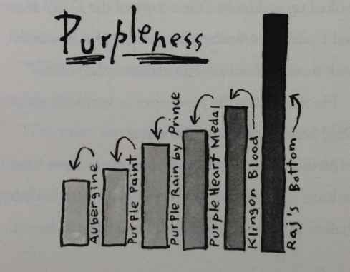

(Ascending order of Purpleness Table 1:

Aubergine

Purple Paint

Purple Rain by Prince

Purple Heart Medal

Klingon Blood

Raj’s Bottom)

210

"Wow, that is purple!" said Joe, studying the graph. "Is it painful?"

"It is a little sore."

"Have you seen a doctor?" asked Joe.

"Yes, and he said he had seen hundreds of people in the local area with brightly coloured bottoms."

"Oh no," said Joe.

"Maybe I will have to have a bum transplant!"

Joe couldn't help but laugh. "A bum transplant?!"

"Yes! This isn't a laughing matter, Joe," chided Raj. There was hurt in his eyes that his bottom had become the subject of mockery.

"No, sorry," said Joe, still giggling.

"I think I will stop using your dad's new Bumfresh wipes and go back to the shiny white my wife used to buy."

"I'm sure it isn't the bum wipes," said Joe.

211

"What else could it be?"

"Look, Raj, I’d better go," Joe said. "I have invited my girlfriend over later."

"Oooh, girlfriend is it now? The pretty girl you came in with when I sold you the ice lollies?" said the newsagent brightly.

"Yes, that's her," said Joe shyly. "Well, I don't know if she really is my girlfriend, but we've been spending lots of time together . . ."

"Well, have a lovely evening!"

"Thanks." Arriving at the door Joe turned back to the newsagent. He couldn't help himself. "Oh, by the way, Raj, good luck with the bum transplant . . ."

"Thank you, my friend."

"I hope they can find one big enough!" Joe laughed.

"Out of my shop! Out! Out!" said Raj.

Ding.

212

"Cheeky boy.” muttered the newsagent with a smile, as he rearranged his Curly Wurlys.

213

# 20 A Beach Ball Rolled in Hair

Bumfresh Towers pulsated with music. Coloured lights spun in every room. Hundreds of people swarmed around the house. This was a party that was going to get complaints about the noise.

From people in Sweden.

Joe had no idea that there was a party at the house tonight. Dad hadn't mentioned anything at breakfast and Joe had invited Lauren over for dinner. As it was a Friday night they could stay up late too. It was going to be perfect. Maybe tonight they might even kiss.

"Sorry, I had no idea about all this," said Joe,

214

as they approached the giant stone steps at the front of the house.

"It's cool, I love a party!" replied Lauren.

As darkness fell and strangers tumbled out of the house clutching bottles of champagne, Joe took Lauren's hand, and led her through the huge oak front door.

"Wow, this is some house," shouted Lauren over the music.

"What?" said Joe.

Lauren put her mouth to Joe's ear so she could be heard. "I said, 'wow, this is some house'." But Joe still couldn't really hear. Feeling the heat of her breath so close to him was so exhilarating he stopped listening for a moment.

"THANK YOU!" shouted Joe back into Lauren's ear. Her skin smelt sweet, like honey.

Joe searched all over the house for his dad. It was impossible to find him. Every room was

215

oozing with people. Joe didn't recognise a single one of them. Who on earth were they all? Guzzling cocktails and gobbling finger food like there was no tomorrow. Being short, Joe really found it hard to see over them. His dad wasn't in the snooker room. He wasn't in the dining room. He wasn't in the massage room. He wasn't in the library. He wasn't in the other dining room. He wasn't in his bedroom. He wasn't in the reptile house.

"Let's try the pool room!" shouted Joe in Lauren's ear.

"You've got a pool! Cool!" she shouted back.

They passed a woman bent over vomiting by the sauna as a man (presumably her boyfriend) patted the small of her back supportively. Some party guests had either dived or fallen into the pool, and were bobbing around in the water. Joe enjoyed swimming, and the thought that none of

216

these people looked like they would get out of the pool if they needed a pee, clouded his mind.

Just then he spotted his dad - wearing just a pair of swimming trunks and his curly afro toupee, and dancing to a completely different song than the one that was playing. Covering the wall behind him was a vast mural of a strangely muscle-bound version of himself reclining in a thong. The real Mr Spud boogied badly in front of it, looking more like a beach ball that had been rolled in hair.

"What's going on, Dad?" Joe shouted, half because the music was so loud and half because he was angry his dad hadn't told him anything about the party. "Who are all these people? Your friends?"

"Oh no, I hired them in. £500 each. Partyguests.com."

"What's the party for, Dad?"

217

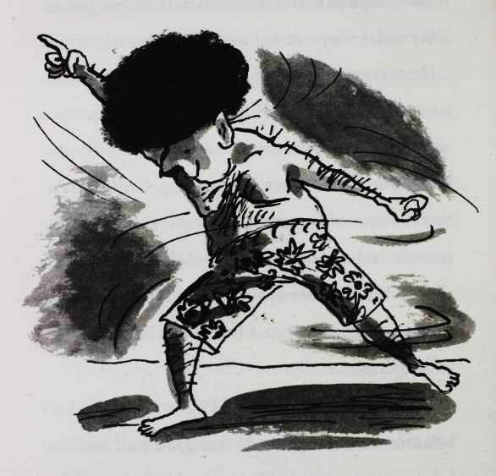

"Well, I know you will be so pleased to know that Sapphire and I have got engaged!" shouted Mr Spud.

"What the —?" said Joe, not able to disguise his shock.

218

"It's great news isn't it?" Dad yelled. Still the music boom boom boomed.

Joe didn't want to believe it. Did this brainless bimbo really have to be his new mum?

"I asked her yesterday and she said 'no', but then I asked her again today and gave her a great big diamond ring and she said 'yes'."

"Congratulations, Mr Spud," said Lauren.

"So you must be a friend of my son's from school?" said Mr Spud, his words tumbling out clumsily.

"That's right, Mr Spud," replied Lauren.

"Call me Len, please," said Mr Spud with a smile. "And you must meet Sapphire. SAPPHIRE!" he shouted.

Sapphire tottered over in her shocking yellow high heels and even more shocking yellow mini-dress.

"Would you show Joe's friend the engagement ring, my gorgeous lady love of all time? Twenty

219

million quid, just for the diamond."

Joe spied the diamond on his soon to be stepmother's finger. It was the size of a small bungalow. Her left arm was dangling lower than the right with the weight of it.

"Er . . . er . . . oh . . . It's so heavy, I can't lift my hand but if you bend down you can see it . . ." said Sapphire. Lauren stepped closer to get a better look. "Haven't I seen ya somewhere before?" Sapphire asked.

Mr Spud leaped in. "No, you haven't, my one true love."

"Yes I have!" said Sapphire.

"No, my angel cake!"

"OMG! I know where I seen ya!"

"I said shut it, my chocolate sprinkled princess!" said Mr Spud.

"You done that ad for Pot Noodle!" Sapphire exclaimed.

220

Joe turned to Lauren, who looked at the floor.

"It's well good, you know the one, Joe," continued Sapphire. "For the new sweet and sour flavour. The one where she has to do karate to stop people from nicking it!"

"You are an actress!" spluttered Joe. The advert was coming back into focus in his mind. Her hair was a different colour, and she wasn't wearing an all in one yellow catsuit, but it was Lauren all right.

"I better go," said Lauren.

"And did you lie about having a boyfriend too?" demanded Joe.

"Goodbye Joe," said Lauren, before weaving past the guests in the poolroom as she ran off.

"LAUREN!" shouted Joe after her.

"Let her go, son," said Mr Spud sadly.

But Joe raced after her, and caught up with her just as she reached the stone steps. He grabbed

221

her arm, harder than he had anticipated and she turned around in pain.

"Oww!”

"Why did you lie to me?" Joe stammered.

"Just forget it, Joe," said Lauren. She suddenly seemed a different person. Her voice was more posh now and her face less kind. The twinkle in her eye had definitely gone, and the glow around her had turned into a shadow. "You don't want to know."

"Don't want to know what?"

"Look, if you must know your dad saw me on that Pot Noodle advert and called my agent. Said you were unhappy at school, and paid me to be your friend. It was all fine until you tried to kiss me."

She skipped down the steps and ran off down the long drive. Joe watched her go for a few moments, before the pain in his heart was so

222

great he had to bend over to stop it. He fell to his knees. A party guest stepped over him. Joe didn't even look up. He felt he was so sad that he was never going to be able to get up again

223

# 