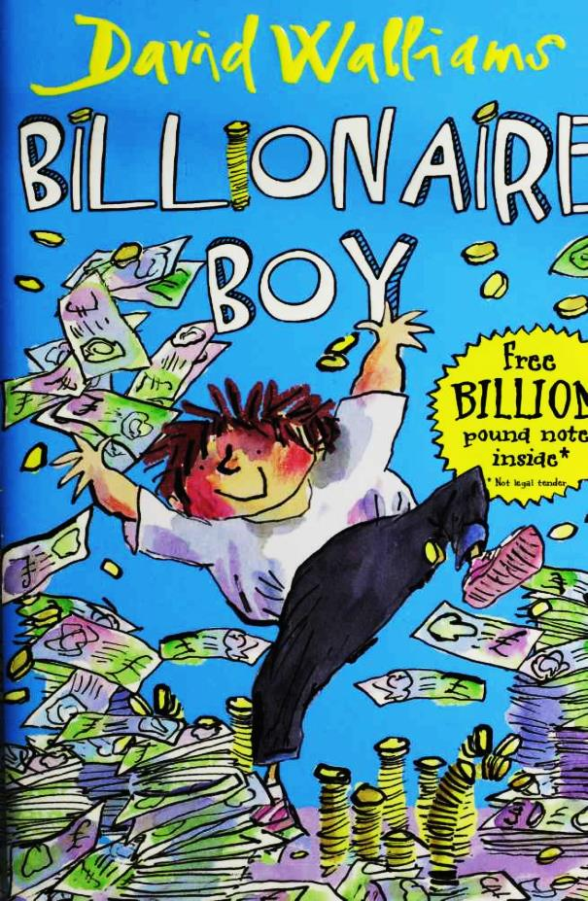

Billionaire Boy
By
David Walliams
Illustrated by Tony Ross
This electronic copy of the original work is made under a Copyright Licensing Agency license by The Seeing Ear. It is for the personal use of a Print Disabled Person and may not be further copied, (including any electronic copying or transmission), or dealt with without permission, save as may be permitted by law.
Contents
1 Meet Joe Spud 9
2 Bum Boy 17
3 Who's the Fattiest? 24
4 "Loo Rolls?" 31
5 Out of Date Easter Eggs 35
6 The Grubbs 40
7 Gerbils on Toast 46
8 The Witch 52
9 "Finger?" 57
10 Dog Spit 63
11 Camping Holiday 67
12 Page 3 Stunna 71
13 New Girl 78
14 The Shape of a Kiss 82
15 Nip and Tuck 85
16 Peter Bread 89
17 A Knock on the Toilet Door 93
18 The Vortex 3000 97
19 A Baboon's Bottom 100
20 A Beach Ball Rolled in Hair 103
21 A GCSE in Make-Up 107
22 A New Chapter 111
23 Canal Boat Weekly 114
24 The Rajmobile 119
25 Broken 122
26 A Blizzard of Banknotes 126
Postscript 130
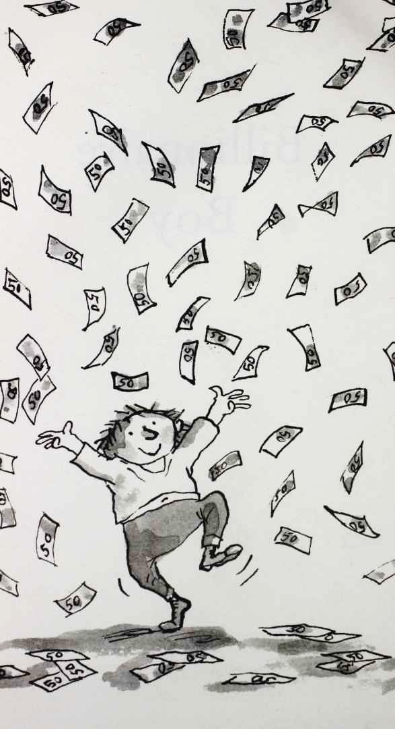
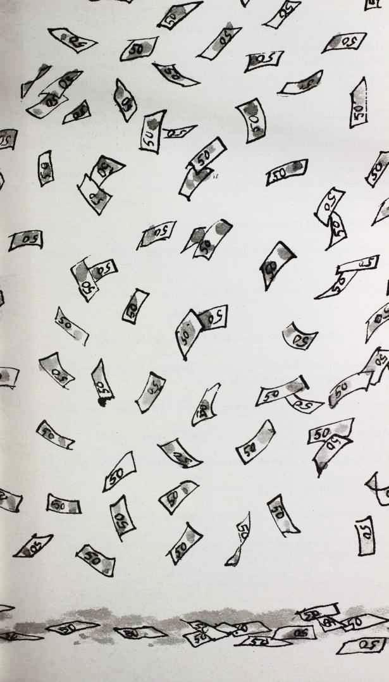
First published in paperback in Great Britain by HarperCollins Children's Books 2011 HarperCollins Children's Books is a division of HarperCollins Publishers Ltd
77-85 Fulham Palace Road, Hammersmith, London W6 8JB
The HarperCollins Children's Books website address is
www.harpercollins.co.uk

Text © David Walliams 2010
Illustrations © Tony Ross 2010
David Walliams and Tony Ross assert the moral right to be identified as the author and illustrator of this work
ISBN 978-0-00-794447-7
Printed and bound in England by Clays Ltd, St Ives plc
Conditions of Sale
This book is sold subject to the condition that it shall not, by way of trade or otherwise, be lent, re-sold, hired out or otherwise circulated without the publisher's prior written consent in any form of binding or cover other than that in which it is published and without a similar condition including this condition being imposed on the subsequent purchaser.

Mixed Sources
FSC is a non-profit international organisation established to promote the responsible management of the world's forests. Products carrying the FSC label arc independently certified to assure consumers that they come from forests that are managed to meet the social, economic and ecological needs of present and future generations.
Find out more about HarperCollins and the environment at www.harpercollins.co.uk/green

Voor Lara,
Ik hou meer van jef dan ik met woorden kan zeggen

Also by David Walliams
The Boy in the Dress
Mr Stink
Gangsta
Granny Ratburger
Thank yous:
I would like to thank a few people who helped make this book possible. I did most of the hard work, but I have to mention them. First, Tony Ross, for his illustrations. He could have coloured them in, but apparently you have to pay him extra. Next, I would like to thank Ann-Janine Murtagh. She is in charge of all HarperCollins children's books and is very nice and always has great suggestions. I have to say that, she is the boss. Then there is Nick Lake who is my editor. His job is to help me with the characters and story, and I couldn't do it without him. Well, I could actually, but he would cry if he wasn't mentioned here.
The cover was designed by James Stevens, and the interior was designed by Elorine Grant. I could say that 'Elorine' is a silly name, but I won't, that would be cruel. The publicist is Sam White. If you see me on Loose Women trying to flog this book, don't blame me, blame her. Sarah Benton, thank you so much for being the most wonderful marketing manager, whatever that is. The sales directors Kate Manning and Victoria Boodle did something too, though I am not sure what. Thank you also to the copy editor Lily Morgan and the proofreader Rosalind Turner. If there are any spelling mistakes it's their fault. And thank you to my agent Paul Stevens at Independent for taking 10% plus VAT of my fee for sitting in his office all day drinking tea and eating biscuits.
Of course, a big thank you to you for buying this book. Really you shouldn't be bothering reading this bit though. It's boring. You need to get on with reading the story. It has already been called 'one of the greatest stories ever written'. Thanks for that, Mum.

1 Meet Joe Spud
Have you ever wondered what it would be like to have a million pounds?
Or a billion?
How about a trillion?
Or even a gazillion?
Meet Joe Spud.
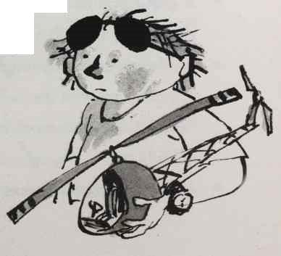
11
Joe didn't have to imagine what it would be like to have loads and loads and loads of money. He was only twelve, but he was ridiculously, preposterously rich.
Joe had everything he could ever want.
• 100-inch plasma widescreen flat- screen high-definition TV in every room in the house 
• 500 pairs of Nike trainers
• A grand-prix race track in the back garden
• A robot dog from Japan 
• A golf buggy with the number plate 'SPUD 2' to drive around the grounds of his house
• A waterslide which went from his
12
bedroom into an indoor Olympic-sized swimming pool
Every computer game in the world
• 3-D IMAX cinema in the basement
• A crocodile
• 24-hour personal masseuse
• Underground 10-lane bowling alley
• Snooker table 
• Popcorn dispenser
• Skateboard park
• Another crocodile 
• £100,000 a week pocket money 
• A rollercoaster in the back garden
• A professional recording studio in the attic
• Personalised football coaching from the England team
• A real-life shark in a tank
13
In short, Joe was one horribly spoilt kid. He went to a ridiculously posh school. He flew on private planes whenever he went on holiday. Once, he even had Disneyworld closed for the day, just so he wouldn't have to queue for any rides.
Here's Joe. Speeding around his own private racetrack in his own Formula One racing car.
Some very rich children have miniature
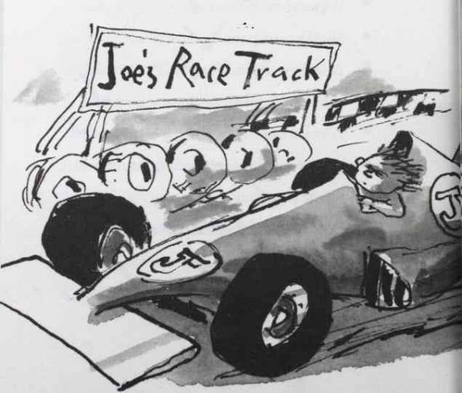
14
versions of cars specially built for them. Joe wasn't one of those children. Joe needed his Formula One car made a bit bigger. He was quite fat, you see. Well, you would be, wouldn't you? If you could buy all the chocolate in the world.
You will have noticed that Joe is on his own in that picture. To tell the truth, speeding around a racetrack isn't that much fun when you are on
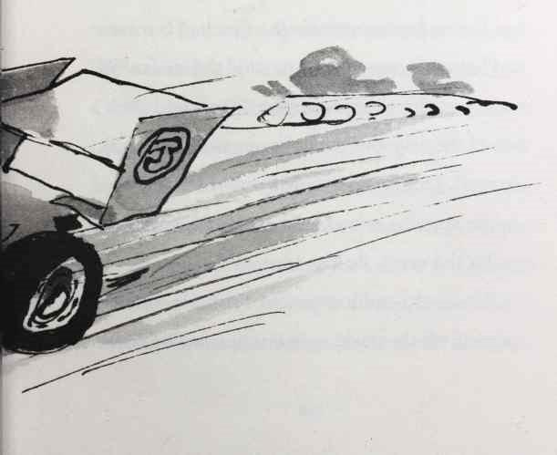
15
your own, even if you do have a squillion pounds. You really need someone to race against. The problem was Joe didn't have any friends. Not one.
Friends X
Now, driving a Formula One car and unwrapping a king-size Mars Bar are two things you shouldn't try and do at the same time. But it had been a few moments since Joe had last eaten and he was hungry. As he entered the chicane, he tore open the wrapper with his teeth and took a bite of the delicious chocolate-coated nougat and caramel. Unfortunately, Joe only had one hand on the steering wheel, and as the wheels of the car hit the verge, he lost control.
The multi-million-pound Formula One car careered off the track, span around, and hit a tree.
16
SSSSSSSSscccccccCCCCCCCCRRRRRRRRRRRRRRREEEeeeeeeeEEEEEECC
ccccccccccHHHHHHHHHHH!!!!!!!!!!!!!!!!!!!!!!!!!!!!!!!!!!!!!!!!!
The tree was unharmed. But the car was a write-off. Joe squeezed himself out of the cockpit. Luckily Joe wasn't hurt, but he was a little dazed, and he tottered back to the house.
"Dad, I crashed the car,” said Joe as he entered the palatial living room.
Mr Spud was short and fat, just like his son. Hairier in a lot of places too, apart from his head - which was bald and shiny. Joe s dad was sitting on a hundred-seater crocodile skin sofa and didn't look up from reading that day’s copy of the Sun.
17
"Don't worry Joe,” he said. "I'll buy you another one.''
Joe slumped down on the sofa next to his dad.
"Oh, happy birthday, by the way, Joe." Mr Spud handed an envelope to his son, without taking his eyes off the girl on Page 3.
Joe opened the envelope eagerly. How much money was he going to receive this year? The card, which read 'Happy 12th Birthday Son', was quickly discarded in favour of the cheque inside.
Joe could barely disguise his disappointment. "One million pounds?" he scoffed. "Is that all?"
"What's the matter, son?" Mr Spud put down his newspaper for a moment.
"You gave me a million last year," whined Joe. "When I turned eleven. Surely I should get more now I'm twelve?"
Mr Spud reached into the pocket of his shiny grey designer suit and pulled out his
18
chequebook. His suit was horrible, and horribly expensive. "I'm so sorry son," he said. "Let's make it two million."
Now, it's important you realise that Mr Spud had not always been this rich.
Not so long ago the Spud family had lived a very humble life. From the age of sixteen, Mr Spud worked in a vast loo-roll factory on the outskirts of town. Mr Spud's job at the factory was sooooo boring. He had to roll the paper around the cardboard inner tube.
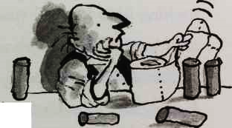
Roll after roll.
Day after day.
Year after year.
Decade after decade.
This he did, over and over again, until nearly all his hope had gone. He would stand all day by the conveyor belt with hundreds of other bored workers, repeating the same mind-numbing task.
19
Every time the paper was rolled onto one cardboard tube, the whole thing started again. And every loo roll was the same. Because the family was so poor, Mr Spud used to make birthday and Christmas presents for his son from the loo roll inner tubes. Mr Spud never had enough money to buy Joe all the latest toys, but would make him something like a loo-roll racing car, or a loo-roll fort complete with dozens of loo-roll soldiers. Most of them got broken and ended up in the bin. Joe did manage to save a sad looking little loo-roll space rocket, though he wasn't sure why.
The only good thing about working in a factory was that Mr Spud had lots of time to daydream. One day he had a daydream that was to revolutionise bottom wiping forever.
Why not invent a loo roll that is moist on one side and dry on the other? he thought, as he
20
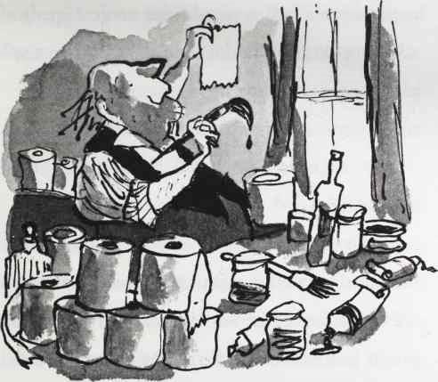
rolled paper around his thousandth roll of the day. Mr Spud kept his idea top-secret and toiled for hours locked in the bathroom of their little council flat getting his new double-sided loo roll exactly right.
When Mr Spud finally launched 'Bumfresh', it was an instant phenomenon. Mr Spud sold a
21
billion rolls around the world every day. And every time a roll was sold, he made 10p. It all added up to an awful lot of money, as this simple maths equation shows.
10p x 1,000,000,000 rolls x 365 days a year = a lot of wonga
Joe Spud was only eight at the time 'Bumfresh' was launched, and his life was turned upside down in a heartbeat. First, Joe's mum and dad split up. It turned out that for many years Joe's mum Carol had been having a torrid affair with Joe's Cub Scout leader, Alan. She took a ten billion pound divorce settlement; Alan swapped his canoe for a gigantic yacht. Last anyone had heard, Carol and Alan were sailing off the coast of Dubai, pouring vintage champagne on their Crunchy Nut Cornflakes every morning. Joe's
22
dad seemed to get over the split quickly and began going on dates with an endless parade of Page 3 girls.
Soon father and son moved out of their poky council flat and into an enormous stately home. Mr Spud named it 'Bumfresh Towers'.
The house was so large it was visible from outer space. It took five minutes just to motor up the drive. Hundreds of newly-planted, hopeful little trees lined the mile-long gravel track. The house had seven kitchens, twelve sitting rooms, forty-seven bedrooms and eighty-nine bathrooms.
Even the bathrooms had en-suite bathrooms. And some of those en-suite bathrooms had en-en-suite bathrooms.
Despite living there for a few years, Joe had probably only ever explored around a quarter of the main house. In the endless grounds were tennis courts, a boating lake, a helipad and even
23
a 100m ski-slope complete with mountains of fake snow. All the taps, door handles and even toilet seats were solid gold. The carpets were made from mink fur, he and his dad drank orange squash from priceless antique medieval goblets, and for a while they had a butler called Otis who was also an orang-utan. But he had to be given the sack.
"Can I have a proper present as well, Dad?" said Joe, as he put the cheque in his trouser pocket. "I mean, I've got loads of money already."
"Tell me what you want, son, and I'll get one of my assistants to buy it," said Mr Spud. "Some solid gold sunglasses? I've got a pair. You can't see out of 'em but they are very expensive."
Joe yawned.
"Your own speedboat?" ventured Mr Spud.
Joe rolled his eyes. "I've got two of those. Remember?"
24
"Sorry, son. How about a quarter of a million pounds worth of WHSmith vouchers?"
"Boring! Boring! Boring!" Joe stamped his feet in frustration. Here was a boy with high-class problems.
Mr Spud looked forlorn. He wasn't sure there was anything left in the world that he could buy his only child. "Then what, son?"
Joe suddenly had a thought. He pictured himself going round the racetrack all on his own, racing against himself. "Well, there is something I really want . . ." he said, tentatively.
"Name it, son," said Mr Spud.
"A friend."
25

2 Bum Boy
"Bum boy," said Joe.
"Bum Boy?" spluttered Mr Spud. "What else do they call you at school, son?"
"The Bog Roll Kid . . ."
Mr Spud shook his head in disbelief. He had sent his son to the most expensive school in England. St Cuthbert's School for Boys. The fees were £200,000 a term and all the boys had to wear Elizabethan ruffs and tights. Here is a picture of Joe in his school uniform. He looks a bit silly, doesn't he?
So the last thing that Mr Spud expected was
26
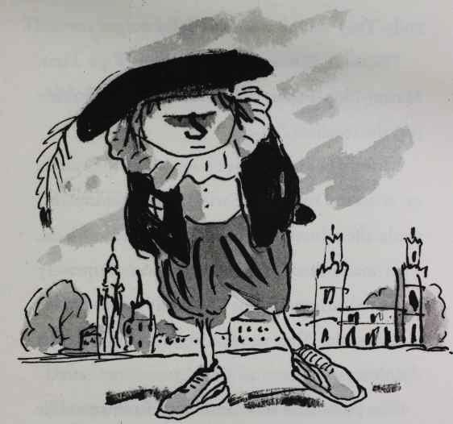
that his son would get bullied. Bullying was something that happened to poor people. But the truth was that Joe had been picked on ever since he started at the school. The posh kids hated him,
27
because his dad had made his money out of loo rolls. They said that was 'awfully vulgar'.
"Bottom Billionaire, The Bum-Wipe Heir, Master Plop-Paper," continued Joe. "And that's just the teachers."
Most of the boys at Joe's school were Princes, or at least Dukes or Earls. Their families had made their fortunes from owning lots of land. That made them 'old money'. Joe had quickly come to learn that money was only worth having if it was old. New money from selling loo rolls didn't count.
The posh boys at St Cuthbert's had names like Nathaniel Septimus Ernest Bertram Lysander Tybalt Zacharias Edmund Alexander Humphrey Percy Quentin Tristan Augustus Bartholomew Tarquin Imogen Sebastian Theodore Clarence Smythe.
That was just one boy.
28
The subjects were all ridiculously posh too. This was Joe's school timetable:
Monday
Latin
Straw Hat wearing
Royal studies
The study of etiquette
Show-jumping
Ballroom dancing
Debating Society ('This house believes that it is vulgar to do up the bottom button on your waistcoat')
Scone eating
Bow-tie tying
Punting
Polo (the sport with horses and sticks, not the mint)
29
Tuesday
Ancient Greek
Croquet
Pheasant shooting
Being beastly to servants class
Mandolin level 3
History of Tweed
Nose in the air hour
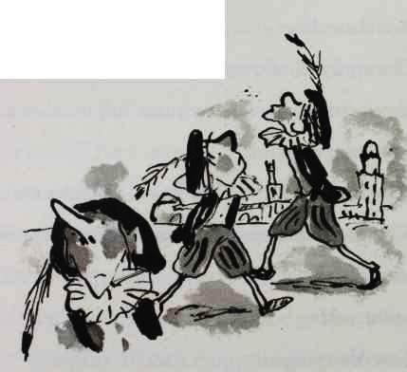
Learning to step over the homeless person as you leave the opera
Finding your way out of a maze
30
Wednesday
Fox-hunting
Flower arranging
Conversing about the weather
History of cricket
History of the brogue
Playing Stately Home Top Trumps
Reading Harper's Bazaar
Ballet appreciation class
Top-hat polishing
Fencing (the one with swords, not selling stolen goods)
Thursday
Antique furniture appreciation hour
Range Rover tyre changing class
Discussion of whose daddy is the richest
31
Competition to see who is best friends with Prince Harry
Learning to talk posh
Rowing club
Debating Society ('This house believes that muffins are best toasted’)
Chess
The study of coats of arms
A lecture on how to talk loudly in restaurants
Friday
Poetry reading (Medieval English)
History of wearing corduroy
Topiary class
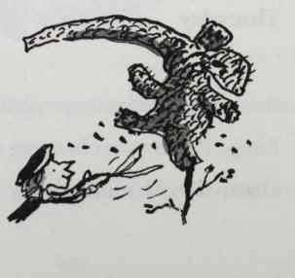
32
Classical sculpture appreciation class
Spotting yourself in the party pages of Tatler hour
Duck hunting
Billiards
Classical music appreciation afternoon
Dinner party discussion topic class (e.g. how the working classes smell)
***
However, the main reason why Joe hated going to St Cuthbert’s wasn't the silly subjects. It was the fact that everyone at the school looked down on him. They thought that someone whose papa made their money from bog rolls was just too, too frightfully common.
"I want to go to a different school, Dad," said Joe.
"No problem. I can afford to send you to the poshest schools in the world. I heard about this
33
place in Switzerland. You ski in the morning and then —"
"No," said Joe. "How about I go to the local comp?"
"What?" said Mr Spud.
"I might make a friend there," said Joe. He'd seen the kids milling around the school gates when he was being chauffeured to St Cuthbert s. They all looked like they were having such a great time - chatting, playing games, swapping cards. To Joe, it all looked so fabulously normal.
"Yes, but the local comp . . ." said Mr Spud, incredulously. "Are you sure?"
"Yes," replied Joe, defiantly.
"I could build you a school in the back garden if you like?" offered Mr Spud.
"No. I want to go to a normal school. With normal kids. I want to make a friend, Dad.
34
I don't have a single friend at St Cuthbert’s."
"But you can't go to a normal school. You are a billionaire, boy. All the kids will either bully you or want to be friends with you just because you are rich. It'll be a nightmare for you."
"Well, then I won't tell anyone who I am. I'll just be Joe. And maybe, just maybe, I'll make a friend, or even two . . ."
Mr Spud thought for a moment, and then relented. "If that's what you really want, Joe, then OK, you can go to a normal school."
Joe was so excited he bumjumped* [*Bumjumping (verb) bum-jump-ing. To move places while sitting using only your bottom to power you, thus meaning you do not have to get up. Much favoured by the overweight.] along the sofa nearer to his dad to give him a cuddle.
"Don't crease the suit, boy," said Mr Spud.
35
"Sorry Dad," said Joe, bumjumping back a little. He cleared his throat. "Um . . . I love you, Dad."
"Yes, son, ditto, ditto," said Mr Spud, as he rose to his feet. "Well, have a good birthday, mate."
"Aren't we going to do something together tonight?" said Joe, trying to hide his disappointment. When he was younger, Joe's dad would always take him to the local burger restaurant as a birthday treat. They couldn't afford the burgers, so they would just order the chips, and eat them with some ham and pickle sandwiches that Mr Spud would smuggle in under his hat.
"I can't son, sorry. I've got a date with this beautiful girl tonight," said Mr Spud, indicating Page 3 of the Sun.
Joe looked at the page. There was a photograph of a woman whose clothes seemed
36
to have fallen off. Her hair was dyed white blonde and she had so much make-up on it was difficult to tell if she was pretty or not. Underneath the image it read, 'Sapphire, 19, from Bradford. Likes shopping, hates thinking.’
"Don't you think Sapphire's a little young for you, Dad?" asked Joe.
"It's only a twenty-seven-year age gap," replied Mr Spud in an instant.
Joe wasn't convinced. "Well, where are you taking this Sapphire?"
"A nightclub."
"A nightclub?" asked Joe.
"Yes," said Mr Spud, in an offended tone. "I am not too old to go to a nightclub!" As he spoke he opened a box and pulled out what looked like a hamster that had been flattened by a mallet and put it on his head.
"What on earth is that, Dad?"
37
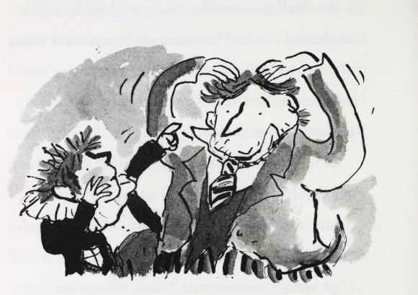
"What's what, Joe?" replied Mr Spud with mock innocence, as he adjusted the contraption to cover his bald dome.
"That thing on your head."
"Ooh, this. It's a toupee, boy! Only ten grand each. I bought a blonde one, a brown one, a ginger one, and an afro for special occasions. It makes me look twenty years younger, don't you think?"
38
Joe didn't like to lie. The toupee didn't make his dad look younger - instead, it made him look like a man who was trying to balance a dead rodent on his head. Therefore, Joe chose a non-committal, "Mmm."
"Right. Well, have a good night," Joe added, picking up the remote. It looked like it would be just him and the 100-inch TV again.
"There's some caviar in the fridge for your tea, son," said Mr Spud as he headed for the door.
"What's caviar?"
"It's fish eggs, son."
"Eurgh . . ." Joe didn't even like normal eggs much. Eggs laid by a fish sounded really revolting.
"Yeah, I had some on toast for me breakfast. It's absolutely disgusting, but it is very expensive so we should start eating it."
"Can't we just have bangers and mash or fish
39
and chips or Shepherd's Pie or something, Dad?"
"Mmm, I used to love Shepherd's Pie, son . . ." Mr Spud drooled a little, as if imagining the taste of Shepherd's Pie.
"Well then . . .?"
Mr Spud shook his head impatiently. "No no no, we are rich son! We have to eat all this posh stuff now like proper rich people do. See you later!" The door slammed behind him and moments later Joe heard the deafening roar of his father's lime-green Lamborghini speeding off into the night.
Joe was disappointed to be on his own again, but he still couldn't suppress a small smile as he turned on the TV. He was going to go to an ordinary school again and be an ordinary boy. And maybe, just maybe, make a friend.
The question was, how long could Joe keep the fact that he was a billionaire a secret . . .?
40

3 Who's the Fattiest?
Finally, the big day came. Joe took off his diamond-encrusted watch and put his gold pen in the drawer. He looked at the designer black snakeskin bag his dad had bought him for his first day at his new school and put it back in his cupboard. Even the bag that bag had come in was too posh, but he found an old plastic one in the kitchen and put his school books in that. Joe was determined not to stand out.
From the back seat of his chauffeur-driven Rolls Royce he had passed the local comprehensive many times on his way to St Cuthbert s, and seen
41
the kids pouring out of the school. A rushing river of swinging bags and swear words and hair gel. Today, he was going to enter the gates for the first time. But he didn't want to arrive by Rolls Royce - that would be a pretty good hint to the other kids that he was rich. He instructed the chauffeur to drop him off at a nearby bus stop. It had been quite a few years since he had travelled by public transport, and as he waited at the bus stop Joe tingled with excitement.
"I can't change that!" said the bus driver.
Joe hadn't realised that a £50 note was not going to be welcome to pay for a two-pound fare, and had to get off the bus. Sighing, he began to walk the two miles to school, his flabby thighs rubbing together as he took each step.
Finally, Joe reached the school gates. For a moment he loitered nervously outside. He had
42
spent so long living a life of wealth and privilege - how on earth was he going to fit in with these kids? Joe took a deep breath and marched across the playground.
At registration, there was only one other kid sitting on his own. Joe looked over at him. He was fat, just like Joe, with a mop of curly hair. When he saw Joe looking at him, he smiled. And when registration was finished, he came over.
"I'm Bob," said the fat boy.
"Hi Bob," replied Joe. The bell had just rung and they waddled along the corridor to the first lesson of the day. "I'm Joe," he added. It was weird to be in a school where no one knew who he was. Where he wasn't Bum Boy, or Billionaire Bum, or the Bumfresh Kid.
"I am so glad you're here, Joe. In the class I mean."
"Why's that?" asked Joe. He was excited. It
43
looked like he might have found his first friend already!
"Because I'm not the fattest boy in the school anymore," Bob said confidently, as if stating an independently verified fact.
Joe scowled, then stopped for a second and studied Bob. It looked to him like he and the other boy were about the same level of fattiness.
"How much do you weigh then?" demanded Joe grumpily.
"Well, how much do you weigh?" said Bob.
"Well, I asked you first."
Bob paused for a second. "About eight stone."
"I'm seven stone," said Joe, lying.
"No way are you seven stone!" said Bob angrily. "I'm twelve stone and you are much fatter than me!"
"You just said you were eight stone!" said Joe accusingly.
44
"I was eight stone . . ." replied Bob, "when I was a baby."
***
That afternoon it was cross-country running. What a dreadful ordeal for any day at school, not least your first day. It was a yearly torture that seemed designed solely to humiliate those kids who weren't sporty. A category Bob and Joe could definitely be squeezed into.
"Where is your running kit, Bob?" shouted Mr Bruise, the sadistic PE teacher, as Bob made his way onto the playing field. Bob was wearing his Y-fronts and vest, and his appearance was greeted by a huge wave of laughter from the other kids.
"S-s-s-someone m-m-must have hidden it S-s-s-sir," answered a shivering Bob.
"Likely story!" scoffed Mr Bruise. Like most PE teachers, it was difficult to imagine him
45
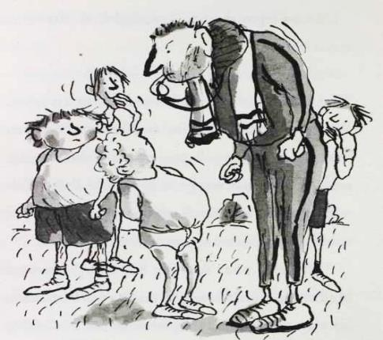
wearing anything other than a tracksuit.
"D-d-do I still have to do the r-r-r-r-run S-s-s-s-s-s-s-sir . . .?" asked a hopeful Bob.
"Oh yes, boy! You don't get off that easily. Right everyone, on your marks, get set . . . wait for it! GO!"
46
At first, Joe and Bob sprinted away like all the other kids, but after about three seconds they were both out of breath and were forced to walk. Soon everyone else had disappeared into the distance and the two fat boys were left alone.
"I come last every year," said Bob, unwrapping a Snickers and taking a large bite. "All the other kids always laugh at me. They get showered and dressed and wait at the finish line. They could all go home, but instead they wait just to jeer at me."
Joe frowned. That didn't sound like fun. He decided he didn't want to be last, and quickened his pace a little, making sure he was at least half a step ahead of Bob.
Bob glared at him, and piled on the speed, going up to at least half a mile an hour. From the determined expression on his face, Joe knew that
47
Bob was hoping that this year was his golden chance not to finish last.
Joe sped up a little more. They were now almost jogging. The race was on. For the ultimate prize: who was going to finish . . . second to last! Joe really didn't want to be beaten at cross-country running by a fat boy in his vest and pants on his first day at school.
After what seemed like an eternity the finish line hazed into sight. Both boys were out of breath with all this power-waddling.
Suddenly, disaster struck Joe. A painful stitch burst in his side.
"Ooww!" cried Joe.
"What's the matter?" asked Bob, now quite a few centimetres in the lead.
"I've got a stitch . . . I've got to stop. Owww . . ."
"You're bluffing. A fifteen-stone girl pulled
48
that on me last year and ended up beating me by a fraction of a second."
"Oww. It's true," said Joe, holding his side tightly.
"I ain't falling for it, Joe. You are going to be last, and this year all the kids in the year are gonna be laughing at you!" said Bob triumphantly, as he edged ahead still further.
Being laughed at on his first day at school was the last thing Joe wanted. He'd had enough of being laughed at when he was at St Cuthbert's. However, the stitch was becoming more and more painful with every step. It was as if it was burning a hole in his side. "How about I give you a fiver to come last?" he said.
"No way," replied Bob, through heaving breaths.
"A tenner?"
"No."
49
"Twenty quid?"
"Try harder."
"Fifty quid."
Bob stopped, and looked around at Joe.
"Fifty quid . . ." he said. "That's a lot of chocolate."
"Yeah," said Joe. "Tons."
"You've got yourself a deal. But I want the wonga now."
Joe searched through his shorts and pulled out a fifty-pound note.
"What's that?" asked Bob.
"It's a fifty pound note."
"I've never seen one before. Where did you get it?"
"Oh, erm, it was my birthday last week you see . . ." said Joe, stumbling over his words a little. "And my dad gave me that as a present."
The marginally fatter boy studied it for a moment, holding it up to the light as if it was a
50
priceless artefact. "Wow. Your dad must be loaded" he said.
The truth would have blown Bob's fat mind. That Mr Spud had given his son two million pounds as a birthday present. So Joe kept schtum.
"Nah, not really,” he said.
"Go on then," said Bob. "I'll come last again. For fifty quid I would finish tomorrow if you like."
"Just a few paces behind me will be fine," said Joe. "Then it will look real."
Joe edged ahead, still gripping his side in pain. Hundreds of little cruelly smiling faces were coming into focus now. The new boy crossed the finish line with only a hum of mocking laughter. Trailing behind was Bob, clutching his fifty-pound note, since there were no pockets in his Y-fronts. As he neared the
51
finish line the kids started chanting.
"BLOB! BLOB! BLOB! BLOB! BLOB! BLOB! BLOB! BLOB! BLOB! BLOB! BLOB! BLOB! BLOB! BLOB! BLOB! BLOB! BLOB! BLOB! BLOB!"
The chants grew louder and louder.
"BLOB! BLOB! BLOB! BLOB! BLOB! BLOB! BLOB! BLOB! BLOB! BLOB! BLOB! BLOB! BLOB! BLOB! BLOB! BLOB! BLOB! BLOB! BLOB! BLOB! BLOB! BLOB! BLOB! BLOB! BLOB! BLOB! BLOB! BLOB! BLOB! BLOB! BLOB! BLOB! BLOB! BLOB! BLOB! BLOB!"
52
They started clapping in time now.
BLOB! BLOB! BLOB! BLOB!
BLOB! BLOB! BLOB! BLOB!
BLOB! BLOB! BLOB! BLOB!
BLOB! BLOB! BLOB! BLOB!
BLOB! BLOB! BLOB! BLOB!
BLOB! BLOB! BLOB! BLOB!
BLOB! BLOB! BLOB! BLOB!
BLOB! BLOB! BLOB! BLOB!
BLOB! BLOB! BLOB! BLOB!
BLOB! BLOB! BLOB! BLOB!
BLOB! BLOB! BLOB! BLOB!
BLOB! BLOB! BLOB! BLOB!
BLOB! BLOB! BLOB! BLOB!
BLOB! BLOB! BLOB! BLOB!
BLOB! BLOB! BLOB! BLOB!
BLOB! BLOB!"
Undeterred, Bob hurled his body across the finish line.
53
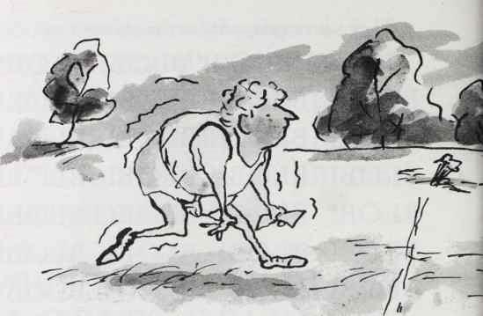
"HA! HA! HA! HA! HA! HA! HA! HA! HA! HA! HA! HA! HA! HA!
ha! ha! ha! ha! ha! ha! ha! ha! ha! ha! ha! ha! ha! ha! ha! ha! ha! ha! ha! HA!
HA! HA! HA! HA! HA! HA! HA! HA! HA! HA! HA! HA! HA! HA! HA!
54
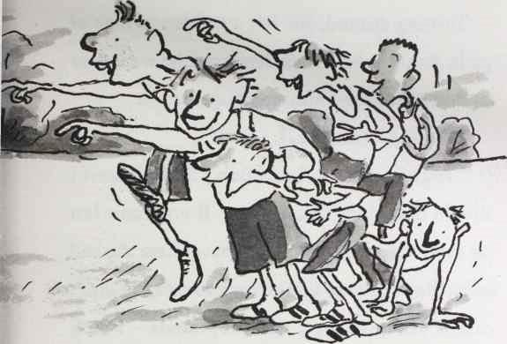
HA! HA! HA! HA! HA! HA! HA! HA! HA! HA! HA! HA! HA! Ha! Ha! Ha!
ha! ha! ha! ha! ha! ha! ha! ha! HA! HA! HA! HA! HA! HA!
ha! ha! ha! ha! ha! ha! ha! ha!"
The other kids fell around laughing, pointing at Bob, as he bent over and panted for breath.
55
Turning around, Joe felt a sudden twinge of guilt. As the school kids dispersed, he went over to Bob and helped him stand up straight.
"Thanks," said Joe.
"You're welcome," said Bob. "To be honest I should have done that anyway. If you came last on your very first day, you'd never hear the end of it. But next year you're on your own. I don't care if you give me a million pounds - I ain't coming last again!"
Joe thought about his two million pound birthday cheque. "What about two million pounds?" he joked.
"Deal!" said Bob, laughing. "Imagine if you really did have that much money. It would be crazy! I guess you could have everything you ever wanted!"
Joe forced a smile. "Yeah," he said. "Maybe . . ."
56

4 "Loo Rolls?"
"So, did you forget your kit on purpose?" asked Joe.
Mr Bruise had locked up the changing rooms by the time Joe and Bob had finished their cross-country run . . . well, cross-country walk. They stood outside the grey concrete building, Bob shivering in his pants. They'd already been to find the school secretary, but there was absolutely no one left in the whole place. Well, apart from the caretaker. Who didn't seem to speak English. Or any other language for that matter.
57
"No," replied Bob, a little hurt at the suggestion. "I may not be the fastest runner, but I'm not that much of a coward."
They trudged through the school grounds, Joe in his singlet and shorts, and Bob in his vest and pants. They looked like two rejects from a boy band audition.
"So who took it?" said Joe. "I dunno. It might be the Grubbs. They're the school bullies."
"The Grubbs?"
"Yeah. They're twins."
"Oh," said Joe. "I haven't met them yet."
"You will," replied Bob, dolefully. "You know, I feel really bad about taking your birthday money off you . . ."
"You don't have to," said Joe. "It's fine."
"But fifty pounds is a lot of money," Bob protested.
58
Fifty pounds was not a lot of money to the Spuds. Here are a few things Joe and his dad would do with fifty-pound notes:
• Light them instead of bits of old newspaper to get the barbecue going
• Keep a pad of them by the telephone and use them as post-it notes
• Line the hamster cage with handfuls of them and then throw them out after a week when they began to smell of hamster wee
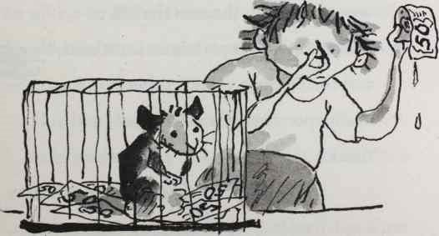

59
• Let the same hamster use one as a towel after it's had a shower «
• Filter coffee through them
• Make paper hats out of them to wear on Christmas day
• Blow their noses on them
• Spit chewed-up chewing gum into them before crumpling them and placing them in the hand of a butler who would then put them in the hand of a footman who would then put them in the hand of a maid who would then put them in the bin
• Make paper aeroplanes out of them and throw them at each other
• Wallpaper the downstairs loo with them
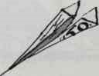
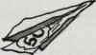
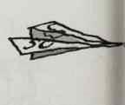
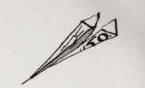
60
"I never asked,' said Bob. "What does your dad do?"
Joe panicked for a moment. "Erm, he, er, he makes loo rolls,” he said, only lying a tiny bit.
"Loo rolls?" said Bob. He couldn't suppress his smile.
"Yes," replied Joe defiantly. "He makes loo rolls."
Bob stopped smiling. "That doesn't sound like it pays all that well."
Joe winced. "Er . . . no, it doesn't."
"Then I guess your dad had to save for weeks to give you £50. Here you go." Bob carefully handed the now-slightly-crumpled fifty-pound note back to Joe.
"No, you keep it," protested Joe.
Bob pressed the note into Joe's hand. "It's your birthday money. You keep it."
Joe smiled uncertainly and closed his hand
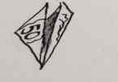
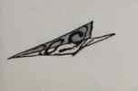
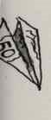
61
over the money. "Thank you, Bob. So, what does your dad do?"
"My dad died last year."
They continued walking in silence for a moment. All Joe could hear was the sound of his heart beating. He couldn't think of anything to say. All he knew was that he felt awful for his new friend. Then he remembered that when someone died people sometimes said, ‘I’m sorry'.
"I'm sorry," he said.
"It's not your fault," said Bob.
"I mean, well, I'm sorry he died."
"I’m sorry too."
"How did he . . . you know?"
"Cancer. It was really scary. He just got more and more ill and then one day they took me out of school and I went to the hospital. We sat by his bed for ages and you could hear his breath rattling and then suddenly the sound just
62
stopped. I ran outside to get the nurse and she came in and said he was 'gone'. It's just me and my mum now."
"What does your mum do?"
"She works at Tesco. On the checkout. That's where she met my dad. He would shop on Saturday mornings. He used to joke that he 'only came in for a pint of milk but left with a wife!'"
"It sounds like he was funny," said Joe.
"He was," said Bob, smiling. "Mum's got another job too. She's a cleaner at an old people's home in the evenings. Just to make ends meet."
"Wow," said Joe. "Doesn't she get tired?"
"Yeah," said Bob. "So I do a lot of the cleaning and stuff."
Joe felt really sorry for Bob. Since he was eight, Joe had never had to do anything at home - there was always the butler or the maid or gardener or the chauffeur or whoever to do everything. He
63
took the note out of his pocket. If there was one person who needed the money more than him it was Bob. "Please, Bob, keep the £50."
"No. I don't want to. I'd feel bad."
"Well, let me at least buy you some chocolate."
"You've got a deal," said Bob. "Let's go to Raj's."
64

5 Out of Date Easter Eggs
Ding!
No, reader, that's not your doorbell. No need to get up. It's the sound of the bell tinkling in Raj's shop as Bob and Joe opened the door.
"Ah, Bob! My favourite customer!" said Raj. "Welcome, welcome!"
Raj ran the local newsagent's shop. All the local kids adored him. He was like the funny uncle you always wished you had. And even better than that, he sold sweets.
"Hi, Raj!" said Bob. This is Joe."
"Hello Joe," exclaimed Raj. "Two fat boys in
65
my shop at one time! The Lord must be smiling on me today! Why have you both got so little on?"
"We came straight from cross-country running Raj," explained Bob.
"Fantastic! How did you do?"
"First and second . . ." replied Bob.
"That's wonderful!" exclaimed Raj.
". . .to last," finished Bob.
"That's not so good. But I imagine you boys must be hungry after all that exercise. How can I help you today?"
"We'd like to buy some chocolate," said Joe.
"Well, you have come to the right place. I have the finest selection of chocolate bars in this parade!" Raj announced triumphantly. Considering the only other shops in the parade were a launderette and a long since closed florist that wasn't saying much, but the boys let it pass.
66
Now, one thing Joe knew for certain was that chocolate didn't have to be expensive to taste nice. In fact, after a few years of gorging themselves on the finest chocolates from Belgium or Switzerland, he and his dad had realised that they weren't half as delicious as a Yorkie. Or a bag of Minstrels.
Or, for the true connoisseur, a Double Decker.
"Well, let me know if I can help you gentlemen," said the newsagent. The stock in Raj's shop was haphazardly laid out. Why was Nuts magazine next to the Tipp-ex? If you couldn't find the Jelly Tots, it was entirely possible that they might be hiding under a copy of the Sun from 1982. And did the post-it notes really have to be in the freezer?
However, local people kept coming to the shop because they loved Raj, and he loved his customers too, particularly Bob. Bob was one of
67
his absolute best customers.
"We are happy just to browse thanks,” replied Bob. He was studying the rows and rows of confectionery, looking for something special. And today money wasn't a problem. Joe had a fifty-pound note in his pocket. They could even afford one of Raj's out of date Easter eggs.
"The Wispas are very good today, young Sirs. Fresh in this morning,” ventured Raj.
"We are just looking thank you," replied Bob politely.
"The Cadbury's Creme Eggs are in season," suggested the newsagent.
"Thank you," said Joe politely, smiling.
"Just to say, gentlemen, I am here to help," said Raj. "If you have any questions please don't hesitate to ask."
"We will," said Joe.
There was a brief moment of silence.
68
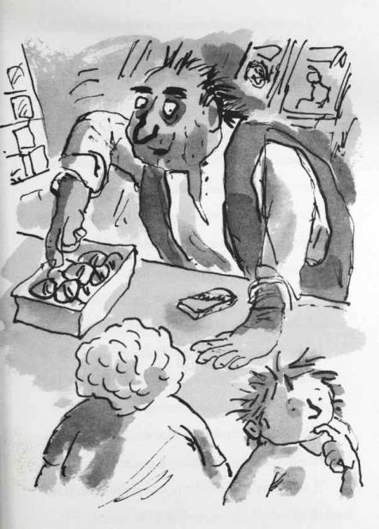
69
"Just to let you know the Flake is off today, Sirs,” continued Raj. "I should have said. A problem with the supplier, but I should have them back on sale tomorrow.”
"Thanks for letting us know,” said Bob. He and Joe shared a look. They were beginning to wish the newsagent would let them shop in peace.
"I can recommend a Ripple. I had one earlier and they are exquisite at the moment." Joe nodded politely.
“I’ll leave you alone to make up your own mind. As I say, I am here to help.”
"Can I have one of these?” said Bob, lifting up a giant bar of Cadburys Dairy Milk to show Joe.
Joe laughed. "Of course you can!" An excellent choice, gentlemen. I have those on special offer today. Buy ten get one free,” said Raj.
"I think we just need the one right now, Raj,” said Bob.
70
"Buy five get half a one free?"
"No thanks," said Joe. "How much is it?"
"£3.20 please."
Joe took out the fifty-pound note.
Raj looked at it in wonder. "Oh my! I have never seen one of those before. You must be a very rich young man!"
"Not at all," said Joe.
"His dad gave it to him for his birthday," chimed in Bob.
"Lucky boy," said Raj. He peered at Joe. "You know, you look familiar, young man."
"Do I?" replied Joe nervously.
"Yes I am sure I have seen you somewhere before." Raj tapped his chin as he thought. Bob stared at him, baffled. "Yes," said Raj eventually. "Only the other day I saw a picture of you in a magazine."
"I doubt it, Raj," scoffed Bob. "His dad
71
makes loo rolls!"
"That's it!" exclaimed Raj. He riffled through a pile of old newspapers and pulled out the Sunday Times Rich List.
Joe started to panic. "I've got to go . . ."
The newsagent flicked through the pages. "There you are!" Raj indicated a photograph of Joe sitting awkwardly on the front of his Formula One racing car, and then read aloud from the magazine. "Britain's Richest Children. Number one: Joe Spud, age twelve. Bumfresh heir. Estimated worth, ten billion."
A large lump of chocolate dropped from Bob's mouth onto the floor. "Ten billion?"
"No way have I got ten billion," protested Joe. "The press always exaggerate. I've got eight billion at the most. And I won't even get most of it till I'm older."
"That's still a lot of money!" exclaimed Bob.
72
"Yes, I suppose it is."
"Why didn't you tell me? I thought we were mates."
"I'm sorry," stammered Joe. "I just wanted to be normal. And it's so embarrassing being the son of a bog-roll billionaire."
"No no no you should be proud of your dad!" exclaimed Raj. "His story is an inspiration to all of us. A humble man who became a billionaire with one simple idea!"
Joe had never really thought of his dad like that.
"Leonard Spud revolutionised the way we wipe our bottoms forever!" Raj chuckled.
"Thanks, Raj."
"Now, please tell your father I have just started using Bumfresh and I love it! My bottom has never been so sparkling! See you next time!"
The two boys walked along the street in
73
silence. All you could hear was Bob sucking the chocolate from between his teeth.
"You lied to me," said Bob.
"Well I did tell you he worked in bog rolls," said Joe, uncomfortably.
"Yeah but . . ."
"I know. I'm sorry." It was Joe's first day at school, and his secret was already out. "Here, have the change," said Joe, reaching in his pocket for the two twenty-pound notes.
Bob looked crushed. "I don't want your money."
"But I'm a billionaire," said Joe. "And my dad's got squillions. I don't even know what that means, but I know it's loads. Just take it. Here, have this lot too." He pulled out a roll of £50 notes.
"I don't want it," said Bob.
Joe's face crinkled with incredulity. "Why not?"
74
"Because I don't care about your money. I just liked hanging out with you today."
Joe smiled. "And I liked hanging out with you." He coughed. "Look, I really am sorry. It's just . . . the kids at my old school used to bully me because I was the Bumfresh boy. I wanted to just be a normal kid."
"I can understand that," said Bob. "I mean, it would be nice to start again."
"Yeah," said Joe. '
Bob stopped, and held out his hand. "I'm Bob," he said.
Joe shook his hand. "Joe Spud."
"No other secrets?"
"No," said Joe, smiling. "That's it."
"Good," said Bob, smiling too.
"You won't tell anyone at school, will you?" said Joe. "About me being a billionaire. It's so embarrassing. Especially when they find out
75
how my dad became rich. Please?"
"Not if you don't want me to."
"I don't. I really don't."
"Well, I won't then."
"Thanks."
The two continued down the street. After a few paces Joe couldn't wait any longer. He turned to Bob, who had already polished off half the massive bar of Dairy Milk. "Can I have some chocolate then?" he asked.
"Yes of course. This is for us to share," said Bob, as he broke off his friend a tiny square of chocolate.
76

