P2-P7 Reading Challenge!
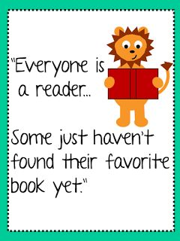
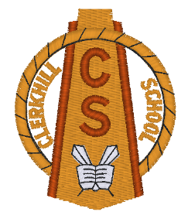
We love to read at Clerkhill School and to encourage all of our pupils to pick up a book, magazine or to listen to an audio book at home, we are setting a House Reading Challenge for the next four weeks!
Every morning children will go to their House Reading Chart and put a tick under their name if they have read or been read to for at least 15 minutes at home the night before. We would very much appreciate it if a parent/career could sign their child’s homework diary / reading record to show that their child has been reading at home.
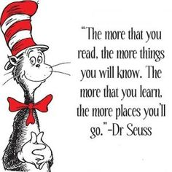
Children will then add a House Point to their Whole Class House Points Chart. When they reach the bottom of the column they can get Ten House Points for their own House Points Card!
Rewards will be given to the winning House and prizes will be awarded to those children at each stage who have shown a real love of reading. A tally of how well each House is doing will be displayed in the big hall. Happy Reading Everybody!

Name: _________________________ Class: _______
I have finished reading / listening to, ______________________________________________
____________________________________ at home / at school.
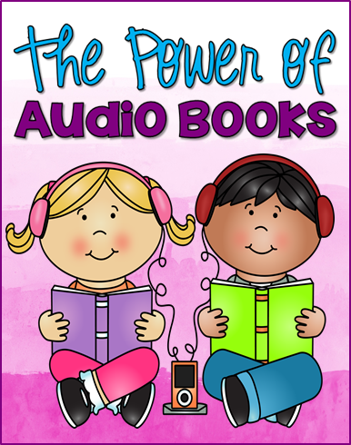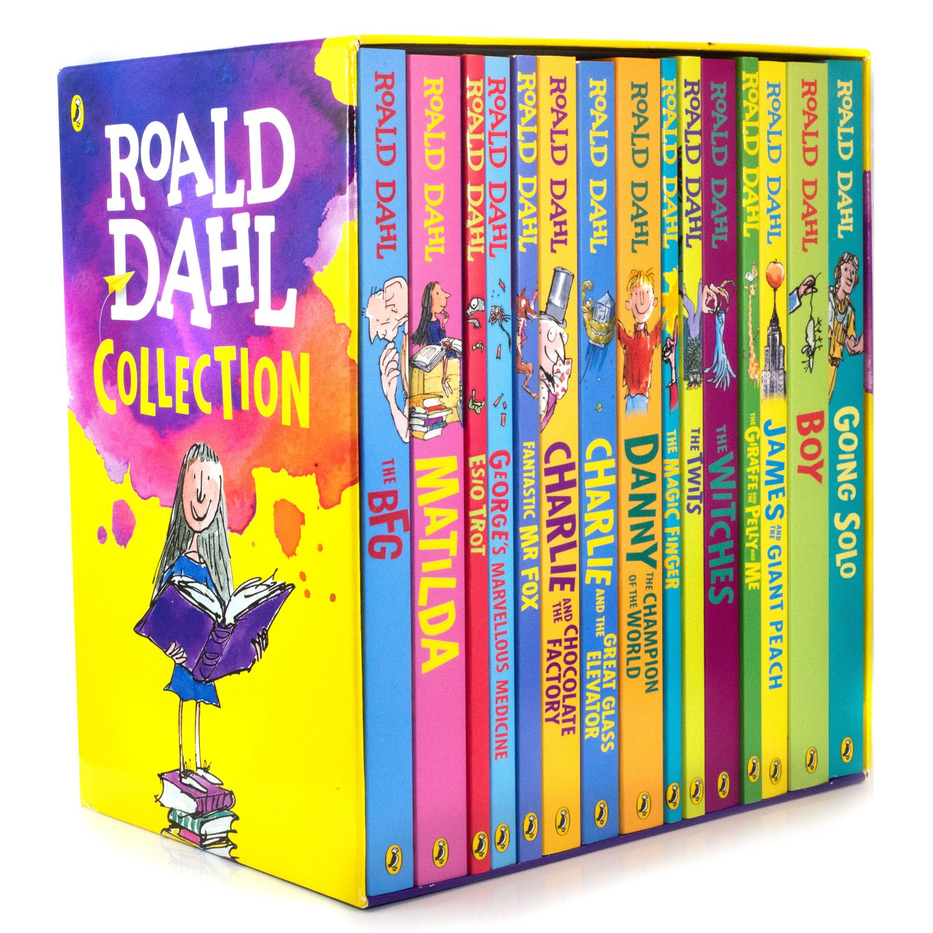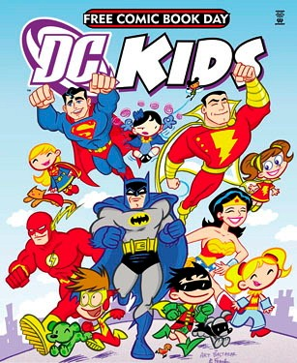
Parent / Teacher signature: ______________________
Date: _________________

Name: _________________________ Class: _______
I have finished reading / listening to, ______________________________________________
____________________________________ at home / at school.
Parent / Teacher signature: ______________________
Date: _________________

Name: _________________________ Class: _______
I have read / listened to, ___________________________
____________________________________ at home / at school.
Parent / Teacher signature: ______________________
Date: _________________

Name: _________________________ Class: _______
I have read / listened to, ___________________________
____________________________________ at home / at school.
Parent / Teacher signature: ______________________
Date: _________________

